

Project Title (Provide a brief, informative, and descriptive title for the proposed work that indicates the nature of the project.)
Internal Applied Science Tools

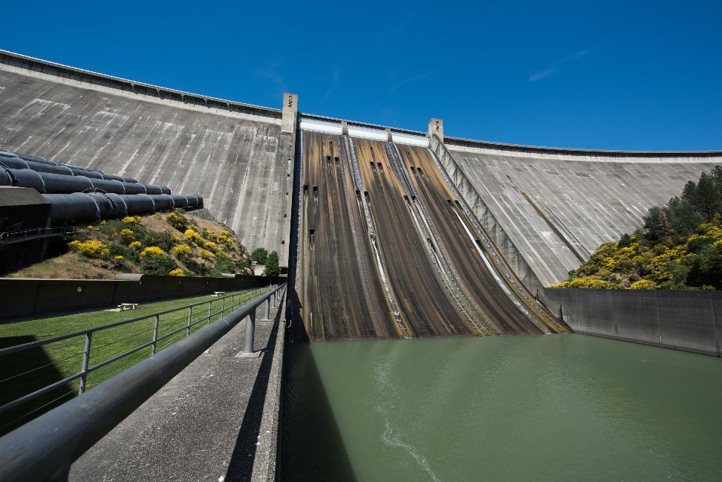
[Please change photo to reflect project]

prepared by (add any additional information here that might be needed, such as the following)

Project Contacts: Manager’s Name, e-mail address, and office location.
Additional Authors
U.S. Department of the Interior
June 2025
Mission Statements

The U.S. Department of the Interior protects and manages the Nation’s natural resources and cultural heritage; provides scientific and other information about those resources; and honors its trust responsibilities or special commitments to American Indians, Alaska Natives, and affiliated Island Communities.

The mission of the Bureau of Reclamation is to manage, develop, and protect water and related resources in an environmentally and economically sound manner in the interest of the American public.

Cover Photo: Add over photo caption & credit.

Acronyms and Abbreviations
Reclamation Bureau of Reclamation

Contents (right+click on TOC>Update Field”)

Page

Technical Proposal (Limited to 10 pages) 1
Executive Summary 1
Technical Description 1
Evaluation Criteria 2
Evaluation Criterion A—Water Management Challenges (25 Points) 2
Evaluation Criterion B—Project Benefits (25 Points) 2
Evaluation Criterion C—Project Collaboration and Communication (25 Points) 3
Evaluation Criterion D—Project Implementation Plan (25 Points) 4
Project Budget (Does not count towards page limit) 5
Total Project Costs 5
Budget Proposal Table 6
Budget Narrative 7
Cost Share Contributions 7
Environmental and Cultural Resources Compliance (as applicable to the project) (Does not count towards page limit) 8
Required Permits or Approvals (as applicable to the project) (Does not count towards page limit) 8
Supervisor and Acquisitions Approvals (Does not count towards page limit) 8
Letters of Support (Does not count towards page limit) 9
References 10
Appendix A 11
Appendix B 12

Technical Proposal (Limited to 10 pages)

Executive Summary

The Executive Summary should not exceed one page and is intended to be a high-level summary of the proposed project. The executive summary should include the following information:

- Project Title: The title should convey the nature of the project and its location.
- Eligible Project Type: Identify which of the eligible project types identified in this CFP the proposed work fits under (applicants may identify more than one eligible project type). See Section B.3. Eligible Projects for eligible project types.
- Applicant Information: Applicant name, Reclamation office, and region.
- Project Summary: Briefly summarize the work proposed in a manner appropriate for website posting. The summary should include:
  - the applicant’s name, organization, and general geographic project location (city, county and state);
  - a one-paragraph project summary that specifies the purpose of the project (e.g., why is it needed, who is involved and what gave rise to the project?), the work proposed, and briefly identifies how the proposed project contributes to accomplishing the goals of this CFP (i.e., how Reclamation will benefit); and
  - a list of any partners.
- Performance Period: Project length and estimated completion date.
- General project location: A general description of the area where the project will be conducted, particularly any site-specific application of the project results.

Technical Description
Provide a more comprehensive description of the technical aspects of your applied science project, including the work to be accomplished and the approach to complete the work. This description should provide detailed information about the existing tool or information that will be improved. This section provides an opportunity for the applicant to provide a clear description of the technical nature of the project and to address any aspect of the project that reviewers may need additional information to understand.

Please do not include your project schedule and milestones here; that information is requested in response to the Evaluation Criterion D—Implementation Plan. In addition, please avoid discussion of the benefits of the project, which are also requested in response to evaluation criteria. This section is solely intended to provide an understanding of the technical aspects of the project.

Evaluation Criteria
The evaluation criteria portion of your application should be addressed in the technical proposal section and will count towards the 10-page limit for the Technical Proposal and Evaluation Criteria portion of your proposal. See Section F. Evaluation Criteria for the evaluation criteria.

It is highly recommended that you copy and paste the evaluation criteria and sub-criteria in Section F. Evaluation Criteria into your applications to ensure that all necessary information is adequately addressed.

Evaluation Criterion A—Water Management Need (25 Points)
Up to 25 points may be awarded based on the water management or operational need. Applicants that demonstrate a water management or operational need that Reclamation is facing and the immediacy of the need will receive the most points under this criterion. Please respond and provide support for your responses to each of the following sub-criteria.

- Describe, in detail, what the water management need is within the project area.
- What prompted the need for the proposed project?
- How and when was it identified? For example, was the need identified as part of everyday work activities, a specific planning activity, a prior Basin Study, or Reservoir Operations Pilot?

- Describe in detail who will utilize the proposed project and why.
- How does the proposed project support and address the water management need?

- Describe the severity of the water management need.
- Describe how the proposed project will address the immediacy of the need.
- What is the outcome if the need is not addressed by this proposed project?

Evaluation Criterion B—Project Benefits (25 Points)
Up to 25 points may be awarded based on the extent to which the project will result in a tool or information that will benefit Reclamation and the extent to which the tool and information will be used beyond project conclusion. Applicants that demonstrate clear benefit(s) for the project and can explain how the project tool, information, or results will be readily applied will receive the most points under this criterion.

- Describe, in detail, the extent of benefits that can be expected to occur upon implementation of the project.
  - How does Reclamation benefit from the tool or data developed under this proposed project? How do stakeholders benefit from the project?
  - Are there any quantifiable benefits? If yes, what are they and how is it quantified?
  - How does the project improve water management decisions?
  - Describe if the results of your project will be applicable elsewhere in Reclamation. Describe how the project results could benefit other Reclamation offices and water managers within Reclamation’s service area. What additional work would need to be done to make the project results transferable to others? How will other communities of practice for this project be engaged and aware of the results?

- Describe how the tool, method, or information will be applied and when will it be applied.
  - Will the tool or information be used immediately or will additional work need to be done before the tool will be used?

- Provide an estimate of the cost per acre-foot of water created, conserved, or delivered as a result of the proposed activity, if applicable.

Evaluation Criterion C—Project Collaboration and Communication (25 Points)
Up to 25 points may be awarded for proposals that include partner involvement and a plan for disseminating, transferring, and communicating project results with others, including internal Reclamation offices and external partners. The applied science program goal is to improve Reclamation’s technical capacity. This section should describe that the applicant has communicated with others within their community of practice and there is consensus that the project is needed; others have been asked to provide input on the project; and the community will be engaged during and after the project. Please respond and provide support for your responses to each of the following sub-criteria.

Note: All applicants whose projects are selected for funding will be expected to prepare a bulletin (factsheet) regarding their project. In addition, recipients may be requested to participate in a Reclamation-sponsored webinar to disseminate deliverable(s) and discuss applying deliverables to management questions. Under this criterion, proposals will be evaluated based on other efforts, beyond the required bulletin and potential webinar they will take to disseminate the results of their project.

- Describe how this project includes partner involvement. Partners may include Reclamation staff from other offices or divisions, customers, operating partners, stakeholders, and other collaborators, including other government agencies, or universities, etc. If so, please respond to the following sub-criteria. If not, please explain why there are no partners.
- Is the project shared by Reclamation partners (internal and external) and have those partners committed to participate in this project? Who are they and have they submitted letters of support?
- Are the partners contributing cost-share (cash or in-kind)? Are partners contributing other resources (e.g., expertise, or input and feedback to the project)? Are the cost-share funds or resources confirmed and readily available?
- Are team members from partners involved in the project? What parts of the project are they responsible for?
- Describe how the project results will be communicated to project partners, to Reclamation staff, and to interested stakeholders and water resources managers in the area, if appropriate.

- Provide a summary description of the products that are anticipated to result from the project. These may include data, metadata, digital or electronic products, reports, and publications. How will the products be disseminated to interested partners. Note: using a table to list anticipated products is suggested.

- Data Management Practices: Please briefly describe any established project-level data management practices, data documentation, format standards, and product delivery processes that will be used throughout the project. Note: An official data management plan is not required. Any spatially explicit data or tools developed in the performance of an award made under this CFP must be developed using industry-standard formats that are compatible with BORGIS and either stored within BORGIS or served internally through BORGIS and RISE if applicable.

Evaluation Criterion D—Project Implementation Plan (25 Points)
Up to 25 points may be awarded based on the applicant’s plan for implementing the project and demonstration of their likelihood of success by selecting appropriate team members, describing the project clearly, and including an adequate budget. Proposals that include a reasonably detailed work plan, with a schedule and specific milestones for completing the work, include appropriately qualified team members, provide a budget that is appropriate for the work proposed, and include reasonable level of detail describing the project are more likely to succeed and will, therefore, receive the most points under this criterion. Your responses to the following sub-criteria should reflect an understanding of the tasks required to complete the project within the required 1 or 2-year timeframe and meet program requirements. Please respond and provide support for your responses to each of the following sub-criteria:

- Briefly describe and provide support for the approach and methodology that will be used to meet the objectives of the project.
- Describe the work plan for the project. Include an estimated project schedule showing the stages and duration of the proposed work, including major tasks, milestones, and dates. Note: using a table or chart to show the schedule is suggested.
- If the project is shared by partner(s), please include costs for each task along with an indication of which partner(s) will contribute the cost-share or resources on a timely basis to allow the work to proceed expeditiously.

- Identify staff with appropriate credentials and experience and describe their qualifications and identify assigned tasks for each staff member.

- Is the project team capable of proceeding with tasks within the proposed project immediately upon being notified of their selection for funding? If not, please explain the reason for any anticipated delay.
- Have the project team members accomplished projects similar in scope to the proposed project in the past either as a lead or team member?

Table 1. Schedule
Proposed Tasks | 2023 |  |  |  | 2024 |  |  |  | 2025 |  | Cost
Proposed Tasks | Q1 | Q2 | Q3 | Q4 | Q1 | Q2 | Q3 | Q4 | Q1 | Q2
Task 1: |  |  |  |  |  |  |  |  |  |  | $
Task 2: |  |  |  |  |  |  |  |  |  |  | $
Task 3: |  |  |  |  |  |  |  |  |  |  | $
Task 4: |  |  |  |  |  |  |  |  |  |  | $
Task 5: |  |  |  |  |  |  |  |  |  |  | $
Task 6: |  |  |  |  |  |  |  |  |  |  | $
Task 7: |  |  |  |  |  |  |  |  |  |  | $
 |  |  |  |  |  |  |  |  |  |  | $
 |  |  |  |  |  |  |  |  |  |  | $
 |  |  |  |  |  |  |  |  |  |  | $
 |  |  |  |  |  |  |  |  |  |  | $
 |  |  |  |  |  |  |  |  |  |  | $
 |  |  |  |  |  |  |  |  |  |  | $
Total |  |  |  |  |  |  |  |  |  |  | $

Project Budget (Does not count towards page limit)
The budget and narrative should reflect the level of effort required to complete the applied science project. The four required components to the budget (i.e., total project costs, budget narrative, budget proposal table, and cost share contributions) are described in the subsections below.

Total Project Costs

The total project costs are the sum of all allowable cost items, including any voluntary cost-share contributions. Please provide the total project costs in the format provided in Table 1.

Table 2. Total Project Cost Table
Source | Amount
Costs to be reimbursed with the requested funding | $
*Cost share contributions by applicant | $
*Cost share contributions by partners | $
TOTAL PROJECT COST | $
*Cost share contributions are encouraged but not required. If you have no cost share, leave these rows blank.

Budget Proposal Table

For work being conducted by Reclamation, the proposal budget should be broken out by year and by Region/Directorate (cost center). For each organization, the amount of labor, travel, contracts, cooperative agreements, and interagency agreements, and non-labor should be described (Table 2). For example, all TSC labor should be summed for each year the project is active in one line in the budget. All external funding should be captured in the contracts and agreements column. Labor, travel, and non-labor breakouts are not needed for contracts and agreements.

Table 3. Budget Proposal Format
BUDGET ITEM DESCRIPTION | COMPUTATION |  | Quantity Type | Fiscal Year 1 | Fiscal Year 2 | TOTAL COST
BUDGET ITEM DESCRIPTION | $/Unit | Quantity
Reclamation Labor Costs
Employee 1 |  |  |  |  |  | $
Employee 2 |  |  |  |  |  | $
Employee 3 |  |  |  |  |  | $
Reclamation non-Labor
Equipment
Item A |  |  |  |  |  | $
Item B |  |  |  |  |  | $
Supplies and Materials
Item A |  |  |  |  |  | $
Item B |  |  |  |  |  | $
Materials Transportation
Item A |  |  |  |  |  | $
Item B |  |  |  |  |  | $
Rent, Communications, and Utilities, including lab fees
Item A |  |  |  |  |  | $
Item B |  |  |  |  |  | $
Printing and reproduction
Item A |  |  |  |  |  | $
Item B |  |  |  |  |  | $
Reclamation Travel
Trip A |  |  |  |  |  | $
Trip B |  |  |  |  |  | $
Reclamation Environmental Compliance
Cost |  |  |  |  |  | $
TOTAL RECLAMATION COSTS |  |  |  |  |  | $
Contracts or Agreements (i.e., non-Reclamation costs)
Contractor 1 |  |  |  |  |  | $
Contractor 2 |  |  |  |  |  | $
TOTAL ESTIMATED PROJECT COSTS |  |  |  |  |  | $

Budget Narrative

The budget narrative provides a discussion of, or explanation for, items included in the budget proposal table. Identify how these costs were estimated (i.e., quotes, previous similar project, or other methodology).

Cost Share Contributions

In this section, please describe any in-kind or cash contributions from partners to this project, if applicable. This can include internal Reclamation partners or partners who are external entities. Consideration will be given for inclusion of cost-share contributions in the selection of proposals for funding.

For each partner, provide the following information:
- Partner name.
- Partner email.
- Organization name: (1) For Reclamation employees, provide the region and area office or directorate, as appropriate; (2) for external partners, provide the organization name (e.g., University of Colorado, United States Army Corps of Engineers).
- Organization type: (Federal Government or Non-Federal Government).
- Commitment type: (Cash - Firm, Cash - Not-Firm, In-Kind - Firm, In-Kind - Not-Firm).
- Explain partner’s participation: Describe how this partner support will contribute to the project success. Describe the role of the partner in this project, and their relevant experience in other projects.
- Contribution amount: (Provide dollar amount).

Environmental and Cultural Resources Compliance (as applicable to the project) (Does not count towards page limit)

Please consult with the environmental resources staff in your office to determine whether your project will require environmental compliance and—if so—include such costs within your project budget. If there is any work that may have an impact on the environment or cultural resources there are likely to be some environmental compliance costs. Environmental and cultural resources compliance costs are considered project costs and must be accounted for in the project budget. Such compliance costs may include, but are not limited to the Clean Water Act, Endangered Species Act, National Historic Preservation Act, National Environmental Policy Act consultation with potentially affected tribes, and consultation with the State Historic Preservation Office.

Under no circumstances may an applicant begin any ground-disturbing activities (e.g., grading, clearing, and other preliminary activities) on a project before environmental and cultural resources compliance is complete and written notification that all such clearances have been obtained has been provided. This pertains to all components of the proposed project, including those that are being funded by project partners. An applicant that proceeds before environmental and cultural resources compliance is complete may risk forfeiting funding under this CFP.

Required Permits or Approvals (as applicable to the project) (Does not count towards page limit)
Recipients of funding under this CFP shall adhere to Federal, State, territorial, Tribal, and local laws, regulations, and codes, as applicable, and shall obtain all required approvals and permits. Recipients shall also coordinate and obtain approvals from site owners and operators.

Supervisor and Acquisitions Approvals (Does not count towards page limit)
Written approval from the project manager’s supervisor for the submittal of the proposal, and for the applicant to conduct the project if selected for funding must be included with the proposal by the proposal deadline identified in this CFP. Please state whether such approval has been obtained and include written approval from the supervisor as an attachment, and reference that attachment here.

Letters of Support (Does not count towards page limit)
Please include letters from interested parties (either internal Reclamation staff, Reclamation operating partners, or external stakeholders) including cost-share partners if applicable, supporting the proposed project. To ensure your proposal is accurately reviewed, please attach all letters of support/ partnership letters as an appendix. Letters of support received after the application deadline for this CFP will not be considered in the evaluation of the proposed project.

References
LastName, F.I. Year. Title. https://URL. Date accessed MM/DD/YYYY.

LastName, F.I. and F.I. LastName. Year. Title. https://URL. Date accessed MM/DD/YYYY.

LastName, F.I., F.I. LastName, and F.I. LastName. Year. Title. https://URL. Date accessed MM/DD/YYYY.

Organization’s Name Fully Spelled Out the First Time (ONFSOTFT), Year. Title. https://URL. Date accessed MM/DD/YYYY.

Reclamation (Bureau of Reclamation), 2020 (FOA). Desalination and Water Purification Research Program Fiscal Year 2020 Pilot Scale Testing Funding Opportunity Announcement No. BOR-DO-20-F001. <https://URL>. Accessed 01/31/2020.

Appendix A
This is placeholder text.

Appendix B
This is placeholder text.

