# March 19, 2014 Hydrology Summary

Snow water equivalent (SWE) as of March 19, 2014, for the Upper Green River and Yampa/White River Basins are 150 and 122 percent of median, respectively. Flaming Gorge SWE is similar to 2011 and Deerlodge SWE is similar to 2008 as shown in Figures 1 and 2 below. The Tower snotel site, used a reference point for Yampa snowpack and runoff, currently has 47.6 inches of SWE (126 percent of median). The March midmonth forecast April-July unregulated inflow volume for Flaming Gorge Reservoir is 1,430 kaf and the Yampa River at Deerlodge is 1,500 kaf. On March 19, Tower SNOTEL measured SWE inches of:

* 2008 = 39.6 in; FG 728 kaf unreg inflow; Yampa 1,847 kaf obs spring vol
* 1993 = 51.3 in; FG 1,046 unreg inflow; Yampa 1,543 kaf obs spring vol
* 2006 = 48.9 in; FG 724 unreg inflow; Yampa 1,202 kaf obs spring vol

The difference between the Tower SNOTEL figures and Yampa River observed spring volume differs significantly and needs to be considered when comparing any values this early in the snow accumulation season. Additionally, the unregulated inflow volumes for Flaming Gorge Reservoir were significantly lower than the current March midmonth forecast of 1,430 kaf. Operations for Flaming Gorge Dam and Reservoir will include considerations for dam safety and downstream flooding.

Figure 3 illustrates the Yampa River at Deerlodge Park SWE as of March 19, 2014 and compares it against water years 1993, 2006, and 2008.



FIGURE 1—Upper Green River Basin Snotel Tracking. 1981-2010 percent of median compared against 2014 YTD Snow Water Equivalent (SWE) and 2011 percent of average SWE



FIGURE 2- Upper Yampa River Basin Snotel Tracking. 1981-2010 percent of median compared against 2013 YTD Snow Water Equivalent (SWE) and 2008 percent of average SWE

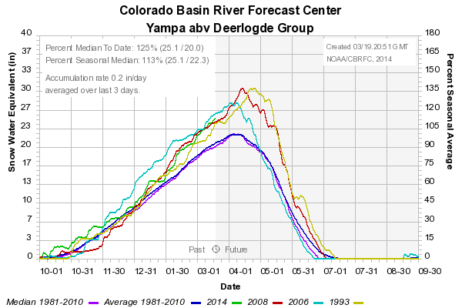

FIGURE 3- Yampa River above Deerlodge SNOTEL Group. 1981-2010 percent of average SWE compared against 2014 YTD, and analog years 1993, 2006, 2008 percent of median SWE

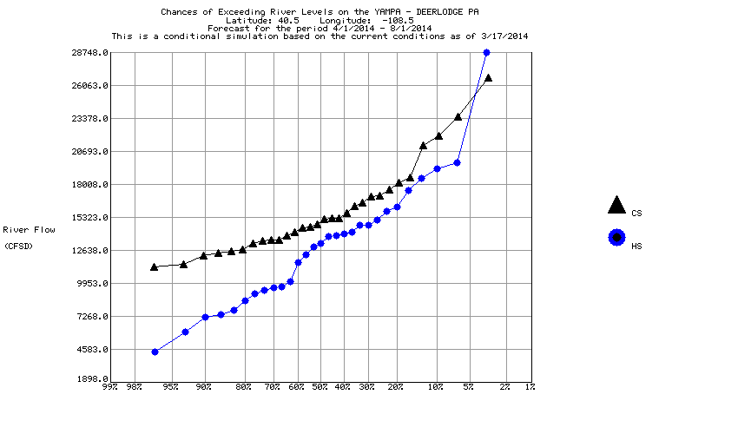

FIGURE 4-Yampa River at Deerlodge Chances of Exceeding River Levels based on Current Conditions as of March 17, 2014

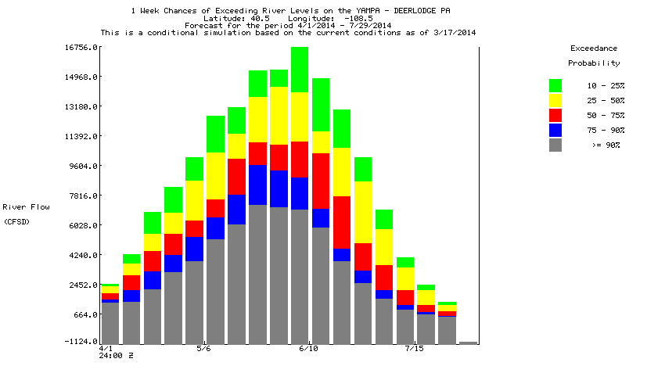

FIGURE 5-Yampa River at Deerlodge One Week Chances of Exceeding River Levels based on Current Conditions as of March 17, 2014

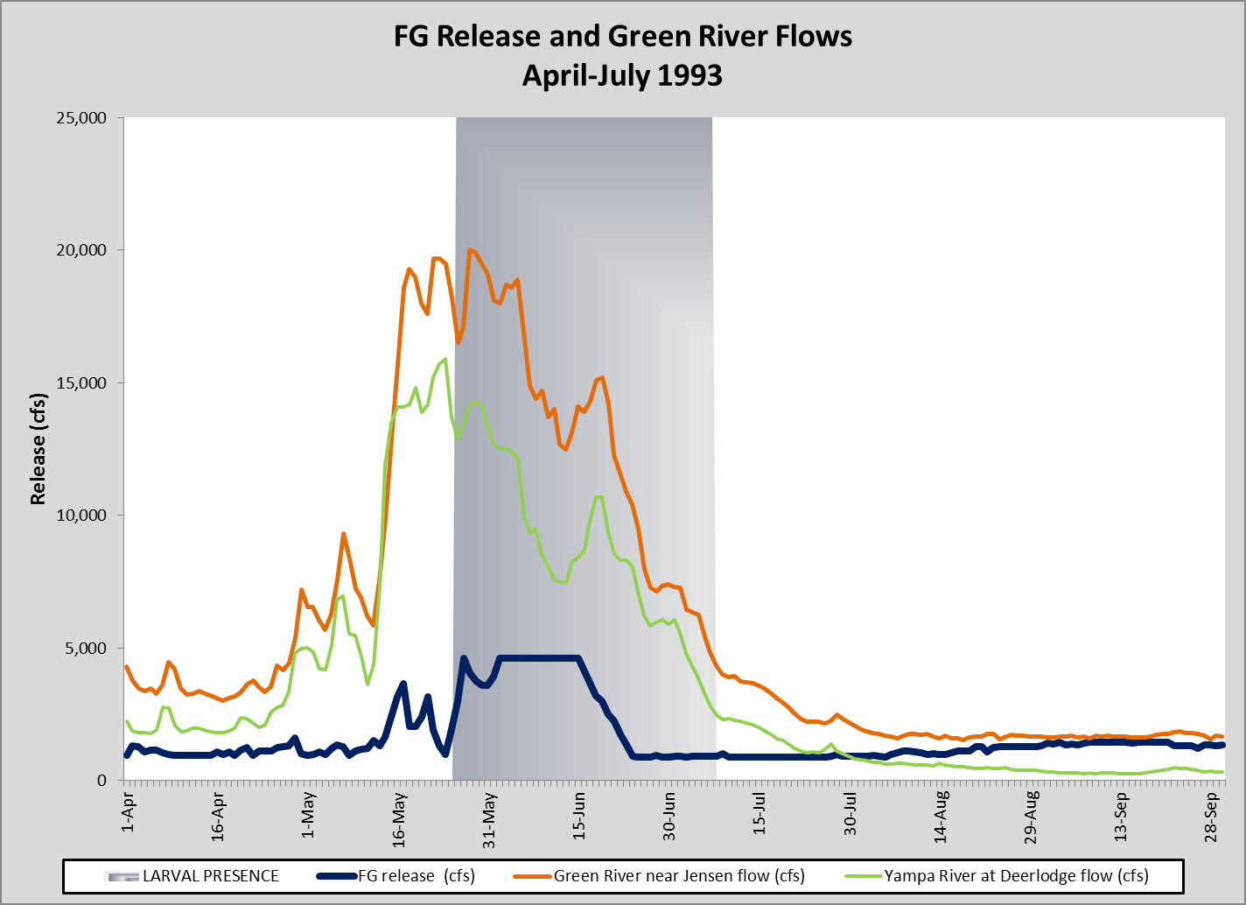

FIGURE 6- Flaming Gorge release and Yampa and Jensen flows for WY1993. Shaded grey area indicates larval presence.

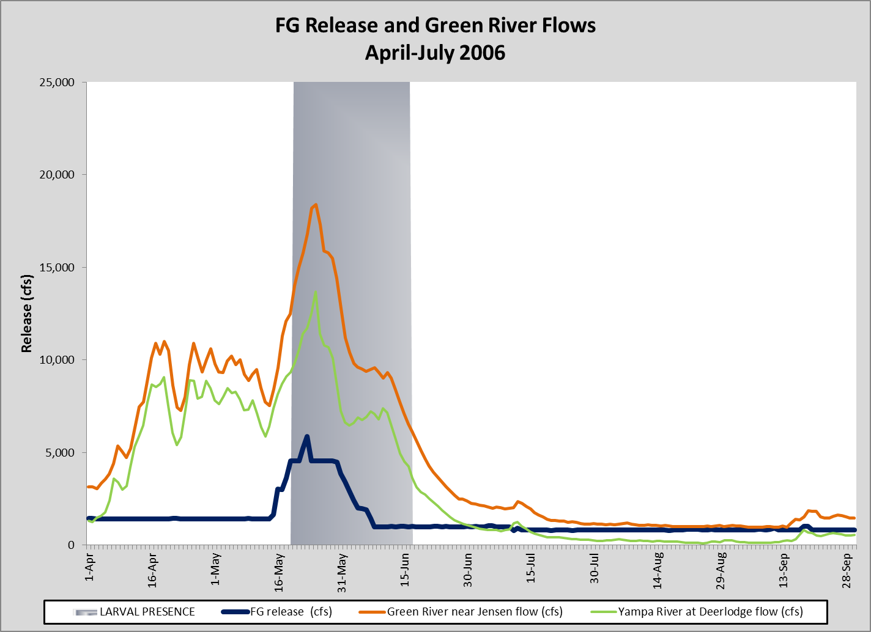

FIGURE 7- Flaming Gorge release and Yampa and Jensen flows for WY2006. Shaded grey area indicates larval presence.

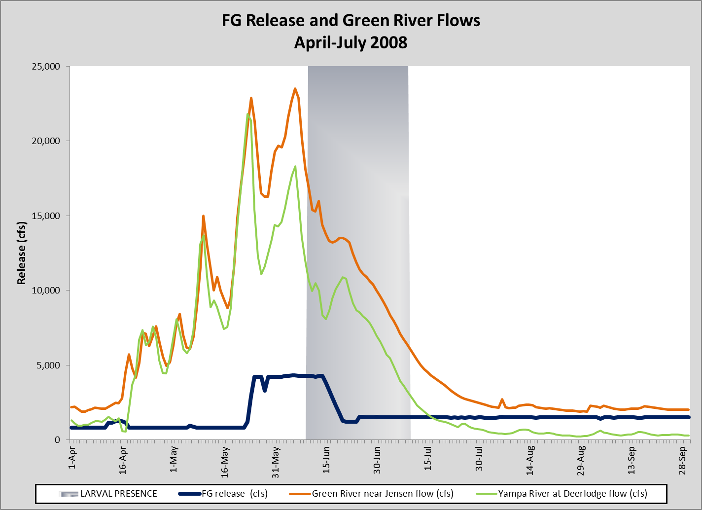

FIGURE 8- Flaming Gorge release and Yampa and Jensen flows for WY2008. Shaded grey area indicates larval presence.