TRAINING ANNOUNCEMENT:
DOI 2019 Dam Safety and Security Training
THEME: Internal Erosion/Geology

DoubleTree by Hilton Durango
501 Camino Del Rio, Durango, CO 81301
Promo Code: BOR
970.259.6580

MAY 14 – 16, 2019
TRAINING: MAY 14 – 15 (8 AM – 5 PM)
(Agenda to follow)
SITE VISIT: MAY 16 (8 AM – 1 PM)
(Site visit to Navajo Dam)

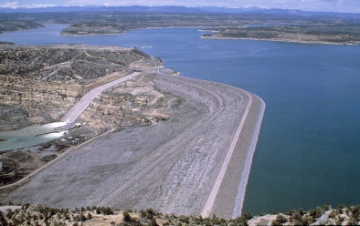

REGISTRATION FOR THIS FREE TRAINING IS AVAILABLE THROUGH THE ATTACHED REGISTRATION FORM

FOR ADDITIONAL INFORMATION:

Jackie Horn at 303-445-2699 jhorn@usbr.gov
OR
Tim Tochtrop at 303-445-2990 ttochtrop@usbr.gov

Please Send Registration to Tim Tochtrop at ttochtrop@usbr.gov

First Name | Last Name | Organization | Title | Work Phone | Cell Phone | Email | Site Visit (Y/N)

