

**New Mexico Water Resources Research Institute**

**Technical Completion Report No. XXX**

Title: Keep as Simple as Possible

**U.S. Department of the Interior Month 201X**

|  |  |  |  |  |  |  |  |
| --- | --- | --- | --- | --- | --- | --- | --- |
| **REPORT DOCUMENTATION PAGE** | | | | | | | *Form Approved  OMB No. 0704-0188* |
| The public reporting burden for this collection of information is estimated to average 1 hour per response, including the time for reviewing instructions, searching existing data sources, gathering and maintaining the data needed, and completing and reviewing the collection of information. Send comments regarding this burden estimate or any other aspect of this collection of information, including suggestions for reducing the burden, to Department of Defense, Washington Headquarters Services, Directorate for Information Operations and Reports (0704-0188), 1215 Jefferson Davis Highway, Suite 1204, Arlington, VA 22202-4302. Respondents should be aware that notwithstanding any other provision of law, no person shall be subject to any penalty for failing to comply with a collection of information if it does not display a currently valid OMB control number.  PLEASE DO NOT RETURN YOUR FORM TO THE ABOVE ADDRESS. | | | | | | | |
| 1. REPORT DATE *(DD-MM-YYYY)*  Date | | | 2. REPORT TYPE  Final | | | | 3. DATES COVERED *(From - To)*  Dates of Investigation |
| 4. TITLE AND SUBTITLE  Report Title | | | | | | 5a. CONTRACT NUMBER  Agreement No. XXX | |
| 5b. GRANT NUMBER | |
| 5c. PROGRAM ELEMENT NUMBER | |
| 6. AUTHOR(S)  Author name and titles | | | | | | 5d. PROJECT NUMBER | |
| 5e. TASK NUMBER | |
| 5f. WORK UNIT NUMBER | |
| 7. PERFORMING ORGANIZATION NAME(S) AND ADDRESS(ES)  Author’s Organization Name and Full Address | | | | | | | 8. PERFORMING ORGANIZATION REPORT NUMBER |
| 9. SPONSORING/MONITORING AGENCY NAME(S) AND ADDRESS(ES)  Bureau of Reclamation  U.S. Department of the Interior  Denver Federal Center  PO Box 25007, Denver, CO 80225-0007 | | | | | | | 10. SPONSOR/MONITOR'S ACRONYM(S)  Reclamation |
| 11. SPONSOR/MONITOR'S REPORT NUMBER(S)  NMSU No. XXX |
| 12. DISTRIBUTION/AVAILABILITY STATEMENT  Available from https://www.usbr.gov/research/dwpr/nmsu/index.html | | | | | | | |
| 13. SUPPLEMENTARY NOTES | | | | | | | |
| 14. ABSTRACT  Short abstract describing the pilot and results | | | | | | | |
| 15. SUBJECT TERMS  Key words | | | | | | | |
| 16. SECURITY CLASSIFICATION OF: | | | | 17. LIMITATION OF ABSTRACT | 18. NUMBER OF PAGES | 19a. NAME OF RESPONSIBLE PERSON  Reclamation’s GOTR | |
| a. REPORT  U | b. ABSTRACT  U | THIS PAGE  U | | 19b. TELEPHONE NUMBER *(Include area code)* Reclamation’s GOTR’s phone number | |
| **Standard Form 298** (Rev. 8/98) Prescribed by ANSI Std. Z39.18 | | | | | | | |

Desalination and Water Purification Research   
and Development Program

New Mexico Water Resources Research Institute

Technical Completion Report No. XXX

Title: Keep as Simple as Possible

**Prepared for the Bureau of Reclamation Under Agreement No. XXXAgreement NumberXXX**

*by*

**XXXAuthors and OrganizationsXXX**

Mission Statements

The Department of the Interior (DOI) conserves and manages the Nation’s natural resources and cultural heritage for the benefit and enjoyment of the American people, provides scientific and other information about natural resources and natural hazards to address societal challenges and create opportunities for the American people, and honors the Nation’s trust responsibilities or special commitments to American Indians, Alaska Natives, and affiliated island communities to help them prosper.

The mission of the Bureau of Reclamation is to manage, develop, and protect water and related resources in an environmentally and economically sound manner in the interest of the American public.

Disclaimer

The views, analysis, recommendations, and conclusions in this report are those of the authors and do not represent official or unofficial policies or opinions of the United States Government, and the United States takes no position with regard to any findings, conclusions, or recommendations made. As such, mention of trade names or commercial products does not constitute their endorsement by the United States Government.

Acknowledgments

The Desalination and Water Purification Research and Development Program, Bureau of Reclamation, sponsored this research. Note participants and their credentials here. Only those persons who made meaningful contributions to the research or to the report should be included.]

Acronyms and Abbreviations

ALD atomic layer deposition

AM atmospheric mass

BGNDRF Brackish Groundwater National Desalination Research Facility

CBD chemical bath deposition

Reclamation Bureau of Reclamation

Measurements

°F degree Fahrenheit

cm centimeter

μg/L microgram per liter

Variables

*Dp* pore diameter,

*Dint* interpore distance

*Dden* pore density

U anodization potential

**Contents**

Page

Mission Statements iii

Disclaimer iii

Acknowledgments iii

Acronyms and Abbreviations iii

Measurements iii

Variables iii

Report Instructions vii

1.1.1. Problem and Needs vii

1.1.1.1. Do Not Worry About Formatting vii

1.1.1.2. We Will Take Care of It vii

Heading 5 If You Need Detailed Headings vii

Heading 5 Use Levels 5 and 6 vii

Heading 6 Point 1 vii

Heading 6 Point 2 vii

Executive Summary ix

Figure Instructions ix

Table Instructions x

1. Introduction 1

1.1. Project Background 1

1.1.1. Objectives and Goals 2

1.1.2. Previous Research 2

1.2. Project Overview 2

1.2.1. Overall Technical Approach and Concepts 2

1.2.2. Overall Accomplishments 3

2. Technical Approach and Methods 5

2.1. Technological Approach 5

2.1.1. Research Idea 5

2.1.2. Equations 5

2.2. Project Facility/Physical Apparatus 5

2.2.1. Design Criteria 5

2.2.2. Source Water 6

2.2.3. Set Up 6

2.2.4. Runs and Experiments Done 6

3. Results and Discussion 7

3.1. Results 7

3.2. Analysis 7

3.3. Conclusions 8

3.4. Challenges 9

3.5. Recommended Next Steps 10

References 11

Glossary (optional) 1

Metric Conversions (optional but highly recommended) 1

**Figures**

Page

Figure 1.—Study area. 1

Figure 2.—Schematic of overall project concept. 3

Figure 3.—Really cool picture 2

Figure 4.—Simple chart 1

Figure 5.—Complex charts 2

Figure 6.—Sum it all up please. 1

**Tables**

Page

Table 1.—Summary of Water Quality Data 1

Table 2.—Summary of results table 1

Report Instructions

Limit the main report to 50 pages. Put any other details into appendices. Put all data for the conducted tests into an excel spreadsheet as an attachment. The only figures and tables in the main report should summarize data and provide an overall picture of your work.

### Problem and Needs

Briefly discuss the problem that the project addresses, if appropriate. (Hint: copy and update the problem statement in your application).

#### Do Not Worry About Formatting

Headings are like road signs. They tell the reader what is coming up in the next few paragraphs. So detailed headings are good to have. Again, for any heading, just copy and paste the heading here and type in what you want it to be. Keep it consistent: Either Capitalize Every Word or Just capitalize the first word. But always do it the same way.

#### We Will Take Care of It

Just type your content in. Reclamation will do a final edit and format.

##### Heading 5 If You Need Detailed Headings

You can go to heading level 5 if you want.

##### Heading 5 Use Levels 5 and 6

But, like road signs, you need to have a choice of where to go. So give us at least two headings per heading level..

###### Heading 6 Point 1

This really gets us into the weeds here, but ok. Please try not to use these headings—use a new section instead if you can.

###### Heading 6 Point 2

Never have a heading all by itself. It gets lonely at night.

Executive Summary

Provide a brief synopsis of the need for the project, the specific technical approach, and the conclusion (Hint: Copy and update the summary slides used at BGNDRF and in your interim reports). Discuss how the technology could be used and any challenges in using the technology in full-scale plants.

Do not put anything here that is not covered in the report.

Figure Instructions

If it will help the reader understand your results, copy the most important figures from the text. For the executive summary, do not use automatic figure numbering. Just type in the figure reference: Figure ES-1 shows the major project results. Note that figure captions should be lower case (except for proper nouns), with a period at the end. Captions should be left-aligned *on the left edge of the figure* (which may or may not be the same as the left edge of the column). Have one space before and after each figure and caption.

Figures should be readable, with contrasting colors and shapes.

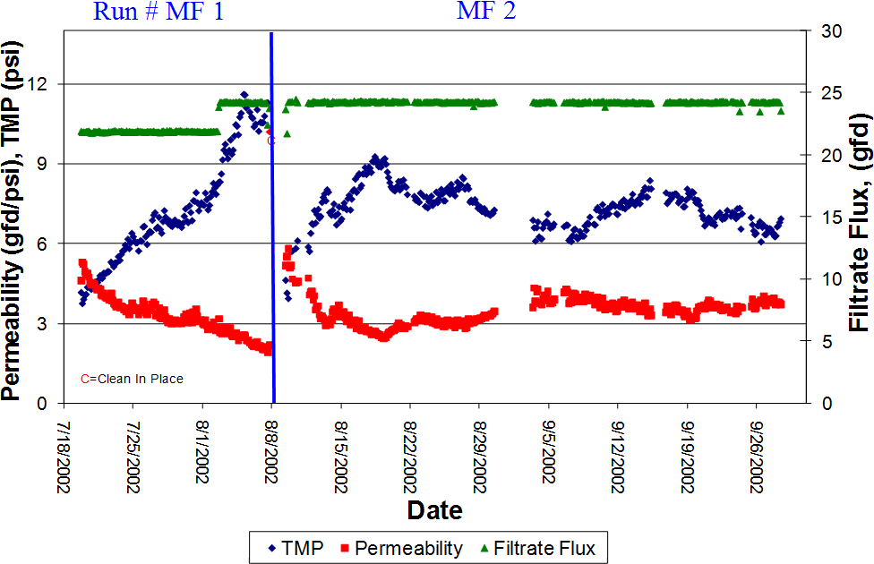

Figure ES-1. Sum it all up in one figure. See the Guide for Effective Displays. Caption style is Figure Caption.

Table Instructions

If it will help the reader understand your results, copy any summary tables (such as Table ES-1). Again, do not use automatic table numbering for the Executive Summary tables, which is used in the body of the text. Use one hard return space before and after the table. Do not provide an image of a table. Copy and paste this table for formatting, then copy data into the table. Or use these styles:

Table ES-1.Summary of results table (style is Table Caption)

|  |  |  |  |
| --- | --- | --- | --- |
| Factor (Style is table heading | Run 1 (cell alignment is top) | Run 2 | Run 3 |
| Name Style is table body) | (align numbers right) 1 | 4 | 7 |
| Name (align text left) | 2 | 5 | 8 |
| Name | 3 | 6 | 9 |
| **This last row is for any footnotes. Id you use any acronyms for the first time in the table, define them here. Style is table footnote. | | | |

# Introduction

This report is designed for water treatment plant planners, stakeholders and decisionmakers to quickly understand your research and how it might apply to their projects. Provide the background needed to understand why we did the project (needs), what the project accomplished (objectives), approach, and overview. (Hint: adapt this from your project application.).

If your report is geared for scientists to further your research ideas, then use the introduction to explain to a lay audience who might fund future research why the research is important and what the research covers. The rest of the report can then be geared to a more technical audience.

## Project Background

Describe the project (for example, location, study area, regulations, origin of the project).Figure 1 shows a map of the study area.

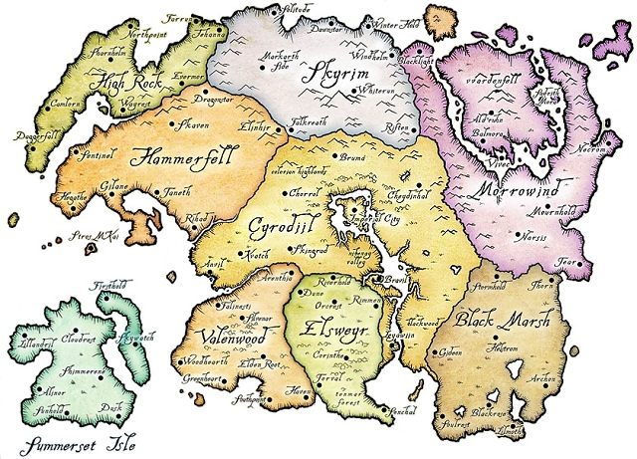

Figure 1. Study area.

### Objectives and Goals

How did the project further DOI and Reclamation goals? (Hint: copy and update the responses from your project proposal for Evaluation Criterion B. Alignment with Department

Priorities and Reclamation 2019 Key Goals.)

How did the project further DWPR objectives (Hint: copy and update the responses from your project proposal for Evaluation Criterion D — Relationship to DWPR

Objectives).

### Previous Research

Briefly discuss previous research for the project, if appropriate.

## Project Overview

### Overall Technical Approach and Concepts

What was the overall approach taken? What were the general concepts? Explain how your

proposed approach differs from other solutions (Hint: Copy and update your proposal response to Evaluation Criterion C — Demonstration of Familiarity in the Field of Work and Evaluation Criterion E — Innovation and Disruptiveness of the Project.)

Provide a schema, such as Figure 2, if appropriate.



Figure 2. Schematic of overall project concept.

### Overall Accomplishments

Briefly discuss the project’s accomplishments (Hint: Copy and update the interim final report accomplishments).

What did the project accomplish? How did this project improve the state-of-the-art water treatment technologies? (Hint: copy and update the impact statement of the proposed work from your summary slides and from your project proposal for Evaluation Criterion A. Impact of the Proposed Work.)

Did the project meet the objectives and goals? If yes, briefly explain how the project met these objectives and goals. If no, briefly explain the challenges that prevented meeting these goals.

# Technical Approach and Methods

In this chapter, detail what was done and how it was done. Provide descriptions of the research approach, project facility or physical apparatus, runs and methods, and analysis (including equations used).

## Technological Approach

Explain the scientific background and research approach that this technology demonstrated as simply as possible. The goal here is to write so that a high school student could understand the basics.

### Research Idea

Explain the basic idea behind the new research application. You can assume a basic knowledge of underlying principles, but try to explain the concepts so that a water treatment planner can see how your grand and wonderful idea would be applied.

### Equations

Use equations only if absolutely needed. Explain all the variables, and list variables in alphabetic order at the beginning of the report. Use this format:

(2)

(3)

(4)

Where:

*Dp* is the pore diameter,

*Dint* is the interpore distance

*Dden* is the pore density

U is the anodization potential

## Project Facility/Physical Apparatus

### Design Criteria

Explain the constraints and criteria that the design had to meet.

### Source Water

What source water did you use? Provide a brief table such as Table 1 if appropriate. Note that data tables should be provided in a separate excel spreadsheet.

Table 1. Summary of Water Quality Data

| Parameter | Units | Feed | Product | Concentrate |
| --- | --- | --- | --- | --- |
| TDS | mg/L | 18,600 | 10,400 | 22,300 |
| Sodium | mg/L | 4,100 | 1,700 | 5,500 |
| Calcium | mg/L | 2,200 | 950 | 1,600 |
| Magnesium | mg/L | 600 | 300 | 700 |
| Chloride | mg/L | 9,900 | 5,700 | 10,600 |
| Sulfate | mg/L | 2,200 | 600 | 3,300 |
| Bicarbonate | mg/L | 200 | 100 | 300 |
| mg/L = milligrams per liter | | | | |

### Set Up

What physical set up did you use? Add pictures of the set up or facility as appropriate (Figure 3).



Figure 3. Really cool picture of the project that makes us wish we were there.

### Runs and Experiments Done

Briefly provide a timeline of the runs and what was done (Hint: Copy and update the milestone reporting in the interim performance reports.)

# Results and Discussion

## Results

Summarize the important results. Have summary figures. Keep your result figures as simple as possible. Use only lines that MEAN something in the figure (Figure 4). Also, do not put additional information in the caption. Put all relevant information in the text.

Figure 4. Ensure the chart conveys your information as simply as possible.

## Analysis

Explain what the results mean for further practical application of your technology. Keep it simple and pitch this so that a water treatment planner can understand and potentially use the method.

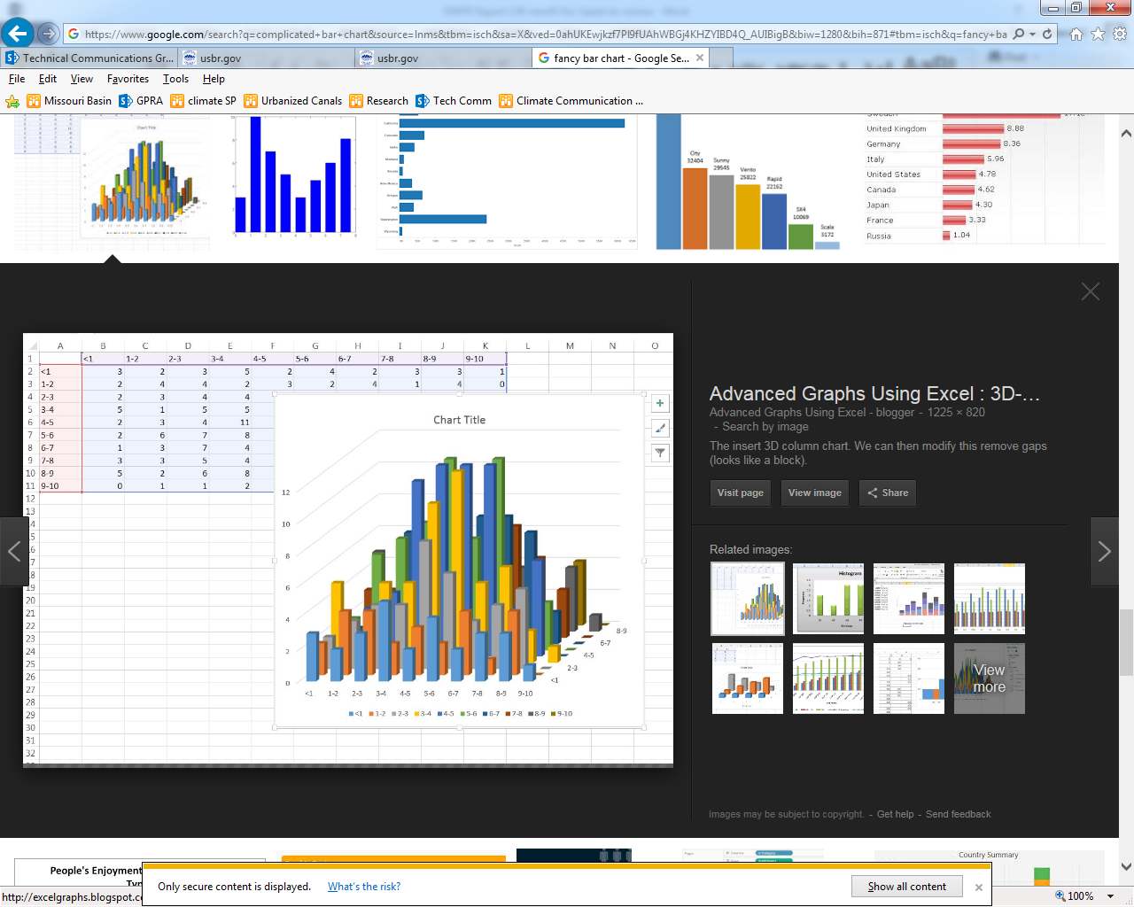

Figure 5. Complex charts will make it virtually impossible for your reader to understand you. ~~Also, do not put additional information in the caption. Put all relevant information in the text. If you really really need this level of complexity, then add these complex figures to your appendix.~~

## Conclusions

Provide the bottom line. Use the same concluding figures and tables as in the Executive Summary, such as Figure 6.



Figure 6. Sum it all up please.

Table ES-1.Summary of results table (style is Table Caption)

|  |  |  |  |
| --- | --- | --- | --- |
| Factor (Style is table heading | Run 1 (cell alignment is top) | Run 2 | Run 3 |
| Name Style is table body) | (align numbers right) 1 | 4 | 7 |
| Name (align text left) | 2 | 5 | 8 |
| Name | 3 | 6 | 9 |
| **This last row is for any footnotes. Id you use any acronyms for the first time in the table, define them here. Style is table footnote. | | | |

## Challenges

What challenges did you identify for future development of this technology? (Hint, copy and update your proposal responses for Evaluation Criterion C — Demonstration of Familiarity in

the Field of Work. Note any problems that you faced in the demonstration project. Extrapolate potential problems to commercialization levels and explain potential solutions.

## Recommended Next Steps

What should happen next? How should we continue this great work and make this investment worthwhile? How can water treatment planners use your results?

k

References

**Bureau of Reclamation. See Reclamation**

LastName, F.I. Year. Title. Anything else. <<http://URL>>. Date accessed.

LastName, F.I. and F.I. SecondLastName, Year. Title. Anything else.<<http://URL>>. Date accessed as MM/DD/YYYY.

LastName, F.I., F.I. SecondLastName, F.I. ThirdLastName, Year. Title. Anything else. <<http://URL>>.. Date accessed as MM/DD/YYYY.

Organization’s Name Fully Spelled Out The First Time (ONFSOTFT), Year. Title. Anything else. <<http://URL>>.. Date accessed as MM/DD/YYYY.

Reclamation (Bureau of Reclamation), 2017 (Guidance). This DWPR Guidance, Which We Wrote for a Reason.

Reclamation (Bureau of Reclamation), 2017 (FOA). Desalination and Water Purification Research Program Fiscal Year 2017 Pilot Scale Testing Funding Opportunity Announcement No. BOR-DO-17-F006. <<https://www.usbr.gov/research/dwpr/docs/DWPR_PilotScale_FOA_012017.pdf>>. Accessed 6/24/2017.

.

Glossary (optional)

**Jargon.** Specialized language and vocabulary used by a particular science. This would include terms such as “deionization,” “omniphobic,” and “water reclamation.”

**Phrase or word to be defined.** Copy this definition and type in the phrase or word to be defined in the bold area and the definition in the plain text area.

Metric Conversions (optional but highly recommended)

Provide metric equivalents for non-metric units used in the text:

|  |  |
| --- | --- |
| Unit | Metric equivalent |
| 1 gallon | 3.785 liters |
| 1 gallon per minute | 3.785 liters per minute |
| 1 gallon per square foot of membrane area per day | 40.74 liters per square meter per day |
| 1 inch | 2.54 centimeters |
| 1 million gallons per day | 3,785 cubic meters per day |
| 1 pound per square inch | 6.895 kilopascals |
| 1 square foot | 0.093 square meters |
| °F (temperature measurement) | (°F–32) × 0.556 = °C |
| 1 °F (temperature change or difference) | 0.556 °C |