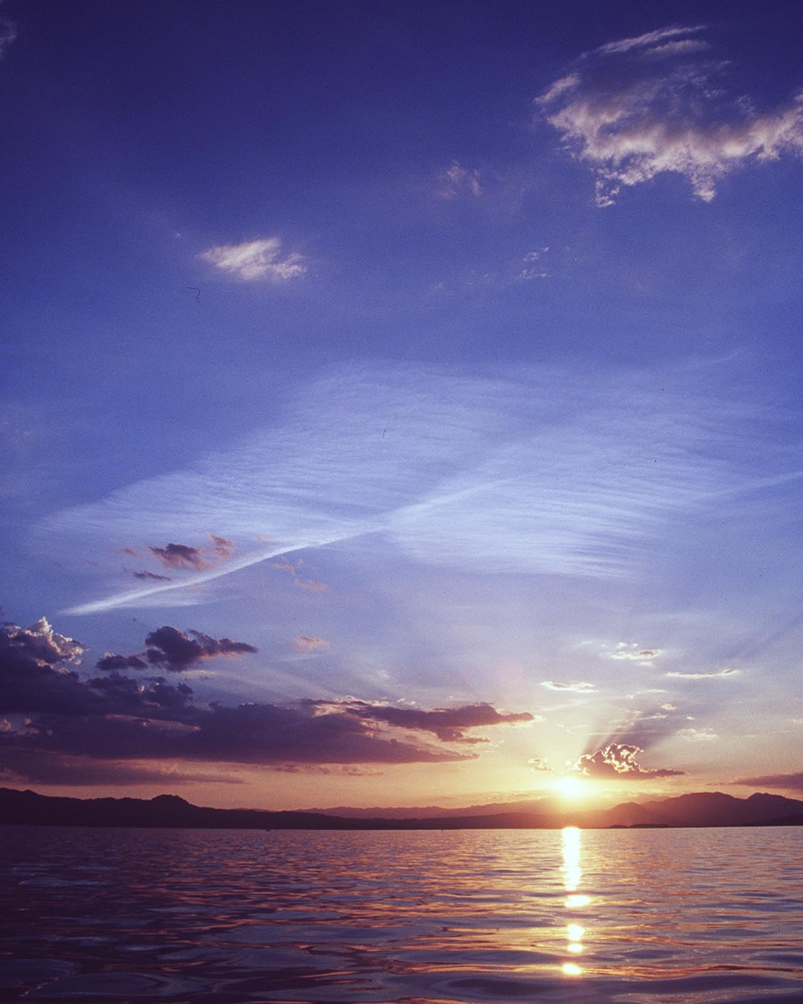

Desalination and Water Purification Research   
and Development Program Report No. XXX

Title in Caps and Lower Case,   
May Wrap to Multiple Lines

**U.S. Department of the Interior**



**Bureau of Reclamation**

**Technical Service Center**

**Denver, Colorado Month 201X**

|  |  |  |  |  |  |  |  |
| --- | --- | --- | --- | --- | --- | --- | --- |
| **REPORT DOCUMENTATION PAGE** | | | | | | | *Form Approved  OMB No. 0704-0188* |
| The public reporting burden for this collection of information is estimated to average 1 hour per response, including the time for reviewing instructions, searching existing data sources, gathering and maintaining the data needed, and completing and reviewing the collection of information. Send comments regarding this burden estimate or any other aspect of this collection of information, including suggestions for reducing the burden, to Department of Defense, Washington Headquarters Services, Directorate for Information Operations and Reports (0704-0188), 1215 Jefferson Davis Highway, Suite 1204, Arlington, VA 22202-4302. Respondents should be aware that notwithstanding any other provision of law, no person shall be subject to any penalty for failing to comply with a collection of information if it does not display a currently valid OMB control number.  PLEASE DO NOT RETURN YOUR FORM TO THE ABOVE ADDRESS. | | | | | | | |
| 1. REPORT DATE *(DD-MM-YYYY)*  Date | | | 2. REPORT TYPE  Final | | | | 3. DATES COVERED *(From - To)*  Dates of Investigation |
| 4. TITLE AND SUBTITLE  Report Title | | | | | | 5a. CONTRACT NUMBER  Agreement No. XXX | |
| 5b. GRANT NUMBER | |
| 5c. PROGRAM ELEMENT NUMBER | |
| 6. AUTHOR(S)  Author name and titles | | | | | | 5d. PROJECT NUMBER | |
| 5e. TASK NUMBER | |
| 5f. WORK UNIT NUMBER | |
| 7. PERFORMING ORGANIZATION NAME(S) AND ADDRESS(ES)  Author’s Organization Name and Full Address | | | | | | | 8. PERFORMING ORGANIZATION REPORT NUMBER |
| 9. SPONSORING/MONITORING AGENCY NAME(S) AND ADDRESS(ES)  Bureau of Reclamation  U.S. Department of the Interior  Denver Federal Center  PO Box 25007, Denver, CO 80225-0007 | | | | | | | 10. SPONSOR/MONITOR'S ACRONYM(S)  Reclamation |
| 11. SPONSOR/MONITOR'S REPORT NUMBER(S)  DWPR Report No. XXX |
| 12. DISTRIBUTION/AVAILABILITY STATEMENT  Available from the National Technical Information Service,  Operations Division, 5285 Port Royal Road, Springfield VA 22161 | | | | | | | |
| 13. SUPPLEMENTARY NOTES  Online at https://www.usbr.gov/research/dwpr/DWPR_Reports.html | | | | | | | |
| 14. ABSTRACT  Short abstract providing the “bottom line” and research conclusions. | | | | | | | |
| 15. SUBJECT TERMS  Key words | | | | | | | |
| 16. SECURITY CLASSIFICATION OF: | | | | 17. LIMITATION OF ABSTRACT | 18. NUMBER OF PAGES | 19a. NAME OF RESPONSIBLE PERSON  Reclamation’s GOTR | |
| a. REPORT  U | b. ABSTRACT  U | THIS PAGE  U | | 19b. TELEPHONE NUMBER *(Include area code)* Reclamation’s GOTR’s phone number | |
| **Standard Form 298** (Rev. 8/98) Prescribed by ANSI Std. Z39.18 | | | | | | | |

**Desalination and Water Purification Research   
and Development Program Report No. XXX**

Title in Caps and Lower Case,   
May Wrap to Multiple Lines

**Prepared for the Bureau of Reclamation Under Agreement No. XXXAgreement NumberXXX**

*by*

**XXXAuthors and OrganizationsXXX**

Mission Statements

The U.S. Department of the Interior protects America’s natural resources and heritage, honors our cultures and tribal communities, and supplies the energy to power our future.

The mission of the Bureau of Reclamation is to manage, develop, and protect water and related resources in an environmentally and economically sound manner in the interest of the American public.

Disclaimer

The views, analysis, recommendations, and conclusions in this report are those of the authors and do not represent official or unofficial policies or opinions of the United States Government, and the United States takes no position with regard to any findings, conclusions, or recommendations made. As such, mention of trade names or commercial products does not constitute their endorsement by the United States Government.

Acknowledgments

XXXXXXXXXX XXXXXXXXXXX XXXXXXXXXX XXXXXXXXXXX [The Desalination and Water Purification Research and Development Program, Bureau of Reclamation, shall be acknowledged as the sponsor of the research. Other acknowledgments are optional. However, only those persons who made meaningful contributions to the research or to the report should be included.] XXXXXXXX XXXXXX XXXXX XXX XXXX XXXXX XXXXXX XXXX.

Acronyms and Abbreviations

Reclamation Bureau of Reclamation

Measurements

°F degree Fahrenheit

c centimeter

μg/L microgram per liter

**Contents**

Page

Mission Statements iii

Disclaimer iii

Acknowledgments iii

Acronyms and Abbreviations iii

Measurements iii

Executive Summary vii

Figure Instructions vii

Table Instructions viii

1. Introduction 1

1.1. Project Background 1

1.1.1. Problem 1

1.1.1.1. Details at Heading 4 2

1.1.1.2. More Heading 4 Details 2

Heading 5 Permission to use 2

Heading 5 But only if there are at least two of them 2

Heading 6 Point 1 2

Heading 6 Point 2 2

1.1.2. Participants 2

1.2. Project Needs and Objectives 2

1.2.1. Needs 2

1.2.2. Objectives 2

1.3. Project Overview 3

1.3.1. Overall Approach and Concepts 3

1.3.2. Overall Method 3

1.3.3. Participants 3

2. Technical Approach and Methods 1

2.1. Project Facility/Physical Apparatus 1

2.1.1. Design Criteria 1

2.1.2. Source Water 1

2.1.3. Set Up 1

2.2. Methodology 2

2.2.1. Methods Used 2

2.2.2. Runs and Experiments Done 2

2.3. Analysis 2

2.3.1. Analytical Background 2

2.3.2. Analytical Process 3

3. Results and Discussion 1

4. Conclusions 1

4.1. Conclusions 1

4.2. Recommended Next Steps 1

References 1

Glossary 1

Metric Conversions 1

**Figures**

Page

Figure 1.—Study area. 1

Figure 2.—Schematic of overall project concept. 3

Figure 3.—Really cool picture of the project that makes us wish we were there. 2

Figure 4.—Ensure the chart conveys your information as simply as possible. 1

Figure 5.—Complex charts will make it virtually impossible for your reader to understand you. ~~Also, do not put additional information in the caption. Put all relevant information in the text.~~ 2

Figure 6.—Sum it all up please. 1

**Tables**

Page

Table 1.—Summary of Water Quality Data 1

Table 2.—Summary of results table 1

# 

Executive Summary

Provide a brief synopsis of the need for research, the specific research questions, methods used to address the research questions, and conclusion. Add any important caveats or salient information that a decisionmaker funding the next project or person using the research should know.

Do not put anything here that is not covered in the report.

Report Limits and Instructions

Limit the main report to 50 pages. Put any other details into appendices. Put all data into an excel spreadsheet. The only figures and tables in the main report should summarize data and provide an overall picture of your work.

Figure Instructions

If it will help the reader understand your results, copy the most important figures from the text. For the executive summary, do not use automatic figure numbering. Just type in the figure reference: Figure ES-1 shows the major project results. Note that figure captions should be lower case (except for proper nouns), with a period at the end. Captions should be left-aligned *on the left edge of the figure* (which may or may not be the same as the left edge of the column). Have one space before and after each figure and caption.

Figures should be readable, with contrasting colors and shapes.

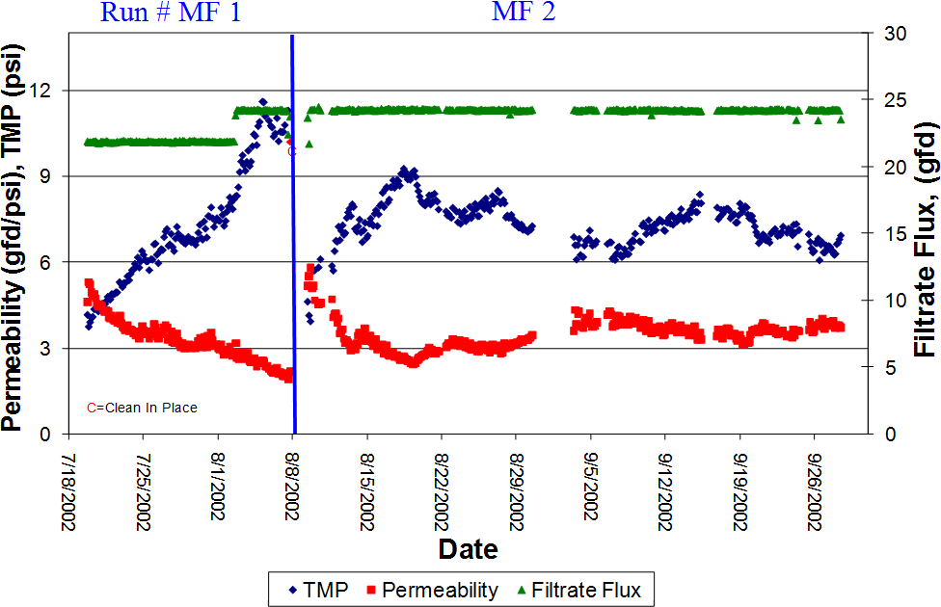

Figure ES-1.—Sum it all up, please.

Table Instructions

If it will help the reader, copy any summary tables (such as Table ES-1). Again, do not use automatic table numbering, which is used in the body of the text. Use one space before and after the table. Do not provide an image of a table.

Table ES-1.—Summary of results table

|  |  |  |  |
| --- | --- | --- | --- |
| **Factor** | **Run 1** | **Run 2** | **Run 3** |
|  |  |  |  |
|  |  |  |  |
|  |  |  |  |

# Introduction

Provide the background needed to understand why we did the project (needs), what the project accomplished (objectives), approach, and overview. (Hint: Copy from your project application.)

## Project Background

Describe the project (for example, location, study area, regulations, origin of the project).Figure 1 shows a map of the study area.

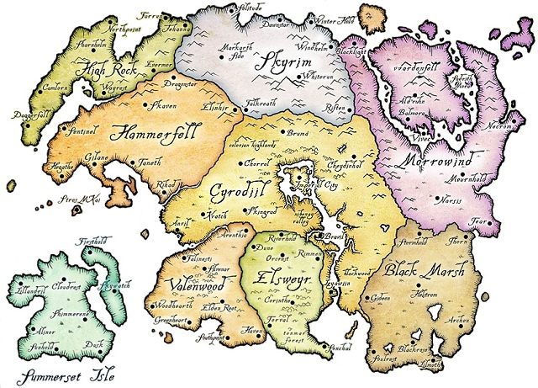

Figure .—Study area.

### Problem

Briefly discuss the problem that the project addresses, if appropriate.

#### Do Not Worry About Formatting

Headings are like road signs. They tell the reader what is coming up in the next few paragraphs. So detailed headings are good to have. Again, for any heading, just copy and paste the heading here and type in what you want it to be. Keep it consistent: Either Capitalize Every Word or Just capitalize the first word. But always do it the same way.

#### We Will Take Care of It

Just type your content in. We will make it consistent.

##### Heading 5 If You Need Detailed Headings

You can go to heading level 5 if you want.

##### Heading 5 Use Levels 5 and 6

But, like road signs, you need to have a choice of where to go. So give us at least two headings per heading level..

###### Heading 6 Point 1

This really gets us into the weeds here, but ok.

###### Heading 6 Point 2

Never have a heading all by itself. It gets lonely at night.

### Participants

Briecly discuss previous research for the project, if appropriate.

## Project Needs and Objectives

### Needs

Why is this project needed? What problem is it solving?

### Objectives

What did the project accomplish?

## Project Overview

### Overall Approach and Concepts

What was the overall approach taken? What were the general concepts? Provide a schema, such as Figure 2, if appropriate.



Figure .—Schematic of overall project concept.

### Overall Method

Briefly discuss the overall methods and analysis.

### Participants

Note who was involved, if appropriate. Or just put names in the acknowledgment section.

# Technical Approach and Methods

In this chapter, detail what was done and how it was done. Provide descriptions of the project facility or physical apparatus, runs and methods, and analysis (including equations used).

## Project Facility/Physical Apparatus

### Design Criteria

### Source Water

What source water did you use? Provide a brief table such as Table 1 if appropriate. Note that data tables should be provided in a separate excel spreadsheet.

Table .—Summary of Water Quality Data

| **Parameter** | **Units** | **Feed** | **Product** | **Concentrate** |
| --- | --- | --- | --- | --- |
| TDS | mg/L | 18,600 | 10,400 | 22,300 |
| Sodium | mg/L | 4,100 | 1,700 | 5,500 |
| Calcium | mg/L | 2,200 | 950 | 1,600 |
| Magnesium | mg/L | 600 | 300 | 700 |
| Chloride | mg/L | 9,900 | 5,700 | 10,600 |
| Sulfate | mg/L | 2,200 | 600 | 3,300 |
| Bicarbonate | mg/L | 200 | 100 | 300 |
| mg/L = milligrams per liter | | | | |

### Set Up

What physical set up did you use? Add pictures of the set up or facility as appropriate (Figure 3).



Figure .—Really cool picture of the project that makes us wish we were there.

## Methodology

### Methods Used

### Runs and Experiments Done

## Analysis

### Analytical Background

Provide the background needed to understand your analysis. Include equations. in accordance with Faraday’s law as shown in Equation 1:

**Error! Objects cannot be created from editing field codes.**

Equation . Faraday's Law

Where:

* mFe is the mass of Fe generated (g),
* I is constant current
* t is variable generation time
* Z is the number of electrons transferred per Fe atom (2 for ferrous ions and 3 for ferric ions)
* F is Faraday’s constant (96,486 C eq-1)

### Analytical Process

Explain how you analyzed the results.

# Results and Discussion

Discuss the conclusions and results. Explain what the results mean. The simpler the language, the better.

Have summary figures. Keep your result figures as simple as possible. Use only lines that MEAN something in the figure. Also, do not put additional information in the caption. Put all relevant information in the text.



Figure .—Ensure the chart conveys your information as simply as possible.

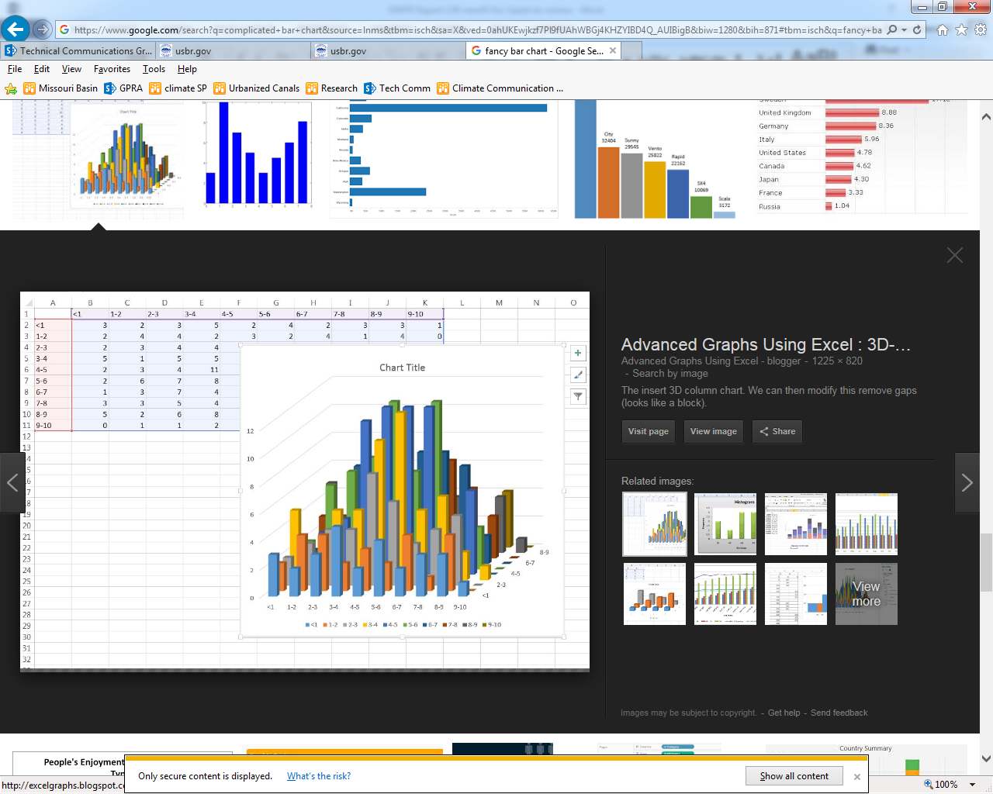

Figure .—Complex charts will make it virtually impossible for your reader to understand you. ~~Also, do not put additional information in the caption. Put all relevant information in the text. If you really really need this level of complexity, then add these complex figures to your appendix.~~

# Conclusions

## Conclusions

Provide the bottom line. Use the same concluding figures and tables as in the Executive Summary, such as Figure 6.



Figure .—Sum it all up please.

Table .—Summary of results table

|  |  |  |  |
| --- | --- | --- | --- |
| **Factor** | **Run 1** | **Run 2** | **Run 3** |
|  |  |  |  |
|  |  |  |  |

## Recommended Next Steps

What should happen next? How should we continue this great work and make this investment worthwhile?

References

**Bureau of Reclamation. See Reclamation**

LastName, F.I. Year. Title. Anything else. <<http://URL>>. Date accessed.

LastName, F.I. and F.I. SecondLastName, Year. Title. Anything else.<<http://URL>>. Date accessed as MM/DD/YYYY.

LastName, F.I., F.I. SecondLastName, F.I. ThirdLastName, Year. Title. Anything else. <<http://URL>>.. Date accessed as MM/DD/YYYY.

Organization’s Name Fully Spelled Out The First Time (ONFSOTFT), Year. Title. Anything else. <<http://URL>>.. Date accessed as MM/DD/YYYY.

Reclamation (Bureau of Reclamation), 2017 (Guidance). This DWPR Guidance, Which We Wrote for a Reason.

Reclamation (Bureau of Reclamation), 2017 (FOA). Desalination and Water Purification Research Program Fiscal Year 2017 Pilot Scale Testing Funding Opportunity Announcement No. BOR-DO-17-F006. <<https://www.usbr.gov/research/dwpr/docs/DWPR_PilotScale_FOA_012017.pdf>>. Accessed 6/24/2017.

.

Glossary (optional)

**Jargon.** Specialized language and vocabulary used by a particular science. This would include terms such as “deionization,” “omniphobic,” and “water reclamation.”

**Phrase or word to be defined.** Copy this definition and type in the phrase or word to be defined in the bold area and the definition in the plain text area.

Metric Conversions (optional but highly recommended)

Provide metric equivalents for non-metric units used in the text:

|  |  |
| --- | --- |
| **Unit** | **Metric equivalent** |
| 1 gallon | 3.785 liters |
| 1 gallon per minute | 3.785 liters per minute |
| 1 gallon per square foot of membrane area per day | 40.74 liters per square meter per day |
| 1 inch | 2.54 centimeters |
| 1 million gallons per day | 3,785 cubic meters per day |
| 1 pound per square inch | 6.895 kilopascals |
| 1 square foot | 0.093 square meters |
| °F (temperature measurement) | (°F–32) × 0.556 = °C |
| 1 °F (temperature change or difference) | 0.556 °C |