Technical Memorandum
Water Temperature Modeling Platform: Model Implementation (DRAFT)
Central Valley Project Water Temperature Modeling Platform
California-Great Basin Region
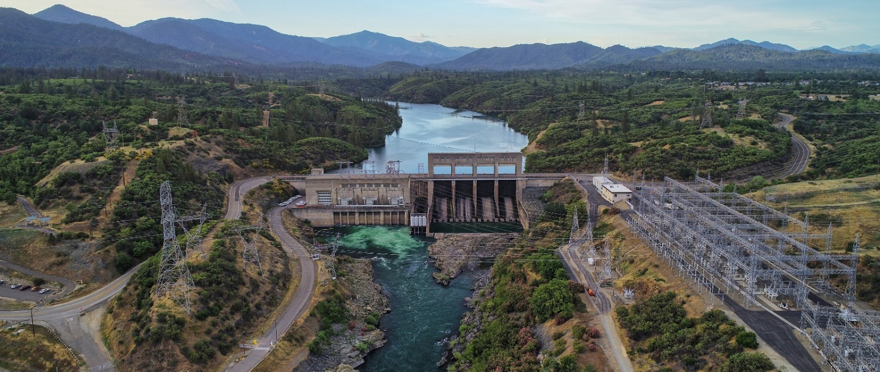

Mission Statements
The U.S. Department of the Interior protects and manages the Nation’s natural resources and cultural heritage; provides scientific and other information about those resources; and honors its trust responsibilities or special commitments to American Indians, Alaska Natives, and affiliated Island Communities.
The mission of the Bureau of Reclamation is to manage, develop, and protect water and related resources in an environmentally and economically sound manner in the interest of the American public.

Water Temperature Modeling Platform: Model Implementation (DRAFT)
Central Valley Project Water Temperature Modeling Platform
California-Great Basin Region
prepared by
United States Department of the Interior Bureau of Reclamation
California-Great Basin
With Technical Support by:
Watercourse Engineering, Inc.

Cover Photo: Keswick Dam on the Sacramento River by John Hannon

Contents
Page
Chapter 1 Introduction 1-1
Chapter 2 Model Implementation 2-1
Model Applications 2-1
WTMP Studies 2-2
WTMP Hierarchy and Definitions 2-3
Platform 2-6
Study 2-6
Study Folder 2-6
Model Program 2-7
Model Alternatives 2-7
Program Order 2-7
Analysis Period 2-8
Simulation 2-8
Simulation Group 2-8
Alternative 2-8
Model Linking 2-8
WTMP Application 2-9
Calibration Simulations 2-10
Validation and Hindcast Simulations 2-11
Validation 2-11
Hindcast 2-12
Iterative Simulations 2-13
Seasonal Temperature Forecast Simulations 2-15
Long-term Planning Study 2-18
Potential Future Applications and Implementation Features 2-20
Chapter 3 Long-Term Planning Simulation – Application 3-1
Analysis Assumptions 3-1
Planning Simulation Inputs 3-1
Boundary Condition Processing 3-2
Input from CalSim3 3-3
Meteorology Data 3-5
Trinity River below Lewiston Dam 3-5
Inflow Temperature Processing 3-5
Allocation of Total Reservoir Release to Reservoir Outlets 3-6
TCD Operation and Temperature Target Assignment 3-7
Results 3-7
Summary 3-17
Chapter 4 Conclusion 4-1
Chapter 5 References 5-1
Appendix A: Forecasting Approaches for Temperature Control Facilities 1
CE-QUAL-W2 – Shasta Lake 1
Determining Gate Levels for Blending 1
TCD Blending Calculations 5
User Specified Inputs 5
Application of W2_TCD Forecasting 7
Model Validation and Testing 10
References 16
ResSim – Shasta Lake 17
Determining Gate Levels for Blending 17
Model Validation and Testing 22
References 28
CE-QUAL-W2: Folsom Dam Selective Withdrawal Logic 30
Automated Municipal Intake Elevation 30
Automated Powerhouse Intake Shutter and Bypass Operations 31
Automated Temperature Target / Schedule Selection 34
Application of the Folsom_W2_TCD Model 37
References 38
ResSim: Folsom Dam Selective Withdrawal Logic 40

Figures
Figure 2-1. Conceptual WTMP scope including the Database (Data Management System or DMS), Modeling and Analytics, and Reporting, and generic inputs (data sources) and outputs (export). 2-3
Figure 2-2. Relationship between Study, Alternatives, Analysis Periods, Model Alternatives and Model Programs, Simulations Groups and Simulations for a conceptual climate change Study. (SHSTA: Shasta Lake, KES: Keswick Reservoir, SAC RIV: Sacramento River, W2: CE-QUAL-W2, RSS: ResSim). 2-5
Figure 2-3. WTMP calibration workflow. 2-11
Figure 2-4. WTMP validation and hindcast workflow. 2-13
Figure 2-5. WTMP iterative simulation workflow. 2-15
Figure 2-6. WTMP seasonal temperature forecast workflow. 2-17
Figure 2-7. WTMP long-term planning simulation workflow. 2-19
Figure 3-1. Shasta Lake inflow for historic daily average, historic monthly average, and disaggregate daily (from historic monthly average) (top), and Shasta Dam total release for historic daily average, historic monthly average (bottom): 2006. 3-3
Figure 3-2. Shasta Lake daily storage (top), and disaggregated daily inflow, and monthly average release based on CalSim3 input (bottom) used in the proof-of-concept ResSim long-term planning model, 2001-2019. 3-9
Figure 3-3. Shasta Lake storage, disaggregated daily inflow, and monthly average release based on CalSim3 input used in the proof-of-concept ResSim long-term planning model, 2001-2005. 3-9
Figure 3-4. Shasta Lake storage, disaggregated daily inflow, and monthly average release based on CalSim3 input used in the proof-of-concept ResSim long-term planning model, 2006-2010. 3-10
Figure 3-5. Shasta Lake storage, disaggregated daily inflow, and monthly average release based on CalSim3 input used in the proof-of-concept ResSim long-term planning model, 2011-2015. 3-10
Figure 3-6. Shasta Lake storage, disaggregated daily inflow, and monthly average release based on CalSim3 input used in the proof-of-concept ResSim long-term planning model, 2016-2019. 3-11
Figure 3-7. Simulated water temperature at Shasta Dam outflow, Keswick Dam outflow, and Sacramento River above Clear Creek based on CalSim3 input used in the proof-of-concept ResSim long-term planning model, 2001-2019. 3-12
Figure 3-8. Simulated water temperature at Shasta outflow, Keswick outflow, and Sacramento River above Clear Creek based on CalSim3 input used in the proof-of-concept ResSim long-term planning model, 2001-2005. 3-13
Figure 3-9. Simulated water temperature at Shasta outflow, Keswick outflow, and Sacramento River above Clear Creek based on CalSim3 input used in the proof-of-concept ResSim long-term planning model, 2006-2010. 3-13
Figure 3-10. Simulated water temperature at Shasta outflow, Keswick outflow, and Sacramento River above Clear Creek based on CalSim3 input used in the proof-of-concept ResSim long-term planning model, 2010-2015. 3-14
Figure 3-11. Simulated water temperature at Shasta outflow, Keswick outflow, and Sacramento River above Clear Creek based on CalSim3 input used in the proof-of-concept ResSim long-term planning model, 2016-2019. 3-14
Figure 3-12. Simulated water temperature distribution in Shasta Lake based on CalSim3 input used in the proof-of-concept ResSim long-term planning model, 2001-2019. 3-15
Figure 3-13. Simulated water temperature distribution in Shasta Lake based on CalSim3 input used in the proof-of-concept ResSim long-term planning model, 2001-2005. 3-16
Figure 3-14. Simulated water temperature distribution in Shasta Lake based on CalSim3 input used in the proof-of-concept ResSim long-term planning model, 2006-2010. 3-16
Figure 3-15. Simulated water temperature distribution in Shasta Lake based on CalSim3 input used in the proof-of-concept ResSim long-term planning model, 2011-2015. 3-17
Figure 3-16. Simulated water temperature distribution in Shasta Lake based on CalSim3 input used in the proof-of-concept ResSim long-term planning model, 2016-2019. 3-17
Figure A-1. Determining gate level(s) to blend. 4
Figure A-2. Example showing relevant sections of “w2_selective.npt” file for W2_TCD forecasting. 9
Figure A-3. (a) Simulated (Forecast A) vs. historic TCD gate settings Shasta Dam release and Shasta Lake water surface elevation and (b) Simulated vs historic Shasta Dam tailbay temperatures in 2013. 11
Figure A-4. (a) Simulated (Forecast A) vs. historic TCD gate settings Shasta Dam release and Shasta Lake water surface elevation and (b) Simulated vs historic Shasta Dam tailbay temperatures in 2015. 12
Figure A-5. (a) Simulated (Forecast A) vs. historic TCD gate settings Shasta Dam release and Shasta Lake water surface elevation and (b) Simulated vs historic Shasta Dam tailbay temperatures in 2016. 13
Figure A-6. (a) Simulated (Forecast A) vs. historic TCD gate settings Shasta Dam release and Shasta Lake water surface elevation and (b) Simulated vs historic Shasta Dam tailbay temperatures in 2017. 14
Figure A-7. (a) Simulated (Forecast A) vs. historic TCD gate settings Shasta Dam release and Shasta Lake water surface elevation and (b) Simulated vs historic Shasta Dam tailbay temperatures in 2018. 15
Figure A-8. (a) Simulated (Forecast A) vs. historic TCD gate settings Shasta Dam release and Shasta Lake water surface elevation and (b) Simulated vs historic Shasta Dam tailbay temperatures in 2019. 16
Figure A-9. Example transition of withdrawal distribution, ResSim Shasta TCD operation logic. 18
Figure A-10. Keswick Reservoir residence time (upper panel), and estimation of Keswick Dam outflow temperature (lower panel): 2018. 20
Figure A-11. Power law fit of average Sacramento River velocity as a function of flow between Keswick dam and the Sacramento River above Clear Creek. 21
Figure A-12. Shasta Dam outflow temperatures (black), and predicted temperatures at CCR site for the ResSim model (blue) and the simple model described above (red) for a representative summer-fall period in 2016. 22
Figure A-13. Observed (Temperature Target) and simulated Shasta TCD gate usage and Shasta Dam outflow (Shasta outflow) temperature, 2012. 23
Figure A-14. Observed (target) and simulated Shasta TCD gate usage and outflow temperature, 2014. 24
Figure A-15. Observed (target) and simulated Shasta TCD gate usage and outflow temperature, 2018. 25
Figure A-16. ResSim simulated water temperature for Shasta Dam outflow (Shasta out) and the Sacramento River above Clear Creek gage (CCR ResSim). Included is the simplified (regression) model calculated water temperature for the Sacramento River above Clear Creek gage (CCR predicted), 2017 through 2019. 26
Figure A-17. ResSim simulated water temperature for Shasta Dam outflow (Shasta out) and the Sacramento River above Clear Creek gage (CCR ResSim). Included is the simplified (regression) model calculated water temperature for the Sacramento River above Clear Creek gage (CCR predicted), 2017 through 2019. 27
Figure A-18. ResSim simulated water temperature for Shasta Dam outflow (Shasta out) and the Sacramento River above Clear Creek gage (CCR ResSim). Included is the simplified (regression) model calculated water temperature for the Sacramento River above Clear Creek gage (CCR predicted), , (top) May through October 2019, (bottom) July and August, 2019. 28
Figure A-19. Simulated water temperature at Shasta Dam outflow, Keswick Dam outflow, and Sacramento River above Clear Creek based on CalSim3 input used in the proof-of-concept ResSim long-term planning model, 2006-2010. 28
Figure A-20. ATSP selection logic in CE-QUAL-W2. 36
Figure A-21. Folsom Dam automated shutter selection logic in CE-QUAL-W2 versus historical operations for 2001 (top) and 2002 (bottom). 38

Tables
Table 2-1. WTMP terms and definitions. 2-6
Table 3-1. Mapping of CalSim3 records to required boundary conditions for the ResSim Upper Sacramento System model (table continues on next page). 3-4
Table 3-2. Inflow water temperature boundary conditions for the ResSim Upper Sacramento System model. 3-6
Table A-1. Description of new user-specified inputs (w2_selective.npt) for blending in W2_TCD. 6
Table A-2. Folsom automated shutter operational rules (table continues on next page). 33
Table A-3. Shutter configuration and elevations at the Folsom Dam shutter system. 40

Abbreviations and Acronyms
API Application programing interface
ATSP Automated temperature selection procedure
CPP Community Participation Plan
CSV Comma separated values
CVP Central Valley Project
DMS Data management system
GUI Graphical User Interface
DSS USACE Hydrologic Engineering Center-Data Storage System, HEC-DSS
HEC-WAT USACE Hydrologic Engineering Center-Watershed Analysis Tool
HEC-ResSim USACE Hydrologic Engineering Center-Reservoir System Simulation (ResSim)
JSON JavaScript Object Notation
L3MTO Local Three-Month Temperature Outlook
QA Quality Assurance
Reclamation U.S. Department of the Interior, Bureau of Reclamation
TCD Temperature Control Device
WTMP Water Temperature Modeling Platform

This page intentionally left blank.

Introduction
Flow and water temperature simulation models are useful and necessary tools to support resource managers in their understanding of temperature dynamics in U.S. Bureau of Reclamation (Reclamation) Central Valley Project (CVP) reservoirs and downstream river reaches. Such tools support evaluation of how operational decisions and various influencing factors can affect water temperature in reservoirs and rivers, and the resulting potential impacts to fishery species that are sensitive to water temperature. These tools provide a means to assess strategies and define objectives for water temperature management, allowing reservoir operators with a finite cold-water supply to effectively plan, forecast, and operate storage and conveyance systems to meet a wide range of water supply demands and limit impacts to aquatic species sensitive to temperature.
Models in the WTMP were developed to include a stakeholder outreach strategy, data management plan and data development, suggested monitoring and data collection, evaluation and selection of appropriate modeling framework, evaluation and selection of appropriate models, model development, model calibration and validation, and documentation. Herein, the planned application approached using the developed and calibrated models is reviewed. This report documents these activities. An appendix is included that outlines the forecasting approaches and logic used in the CE-QUAL-W2 and HEC-ResSim (ResSim) models representing the temperature control facilities at Shasta and Folsom Dams.

This page intentionally left blank.

Model Implementation
This technical memorandum addresses model implementation. Model implementation includes application and refinement of WTMP modeling components for operational use, given the need to ensure that the new/refined modeling component is functioning and that a fully operational modeling system is functional in the WTMP. WTMP model components are tested and the WTMP applied to various modeling applications typical of Reclamation modeling activities that parallel existing modeling and management approaches. This process provides a means for assessing model performance, identifying further data gaps or information needs, and determining if continued model development or refinement of new or existing models may be desired in the future. Data and similar forecasting information currently used in the temperature modeling planning and management process were used to explore a range of simulations, including historic simulations, forecasts and hindcasts, model validation exercises, and planning analyses. The WTMP was designed and developed to address a wide range of water temperature analyses. Outlined in this technical memorandum are selected examples of the more commonly completed activities. Potential future applications and implementation features are included at the end of this memorandum.

Model Applications
A primary use of the WTMP is to support the development of annual Temperature Management Plans (TMP) on the Sacramento and American Rivers, and reporting on temperature management in the Sacramento, Trinty, American, and Stanislaus Rivers. Producing the TMP involves making seasonal forecasts multiple times from early spring through fall of each year. Other uses include establishing common tasks, such as model calibration and testing (validation) and hindcasting, activities that offer users efficient ways to compare model prediction to observations and provides an additional measure of model performance and confidence. Finally, long-term planning, which may require different reporting formats, can also be supported by the platform.
Currently completed model applications using the WTMP include simulations based on historical observations, seasonal forecasts, and long-term planning simulations using input from external operations models. WTMP simulations based on historical data include calibration, testing (validation), and hindcasts where initial conditions, boundary conditions, and Shasta Dam temperature control device (TCD) and Folsom Dam shutter system operations are known over a predetermined analysis period. Seasonal forecast simulations used a modified workflow, where the WTMP facilitated development of daily and sub-daily boundary conditions from forecast monthly operations and meteorologic conditions. Also in seasonal forecasts, TCD operations to meet tailbay temperatures are determined by model logic rather than externally specified. Long-term planning simulations are based on long-term operations model output (e.g., CalSim3 period analysis) to assess implications of operations, temperature management strategies, climate change for a range of hydrology conditions and/or other analysis objectives. Similar to seasonal forecasts, boundary conditions required to run the temperature models must be derived from the monthly operations model results in combination with corresponding meteorologic data and TCD operation is managed through model logic.
One element of the WTMP is generating reports using common report formats across modeling efforts in the framework. Most temperature models produce similar outputs (e.g., hourly flow and water temperature) at specific locations in the model domains, allowing standardization of reports (calibration/validation, seasonal, and long-term planning reports) based on output from any temperature model. For example, the two-dimensional model CE-QUAL-W2 applied to reservoirs, shares some common outputs with the one-dimensional model ResSim, including reservoir release flow and temperature and vertical temperature profiles. Common outputs allow common reporting of results and comparison to historical data, forecasts, or other simulated results. The reporting mechanism also supports statistical analysis of results such as monthly and annual performance metrics (e.g., bias, mean absolute error, etc.). Several of these applications utilize similar mechanisms for assessment in the WTMP. For example, calibration and testing (validation), and forecasting and hindcasting applications are carried out within the WTMP in a similar manner. However, each application has a distinct purpose within the breadth of Reclamation temperature management activities, and as such can have a system specific reporting.
Outlined herein are aspects of the WTMP structure, followed by discussions of short- and long-term studies.

WTMP Studies
The WTMP is the overarching software framework houses HEC-WAT, model programs (e.g., ResSim, CE-QUAL-W2), and data sources in the Data Management System (DMS) (Figure 2-1). HEC-WAT is software that functions as a model integration tool that provides the user the ability to perform studies in a comprehensive, systems-based approach. The HEC-WAT framework promotes the building, editing, and running of models using common data sets; managing and displaying of data and results in a coordinated fashion; and comparing different model simulations. HEC-WAT allows existing software to work together using plug-ins – software that is external to HEC-WAT but can be managed by HEC-WAT. Plug-ins allow the integration of ResSim and CE-QUAL-W2 to utilize the features of HEC-WAT.
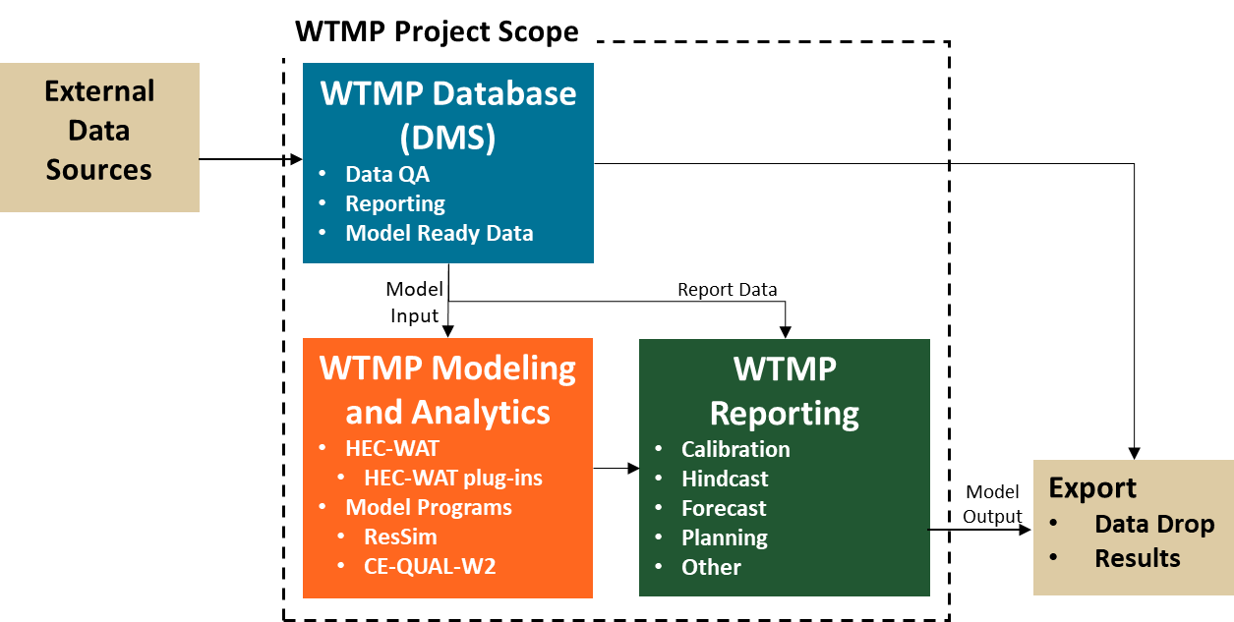
Figure 2-1. Conceptual WTMP scope including the Database (Data Management System or DMS), Modeling and Analytics, and Reporting, and generic inputs (data sources) and outputs (export).
The WTMP uses historical observations, forecast observation (short and long-term), or other data sources as input to the ResSim and CE-QUAL-W2 models to develop a wide range of analysis and associated outputs. The strength of the WTMP is to employ developed models for CVP systems (e.g., calibrated models for Shasta Lake, Folsom Lake, etc.) and then deploy them in a framework that allows the user to efficiently carryout different analyses by feeding these developed models different model input (e.g., boundary conditions, operational, and time periods). When models are recalibrated (e.g., updated geometry, additional years, modification to infrastructure, etc.) a new model configuration can be readily imported into the framework.

WTMP Hierarchy and Definitions
WTMP hierarchy consists of several levels of organization with levels including specific attributes to allow model users to systematically track and complete analysis in an automated framework to efficiently develop, perform, and compare analyses, and report results.
The basic structure includes an overarching Study, which organizes model configurations, boundary conditions, and simulation results. Alternatives within a Study are labels describing the various physical or operational conditions to be represented by one or more Simulations. Simulations consist of Model Alternatives that characterize various configurations of Model Programs representing reservoir and river systems. A Program Order determines the sequence in which each Model Alternative will be executed within a Simulation. Simulations that have the same Analysis Period can be organized within a Simulation Group.

For example, assume a simple climate change Study with Alternatives that assesses different water temperature responses in the Shasta Lake-Keswick Reservoir-Sacramento River system for a dry, low storage condition (Dry Year) and a wet high storage condition (Wet Year) under different future climate change circumstances. This study includes two potential climate change scenarios with +2ºC and +4ºC respectively, as well as the Existing Condition (i.e., baseline). In the terminology of HEC-WAT these are considered three “Alternatives”. These Alternatives will be evaluated for two different Analysis Periods, one Dry Year and one Wet Year. A Simulation Group will be created for each of the Analysis Periods, and three Simulations will be performed within each group corresponding to the three Alternatives. Each Simulation includes Model Alternatives (developed from Program Models) that describe which models and model configurations are used and a specified Program Order for Shasta Lake, Keswick Reservoir, Sacramento River as CE-QUAL-W2, CE-QUAL-W2, ResSim, respectively. The relationship of these steps is shown conceptually in Figure 2-2. In this example the important difference between the Alternative simulations is the model linking that maps inflow and meteorologic boundary conditions from the historical, +2ºC climate change, and +4ºC climate change data sets. In other studies, the important differences between “Alternatives may be in the physical configuration, operating strategies, or other aspects of the Model Alternative data.
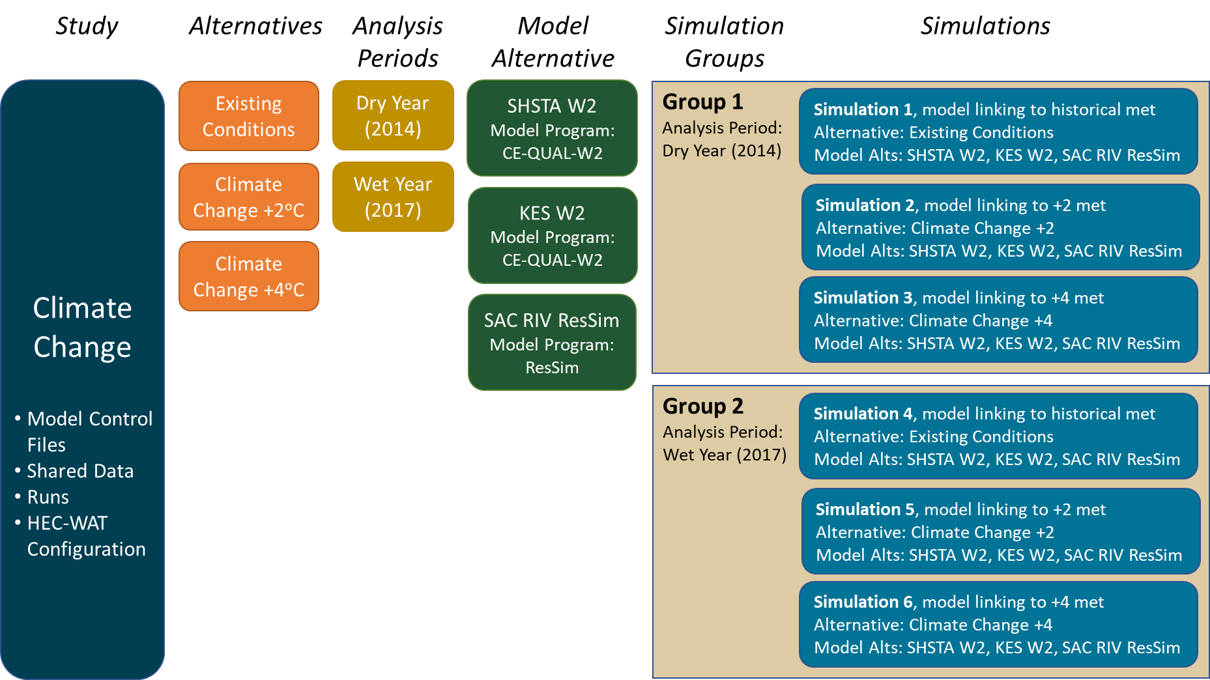
Figure 2-2. Relationship between Study, Alternatives, Analysis Periods, Model Alternatives and Model Programs, Simulations Groups and Simulations for a conceptual climate change Study. (SHSTA: Shasta Lake, KES: Keswick Reservoir, SAC RIV: Sacramento River, W2: CE-QUAL-W2, RSS: ResSim).
The process of developing Model Alternatives from Model Programs is a time and resource intensive task (developing system geometry, acquiring, and organizing all boundary conditions data, and parameterizing and calibrating models for reservoir and river reaches). However, once Model Alternatives are developed, they can readily be used to construct Simulations for specific Alternatives. This approach and structure provide an efficient and consistent means to manage model input data, complete model analysis, and compare model output for reporting.
WTMP elements and definitions as they relate to Studies are described in Table 2-1 and discussed below. The nomenclature of the WTMP is consistent with the interface, software, and directory structures that a modeler uses when operating the WTMP.
Table 2-1. WTMP terms and definitions.
Term | Definition
Platform | An overarching software framework composed of Model Program(s) and data sources (e.g., WTMP).
Study | A name or descriptor describing the suite of physical or operational conditions to be assessed. A Study is the highest-level grouping within HEC-WAT.
Study Folder | Directory structure containing all HEC-WAT configuration data (as well as Model Program control files, and initial condition and boundary condition data from the Data Management System¹) and simulation results.
Alternative | A name and text descriptor for a physical or operational condition to be represented by one or more Simulations.
Simulation | A computable data set that includes one Model Alternative selected for each “slot” in a Program Order. The Simulation references a single Analysis Period.
Simulation Group | A collection of independent Simulations that are run for a common Analysis Period.
Analysis Period | A time window (e.g., simulation period).
Program Order | A template defining the sequence of Model Program computations, i.e., the order in which Model Programs are run.
Model Alternative | A specific configuration of a Model Program (e.g., an existing conditions calibrated configuration for Shasta Lake in CE-QUAL-W2 called “Shasta-Exist-W2”).
Model Program | Numerical modeling software (e.g., CE-QUAL-W2, ResSim).
Model Linking | Definition of the linkage that allows substitution of time dependent input data with observed data or output from models computed within a Program Order.
1 The DMS contains extensive individual time series throughout the project watersheds that are organized as “templates,” grouping time series related to individual lakes and river segments in the project watersheds. A web data service has been implemented that allows automated queries of data held in the DMS. Data is transferred through the web application programing interface (API) in JavaScript Object Notation (JSON) format and saved locally in the WTMP Study shared folder (e.g., HEC-DSS (DSS) or CSV format). Importantly, the DMS web data service API supports quality flags that control the level of processing on the data that is to be retrieved, allowing the analyst insight into data origin, completeness (missing data and how gaps are filled for boundary condition data), and quality.

Platform
The Water Temperature Management Platform is the overarching framework that includes HEC-WAT, Model Programs, other software, and data sources.

Study
A name or descriptor (text) describing the suite of physical or operational conditions to be assessed. A Study is the highest-level grouping within HEC-WAT. A Study includes a Study Folder and is developed for Alternatives, Simulations/Simulation Groups, Analysis Periods, and model Program Order that use specific Modeling Alternatives developed from Model Programs.

Study Folder
The Study Data Folder includes a directory structure to organize the various information to complete a WTMP analysis, including:
- Model Control. Model configuration data files are in model specific directories:
  - W2: CE-QUAL-W2 files
  - rss: ResSim files
- Shared. The shared directory includes initial and boundary condition data extracted from the WTMP Data Management System.
- Runs. Copies of data from the model control and shared directories for use in model computations are included herein, and model results are also stored here.
- WAT. HEC-WAT configuration information (e.g., WAT controls, data processing scripts, configuration files for automated reporting, etc.).

The data in the shared folder of the Study acts as a local database for input data used by models. The primary data storage format for managing time series data in HEC-WAT is HEC-DSS (DSS), which allows an efficient mechanism to share time series data between models. Other data formats are also used, especially to support automated reporting.

Model Program
Numerical modeling software (programs) in the WTMP include CE-QUAL-W2 (reservoirs) and ResSim (reservoirs and rivers). These models are available in the public domain and initially are not location, watershed, or condition specific, and have no predetermined Analysis Period. The executable files of each Model Program are included with the WTMP software, which is stored on disk in a separate folder from WTMP studies. An executable file has been compiled from the model source code and when the file is opened, the code runs the Model Program using data files providing model input (e.g., boundary conditions) and model control parameters (e.g., starting date, time, time step, calibration parameters, etc.) which are stored in the WTMP study.

Model Alternatives
A Model Alternative is a specific model configuration (location, watershed, or condition specific) without a specified Analysis Period that can be used in a Simulation. These include the CE-QUAL-W2 and ResSim calibrated models for the various reservoir-river systems in the WTMP. A Model Alternative represents a specific model configuration, such as a calibration configuration, or an alternate configuration with a different physical (e.g., new infrastructure that increases outlet capacity) or operational (e.g., new operating rules) configuration. An example of a Model Alternative is the calibrated CE-QUAL-W2 application to Folsom Reservoir. The WTMP can manage as many Model Alternatives as desired within a study. For example, a study focusing on examining strategies for Shasta TCD shutter operations might include several ResSim Model Alternatives, each with some variation of the Shasta TCD operations script.

Program Order
Program Order is a sequence of “slots” that are filled with Model Alternatives that define the order in which Model Programs are run. For example, a simulation of Shasta Lake, Keswick Reservoir, and Sacramento River could use various permutations of CE-QUAL-W2 and ResSim. The Program Order for a Shasta Lake, Keswick Reservoir, Sacramento River sequence could be CE-QUAL-W2, CE-QUAL-W2, ResSim. Other Program Orders using CE-QUAL-W2 for reservoirs and ResSim for reservoirs and rivers can be defined.

Analysis Period
The Analysis Period represents the duration (time period) of a Simulation. Assignment of an Analysis Period is used to identify the start and end time for model runs.

Simulation
A Simulation is a computable data set that includes one model alternative selected for each “slot” in a Program Order. The Simulation references Model Alternative(s), Program Order, and an Analysis Period. Existing model Simulations can be an efficient approach to develop new model Simulation.

Simulation Group
In the WTMP, sets of Simulations are arranged in a structure termed a Simulation Group. All Simulations within a Simulation Group use the same Analysis Period. Because much of the work in preparing Simulations is in setting up Model Alternatives and Model Linking (see below) to correctly map boundary conditions, a key feature of Simulation Groups is facilitating reuse of previously created Simulations (i.e., Simulation Groups allow creation of new Simulations from previously configured Simulations). Reporting is supported across the Simulations within a Simulation Group providing means for comparison.

Alternative
In HEC-WAT, the Alternative is a name or descriptor related to a physical or operational condition to be modeled, which is helpful in organizing sets of Simulations. Each Simulation is associated with one Alternative, and more than one Simulation can be associated with a single Alternative. For example, a user may define a “2023 Existing Condition” Alternative that represents the physical and operational conditions present in the year 2023. Simulations could be created for different Analysis Periods using the “2023 Existing Condition” configuration, for example, separate Simulations could be set up for calendar years 2000, 2010, and 2020 resulting in three Simulations that were all representing on the “Existing Condition” Alternative.

Model Linking
Model Linking maps boundary conditions to external sources (e.g., DMS) and/or between models (Model Alternatives). This linkage allows substitution of time dependent input data (boundary conditions) with observed data or output from “upstream” models computed within a Program Order.

WTMP Application
The WTMP modeling framework design facilitates a range of temperature modeling applications including:
- Calibration
- Testing (Validation)/Hindcast
- Iterative Simulation
  - Ensemble Simulation
  - Position Analysis
  - Sensitivity
- Seasonal Temperature Forecast
- Long-term Planning Analysis
To perform any model simulation, model configuration data, initial conditions, boundary conditions, and operational controls are required. The primary difference between the modeling applications listed above is how model input data is prepared and how model results are post-processed for presentation and reporting. This section presents an overview of the objectives for each of the modeling applications listed above, as well as the general workflow for accomplishing the modeling analysis within the WTMP modeling framework.
Before describing each modeling application and workflow in the WTMP, certain activities that are common to all WTMP modeling applications are presented, including creating new Studies and importing model configuration data, creating “base” Simulations and Model Linking, and creating a new Study from an existing Study.
Creating a new Study and Importing Model Configuration Data – Creating an WTMP Study involves establishing geographic limits and importing numerical model configurations to create Model Alternatives using Model Programs. Typically, initial versions of CE-QUAL-W2 and ResSim models will be created externally to the WTMP and then the import process within WTMP is used to copy externally created model configurations into a WTMP Study. This process creates CE-QUAL-W2 or ResSim Model Alternatives which can be used in WTMP Simulations.
Creating “base” Simulations and Model Linking – All of the model application workflows presented below rely on preparing an initial set of one or more Simulations where Model Linking has been performed to correctly map boundary conditions to the Model Alternatives. These are referred to as “base” Simulations. When creating Simulation Groups, users select one or more existing base Simulations and the WTMP makes a copy of those simulations for use within the Simulation Group.
Creating a new Study from an existing Study – A copy of an existing Study can be used as the starting point for a new analysis. In this way it is possible to leverage previous work configuring the Study and performing the initial importing and linking required to create base Simulations.

Calibration Simulations
The CE-QUAL-W2 and ResSim models in the WTMP are mechanistic models that are applied to a wide range of systems and include parameters that can be adjusted to accommodate specific reservoir or river system attributes. The calibration process typically aims to adjust or “fit” these model parameters to minimize differences in model results and observed/measured data (Chin 2013). Model results are compared graphically and statistically to assess model performance and refine model parameters to arrive at a final calibration (for details see Reclamation 2023d, g).
The workflow for manual calibration in the WTMP is illustrated in Figure 2-3. In the WTMP, a Simulation Group is created for the calibration period. This period could be limited to a single year or span multiple years. A Simulation is added to the Simulation Group for each Alternative that is to be calibrated. Historical data for initial and boundary conditions are stored in the WTMP data management system (DMS) where they have been reviewed for quality and completeness (i.e., “model ready”. Model ready data sets representing initial and boundary conditions are downloaded from the WTMP DMS. The Simulations are immediately able to run from the downloaded data. Automated reporting is used to create calibration reports and extract summary data from the full result set, including graphical representation and tabular model performance metrics (see Reclamation (2023f)) for extensive examples of reporting). Results are reviewed in light of the pre-established model performance metrics and if calibration adjustments are needed, the user can either (a) save current results as a reference set and then edit the current model configuration data, or (b) perform a save as action on the current Model Alternative(s) and add new Simulations to the Simulation Group so the next calibration adjustments will not overwrite the current calibration. The former action, where previous results are overwritten, may be useful for a modeling analysis when they are exploring different settings and results early in a calibration process. The latter action (save) can be useful when comparing different model parameter sets, completing sensitivity analysis, or other action where saving discrete model results is desired.
The WTMP does not support automated calibration at this time, though that function could be considered for a future enhancement. The WTMP supports several forms of iterative simulation which are described later in this section.

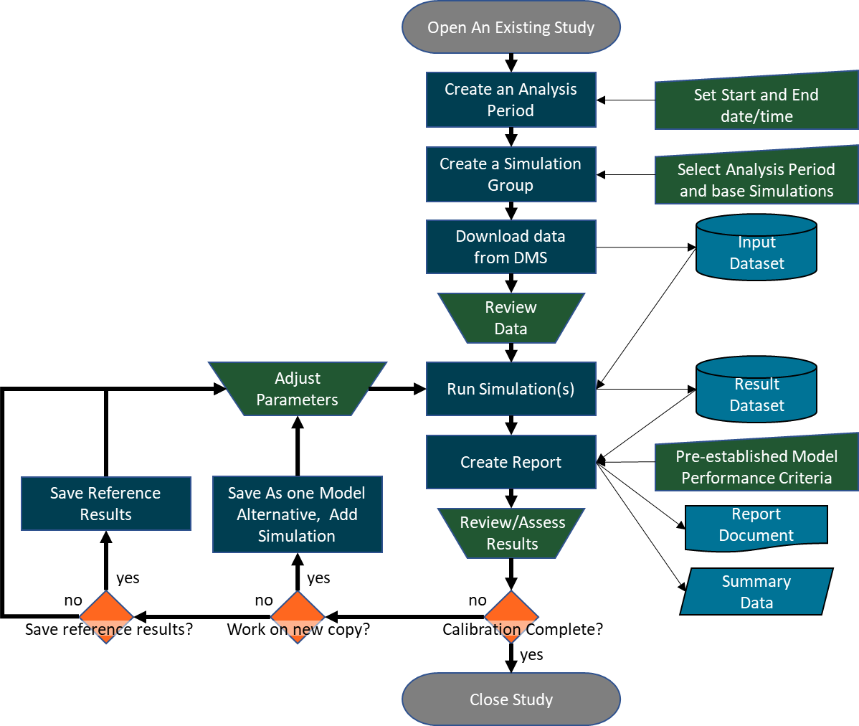
Figure 2-3. WTMP calibration workflow.

Validation and Hindcast Simulations
Validation and hindcast simulations serve different purposes but are carried out in the WTMP in a similar fashion.

Validation
Model validation follows calibration and is used to demonstrate that a model possesses a satisfactory range of accuracy, or more specifically, validation is testing a calibrated model against an independent set of empirical data, to evaluate model fit and assess its general applicability. Similar performance measures as in the calibration stage are applied. Another validation process is included in the WTMP wherein when additional data are available (e.g., an additional year or years of boundary condition data), a model validation for the period in question is completed. The purpose of this validation process is to ascertain if model performance is consistent with the calibration, or if there is a need to recalibrate the model considering the new data.

Hindcast
A hindcast is a retrospective simulation and uses the actual or observed input data (e.g., hydrology, operations, meteorology, inflow water temperatures) for the same forecast period. The hindcast provides a means to assess how well the original forecast model simulation compares to the model when provided observed input data. If forecast and observed values do not deviate considerably based on pre-established model performance metrics, model uncertainty (parameter (calibration) uncertainty, model development uncertainty) can be assumed small and the difference in the simulations is largely due to the forecast inputs.
In the WTMP, both validation and hindcast simulations follow the same workflow. For these two model applications, the workflow is essentially the same as in the calibration workflow, except there is no iterative process to update model parameters. The purpose of these applications is to report on the quality of model results without additional calibration, so a single pass through the simulation process is appropriate as shown in Figure 2-4.
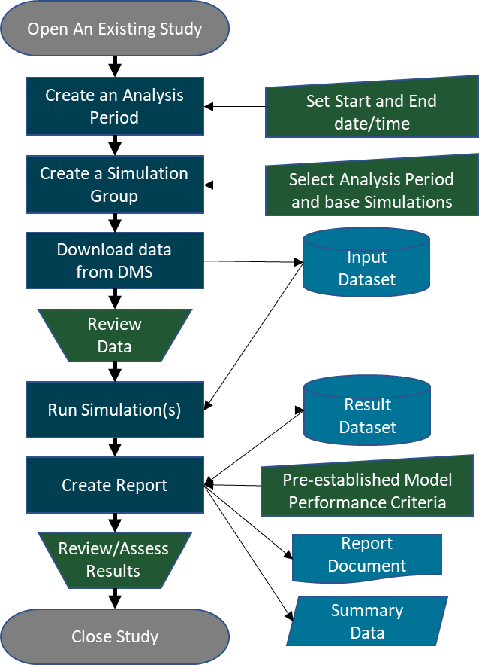
Figure 2-4. WTMP validation and hindcast workflow.

Iterative Simulations
Three general iterative simulation techniques have been implemented within the WTMP modeling framework which include ensemble simulation, position analysis, and sensitivity analysis. Definitions for these types of simulation vary. Herein, ensemble analysis includes an assemblage (ensemble) of simulations that use the same analysis period to analyze a range of potential outcomes associated with different boundary conditions; position analysis uses a large number of possible flow sequences as inputs to a simulation for a given set of operating rules to forecast the likelihood of specified outcomes, where flow sequences can be based on a historic record or stochastic models (Tasker and Dunne 1997); and sensitivity analysis explores the sensitivity of the model to individual inputs and parameters (e.g., testing model response to changing variable or parameters over a range of representative values). The basic workflow for iterative simulation types is shown in Figure 2-5.
Ensemble and position analysis are accomplished by automatic manipulation of boundary conditions while sensitivity analysis is accomplished through user created scripts that modify model configuration files. For ensemble simulation, the user creates a DSS collection of time series records (termed a DSS collection) for the input time series that are to be varied. The WTMP user interface allows linking of one or more boundary conditions to DSS collection time series records. The model simulation then iterates over collection members, using the corresponding time series collection member for each mapped boundary condition. Model output is saved automatically as DSS collections, and the set of output can be used in automated reporting. Position analysis is similar to the ensemble simulation process; however, in this case the WTMP iterates over selected years, mapping time series values from reference years to the current simulation year. Model results are again saved automatically to DSS collections that identify the reference year as a collection identifier (ID).
Sensitivity analysis uses a significantly different approach where the WTMP calls user defined scripts before and after each simulation in the iteration. Users are required to set up model configuration files to accomplish the desired input modifications and then to reset the configurations to the original data. Output is saved to DSS collections where collection IDs are related to the iteration number to track the range of sensitivity results.
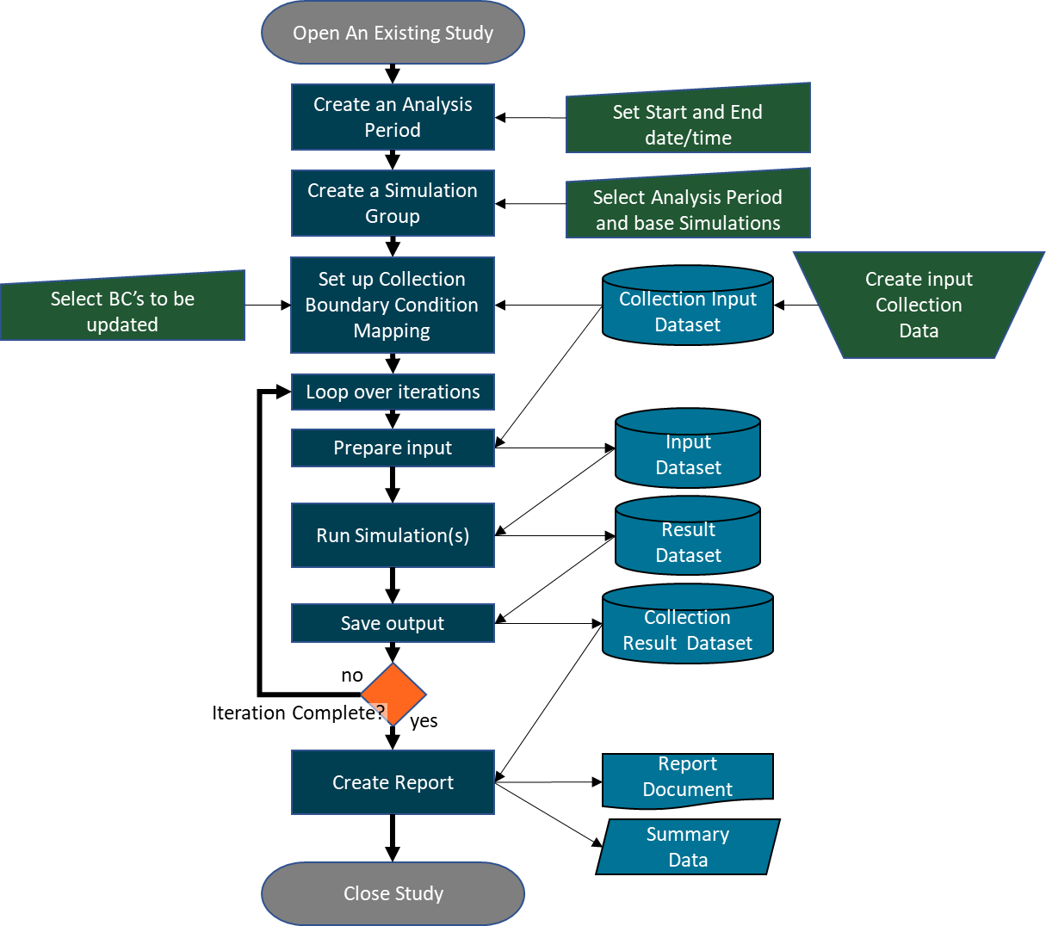
Figure 2-5. WTMP iterative simulation workflow.

Seasonal Temperature Forecast Simulations
For CVP watersheds included in the WMTP, a seasonal water temperature forecast describes future expected downstream water temperature (Reclamation 2020b). This forecast, or simulation of expected water temperature performance, is based on the temperature targets at the reservoir tailbay or at a location downstream as specified by the analyst. Future water temperature is forecasted using simulation models that utilize estimated future flow, operations, and meteorology (and associated inflow water temperatures). Generally, these forecasts are based on an array of potential conditions (e.g., 50 percent exceedance, 90 percent exceedance inflow forecast) as well as appropriate assumptions regarding the expected range of operations and meteorology. Because this forecast cannot exactly predict the actual future hydrology, operations, and meteorology in advance, model results are not expected to precisely match actual water temperatures. However, the expectation is that forecasted downstream water temperatures have an acceptable measure of error (uncertainty). Simulation error includes inherent model error or bias, uncertainty of the forecast future conditions and assumptions used in formulating the forecast (e.g., disaggregation of monthly forecasts to sub-monthly time periods). The uncertainty associated with assumptions used in formulating the forecast are discussed in detail in Reclamation (2023f).
Key characteristics of boundary conditions for temperature forecast simulations that are different from calibration/validation simulations include:
- Reservoir inflow and release operational forecasts provide monthly average flow values,
- Meteorologic data are estimated from historic data or forecasts,
- Inflow temperatures are estimated based on historic data or using flow rates and meteorologic forecasts.
- Tailbay or downstream Temperature Targets are defined as weekly or monthly values (approximately), and
- TCD operation is determined by model logic.
In the WTMP, the approach to ensemble simulation for seasonal temperature forecasts is essentially the same as the ensemble simulation described above, however, special workflow has been established to streamline creation of the boundary condition data (Figure 2-6). The WTMP user interface facilitates selection and importing reservoir initial conditions, CVP monthly forecast spreadsheets, Local Three-Month Temperature Outlook (L3MTO) or position analysis type meteorologic data, and collections of temperature target time series. Data processing scripts within the WTMP are used to create the daily flow and water temperature input time series based on the forecast data. This scripted process replaces the manual spreadsheet manipulations previously used by Reclamation to create seasonal temperature forecast boundary conditions in previous modeling efforts. The daily boundary condition time series are automatically saved to DSS collection time series. The final step before simulation is for the user to select which combinations of boundary conditions and temperature targets will be simulated. The WTMP will then iterate over the selected ensemble members carrying out the simulations and organization of results into DSS collections. The automated reporting capability can then be used to create summary graphics and tables based on the ensemble results.
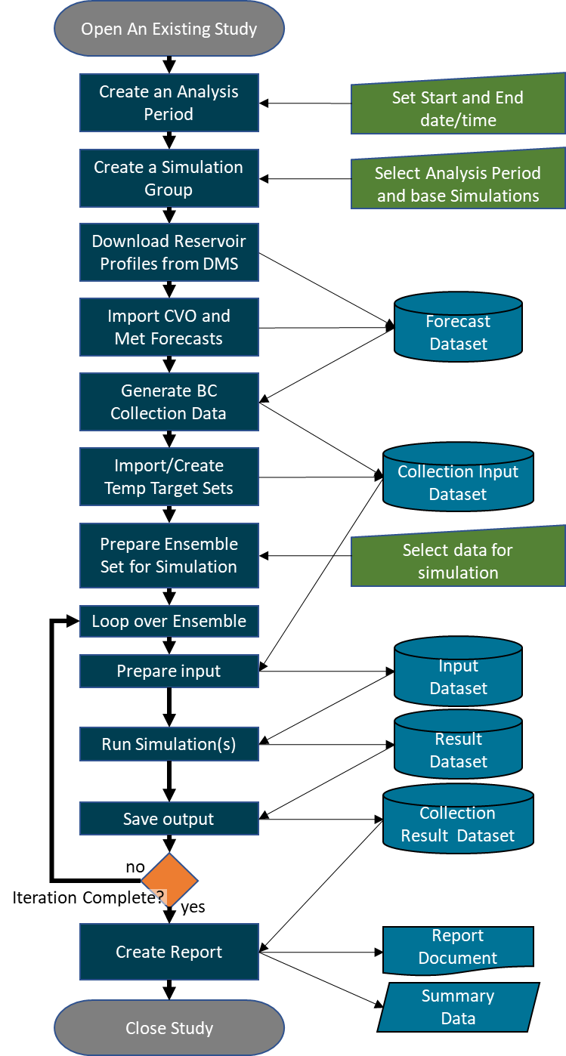
Figure 2-6. WTMP seasonal temperature forecast workflow.

Long-term Planning Study
Long-term planning studies include a range of temperature analyses related to water supply and assessment, operations assessment, policy support, regulatory compliance, environmental evaluations, to other analyses. A widely used water supply planning model is CalSim and the CalSim3 version with a simulation period of 1922-2015 (DWR 2022), that has recently been extended to 2022. Reclamation has identified that populating the WTMP with CalSim3 operations and hydrology-based simulations is consistent with the overall goals of Reclamation to have forward looking technical tools to support operations and associated obligations. While the various components of CalSim3 are widely available, there are elements that are still under development that would be necessary to support long-term simulations in the WTMP environment. Examples include:
- development of appropriate representation of CalSim3 output information for input into the WTMP. CalSim3 has a high level of detail in some locations (e.g., inflows and outflow in the upper Sacramento River) and less detail in others (e.g., Trinity River inflows and outflows in the Trinity River below Lewiston Dam).
- a long-term meteorological data set is required to produce long-term water temperatures in the WTMP, extending back to 1922. Development of this long-term hourly record has not been completed in all basins (a long-term record is available for the American River basin, but the development in the Sacramento, Trinity, and Stanislaus basins has not been completed).
- forecasting certain inflows on the necessary resolution for temperature modeling are incompletely developed. Shasta Lake and Trinity Lake inflows are single monthly values, and all flows into New Melones are likewise combined into a single inflow. While developing methods for representing these inflows is relatively straightforward, such decisions often require collaboration with agencies and stakeholders to ensure acceptable methods are defined and agreed upon.
Herein, a proof-of-concept long-term planning workflow and example are presented to illustrate the process of such simulations in the WTMP. Assumptions, inputs, simulation process, and results and results presentation are included herein. As these current information sharing procedures between CalSim3 and the WTMP are defined over time, they can readily be incorporated into the long-term planning modeling process. The Sacramento/Trinity system is used as an example. ResSim is the model employed herein because this system model can simulate extended time periods in an efficient fashion (CE-QUAL-W2 experience extended run times and would be computationally inefficient to make the expected number of simulations).
Assumptions for this exercise include the following:
- Use 20 years of historical meteorology - 20 years starting in 2000.
- Use historical flow and inflow temperature boundary conditions for the Trinity River below Lewiston Dam.
- A simple constant temperature target of 54ºF during the temperature management season (5/1 to 10/31) at the Sacramento River compliance location located above the confluence with Clear Creek.
The proof-of-concept long term planning simulation workflow is illustrated in Figure 2-7. This workflow is similar to calibration or validation simulations, with the key difference being that the boundary condition time series are based on CalSim3 monthly results. For this example, a manual step is introduced to import the CalSim3 DSS result set and corresponding meteorological data. Data processing scripts, similar to those used for seasonal forecast data, are manually run to perform disaggregation of the data to daily flow as well as to estimate inflow temperatures (similar to methods identified in Reclamation 2023f). Model linking is also modified to map the CalSim3 based boundary condition time series to the computational models’ inputs rather than historical data. Manual steps identified herein can be automated in the WTMP at a future time, when the required CalSim3 elements listed above are completed. An example of a planning application is provided in Chapter 3.
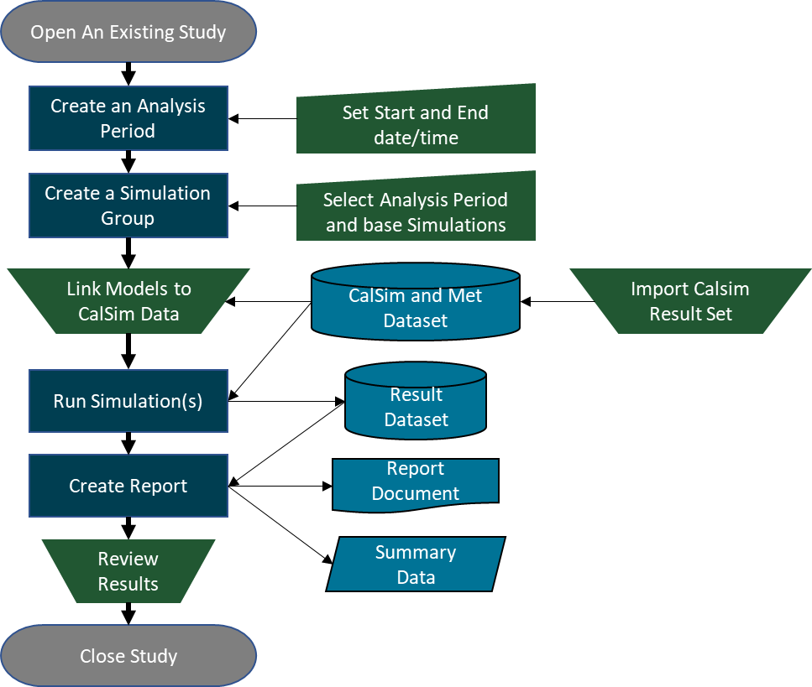
Figure 2-7. WTMP long-term planning simulation workflow.

Potential Future Applications and Implementation Features
The aforementioned simulations address the immediately identified needs for Reclamation to carry out the current and planned activities of annual temperature management planning, end of season hindcast, updating the model with additional date (validation), and long-term planning. The iterative simulations provide additional opportunities for Reclamation to extend its current water temperature related analyses and explore additional approaches to manage cold water resources in project reaches. The expectation is that Reclamation will use ensemble, position analysis, and sensitivity analysis to augment its temperature management tools. In addition, selective scenario forecasts for annual temperature management planning activities can be employed, where a limited, but informative set of simulations can be used to constrain the range of outcomes. For example, a 10, 25, 50, 75, 90, 95, and 99 percent exceedance hydrology forecast (n=7) and associated operations can be coupled with a 75, 50, 25, and 10 percent exceedance meteorology forecasts (n=4) to develop a set of 28 simulations. While each of these realizations is not equally probable, the outcome from such an analysis can be readily completed in the WTMP and provide resource managers valuable information for decision-making or refining the analysis through a sub-set of simulations.

Long-Term Planning Simulation – Application
The WTMP will be capable of performing temperature simulations based on output from planning simulations performed using the CalSim operations model, with a focus on supporting CalSim version 3 (CalSim3). This chapter presents an initial proof-of-concept simulation demonstrating the ability of the WTMP modeling framework to configure and carry out simulation utilizing CalsSim3 model output. This simulation uses the Upper Sacramento System model which includes Shasta, Keswick, Trinity, Lewiston, and Whiskeytown reservoirs, however the results presentation focuses on operation of the Shasta Lake Temperature Control Device to meet a downstream temperature target.
The CalSim3 operations model represents California’s water system with a detailed computational network suitable for providing flow boundary conditions required by the WTMP temperature simulation. Some processing is required to make the monthly flow results produced by CalSim3 model ready for WTMP temperature simulations, and those steps are described later in this chapter. CalSim3 outputs do not include meteorology or inflow temperature information required for WTMP temperature simulation.
Detailed hourly meteorologic data sets need to be prepared that correspond to the CalSim3 flow simulations. When CalSim3 hydrology is reflective of historical conditions, historical meteorologic conditions can be used, and that approach is used for the proof-of-concept simulation. In future use of the WTMP for long-term planning simulation, alternate meteorology data sets may be specified that relate to alternate CalSim3 model input hydrology, such as future climate change scenarios.
Water temperature must be assigned for all inflow boundary conditions. This is accomplished using regression relationships developed relating inflow volume and meteorologic time series, an approach that has been successfully applied in previous forecast modeling efforts for the Upper Sacramento and American River systems. Boundary condition processing for the proof-of-concept simulation was accomplished by running Python scripts external to the WTMP. The Python scripts were derived from the scripts used within the WTMP for preparing seasonal forecast boundary condition data. In the future the capability to prepare the full set of boundary conditions for long-term planning runs will also be made available within the WTMP.

Analysis Assumptions

Planning Simulation Inputs
The long-term planning simulation inputs for ResSim representing the Shasta-Trinity system were developed for the 2000-2020 period. The ResSim model was selected for computational run time efficiency and is anticipated for coarser, monthly operational time-step type analyses. This period was selected because complete meteorological data sets are required to simulate temperature in the WTMP, and these have not been developed for the 1922 to 2021 period (current CalSim3 simulation period). Additional considerations include boundary condition representation for the Trinity River below Lewiston Dam. Input information included:
- Flows for all boundary conditions and operations at system reservoirs from CalSim3 (as DSS Files). This is an example input data set from the on-going LTO (Long Term Operation) study and does not represent historical conditions and is only used here as an example data set to drive the proof-of-concept WTMP simulation.
  - Monthly average input hydrologic time series: L2020A_2022MED_wWestSideMod_HistAR_051923_SV.dss
  - CalSim3 monthly average simulation results: LTO_NAA_2022MED_05192023_DV.dss
- Historical meteorology data for the Trinity River and Sacramento River basins was employed (hourly)
- Historical tributary inflows (daily) and inflow temperatures (daily) to the Trinity River downstream of Lewiston Dam.

Boundary Condition Processing
CalSim3 output provides monthly information (boundary conditions, operations). These values were disaggregated to daily values for reservoir inflows (monthly to daily). The daily reservoir inflows were assigned to individual tributaries based on regression relationships based on historically available data. To ensure a water balance in the Sacramento River between Keswick Dam and Red Bluff (extent of Sacramento River in WTMP model domain), an accretion/depletion was computed based on a water balance using CalSim3 inflow and diversion results for this reach. Reservoir inflow temperatures were based on regressions relating daily flow and air temperature (see Reclamation (2023f) for additional details). A typical example of the relationship between daily average (historical) inflow and releases versus monthly average flows as well as disaggregated daily flow developed by scaling a representative historical pattern by monthly average flow volume is shown in Figure 3-1. Peak storm flows are not represented by either the monthly average or disaggregated daily records, but the total volume of inflow and outflow is preserved.
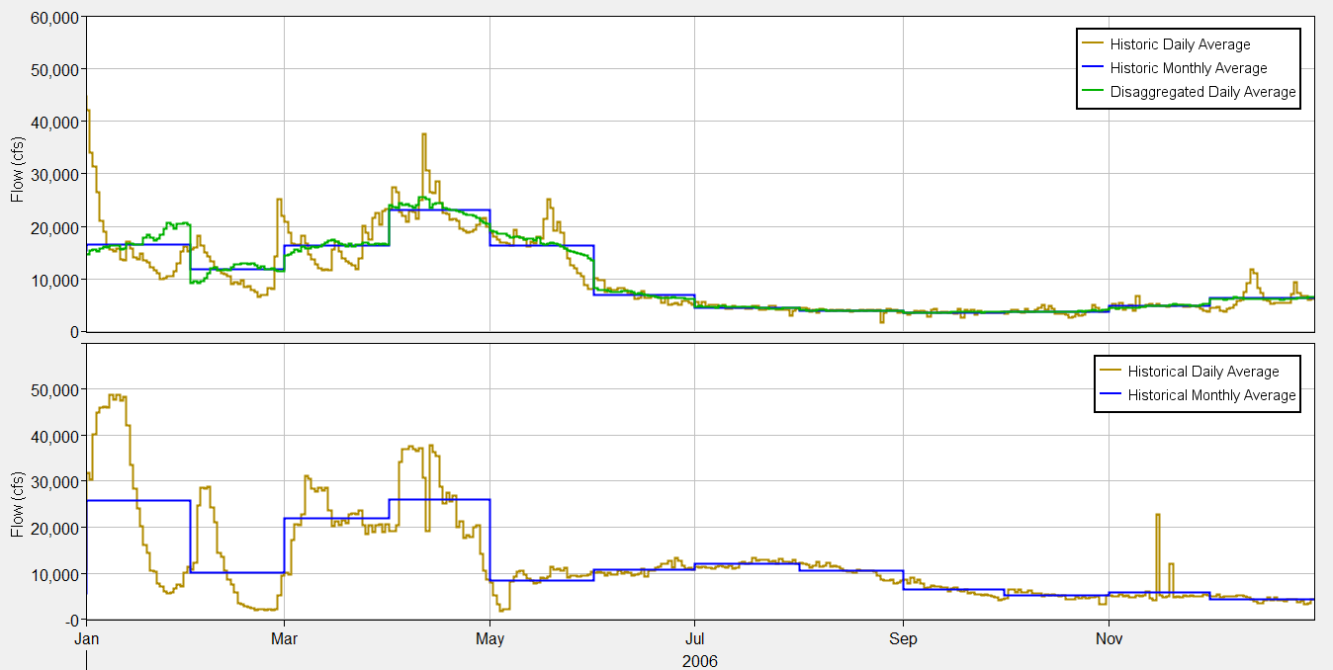
Figure 3-1. Shasta Lake inflow for historic daily average, historic monthly average, and disaggregate daily (from historic monthly average) (top), and Shasta Dam total release for historic daily average, historic monthly average (bottom): 2006.

Input from CalSim3
Monthly time series from the input (SV) and output (DV) CalSim3 DSS files were used to create the boundary conditions needed for the ResSim simulation. All CalSim3 inflows and outflows to reservoirs were included. For river locations, some net accretion/depletions were computed by difference between key channel flow locations. The list of CalSim3 DSS records used and the mapping to HEC-ResSim inputs is included in Table 3-1.

Table 3-1. Mapping of CalSim3 records to required boundary conditions for the ResSim Upper Sacramento System model (table continues on next page).
System | ResSim Model Input | Parameter | CalSim3 Record | Notes
Trinity Lake | Inflow-East Fork Trinity River | Flow | I_TRNTY split | footnote 1
Trinity Lake | Inflow-Trinity River | Flow | I_TRNTY split | footnote 1
Trinity Lake | Inflow-Swift Creek | Flow | I_TRNTY split | footnote 1
Trinity Lake | Inflow-Stuart Fork | Flow | I_TRNTY split | footnote 1
Trinity Lake | Balance Flow | Flow | E_TRNTY | -
Trinity Lake | Release-Powerhouse | Flow | C_TRNTY | footnote 2
Trinity Lake | Release-Bypass | Flow | - | -
Trinity Lake | Release-Spillway | Flow | - | -
Lewiston Reservoir | Balance Flow | Flow | I_LWSTN - E_LWSTN | -
Lewiston Reservoir | Diversion-Clear Creek Tunnel | Flow | D_LWSTN_CCT011 | -
Lewiston Reservoir | Release-Gated Spillway | Flow | C_LWSTN | footnote 3
Lewiston Reservoir | Release-Powerhouse | Flow | - | -
Lewiston Reservoir | Release-Fish Hatchery | Flow | - | -
Whiskeytown Lake | Inflow-Clear Creek | Flow | I_WKYTN | -
Whiskeytown Lake | Balance Flow | Flow | -(E_WKYTN + D_WKYTN_WTPCSD + D_WKYTN_02_PU + D_WKYTN_WTPBUK) | -
Whiskeytown Lake | Diversion-Spring Creek Tunnel | Flow | D_WKYTN_SPT003 | -
Whiskeytown Lake | Release-Controlled Outlet | Flow | C_WKYTN | footnote 4
Whiskeytown Lake | Release-Spillway | Flow | -
Clear Creek | Balance Flow | Flow | C_CLR011 - C_WKYTN | -
Shasta Lake | Inflow-Pit River | Flow | I_SHSTA – split | footnote 1
Shasta Lake | Inflow-Sulanharas Creek | Flow | I_SHSTA – split | footnote 1
Shasta Lake | Inflow-McCloud River | Flow | I_SHSTA – split | footnote 1
Shasta Lake | Inflow-Sacramento River | Flow | I_SHSTA – split | footnote 1
Shasta Lake | Balance Flow | Flow | -(E_SHSTA+ D_SHSTA_WTPJMS) | footnote 1
Shasta Lake | Release-Powerplant | Flow | C_SHSTA | footnote 5
Shasta Lake | Release-RRU | Flow | - | -
Shasta Lake | Release-RRM | Flow | - | -
Shasta Lake | Release-RRL | Flow | - | -
Shasta Lake | Release-Spillway | Flow | - | -
Keswick Reservoir | Inflow-Spring Creek Debris Dam | Flow | SR_02_KSWK | -
Keswick Reservoir | Balance Flow | Flow | SR_03_KSWK + R_03_PU1_KSWK - E_KSWCK | -
Keswick Reservoir | Release-Keswick Dam | Flow | C_KSWCK | -
Sacramento River below Keswick | Diversion-ACID | Flow | C_SAC289 - C_KSWK | footnote 6
Sacramento River below Keswick | Inflow-Cow Creek | Flow | C_COW003 | -
Sacramento River below Keswick | Inflow-Cottonwood Creek | Flow | C_CWD003 | -
Sacramento River below Keswick | Inflow-Battle Creek | Flow | C_BTL006 | -
Sacramento River below Keswick | Balance Flow-Bend Bridge | Flow | C_SAC257 - C_SAC269 | footnote 6
1 - Split total inflow based on regression of historical total inflow to tributary inflows.
2 - Assume total Trinity release through powerplant for proof-of-concept simulation.
3 - Assume total Lewiston release through gated spillway for proof-of-concept simulation.
4 - Assume total Whiskeytown release through controlled outlet for proof-of-concept simulation.
5 - Assume total Shasta release through powerplant for proof-of-concept simulation.
6 - Net accretion/depletion

Meteorology Data
The ResSim and CE-QUAL-W2 models used in the WTMP require hourly meteorology data to perform water temperature simulation. The required parameters include:
- Air Temperature
- Wind Speed
- Cloudiness Fraction
- Relative Humidity
- Short Wave Solar Radiation
For the calibration simulations of the Upper Sacramento System, observations from the Redding Airport and Trinity Center meteorologic stations were used to provide data across all reservoirs and river segments included in the model. Because full meteorology data corresponding to the example CalSim3 data set was not yet available, the historical meteorology data prepared for the calibration period was used for the proof-of-concept planning simulation.

Trinity River below Lewiston Dam
At the current time, the CalSim3 model does not extend below the Lewiston Dam release point on the Trinity River. For the proof-of-concept planning simulation, historical data prepared for the calibration period was used for all inflows below Lewiston Dam.

Inflow Temperature Processing
The ResSim and CE-QUAL-W2 models in the WTMP require water temperature to be assigned to all inflows (boundary conditions). Following the approach established for seasonal temperature management forecasting runs, tributary inflow temperatures are estimated by means of regressions relating historical tributary inflows to observed tributary temperatures (see Reclamation (2023f)). For minor balance flows (accretions/depletions) inflow temperatures are assumed to be the same as the ambient water temperature at the inflow location. The following table (Table 3-2) identifies the locations and method of estimating inflow temperature.
Table 3-2. Inflow water temperature boundary conditions for the ResSim Upper Sacramento System model.
System | ResSim Model Input | Parameter | Notes
Trinity Lake | Inflow-East Fork Trinity River | Water Temperature | footnote 1
Trinity Lake | Inflow-Trinity River | Water Temperature | footnote 1
Trinity Lake | Inflow-Swift Creek | Water Temperature | footnote 1
Trinity Lake | Inflow-Stuart Fork | Water Temperature | footnote 1
Trinity Lake | Balance Flow | Water Temperature | footnote 2
Lewiston Reservoir | Balance Flow | Water Temperature | footnote 2
Whiskeytown Lake | Inflow-Clear Creek | Water Temperature | footnote 1
Whiskeytown Lake | Balance Flow | Water Temperature | footnote 2
Clear Creek | Balance Flow | Water Temperature | footnote 2
Shasta Lake | Inflow-Pit River | Water Temperature | footnote 1
Shasta Lake | Inflow-Sulanharas Creek | Water Temperature | footnote 1
Shasta Lake | Inflow-McCloud River | Water Temperature | footnote 1
Shasta Lake | Inflow-Sacramento River | Water Temperature | footnote 1
Shasta Lake | Balance Flow | Water Temperature | footnote 2
Keswick Reservoir | Inflow-Spring Creek Debris Dam | Water Temperature | footnote 1
Keswick Reservoir | Balance Flow | Water Temperature | footnote 2
Sacramento River below Keswick | Inflow-Cow Creek | Water Temperature | footnote 1
Sacramento River below Keswick | Inflow-Cottonwood Creek | Water Temperature | footnote 1
Sacramento River below Keswick | Inflow-Battle Creek | Water Temperature | footnote 1
Sacramento River below Keswick | Balance Flow-Bend Bridge | Water Temperature | footnote 2
¹ Estimate daily average inflow water temperature based on inflow volume and meteorologic conditions.
² Assume ambient inflow temperature for proof-of-concept simulation.

Allocation of Total Reservoir Release to Reservoir Outlets
The CalSim3 result set does not provide detailed distribution of release flows across all reservoir outlets represented by the WTMP temperature models. For the proof-of-concept simulation, the full release flow is made either through the powerplant outlet, or the controlled outlet with sufficient capacity to manage the monthly average releases (see Table 3-1 above). For the 2000-2020 period, there were no significant spill events where monthly average release flows exceeded capacity for the selected outlets. For full implementation of long-term simulation capability, it will be necessary to at a minimum allow spill flows to be passed to the reservoir spillway outlets. It is also possible to utilize release logic to perform more detailed distribution of flows to various outlet structures.

TCD Operation and Temperature Target Assignment
The Shasta TCD operation is determined by the ResSim scripted rule logic developed for seasonal temperature forecast documented here (TM 14 Reclamation 2023f – forecasting protocols). The temperature target was specified as a constant 54ºF (12.2ºC) at the Sacramento River above Clear Creek temperature compliance location. The temperature target was input to the model as a daily time series, but the model can accommodate daily, weekly, or monthly variations in the target. The constant target was suggested by Reclamation as an appropriate first test for the planning simulation.
The TCD operation logic manipulates the TCD shutter openings to meet a Shasta Dam tailbay temperature. To meet a temperature at a downstream river location, the effects of heating through Keswick Reservoir and the Sacramento River down to the compliance location must be considered. In general, during summer and early fall the Shasta Dam tailbay temperature will need to be cooler than the downstream temperature requirement to account for this heating. In this pilot simulation, a regression technique was employed to determine the Shasta Dam tailbay temperature requirement based on flow and meteorologic conditions (see Appendix on ResSim regression forecast approach).
Future implementation of long-term planning runs may be desired to accommodate dynamic determination of temperature targets based on yearly hydrologic conditions and/or an iterative simulation technique to fine tune at site TCD release temperature to meet the downstream temperature constraints more precisely.

Results
The WTMP ResSim model for the Upper Sacramento River System was successfully run with the proof-of-concept simulation boundary conditions for the period of 2001 through 2019. An overview of the model results is presented in this section focusing on the general behavior of the model when driven by CalSim3 based boundary conditions. It is not the purpose of this analysis to carefully evaluate the detailed behavior of the specific CalSim3 result set provided as an example data set.
Shasta Lake inflow, outflow, and storage time series over the simulation period are presented in Figure 3-2 through Figure 3-6. The simulated daily reservoir storage time series track the end of month storage calculated by CalSim3, indicating that volumetric balances were correctly represented in the boundary conditions used to drive ResSim. The total reservoir inflow shown in the plots is the sum of the disaggregated daily flow time series developed for each tributary inflow plus the balance flow which includes the net evaporation record and minor diversions from the reservoir.
The historic Shasta Lake storage time series is also plotted with the CalSim3 based storage for reference. This is relevant because the particular CalSim3 result set used for this proof-of-concept simulation allows Shasta Lake to reach very low storage volume of 500 TAF during 2014 and 2015 while the historical storage in both those years was over 1,000 TAF. The very low storage levels in the CalSim3 result set lead to release of very warm water during 2014 and 2015, considerably warmer than occurred historically during that period. The very warm Shasta release temperatures in the CalSim3 based simulation results are not model errors, they are result of the storage balance in Shasta Lake under this particular example CalSim3 data set.

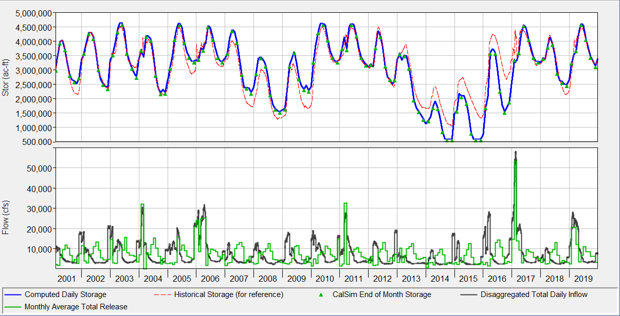
Figure 3-2. Shasta Lake daily storage (top), and disaggregated daily inflow, and monthly average release based on CalSim3 input (bottom) used in the proof-of-concept ResSim long-term planning model, 2001-2019.
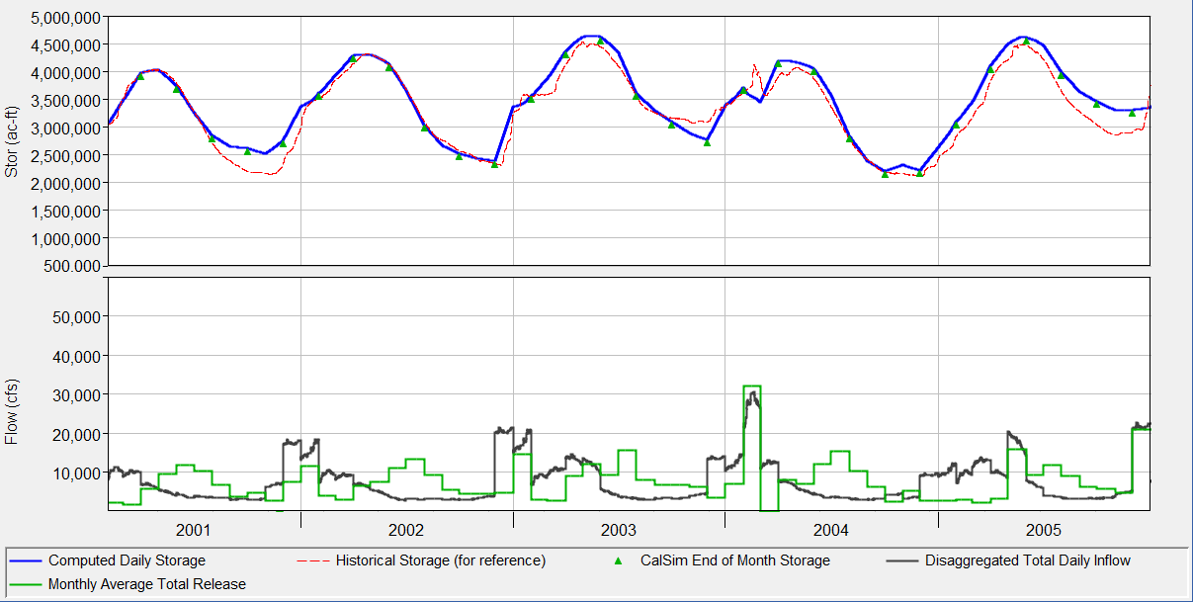
Figure 3-3. Shasta Lake storage, disaggregated daily inflow, and monthly average release based on CalSim3 input used in the proof-of-concept ResSim long-term planning model, 2001-2005.

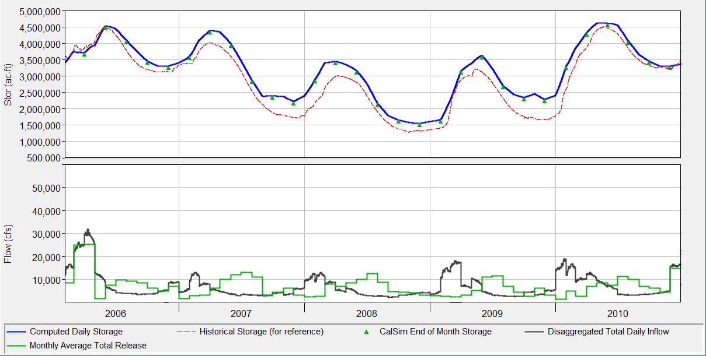
Figure 3-4. Shasta Lake storage, disaggregated daily inflow, and monthly average release based on CalSim3 input used in the proof-of-concept ResSim long-term planning model, 2006-2010.
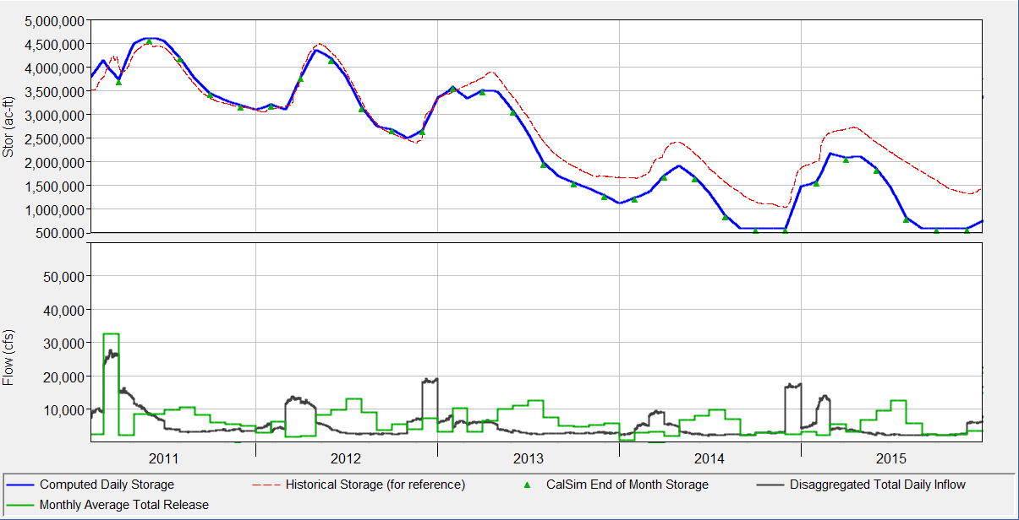
Figure 3-5. Shasta Lake storage, disaggregated daily inflow, and monthly average release based on CalSim3 input used in the proof-of-concept ResSim long-term planning model, 2011-2015.

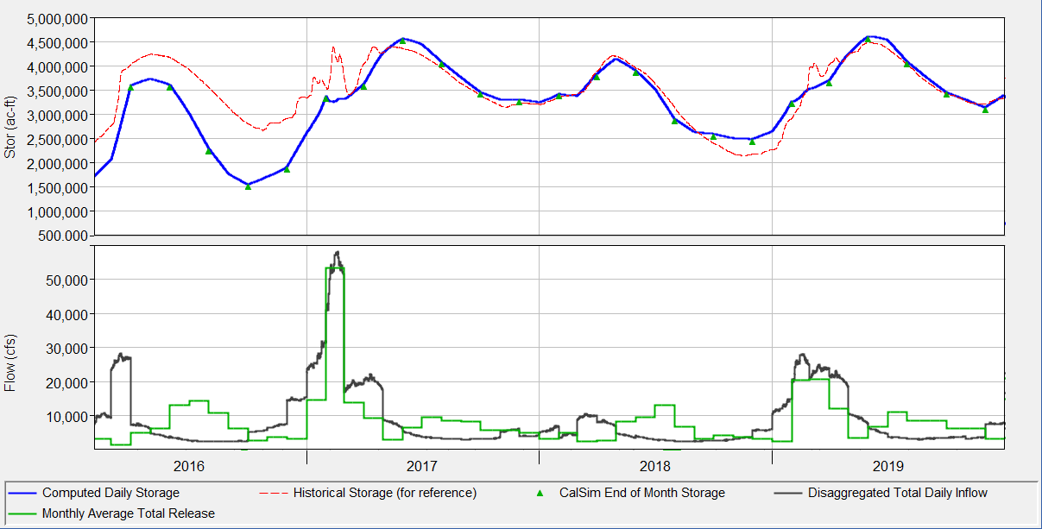
Figure 3-6. Shasta Lake storage, disaggregated daily inflow, and monthly average release based on CalSim3 input used in the proof-of-concept ResSim long-term planning model, 2016-2019.
A key objective of this proof-of-concept simulation is to test the ability of the ResSim model to meet a downstream temperature target. A constant maximum limit of 54º F (12ºC) at the Sacramento River above Clear Creek gage was established as the target for this simulation. To meet that requirement, during the summer and early fall the release temperature from Shasta Dam must typically be lower than the target temperature because water will warm as it passes through Keswick Reservoir and downstream along the Sacramento River. Later in the fall, air temperatures are lower and the release from Shasta may be allowed to be warmer than the target as water can cool as it travels to the downstream target location. Through most of the winter and early spring, water temperatures are generally cool enough where management for the downstream target is not required.
Water temperature at the Shasta outflow, Keswick outflow, and at the target location on the Sacramento River are presented in Figure 3-7 through . The target temperature at the Sacramento River above Clear Creek is consistently met, with only small, short-duration deviations above the target throughout the simulation period except for 2014 and 2015 when temperature control is lost due to very low storage in Shasta Lake. Simulated temperature at the downstream target location is not expected to be precisely met given the regression equation estimation on heating rates from Shasta Dam to the target location, limitations on TCD operation, small variations in routing time, and short time scale variations in meteorology. In real-time management of water temperature in the Sacramento River, operators have a host of factors to consider and may operate to a temperature slightly lower than the target to ensure desired conditions are achieved. The forecast approach represented in this exercise is an effective proxy for long-term planning model applications and can be refined in the future to accommodate conditions that may vary from historic (e.g., climate change).
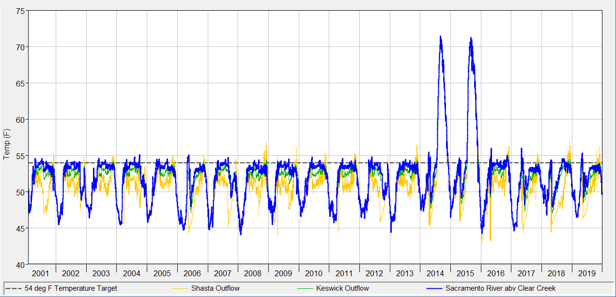
Figure 3-7. Simulated water temperature at Shasta Dam outflow, Keswick Dam outflow, and Sacramento River above Clear Creek based on CalSim3 input used in the proof-of-concept ResSim long-term planning model, 2001-2019.

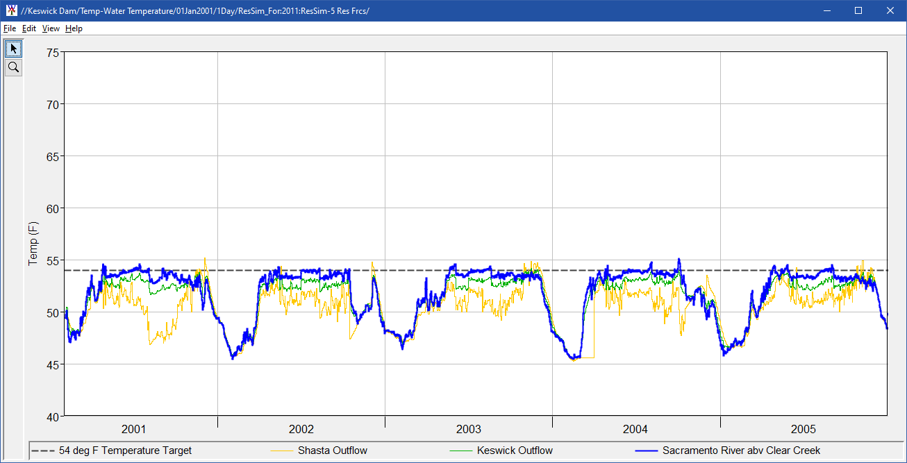
Figure 3-8. Simulated water temperature at Shasta outflow, Keswick outflow, and Sacramento River above Clear Creek based on CalSim3 input used in the proof-of-concept ResSim long-term planning model, 2001-2005.

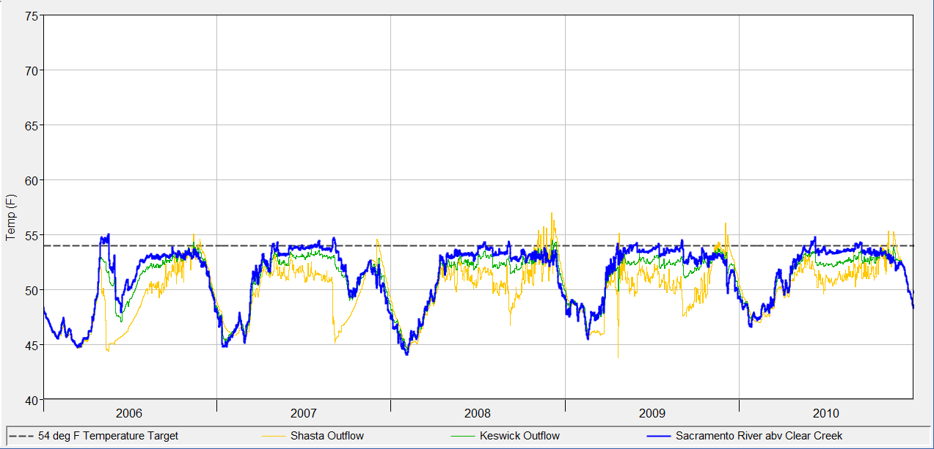
Figure 3-9. Simulated water temperature at Shasta outflow, Keswick outflow, and Sacramento River above Clear Creek based on CalSim3 input used in the proof-of-concept ResSim long-term planning model, 2006-2010.

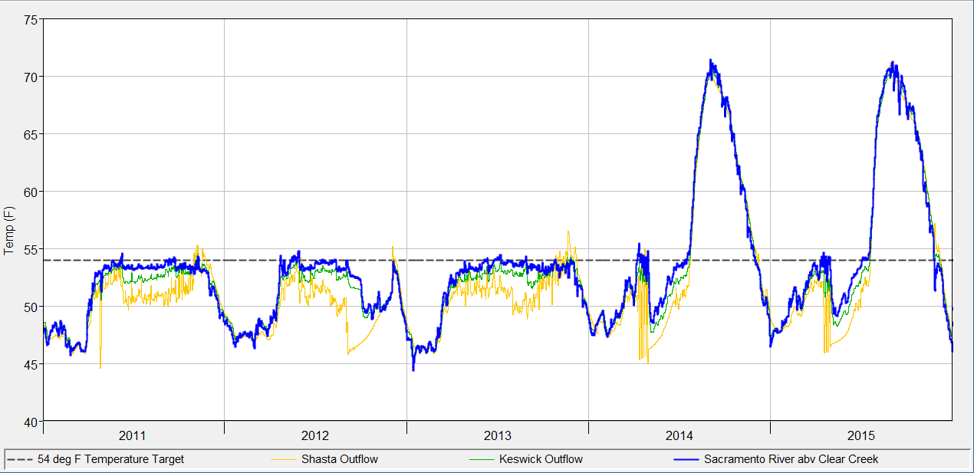
Figure 3-10. Simulated water temperature at Shasta outflow, Keswick outflow, and Sacramento River above Clear Creek based on CalSim3 input used in the proof-of-concept ResSim long-term planning model, 2010-2015.
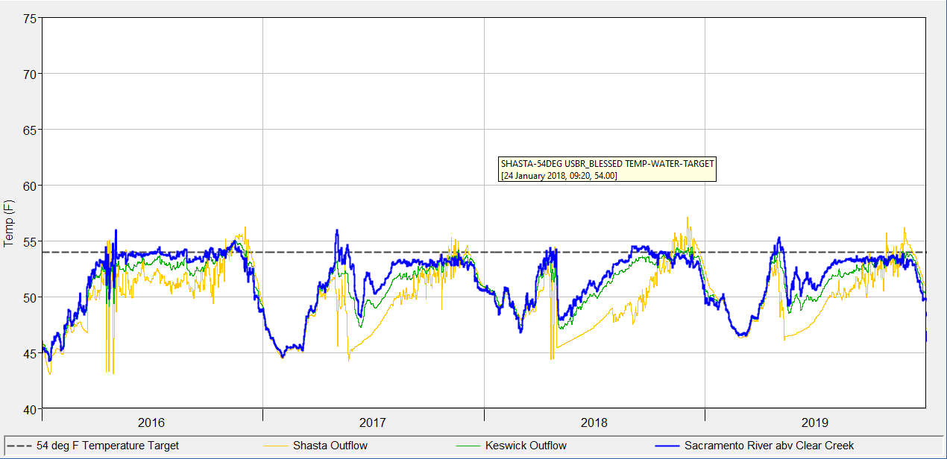
Figure 3-11. Simulated water temperature at Shasta outflow, Keswick outflow, and Sacramento River above Clear Creek based on CalSim3 input used in the proof-of-concept ResSim long-term planning model, 2016-2019.

Variation of the thermal profile in Shasta Lake over the simulation period is presented in Figure 3-12 through Figure 3-16. During most years sufficient cool water is maintained at or above the level of the Shasta TCD side gates, which permits the temperature target to be met through operation of the TCD. During 2014 and 2015, very low reservoir levels lead to very warm temperatures well below the side gate elevation and loss of temperature control. In those years during the late summer and fall, the TCD operation is set with only the side gates (lowest possible withdrawal locations) open, and the release temperature is simply a function of the thermal profile in the reservoir at that elevation.
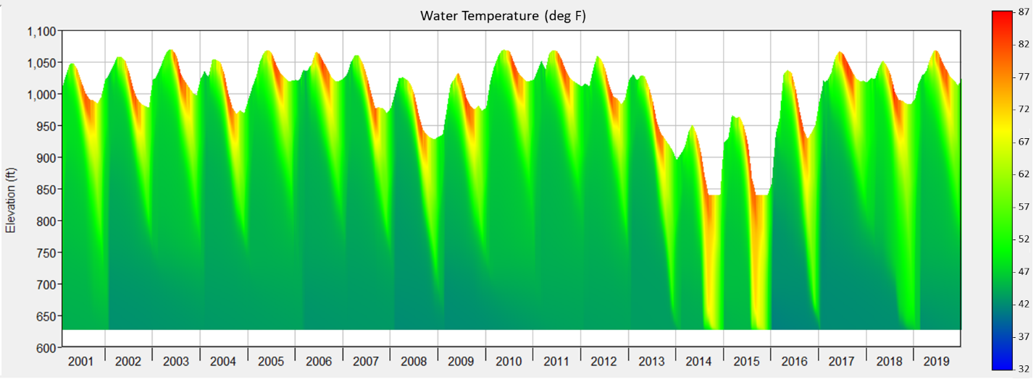
Figure 3-12. Simulated water temperature distribution in Shasta Lake based on CalSim3 input used in the proof-of-concept ResSim long-term planning model, 2001-2019.

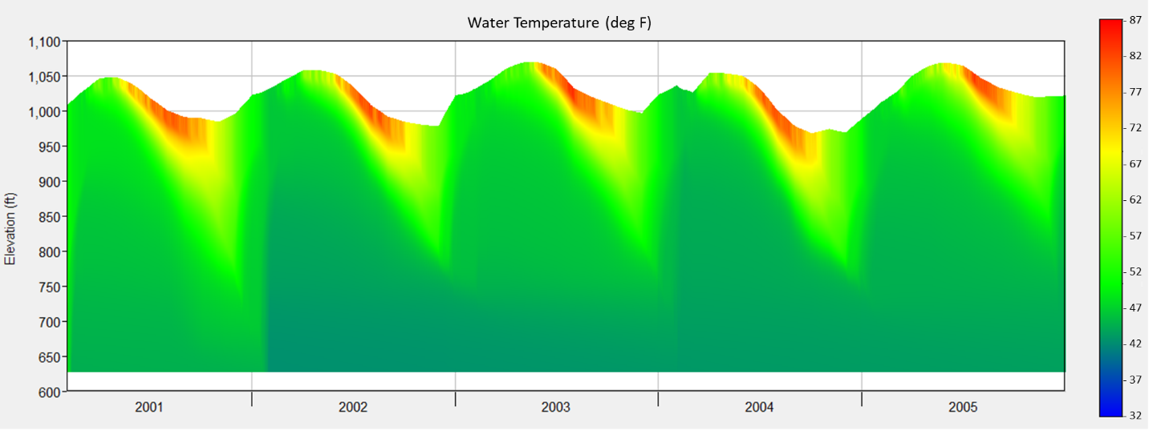
Figure 3-13. Simulated water temperature distribution in Shasta Lake based on CalSim3 input used in the proof-of-concept ResSim long-term planning model, 2001-2005.

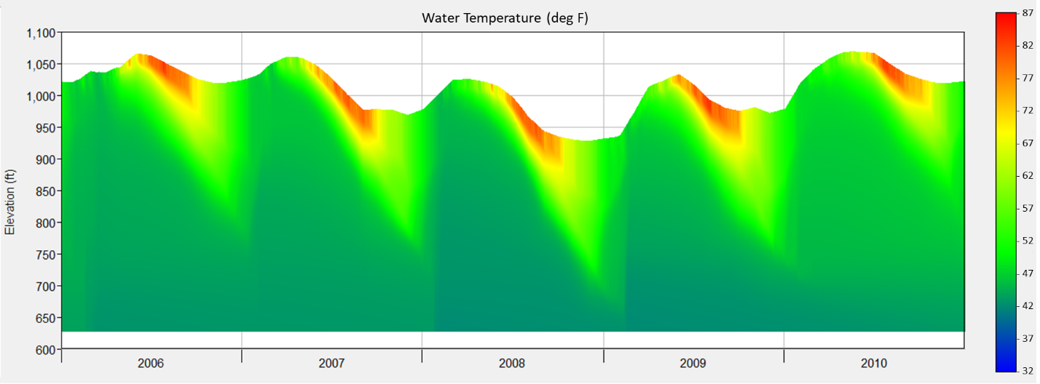
Figure 3-14. Simulated water temperature distribution in Shasta Lake based on CalSim3 input used in the proof-of-concept ResSim long-term planning model, 2006-2010.

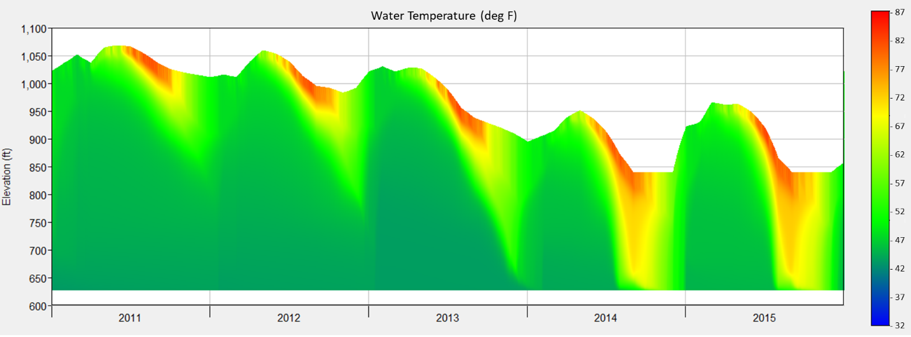
Figure 3-15. Simulated water temperature distribution in Shasta Lake based on CalSim3 input used in the proof-of-concept ResSim long-term planning model, 2011-2015.
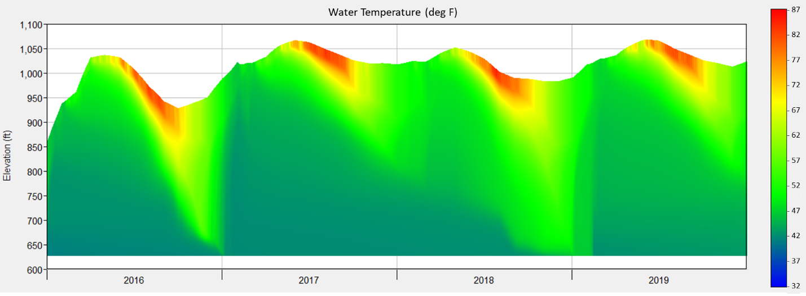
Figure 3-16. Simulated water temperature distribution in Shasta Lake based on CalSim3 input used in the proof-of-concept ResSim long-term planning model, 2016-2019.

Summary
The proof-of-concept long-term planning simulation was successfully accomplished. Although this test was limited to a 20-year period, it is extensible to simulation with the full 100-year CalSim3 simulation period provided corresponding meteorologic data is available. CalSim3 monthly hydrologic inputs and computed flows were mapped to the WTMP Upper Sacramento System ResSim model and simulation results demonstrate that the mapping was successful with respect to volume conservation through comparison of computed reservoir storage levels over the simulation period. The ResSim TCD operation logic was shown to be successful in meeting the downstream temperature target to an acceptable level of accuracy, provided there is sufficient cold water available within Shasta Lake.
The temperature target for this proof-of-concept simulation was set simplistically at a constant 54 deg F at the Sacramento River above Clear Creek gage. The target was input as a daily time series and could easily be made to vary year-to-year or on a weekly or monthly basis, provided the target is known before performing the simulation. In the previous applications of the HEC5Q water temperature model, an iterative technique was used to test and adjust temperature targets during simulation on a year-to-year basis. This approach is possible with the ResSim model but will require additional coding in the WTMP control process. Some legacy applications of the HEC5Q model also included a short time scale iteration to adjust TCD operation to determine release temperature requirements to meet downstream temperature targets as opposed to the regression technique currently implemented for the ResSim model. Further investigation is needed to determine if a short time scale iteration would provide sufficiently better downstream operation in the ResSim model.
Boundary conditions to drive this proof-of-concept simulation were prepared externally to the WTMP model framework interface using a set of Python scripts. The boundary conditions were then mapped to a ResSim Model Alternative in the WTMP interface in a fashion similar to performing calibration or validation type simulations. This approach is a viable method of performing long-term planning simulations, however, it would be more efficient for users if the boundary condition preparation process could be managed through the WTMP user interface in a fashion similar to the seasonal temperature forecasting workflow. This can be implemented as a future enhancement to the WTMP.
As noted above, detailed meteorologic data must be provided that corresponds to the CalSim3 hydrologic inputs. A standard data set can be prepared for CalSim3 runs based on historical hydrology, but it will be necessary to establish appropriate meteorologic data sets for analysis of future conditions, including assumptions of climate change. Further, the CalSim3 model currently does not extend downstream on the Trinity River below Lewiston Dam. To include the Trinity River in WTMP model simulations, local inflows and corresponding meteorologic data are needed.

Conclusion
The WTMP has been developed to support Reclamation’s planning and management activities in the Central Valley. Modeling analyses are an important element in evaluation of how operational decisions and various influencing factors can affect water temperature in CVP reservoirs and downstream rivers, providing invaluable information to decision makers. Model implementation and application is one of the final steps in the WTMP development. A range of model applications existing within the WTMP that support current Reclamation temperature management activities, as well as potential future applications to explore other avenues of temperature analysis, have been presented. Current temperature model applications include seasonal forecasting and hindcasting associated with annual temperature management and long-term planning applications. Future temperature model applications include position analysis, ensemble analysis, and sensitivity and validation assessments.
Developing these applications in the WTMP follows a logical progression of inter-related elements within the HEC-WAT component and includes an overarching Study, which organizes model configurations, boundary conditions, and simulation results. Alternatives within a Study are labels describing the various physical or operational conditions to be represented by one or more Simulations. Simulations consist of Model Alternatives that characterize various configurations of Model Programs representing reservoir and river systems. A Program Order determines the sequence in which each Model Alternative will be executed within a Simulation. Simulations that have the same Analysis Period can be organized within a Simulation Group. The workflow for each application identified similarities as well as unique attributes. The WTMP provides a foundational element for all applications that address data sources and model ready data, calibrated and documented models as the basis for applications, common assessment metrics, and reporting tools that create an environment where technicians and modelers can complete an array of analyses.
Current WTMP applications include calibration, validation, hindcast, iterative simulations (ensemble simulation, position analysis, sensitivity analysis), seasonal temperature forecast, and long-term planning analyses. There are other potential applications that the WTMP can accommodate in the future as the need arises. Of the current Reclamation modeling activities, calibration application is addressed in Reclamation (2023d) and a forecasting application is addressed in (2023f). Herein, the long-term planning application example, based on the concept of using the monthly water balance planning model CalSim3, was presented as another example of the utility of the WTMP in addressing Reclamations modeling needs.
Reclamation identified a need to utilize hydrology and operations output from the monthly CalSim3 water resources planning model as input into the WTMP. As identified in Reclamation (2020a), long-term planning studies will utilize ResSim due to efficient computation simulation time (as opposed to CE-QUAL-W2 that has considerably longer simulation times).
A proof-of-concept simulation was completed to demonstrate the ability of the WTMP modeling framework to configure and conduct simulation utilizing CalsSim3 model output for the upper Sacramento and Trinity River system ResSim model that includes Shasta, Keswick, Trinity, Lewiston, and Whiskeytown reservoirs. The effort was designed to illustrate the long-term operation of the Shasta Dam TCD to meet a downstream temperature target in the Sacramento River in the setting of the entire Shasta-Trinity system. A 20-year period was developed using CalSim3 monthly time-step data and other available data for a proof-of-concept simulation. The simulation was restricted to 20 years because not all elements necessary to simulate an extended CalSim3 period of analysis have been developed (e.g., a complete 100-year meteorological data set for the Shasta and Trinity region). Using this period, all elements of a long-term modeling simulation were completed, including methods of monthly CalSim3 flow disaggregation (to daily), meteorological and inflow temperature forecasts, and automated TCD gate selection to meet a downstream temperature target in the Sacramento River above Clear Creek. Model reporting included continuous (i.e., 20 year) flow and sub-daily temperature time series of Shasta Dam, Keswick Dam, and Sacramento River above Clear Creek and vertical water temperature distributions in Shasta Lake. The model performed as expected over a wide range of hydrology and meteorology conditions, through different ranges of storage, reproducing seasonal stratification, and operating the TCD to meet a downstream temperature objective. The model effectively reproduced flow (conservation of mass was preserved monthly to match CalSim3 outputs) and met the assigned temperature target in the Sacramento River at Clear Creek except for two years when temperature control was lost due to CalSim3 simulation operational assumptions.
The WTMP has been successfully applied to a variety of Reclamation modeling activities as part of the overall testing (e.g., calibration, seasonal forecasting, long-term planning). As Reclamation implements the framework into their temperature management activities, the use of the platform to support these activities, as well as other analyses is expected to provide additional insight and improve temperature management activities into the future.

References
California Department of Water Resources (DWR). 2022. CalSim 3 Report: A Water Resources System Planning Model for State Water Project & Central Valley Project. August.
California Water and Environmental Modeling Forum (CWEMF). 2021. Protocols for Water and Environmental Modeling. November 19.
Tasker, G. D., and P. Dunne. 1997. Bootstrap position analysis for forecasting low flow frequency. Journal of Water Resources Planning Management. 123(6). 359–367.
U.S. Bureau of Reclamation (Reclamation). 2020a. Temperature Model Development, Solicitation 140R2020Q0064. Central Valley Operations Office, Sacramento, CA. July 2.
U.S. Bureau of Reclamation (Reclamation). 2020b. 2020 Seasonal Report for the Shasta Cold Water Pool Management. Central Valley Operations, Sacramento CA and Bay-Delta Office, Sacramento, CA in coordination with California Department of Fish and Wildlife, California Department of Water Resources, U.S. Fish and Wildlife Ser ice, National Marine Fisheries Service. December.
U.S. Bureau of Reclamation (Reclamation). 2023a. Water Temperature Modeling Platform: Data Development. June.
U.S. Bureau of Reclamation (Reclamation). 2023b. Water Temperature Modeling Platform: Data Management Plan. May.
U.S. Bureau of Reclamation (Reclamation). 2023c. Water Temperature Modeling Platform: Framework Selection. May.
U.S. Bureau of Reclamation (Reclamation). 2023d. Water Temperature Modeling Platform: Model Development, Calibration, Validation, and Sensitivity Analysis. July.
U.S. Bureau of Reclamation (Reclamation). 2023e. Water Temperature Modeling Platform: Model Selection and Design. May.
U.S. Bureau of Reclamation (Reclamation). 2023f. Water Temperature Modeling Platform: Model Uncertainty - Protocols. July.
U.S. Bureau of Reclamation (Reclamation). 2023g. Water Temperature Modeling Platform: Model Uncertainty - Sources. July.
U.S. Bureau of Reclamation. 2023h. DRAFT Sacramento River Temperature Management Plan for Water Year 2023. April 26.
This page intentionally left blank.

Appendix A: Forecasting Approaches for Temperature Control Facilities
A critical element of WTMP model implementation was the representation of forecasting short-term and long-term planning approaches incorporated into the CE-QUAL-W2 and ResSim models for Shasta Lake and Folsom Lake. Other reservoirs do not include temperature control facilities currently.

CE-QUAL-W2 – Shasta Lake
The hydrodynamic and water quality model, CE-QUAL-W2 (W2), has been modified to simulate Shasta Dam TCD operations. The TCD is operated to meet target release temperatures for downstream habitat. The model is designed to operate in two different modes: a “Prescribed” mode in which historic TCD gate level operations are specified by the user, and a “Forecasting” mode in which gate levels are automatically selected and outlets opened by the model under forecast hydrologic and meteorologic conditions according to a set of operating rules.
As a forecasting simulation progresses, selective withdrawal routines in W2 determine release flows through TCD gate level by comparing target temperatures to estimated release temperatures blended from different sets of outlets. When the estimated release temperature of blended outlets matches prescribed target temperature, flow through each outlet is set.
When forecasting, the model searches among all four TCD gate levels to identify one or two adjacent gate levels for potential blending. Once gate level(s) are selected, the model determines the set of available outlets at those levels, selects outlets to blend, and apportions total release flow among all available outlets to meet temperature targets and honor minimum and maximum flow requirements. Using these flows and specified non-blending flows, the model calculates flow fractions for each outlet. These flow fractions are used to distribute release flows at each time step until the next flow-fraction update. The interval for flow-fraction updates is a constant set by the user.

Determining Gate Levels for Blending
The Shasta TCD is operated in consideration of its physical limitations with a goal of preserving the cold-water pool. Early in the management season, operators release water from the uppermost and warmest elevations before shifting releases to outlets at lower and colder elevations as surface temperatures rise. This general rule preserves cold water for later in the season. Gate operations must also consider other, more physical, constraints. For instance, gates are only opened or closed periodically by operators and then only when specific physical requirements are met. The model is designed to select gate levels as an operator would.
Mechanical characteristics and operations of the TCD suggest that there should be some consideration prior to allowing the model to change gate settings, and historical data bear this out. Gate settings do not typically “bounce” between a higher and a lower gate, but rather always tend to move steadily to lower elevations during the management season. The model incorporates rules to mimic the smooth transition that is involved in changing gate settings from higher to lower gates. These rules prevent frequent changes in gate setting and force gate selection consistently deeper as shallower reservoir temperatures warm.
To mimic smooth top-down gate settings, the model requires that a certain number of consecutive attempts be made before changing to any selected gate combination. The number of required attempts is set by the user in the input parameter “N_TRIES.” To match target temperatures, the model will select a specific combination of one or two gates for blending, but that selection will not be allowed until it is attempted N_TRIES times. These attempts must be over consecutive, and they must be attempts to change to the same setting. As an example, consider a case in which only the upper gate is open, but the model determines that the middle gate must also be opened to meet temperature targets. If blending is updated daily and N_TRIES = 3, the model will stay on the upper-level-only setting for at least three days and will only change to an upper-middle-level setting after attempts to set the model to the upper-middle setting have been made on three consecutive days.
Another constraint on the selection of gate levels is submergence criteria. In actual operation of the TCD, no gate may be opened unless it is either almost fully submerged or is being blended with a lower gate. This physical rule is implemented in W2 with a requirement for minimum submergence (elevation above the gate invert elevation). If the model finds that a single gate level can provide release water at the target temperature, it requires that gates at that level be submerged to a depth of “MINSUB” above their lowest point (or, “invert”). If gates are not submerged to this user-specified depth, the model selects both that level and the level below for blending. Practically, this requirement only affects the upper and middle gate levels. At both levels, gates are 45 ft (13.72 m) high and must be submerged to a depth of 35 ft (10.67 m) above their invert to be used without blending. In TCD simulations, MINSUB should be set equal to 35 feet (10.67 meters), ensuring that all gates are submerged to the required depth if opened alone.
A final set of user-specified restrictions ensure that the model does not re-open higher gates that have been closed as lower gates are opened during the management season. In practice, TCD gates are opened progressively lower in the reservoir as the management season progresses. Once the TCD begins to draw water from lower levels and gates higher in the reservoir are closed, these higher gates are typically not re-opened during the management season. To mimic this behavior, W2_TCD implements a user-specified period of “high-gate” restriction, defined by input parameters “BEGIN_HI” and “END_HI.” During this period, two rules are applied:
1) If a single gate level is selected for blending, then all gates above are set “off-limits” and cannot be selected again until the “high-gate” restriction period has ended.
2) If two gate levels are selected for blending, then the higher of the two levels may not be used alone and may only be used in conjunction with the level below it until the “high-gate” restriction period has ended. The process for determining gate levels to blend is shown in Figure A-1.
Figure A-1. Determining gate level(s) to blend.

TCD Blending Calculations
During each blending period, outlet structures are associated with specific TCD gate levels by gate-level numbers ranging from one to four (highest elevation to lowest elevation). When a blending period is entered, the model determines which outlets are available (that is, which outlets are submerged and meet minimum and maximum head criteria) and assigns outlets to their respective gates as specified in the “w2_selective.npt” input file.
To estimate blended release temperatures and establish gate levels for blending, the model uses average flows through each outlet. In forecasting, the model chooses gate level(s) from which to release blended flow by checking temperatures at each outlet and selecting gate levels associated with the outlets that bracket the target temperature. When an outlet is selected, that outlet is assigned the bulk of release flow and all other outlets at the associated gate level are assumed to release minimum flows. But large flow fluctuations, as occur with hydropower peaking flow operations, can affect temperature estimates and gate selection. To reduce the impact of these fluctuations on gate level selection, the model averages flow over the interval since the last blending update and uses this average flow to estimate release temperatures and select gate levels for blending.
The TCD logic allows the user to control the progression and selection of lower gates by providing a bias towards upper gates. During TCD operations, only a single gate level or two adjacent gate levels are ever selected for blending (i.e., there is no option for a three gate level blend, a rare and transient condition in historic operations). In selecting gate levels for blending, the model attempts to release the warmest water possible to meet target temperatures. Starting at the top of the upper gate level, estimated release temperatures at each outlet are checked successively against the target temperature to identify which outlets to blend. The user can bias the model towards selecting higher gate levels by giving a positive value to the parameter LWRGATE in the input file. This value is added to the target temperature when comparing outlet combinations during gate level selection.
Once gate level(s) are selected for blending, the model allocates blended flows to outlets at those gate levels as described in “Appendix C. Selective Withdrawal Using W2_TCD” of Deas and Sogutlugil (2020). Flow fractions assigned to outlets in blending are used until the next blending update. Leakage is included as a non-blended flow in all selective withdrawal operations.

User Specified Inputs
To use the TCD logic, the parameter “SELECTC” must be set to “ TCD” in the W2 control file, “w2_con.npt.” All inputs to the selective withdrawal routines are read from the “w2_selective.npt” file. This input file and its construction are described in detail in “Appendix C. Selective Withdrawal Using W2_TCD” of Deas et al. (2020). As described, the input file contains some parameters taken from selective withdrawal logic developed by United States Geologic Survey (USGS; Rounds and Buccola, 2015) and some new parameters that are specific to the TCD logic. Ten new parameters are used to specify mode of model operation, define a second minimum flow, control gate level selection and restrict periods during which gates may be opened. One new parameter listed in the input file, “HR_SET,” is not currently used. New parameters are listed in Table A-1.
Table A-1. Description of new user-specified inputs (w2_selective.npt) for blending in W2_TCD.
Input parameter | Input section | Parameter name in code | Description
FCST | SPLIT1 | FORECASTING | Determines whether model will search for best gate(s) for blending (ON) or use specified gate(s) (OFF). Maximum of two specified gates.
MINFRCx | MINFRAC2 | tsminfrac2(j,n) | A minimum flow fraction (between 0 and 1) specifying that at least that fraction of the blended release should go through that outlet. When specified as a negative number, this input is interpreted as a minimum flow rate in cubic meters per second. Used when two levels are blended.
MINJDx | MINJD | tsminjday(j,n) | The first Julian day on which the outlet may be open.
MAXJDx | MAXJD | tsmaxjday(j,n) | The last Julian day on which the outlet may be open.
LWRGATE | SPLIT1 | LWR_GATE_CRITERION | A value added to target temperature when selecting gate levels for blending. (FCST)
BEGIN_HI | GATESET | BEGIN_HI_RESTRICTIONS | Begin period (JDAY) during which the model is restricted in its selection of higher gate levels. (FCST)
END_HI | GATESET | END_HI_RESTRICTIONS | End period (JDAY) during which the model is restricted in its selection of higher gate levels. (FCST)
HR_SET | GATESET | HR_SET | Not currently used.
N_TRIES | GATESET | N_CONSECUTIVE_ATTEMPTS | Number of consecutive identical attempts before allowing selection of a gate level combination. (FCST)
INGATE | GATESET | INIT_GATE | Gate level to begin forecast blending. (FCST)
MINSUB | GATESET | MIN_SUBMERGENCE | Minimum submergence for gate levels to be opened alone. (FCST)
Notes: For code parameters, parentheses signify an array in which j is blending group and n is outlet number. Parameters with (FCST) notation in description are used only in forecasting
Four new parameters are used whenever the TCD logic is used, in both “Forecasting” and “Prescribed” modes. The parameter “FCST” determines whether the model will operate in “Forecasting” mode (“ ON”) or operate in “Prescribed” mode (“ OFF”). Either entry must be right-justified in a field of eight characters. Parameters listed in the MINFRAC2 section of the input file are used to specify minimum flow fraction released in any blending period “j” through any outlet “n” when outlets from two levels are blended. A negative number for minimum flow fraction indicates that the value is a minimum flow with units of cubic meters per second. Parameters MINJDx and MAXJDx are used to set the first and last Julian days on which any specific outlet, “n,” may be open during any given blending period, “j.”
Six new parameters, including all parameters in the “GATESET” section of the input file, are used in “Forecasting” mode only. They impose constraints on selecting gate levels for blending. The parameter “LWRGATE” is used to increase target temperatures in selecting gate levels, in effect allowing the model to stay on higher gate levels longer when selecting gate levels. The parameters “BEGIN_HI” and “END_HI” define the period, in Julian days, during which the model is restricted in its selection of higher gate levels for blending. The parameter “HR_SET” is not currently used but a real value should be specified as a placeholder. The value of “N_TRIES” determines the number of consecutive identical attempts the model must make before allowing the selection of a gate level combination. The value of “INGATE” sets the initial gate level (values not in the range 1 to 4 default to “1") for blending. The parameter “MIN_SUB” defines the submergence, in meters, that gates at any level must have above invert before water may be released from that level alone.

Application of W2_TCD Forecasting
The W2_TCD model forecasting logic is validated by comparing simulated TCD operations to historic operations using historic outflow temperatures as the tailbay target under historic hydrologic and meteorologic conditions. In testing, target temperatures were derived from projected release temperatures used in each year. The model simulated the entire year and all outlets and TCD gate levels used in calibration were available (Deas et al. 2020). In this simulation, there are outlets for Shasta Dam spillway, the openings associated with the four TCD gate levels, and outlets representing unblended flows/leakage. Relevant parts of the “w2_selective.npt” input file used in this forecasting simulation are presented in Figure A-2. For more information on settings in this file see Deas et al. (2020).
Outlet #1 is at the top of the dam, the spillway. This outlet is listed as an unblended flow and represents spillway releases. The following twelve outlets represent the four TCD levels with three outlets each. Each of these outlets is assigned a priority that represents the gate level that it is associated with. The upper gates (priority = 1) are represented by outlets #2-4, the middle gates (priority = 2) by outlets #5-7, the lower gates (priority = 3) by outlets #8-10, and the side gates (priority = 4) by outlets #11-13. Nine more outlets represent leakage in the TCD and are designated “unblended” by a priority value of “-1”. Outlet #16 represents “TCDdown,” a low intake for the side gate that is never blended with another outlet. TCDdown is identified with a priority of “5,” and in the code it is assigned to the side gate level. For discussion of the TCDdown outlet, see Deas et al. (2020). Elevations for all outlet structures are specified in the input control file (“w2_con.npt”).
The input file specifies that the model will operate in “Forecasting” mode, with FCST = OFF. In the file, minimum flow fractions are set for each outlet used in blending. Values for minimum flow fractions are parameterized from historic simulation as described in Deas et al. (2020). When blending occurs at one level, each of the two upper outlets associated with that level releases at least, in this example, 2% (MINFRAC = 0.02) and the lower outlet is required to release at least 10% (MINFRAC2 = 0.10) of the blended flow. When blending occurs at two levels, each of the two upper outlets associated with those gate levels releases at least the assigned minimum flow fraction (e.g., MINFRAC2 = 0.02) and the lower outlet of those gate levels is required to release the assigned minimum flow fraction (e.g., MINFRAC2 = 0.05) of the blended flow. Whenever the side gates are opened, TCDdown (outlet #16) will always draw its minimum blended flow fraction of 35%.
The input file specifies one blending period defined by Julian day (JD) that spans the entire simulation period of one year, beginning at 9 am (JD = 1.375 – 366.0). Blending ratios are updated daily (TSFREQ = 1.0 days) and the convergence criterion for matching target temperatures is specified by TSCONV equal to 0.02ºF (0.01°C). During selection of gate levels to blend, target temperatures are increased by 1.0ºF (0.5°C), in effect biasing selection towards higher gate levels (LWRGATE = 0.5, this entry is in degrees Celsius). The dynamic temperature target option is turned on for each blending period (TSDYN = “ON”), so that temperature targets are read dynamically from an input time series. All outlets, including leakage, are present throughout the simulation period, and any blending outlet may be selected at any time during the year if specified restrictions are observed.
The model is restricted in its selection of higher gate levels from JD 135-300 (BEGIN_HI = 135; END_HI = 300). The parameter “HR_SET” is not currently used and has no effect. The model must make three consecutive identical attempts before allowing the selection of any gate level combination (N_TRIES = 3) and begins its search for gate levels to blend at the lower gates (INGATE = 3). If they are to be opened alone (i.e., not blending with a lower gate level) gates must be submerged to a depth of MIN_SUB (i.e., 35 feet; (10.67m), this entry is in meters).

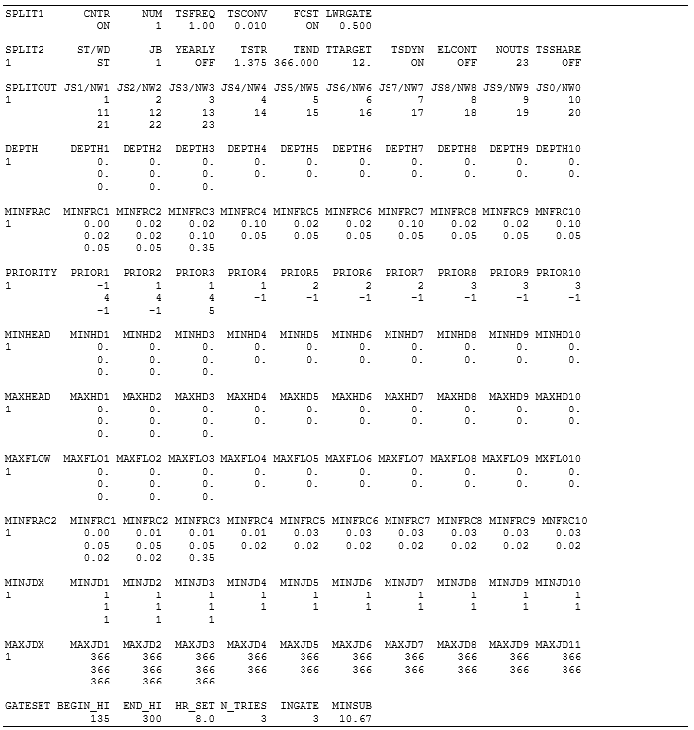
Figure A-2. Example showing relevant sections of “w2_selective.npt” file for W2_TCD forecasting.

Model Validation and Testing
The W2_TCD forecasting model was validated with simulated historic gate operations and Shasta release temperatures for selected years between 2013 and 2019. Specifically, the TCD logic was allowed to “select” the TCD gate levels using a simulated historic daily Shasta Dam tailbay target temperature. This simulated historic daily tailbay target temperature was determined using W2 in the “prescribed” mode, i.e., using historic gate settings. Using simulated historic daily tailbay target temperatures allows assessment of model-to-model performance between “prescribed” and a “forecast” simulation. The historic simulations used in this exercise are documented in Deas et al. (2020). In this validation exercise, the model forecast gate operations over each year to meet daily temperature targets prescribed at 9 AM each day. Forecast TCD gate settings are compared to historic gate settings in through . In each figure, a chart of gate operations is shown with release temperatures for the year. Gate operation charts show forecast and historic gate level openings, Shasta Lake water surface elevation (WSE), and Shasta Dam daily average release flows. (Note that simulated historic gate operations are, by definition, identical to actual historic gate operations.) Both forecast and simulated historic release temperatures and the temperature targets used in forecasting is also shown in the figures. Overall, the
The model’s gate level operations resemble historic choices made by operators, and release temperatures match observed temperatures reasonably well. Generally, during the simulated management period from May 15 to October 31, top level gates were closed and abandoned earlier in forecasting simulations than they were in historic operations, but middle, lower, and side gate operations match historic operations well.
Forecast release temperatures follow target temperatures very well throughout the year. A few spikes in forecast simulations appear to result from the requirement that any gate combination must be maintained for at least three days (NTRIES = 3). This requirement can keep the model on higher gates longer than necessary. Also shown in the release temperature charts are simulated historic release temperatures from which the targets were derived. These simulated historic temperatures were simulated using hourly target temperatures equal to those of observed Shasta releases. Comparing simulated historic to forecast release temperatures shows how well the model reproduces daily temperature ranges and it also illustrates the impact of choosing daily targets. The model reproduces daily temperature ranges well and choosing temperature targets at 9 am gives reasonably good results.

(a)
(b)
Figure A-3. (a) Simulated (Forecast A) vs. historic TCD gate settings Shasta Dam release and Shasta Lake water surface elevation and (b) Simulated vs historic Shasta Dam tailbay temperatures in 2013.

(a)
(b)
Figure A-4. (a) Simulated (Forecast A) vs. historic TCD gate settings Shasta Dam release and Shasta Lake water surface elevation and (b) Simulated vs historic Shasta Dam tailbay temperatures in 2015.

(a)
(b)
Figure A-5. (a) Simulated (Forecast A) vs. historic TCD gate settings Shasta Dam release and Shasta Lake water surface elevation and (b) Simulated vs historic Shasta Dam tailbay temperatures in 2016.

(a)
(b)
Figure A-6. (a) Simulated (Forecast A) vs. historic TCD gate settings Shasta Dam release and Shasta Lake water surface elevation and (b) Simulated vs historic Shasta Dam tailbay temperatures in 2017.

(a)
(b)
Figure A-7. (a) Simulated (Forecast A) vs. historic TCD gate settings Shasta Dam release and Shasta Lake water surface elevation and (b) Simulated vs historic Shasta Dam tailbay temperatures in 2018.

(a)

(b)
Figure A-8. (a) Simulated (Forecast A) vs. historic TCD gate settings Shasta Dam release and Shasta Lake water surface elevation and (b) Simulated vs historic Shasta Dam tailbay temperatures in 2019.

References
Deas, M., I.E. Sogutlugil, A. Bale, and S. Tanaka. 2020. Shasta Lake and Keswick Reservoir Flow and Temperature Modeling - Development Report. Watercourse Engineering, Inc. Davis, CA. December 2020.
Rounds, S.A., and N.L. Buccola. 2015. Improved algorithms in the CE–QUAL–W2 water-quality model for blending dam releases to meet downstream water-temperature targets: U.S. Geological Survey Open-File Report 2015-1027, 36 p., https://dx.doi.org/10.3133/ofr20151027. ISSN 2331-1258 (online)

ResSim – Shasta Lake
Similar to CE-QUAL-W-2 for the Shasta Dam TCD, ResSim simulations can be run in either “prescribed” mode where gate operations are specified, or “forecasting” mode where TCD gate selection are predicted by the model. In ResSim, these different modes take the form of different TCD scripted operation rules. To run ResSim in prescribed-mode, a prescribed-mode ResSim alternative is selected; this alternative uses a prescribed-mode reservoir operation set for Lake Shasta, which includes the scripted rule detailing prescribed-mode operations logic. To run ResSim in forecast-mode, a forecast alternative is selected, which points toward a forecast reservoir operations set; this set includes the forecast-mode operation rule for the TCD.
Forecast simulations use initial reservoir temperature profiles, gate settings, and forecasted hydrology and meteorological conditions to model future gate operations and system temperatures. Once the forecast script selects appropriate TCD gate operations for a given time step, the TCD operation logic is the same as in a prescribed-mode simulation; this logic is described above and detailed in Deas et al. (2022). In summary, an optimization problem is solved to determine flows through all open outlets of the TCD. The optimization minimizes the difference between the temperature target value and the blended outflow temperature and respects any minimum flow fractions through individual outlet points. Supporting routines account for uncontrolled leakage (non-blended) through the TCD and any flow through the power bypass river outlets when performing the optimization.

Determining Gate Levels for Blending
The selection of the appropriate TCD gate openings in ResSim forecast mode is consistent with the W2 model described above, and was designed to replicate how operation managers control the openings. A seasonal operation period is defined during which the gates are operated in a uni-directional manner, only moving to release water from progressively deeper gate levels as the season progresses. The observed gate level is provided at the start of the simulation and serves as an initialization point. If the temperature target value cannot be met with outlet flows optimized for the current TCD openings, the TCD will be updated to use the next deepest gate level setting. To model the smooth, one-way progression of the gates to deeper levels, logic similar to the W-2 model was incorporated into the ResSim forecast script. All user-defined variables controlling aspects of the forecast script are defined in a header at the top of the script. This includes the seasonal start and end dates for the operational period, the number of allowable days in violation of the temperature target before switching levels, and the tolerance used in declaring the temperature to be in violation of the target. Like the W-2 forecast simulation, forecast operations are only checked and updated once per day, at a user-defined time.
Forecast operation of the Shasta TCD is based on a flow weighted average daily temperature target. That target can vary daily, but for typical forecasting simulations, the target will only vary on a weekly or monthly basis. The ResSim model does support simulation of hourly varying hydropower releases, but for forecast simulations hydropower operation is typically not simulated.
The physical Shasta TCD gate structures have large vertical openings and the withdrawal envelope associated with each TCD gate level is a complex function of individual shutter openings, reservoir storage level, and local stratification near the TCD. Ongoing hydrodynamic studies of flow in the region of the TCD (Berry et al. 2021) may allow a better process-based description of the withdrawal envelop associated with TCD gate levels, but at this time an approximate approach has been adopted in ResSim based on a method developed originally for CE-QUAL-W2. The set of individual TCD gates at each level (Upper, Middle, Lower, and Side Gates) are represented as 3-point withdrawal locations at the bottom, mid-point, and upper elevation of the gate shutters. It is assumed that in actual operation the number of individual gates on a level can be managed to blend water between gate levels to meet target temperatures, so that releases can selectively withdraw water from within the range of the gate opening. In the ResSim TCD operation script, the following logic is implemented.
- For a given, fully-submerged, open gate level, there are 3 withdrawal points, Q₁ (lowest withdrawal point), Q₂ (middle point), and Q₃ (highest point)
- When all points are submerged, a linear constraint is applied to the distribution of flow across the three withdrawal points: Q₂ = 0.5 * (Q₁ + Q₃).
- This leads to smooth gate transitions when switching levels as the optimized flows tend to evolve as shown in Figure A-9.
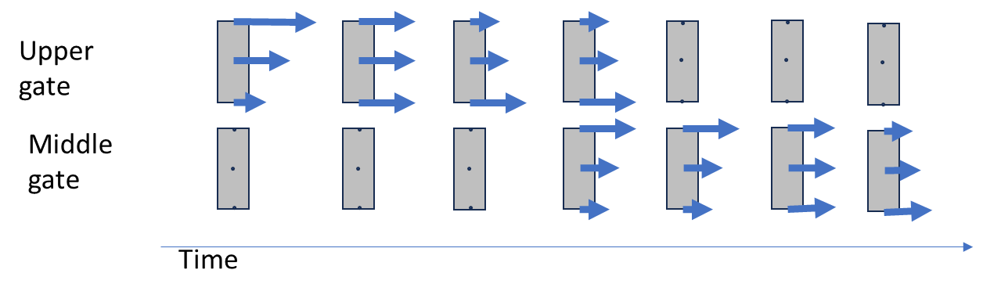
Figure A-9. Example transition of withdrawal distribution, ResSim Shasta TCD operation logic.

- If only two points on a gate level are submerged (the top point is above the water surface), a constraint of Q₁ = Q₂ is applied.
- If only the lower point is submerged, flow may be limited by the weir equation.
- A 1% flow fraction was kept at all points to prevent total zero flow out of a point.
Additional logic is required to control the timing of the transition between gate levels. During the period of May through November when the TCD is actively managed to meet temperature targets, TCD gate openings are restricted to move from shallower to deeper levels. The period when this is enforced is controlled within the operation script. During this period, if it is not possible to meet the temperature target within a user defined tolerance by balancing flow across the gate withdrawal points for three days in a row, then the gate on the next level down is opened. The allowed level combinations are upper only, upper and middle blending, middle only, middle and lower blending, lower only, lower and side gate blending, and side gates only.
Outside of operating period (December through April) the script logic chooses the gate level that best meets the required target temperature, and the only constraints on gate openings are reservoir elevation constraints and not switching gate operations too often (which is controllable by a script setting).
To help prevent the model from prematurely moving to lower gate levels, expected release temperatures at the lower level are checked to ensure they would not produce outflow temperatures that are more than 1.0ºF (0.5ºC) below the target.
Operation for temperature targets located downstream of the Shasta outflow utilizes essentially the same logic as forecast operations at the Shasta Dam outflow; however, the target temperature applied at the Shasta Dam outflow is derived from the required downstream target temperature with an offset to account for temperature changes as waters travel downstream. A simplified model was developed to rapidly estimate the release temperature from Shasta Dam required to meet the downstream target location based on reservoir outflows, the current temperature in Keswick Reservoir, and forecasted meteorologic data.
The simplified model calculates the change in temperatures from Shasta Dam to a downstream location on the Sacramento River with two main steps:
- Assess the temperature impact of Keswick Reservoir, on outflows from Shasta Dam
  - During the summer and fall operation period, Keswick Reservoir residence times are typically around 1 day, and the reservoir is not strongly stratified. If we assume it acts like a continuously stirred tank reactor (CSTR) and neglect Spring Creek powerhouse inflows (from Whiskeytown Lake), the outflow temperature from Keswick Dam, $T_{KesOut}$, can be predicted as:
$$T_{KesOut}=\frac{Q_{Sha}∆t * T_{Sha}+\left({Vol}_{Kes} -Q_{Sha}∆t\right)*T_{KesAvg}}{{Vol}_{Kes}}$$
  - where $Q_{Sha}$ is the outflow from Shasta Dam, $T_{Sha}$ is the Shasta Dam outflow temperature, ${Vol}_{Kes}$ is the total volume in Keswick Reservoir, Δt is the model time step (1-hour), and $T_{KesAvg}$ is the average temperature in Keswick Reservoir.
  - This approach is a reasonable first approximation, but in summer the colder, denser inflows to Keswick Reservoir from Shasta Dam can seek deeper locations in Keswick Reservoir and can influence Keswick Dam outflow temperatures, particularly under low flow conditions. This deviates from the CSTR assumption.
  - To correct for this, a constant multiplier was added to the Shasta Dam outflow term of the $T_{KesOut}$ equation and that constant was calibrated to best fit the observed Keswick Dam outflow temperature (best fit for the multiplier equals 3.3, see Figure A-10).

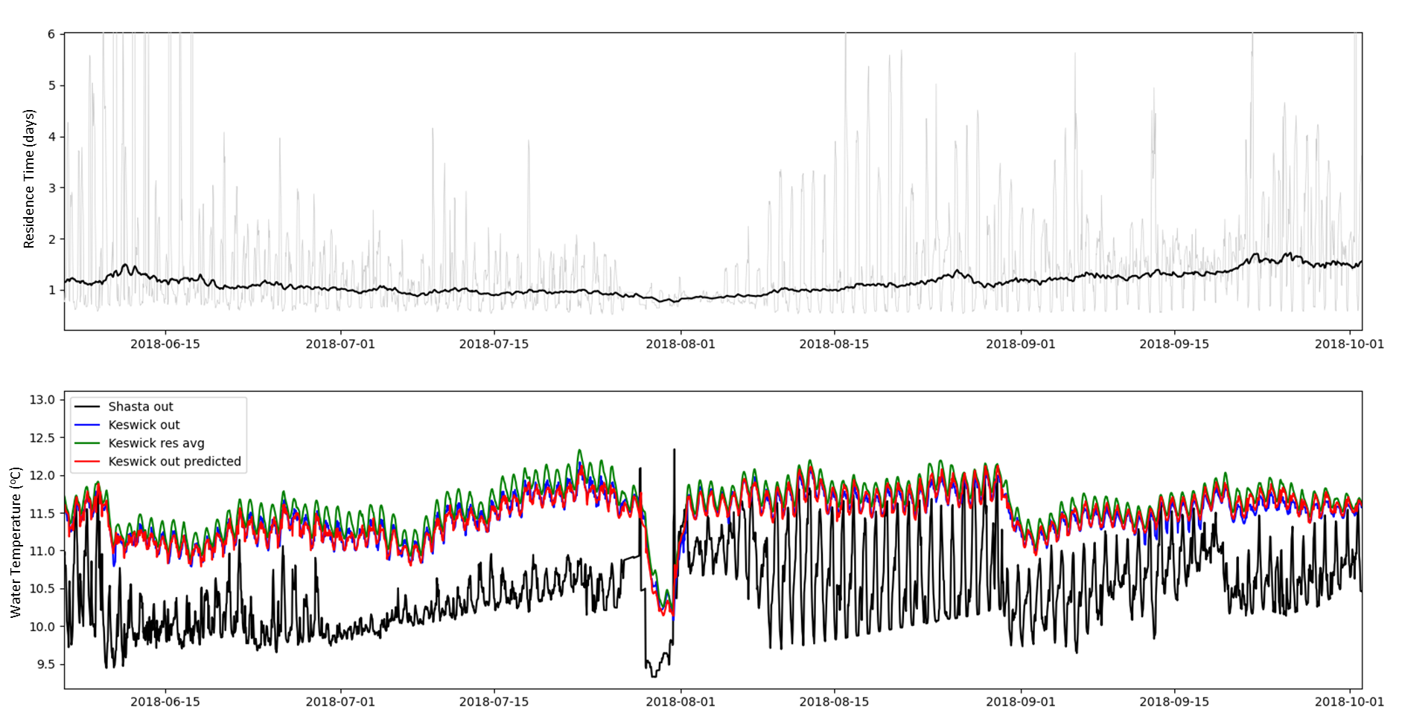
Figure A-10. Keswick Reservoir residence time (upper panel), and estimation of Keswick Dam outflow temperature (lower panel): 2018.
- The impact of temperature changes from Keswick Dam to the downstream temperature target location can be made using an estimation of travel time and the equilibrium temperature approach.
  - Average velocity in the Sacramento River between Keswick Dam and the downstream temperature target location can be approximated as a function of flow (in cfs) using a power law.
Velocity = K (Q_{KesOut} / 1000)^{α}
    - The RAS steady flow file (an input to the ResSim model) includes RAS-model-predicted average channel velocities at dozens of cross-sections along the upper Sacramento River, for multiple representative flow values.
    - RAS data for a few representative cross-sections was extracted and used to estimate the power law fitting coefficients, K (2.3) and α (0.3625), as shown in Figure A-11.
  - Based on this velocity, travel time in the Sacramento River between Keswick Dam and the downstream temperature target location can be estimated as:
Travel time = Downstream distance / Velocity
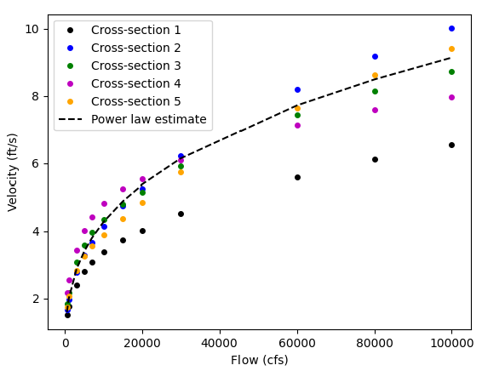
Figure A-11. Power law fit of average Sacramento River velocity as a function of flow between Keswick dam and the Sacramento River above Clear Creek.
- With travel time estimated, the equilibrium temperature approach was used to update the temperature of Keswick Dam outflow as it is conveyed downstream.
- For each hourly time step that it takes for water to travel from Keswick Dam to the downstream location, a change in temperature (ΔT) is calculated as:
ΔT = (T_{equil}^{n} – T) * K_{ex}
- where T_{equil}^{n} is the equilibrium temperature at time step n, T is the routed water temperature, and K_{ex} is an exchange coefficient
- The equilibrium temperature is pre-computed for the duration of the simulation based on the input meteorological data sets, using the methods described in TVA (1972)
- The exchange coefficient (K_{ex} = 0.016) was calibrated based on fitting to the ResSim model predicted data at the downstream location (Figure A-12)
Predictions from the simple model have an average absolute error of 0.27ºF (0.15ºC) over the 20-year calibration period.
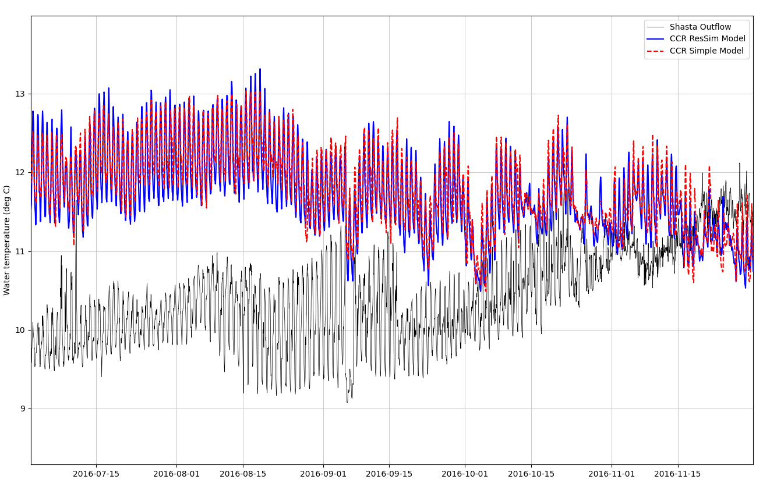
Figure A-12. Shasta Dam outflow temperatures (black), and predicted temperatures at CCR site for the ResSim model (blue) and the simple model described above (red) for a representative summer-fall period in 2016.

Model Validation and Testing
The ResSim TCD forecasting model was validated with simulated historic gate operations and Shasta Dam release temperatures. Comparison of modeled gate operations versus historic and Shasta outflow temperature showing the progression from upper to middle to lower to side gates are presented example years 2012, 2014, and 2018 in Figure A-13 through Figure A-15.
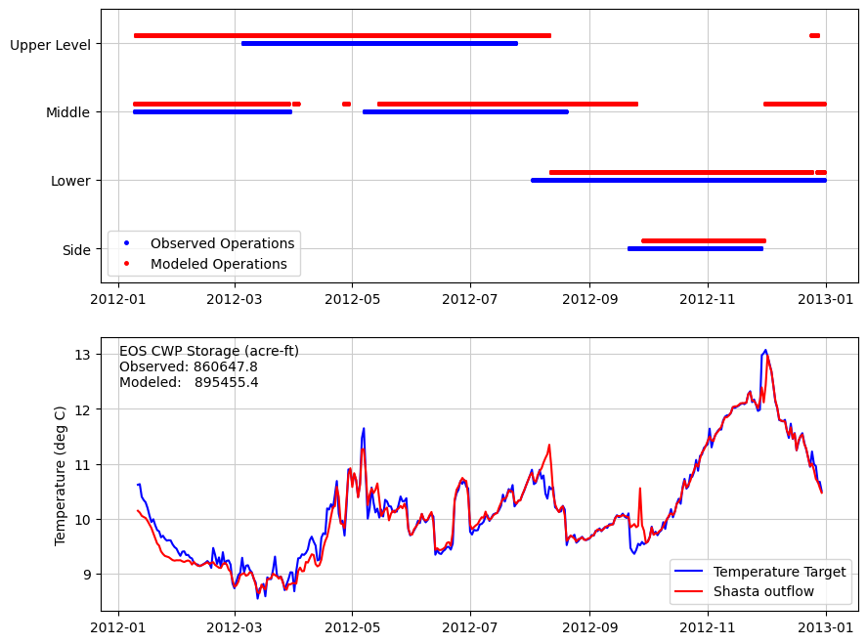
Figure A-13. Observed (Temperature Target) and simulated Shasta TCD gate usage and Shasta Dam outflow (Shasta outflow) temperature, 2012.

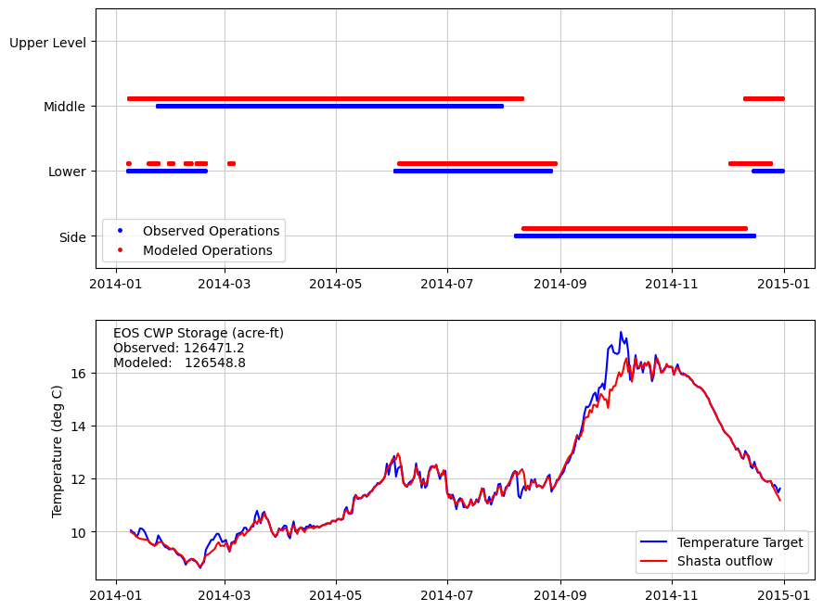
Figure A-14. Observed (target) and simulated Shasta TCD gate usage and outflow temperature, 2014.

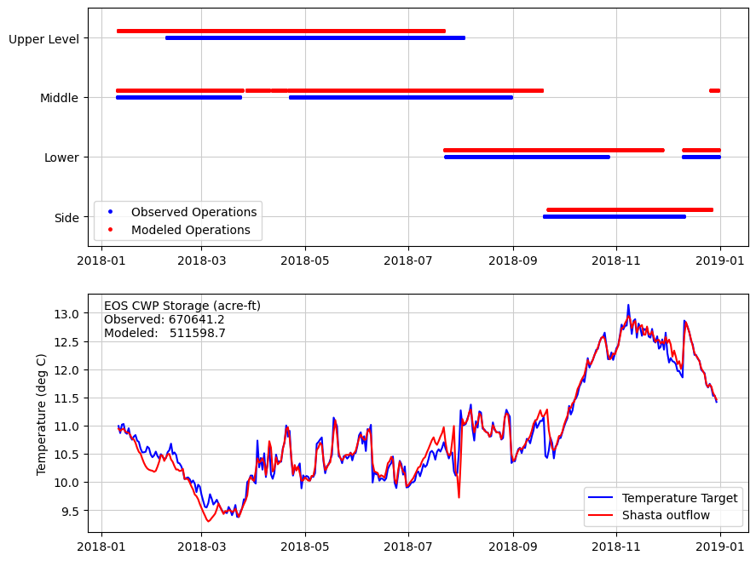
Figure A-15. Observed (target) and simulated Shasta TCD gate usage and outflow temperature, 2018.
Comparisons of ResSim computed water temperature versus the water temperature predicted by the simplified (regression) model used to estimate heat exchange between the Shasta Dam outflow and the target location (Sacramento River above Clear Creek gage in this example) are show in Figure A-16 through Figure A-18. for 2000-2019, 2017-2019, and seasonally, respectively. The Shasta Dam ResSim simulated outflow temperature is also shown in these plots for reference. These figures indicate that the simple model provided a useful and effective approximation to compute the Shasta Dam release temperature target to meet the downstream compliance point – in this case the Sacramento River above the Clear Creek gage.

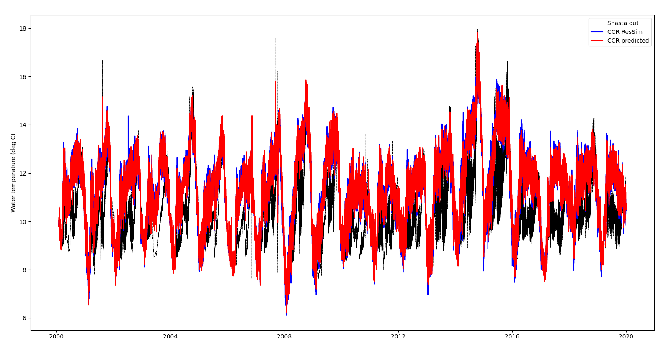
Figure A-16. ResSim simulated water temperature for Shasta Dam outflow (Shasta out) and the Sacramento River above Clear Creek gage (CCR ResSim). Included is the simplified (regression) model calculated water temperature for the Sacramento River above Clear Creek gage (CCR predicted), 2017 through 2019.
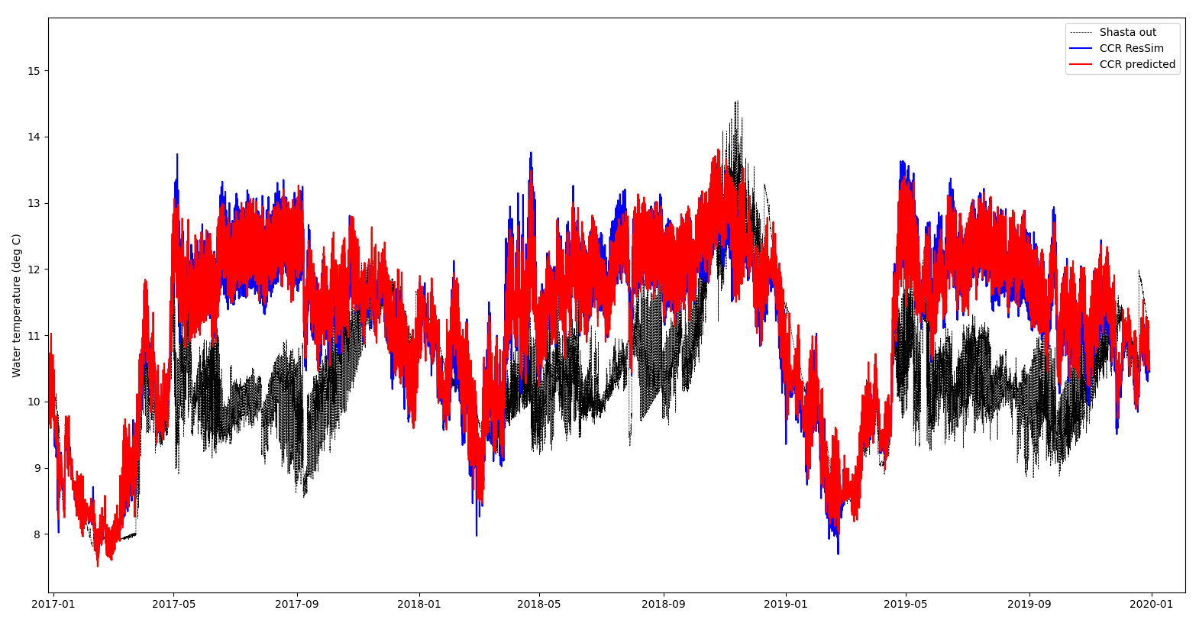
Figure A-17. ResSim simulated water temperature for Shasta Dam outflow (Shasta out) and the Sacramento River above Clear Creek gage (CCR ResSim). Included is the simplified (regression) model calculated water temperature for the Sacramento River above Clear Creek gage (CCR predicted), 2017 through 2019.

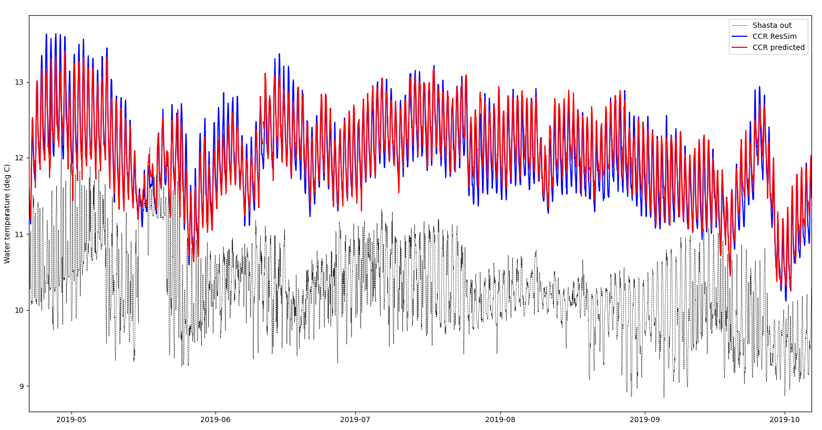
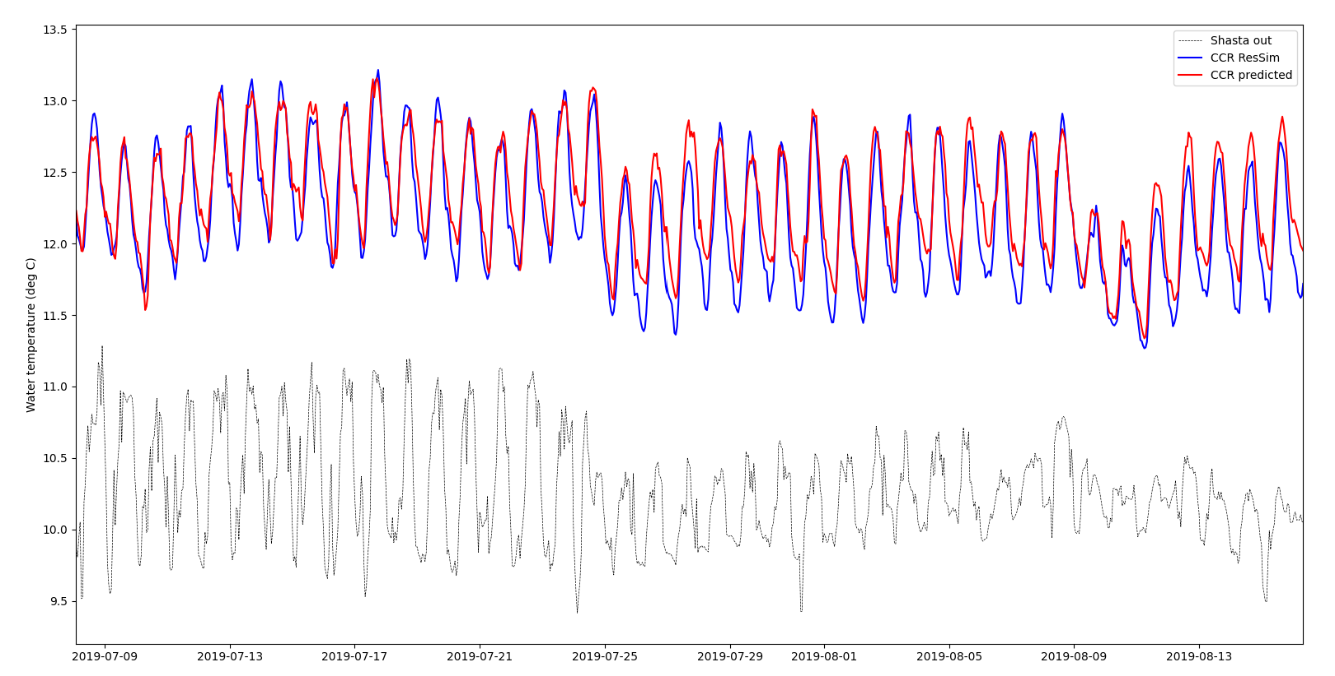
Figure A-18. ResSim simulated water temperature for Shasta Dam outflow (Shasta out) and the Sacramento River above Clear Creek gage (CCR ResSim). Included is the simplified (regression) model calculated water temperature for the Sacramento River above Clear Creek gage (CCR predicted), , (top) May through October 2019, (bottom) July and August, 2019.
An example result of model simulated temperatures meeting the seasonal 54ºF (12.2ºC) target in the Sacramento River above the Clear Creek gage is illustrated Figure A-19. This example is taken from the Proof-of-Concept planning simulation described in Chapter 3 of this document. The simulated water temperature at Sacramento River above Clear Creek gage is shown to track the required downstream temperature target closely during the temperature management season.

Figure A-19. Simulated water temperature at Shasta Dam outflow, Keswick Dam outflow, and Sacramento River above Clear Creek based on CalSim3 input used in the proof-of-concept ResSim long-term planning model, 2006-2010.

References
Berry, B., J. McInerney, A. Stang, A. Sharp, A. Forrest, G. Schladow. 2021. Lake Shasta Bathymetric Sonar and ADCP Survey. Department of Civil & Environmental Engineering & Tahoe Environmental Research Center, University of California, Davis. June 22.
Tennessee Valley Authority (TVA). 1972. Heat and Mass Transfer Between a Water Surface and the Atmosphere. Water Resources Research Laboratory Report No. 14. Norris, Tennessee. April 1972.

CE-QUAL-W2: Folsom Dam Selective Withdrawal Logic
The Folsom Lake W2 hydrodynamic and water quality model has been customized to operate the Folsom Dam municipal intake temperature control device (Municipal TCD), powerhouse temperature control shutters (Powerhouse Shutters), and low-level outlet for power bypass (Bypass) in the same way as Reclamation operators control Folsom Dam operations to meet downstream temperature targets. The new model (Folsom_W2_TCD) can be operated in a short-term planning forecast or long-term planning mode. The model is generally the same as the Folsom W2 TCD model developed previously (PCWA 2015) but has been updated to use the most recent version of W2, version 4.5. The W2 models for the American River are an evolution of the 1D iterative cold water pool management model (ICPMM) that has been used historically on Folsom Reservoir and American River.
The Folsom_W2_TCD forecasting model differs from standard W2 modeling of historical conditions (calibration, hindcasting), because in forecasting mode the model automates the dam operations over the simulation period (using similar logic to that used by real-time human operators) rather than the model being run using known historical operations (Municipal TCD elevations, Powerhouse Shutter elevations, downstream temperature target.)
To model a forecast simulation, the forecasted hydrology and meteorological data are provided and the Folsom_W2_TCD model automates the Municipal TCD and Powerhouse Shutter operations (elevations and flow through each powerhouse) to achieve either a specified downstream temperature target or iteratively select the best achievable downstream temperature schedule. The following sections describe how each of these functions (Municipal Intake, Powerhouse Shutters, Temperature Schedule) have been automated.

Automated Municipal Intake Elevation
The dam operators generally position the Municipal Intake to extract water at approximately 65°F (18°C) (within the maximum and minimum operating elevation constraints of the TCD). This same capability was built into the Folsom_W2_TCD model to allow the modeler to specify general TCD constraints: (1) target water temperature (65°F (18ºC)), typically, but can be any temperature specified); (2) maximum and minimum TCD elevations (the existing Municipal TCD structure minimum and maximum elevations are 331 ft (101 m) and 401 ft (122.2 m), respectively, but can be specified differently in the model); and (3) minimum TCD elevation below the water surface elevation (WSE) for the purpose of avoiding vortex formation at the intake (18.8 ft (5.73 m), typically, but can be specified). These constraints can be adjusted in the input file “w2_selective.npt” (structure 7).
In addition, the following operation rules were developed in the Custom W2 Model code:
- On March 1st typically (or any specified starting Julian day [JDAY]) of each model year, the elevation of the municipal intake is raised as high as possible given the WSE constraint.
- The model continues checking daily and either raises or lowers the TCD based on the WSE constraint and the water temperature criteria through the remainder of the year (e.g., December 1st, or any specified ending JDAY).
- If the municipal intake temperature criteria are violated on a particular day, the intake is lowered in one-meter increments until the water temperature meets the criteria.
These operational rules can be changed in “w2_selective.npt” (row 16).

Automated Powerhouse Intake Shutter and Bypass Operations
The automated powerhouse intake structure bypass operations can be operated as a general or detailed approach.

General Approach
A power penstock shutter algorithm was set up to determine the appropriate shutter configuration and to apportion flow through each of the power generation penstocks to meet the Folsom Dam release temperature target (see Automated Temperature Schedule below). The automated code calculates the percent flow for each penstock and the elevation of each shutter given the following constraints:
- Possible shutter configuration/elevations
- The minimum and maximum flow through each powerhouse
- A minimum shutter elevation of 18.8 ft (5.73 m) (or other if specified) below the WSE to avoid the formation of a vortex; otherwise, the shutter elevation would be lowered to next lowest level.
If during a forecast model run all shutters are at their lowest level and the release temperature target is still not being met, the model is set up to allow a Bypass or cold water power bypass flow release from low level river outlets at the bottom of the dam, which are lower than the power penstock intakes. This provides access to a significant amount of cold water in the reservoir that is below the power intake elevation. The Bypass can be constrained to allow operation only after a user-specified date each year and with a user-specified maximum flowrate.

Detailed Algorithm
The Custom W2 Model requires the user to specify total combined generation flow through the three powerhouses. The model reads in the outflow (from file “qot_br1.npt”) from structures 1-3 in the first three columns of the file. The total generation flow should initially be split equally between PH1, PH2, and PH3. Water leakage through the powerhouse TCDs must also be independently specified (structure 7 – Qleakage) and is assumed to be 35% of the total generation flow. The model will then add up the total generation flow and redistribute the flow through each of the powerhouse / shutter combinations as appropriate to meet the daily outflow temperature target.
The file “w2_selective.npt” allows the modeler to modify the following parameters (some of which were mentioned previously):
- Start day of temperature management (JDAY)
- End day of temperature management (JDAY)
- Number of outlet structures
- Number of shutter locations and elevations
- Minimum flow rate for each powerhouse
- Maximum flow rate for each powerhouse
- Minimum allowable WSE above the shutters (i.e., to avoid vortex formation)
- Earliest date the river outlet (bypass) can be used (JDAY)
- Maximum flow allowed through river outlet for a bypass
Additional elevations can be added as needed if the existing shutters are “deganged.” The modeler is required to set the initial shutter elevations in the main control file. The model will then modify those starting elevations based on the logic set out in
Table A-2 to meet the Folsom outflow temperature target.

Table A-2. Folsom automated shutter operational rules (table continues on next page).
Rule # | Rule
1a. Shutters and WSE | Raising Shutter Level:  Beginning on a user-specified day start checking water surface elevation and add shutters if WSE >27 ft (8.23 m) above shutter (18.8 ft (5.73 m) above centerlines in control file) for 3 days in a row (not an average over 3 days). Keep shutters as high as possible unless other temperature rules require removing shutters. Once shutters are removed, they are not added back during this rule.
1b Shutters and WSE | Lowering Shutter Level:  Check minimum water level above each current shutter elevation. If water level above shutter is less than specified (m), lower that shutter regardless of temperature. Consider each shutter independently. This is operative at all times.
May-Nov | Shutter and Powerhouse Flow Options
2 | If all shutters are at the same elevation
2a | Shutters at top, middle, or bottom level  If T_{1,2,3}<=T_{target}, then Q₁=Q₂=Q₃=Q_{sum}/3, i.e., take all flow equally from the power outlets using existing shutter elevations. [Note: Based on rule 1a all shutters should remain at their highest elevation beginning May 1 (or February 1) unless they are lowered due to Rule 1b (low WSE) or Rule 4 (temperature) and because during the summer reservoir elevation and shutter removal is unidirectional and in the fall the reservoir is no longer stratified, there is no need to raise shutters until the following May or February depending if Option 1 or 2 is being used, respectively]
2b | Shutters are above bottom level  If T_{1,2,3}> T_{target},  then reduce shutter elevation of shutter #1.
 | Shutters are at bottom level of the powerhouse but not at the river outlet
2c1 | If T_{1,2,3}> T_{target}  Lower outlet 1 to the lowest outlet (river outlet), then use Q₁ to apportion the flow based on the following equation if T₁ (at river outlet) < T_{target}:  i.e., take flow equally from power outlets 2, and 3 using the bottom shutter elevation. Do not change elevations for the rest of the rule of the outlets.
3 | Shutter 1 at a lower elevation and shutters 2&3 are at the next higher level
3a | If T_{2,3}> T_{target} and T₁<=T_{target},  then apportion flow based on the flow balance equation:  and  Check for maximum/minimum flows:  If Q₁>Q_{max} then lower shutter 2 to same level as shutter 1  [Change in shutters – restart loop]  If Q₁< Q_{min} then  [Final flows - exit loop]  If passes above tests and no change in shutters
3b | If T_{1,2,3}> T_{target}  If shutter 1 is at bottom level then drop all shutters to bottom level  [Change in shutters – restart loop]  else lower all shutters, 1, 2, and 3, by one level  [Change in shutters – restart loop]
3c | If T_{1,2,3}<= T_{target}  If Q_{sum}<= 2Q_{max} then Q₁=0, and Q₂=Q₃= Q_{sum}/2  else Q₁= Q_{sum}- 2Q_{max}, and Q₂= Q₃= Q_{max}
4 | Shutter 1&2 at a lower elevation and shutter 3 at next higher level
4a | If T₃> T_{target} and T_{1,2}<=T_{target},  then apportion flow based on the flow balance equation:  and  Check for maximum/minimum flows:  If Q1>Qmax or if Q3<Qmin, then lower shutter 3 to same elevation as shutter 1&2  [Change in shutters – restart loop]  If passes above min/max tests and no change in shutters
4b | If T_{1,2,3}> T_{target.}  If shutters 1&2 are already at bottom level, then put all 3 shutters to bottom level  [Change in shutters – restart loop]  else lower shutter 1 and 3 by 1 level  [Change in shutters – restart loop]
4c | If T_{1,2,3}<= T_{target}  If Q_{sum}<=Q_{max}, Q₃=Q_{sum} and Q₁= Q₂=0  else Q₃=Q_{max} and Q1= Q2= (Qsum- Qmax)/2  [Final flows - exit loop]

Definitions:
1,2,3: refer to powerhouse #. For each powerhouse there are several outlet levels that can be accessed.
Q_{i}: flow rate for shutter i
T_{target}: Temperature target for the release temperature
T_{i}: Temperature for shutter i, this is the estimated withdrawal temperature for the shutter. A separate computation is done to estimate the withdrawal envelope of the outlet and its expected integrated temperature
Q_{sum}: Total flow (daily averaged) out the powerhouse
Q_{min}: Minimum flow from 1 powerhouse outlet (currently 0 m³/s)
Q_{max}: Maximum flow from 1 powerhouse outlet (currently 81.8 m³/s)
Q_{r}: River outlet flow rate (64.01 m elevation)
Q_{L}: Leakage flow rate (93.57 m elevation)
Q_{sp}: spillway flow rate
T_{sp}: temperature of spillway outlet
T_{r}: temperature of river outlet
T_{L}: temperature of leakage

For the Folsom_W2_TCD model to determine the release water temperature through the powerhouses the water temperature target is revised to account for other releases (spill, low level outlet) as follows:

Automated Temperature Target / Schedule Selection
A downstream temperature target is established on a yearly basis on the Lower American River based on Reclamation collaboration with National Marine Fisheries Service and the American River Group. Generally, the temperature target is set at Watt Avenue, but in recent dry years, the target has been set at Hazel Avenue (near Nimbus Dam). The temperature target is based on projected hydrology and meteorological data, typically through model runs and historical data. The temperature target roughly corresponds to one of a series of automated temperature selection procedure (ATSP) schedules (from 1 – coldest to 78 – hottest) that have been developed to manage temperature most efficiently (Water Forum 2006, Water Forum 2017).
The Folsom_W2_TCD model algorithm was developed to automatically converge on the coldest ATSP temperature schedule that could be met each year given forecasted hydrology and meteorological data. The temperature targets or ATSP schedules can be modified as needed for the modeling if they are ordered from coldest to warmest.
Given a forecasted hydrology and meteorological data and a compliance location (e.g., Watt Avenue), the Folsom_W2_TCD model user preprocesses daily Folsom Dam release temperatures required to meet each of the ATSP schedules (or modified target temperature schedules) and provides them to the model in a “TargetSchedulesA.npt” file. The Folsom Dam release target temperatures are back-calculated from the ATSP schedules using a water temperature regression (provided as part of the modeling package) or other approach. The calculation is external to W2 and must be done using either Excel or a separate code.
The Folsom_W2_TCD model starts with the schedule identified by the model user as the “best guess” in the file “BestGuessTTS.csv” and proceeds to use either a bisection approach (Method 1) or a 2-step technique (Method 2), according to the modeler user’s preference (set in Folsom_in.npt) to identify the best (lowest) water temperature schedule achievable. Method 1 starts by running the initial best guess temperature schedule. If this schedule is exceeded, the model proceeds to a temperature target that is halfway between the original run and the warmest temperature target (also an input set by the modeler). It proceeds upwards or downwards within the list of ATSP schedules using bisection until a schedule is found where the modeled water temperature does not exceed the ATSP. The model will check to see if a cooler target exists that has not been attempted before determining the final schedule. Method 2 uses a 2-step method to step up or step down two ATSP schedules (in the case of a non-exceedance) until it converges on the final schedule. Subsequently, the logic then checks one schedule higher or lower to guarantee the most efficient schedule has been identified. Both methods share the same general logic for running the model, which is shown in Figure A-20. Method 1 is the fastest approach if a good guess of the best ATSP schedule is not available. Method 2 is the fastest algorithm if an accurate estimate of the best ATSP schedule is available.

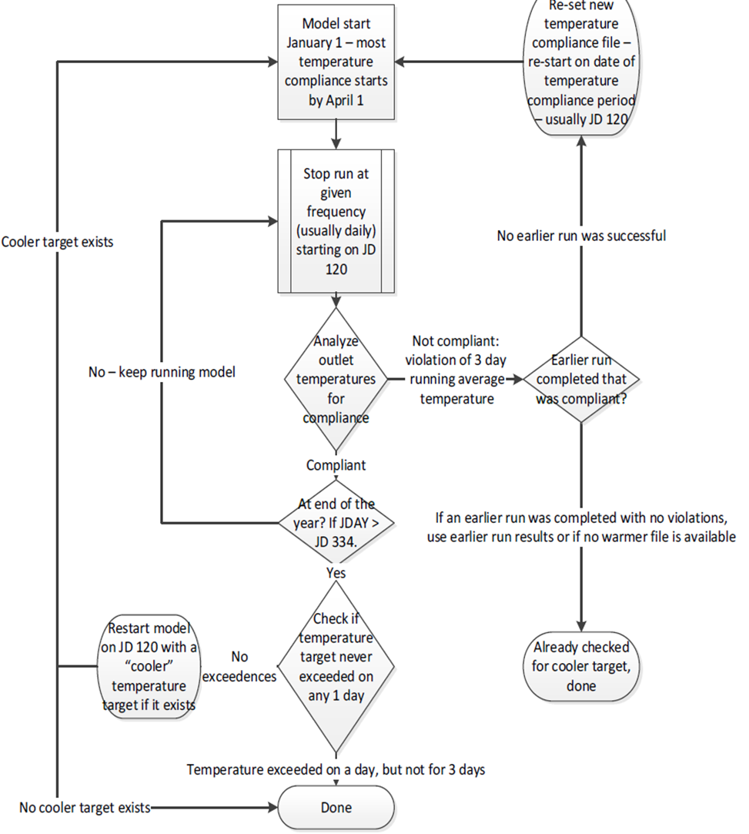

Figure A-20. ATSP selection logic in CE-QUAL-W2.
To control the Custom W2 Model operation, a control file called “folsom_in.npt” allows the model user to set the following parameters:
- Restart Date (JDAY when model will restart to run another model iteration. Generally, May 1st, but can be later if model starts after May 1st)
- Name of “Best Guess” file
- Name of temperature schedule file
- Number of days of water temperature violations allowed
- Specify consecutive or cumulative violations allowed
- Temperature violation threshold (allows model to continue running if temp is only X or less above target temp)
- Method of finding best schedule (1 or 2 discussed earlier)
- Number of temperature schedules (78 official schedules, but more have been developed or they can be modified)
- Fix shutter elevations (ON/OFF) – this keeps shutters from being added in the first calendar year
- Fix ATSP (ON/OFF) – allows the model to either seek best schedule or run a fixed ATSP schedule

Application of the Folsom_W2_TCD Model
The version of the Folsom_W2_TCD model has be run extensively (9⁺ years) on Folsom Reservoir and the American River since its development (PCWA 2015). The model has been used for seasonal temperature planning (Water Forum 2017), modeling temperature issues related to water transfers, and long-term planning studies (CalSim II).
The Folsom_W2_TCD model was validated as part of the CE-QUAL-W2 model development (PCWA 2015). The model replicates the calibrated CE-QUAL-W2 model runs when the Municipal Intake, Powerhouse Shutters, and Bypass are operated similarly. The Folsom_W2_TCD model in automated mode has been tested (PCWA 2017) to verify that it operates Folsom Dam in a similar manner to how operators operate the dam. Because the automated version has foresight and can immediately change shutters as needed (operators need to submit work orders for the shutters to be changed), it typically operates Folsom Dam slightly more efficiently than actual historical operations (as would be expected) (PCWA 2017) (Figure A-21).
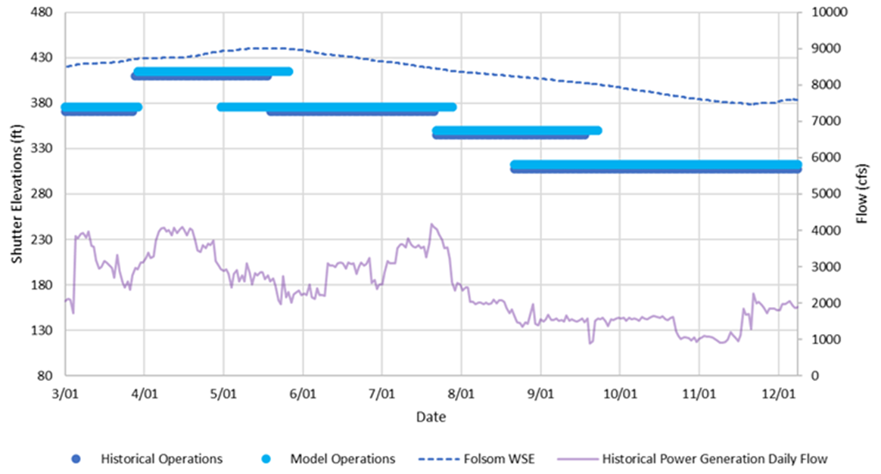
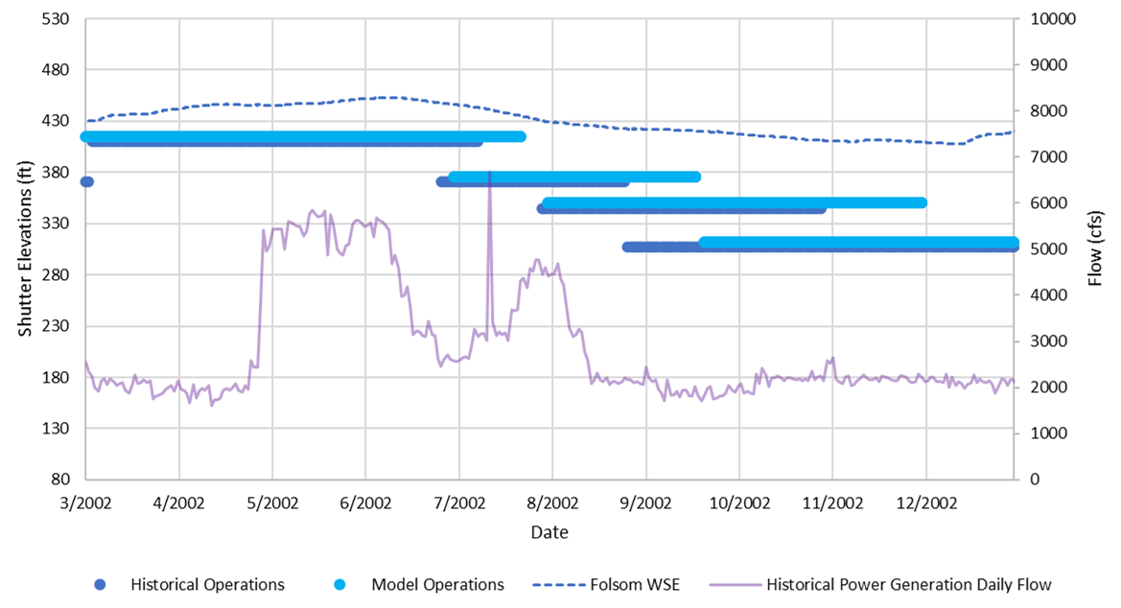
Figure A-21. Folsom Dam automated shutter selection logic in CE-QUAL-W2 versus historical operations for 2001 (top) and 2002 (bottom).

References
Placer County Water Agency (PCWA). 2015. American River Water Rights Extension Project (ARWRE) Folsom Reservoir CE-QUAL-W2 Temperature Model Report.
PCWA 2017. Folsom Reservoir CE-QUAL-W2 Model. Placer County Water Agency
Water Forum. 2017. Exhibit ARWA-602, Lower American River Flow Management Standard Technical Memorandum 1. 30 pgs.
Water Forum. 2006. Lower American River Flow Management Standard. 33 pgs.

ResSim: Folsom Dam Selective Withdrawal Logic
Similar to the Upper Sacramento model, the ResSim American River watershed can be run for a “prescribed” alternative, where the shutter operations on Folsom Dam penstock intakes are specified based on historical logs, or a “forecast” alternative, where the shutter operations are predicted with the goal of meeting a downstream temperature target. The choice between the two simulation types is made by choosing the appropriate ResSim Model Alternative for use in a WTMP Simulation.
ResSim forecast operations logic for modeling the Folsom Dam follows similar logic to that detailed in the previous section on CE-QUAL-W2. In the ResSim forecast alternative, one master scripted rule is used to determine the flow through the three penstocks, the shutter elevations on the three penstocks, and flow through the lower river outlets, if necessary. This master rule is applied to the first penstock outlet. During the course of the script, it sets ResSim global variables for the second and third penstocks and lower river outlet flows, and the second and third penstock shutter elevations. Subordinate scripted rules on the second and third penstocks and the lower river outlets pick up the values of these global variables and set flows and shutter elevations. Shutter operations for the penstocks are based on a set of four available shutter configurations for each penstock intake (Table ).
Table A-3. Shutter configuration and elevations at the Folsom Dam shutter system.
Shutter Configuration | Top of Shutter Elevation (ft) | Point Withdrawal Elevation (ft)
All shutters in | 401 | 409.9
Lower and middle shutters in | 362 | 370.9
Only lower shutters in | 336 | 344.9
All shutters out | 307 | 307

This assumes shutters in each level operate collectively in “ganged” form. In 2015 and 2021, lower and middle shutter levels were de-ganged to provide additional operational flexibility. This is not considered in the current version of the forecast script, but the script can be modified to accommodate unique settings.
The forecast script logic begins by setting the shutter elevations at levels determined by the historical logs. If the historical levels do not match a possible operation in the script (i.e., they are de-ganged), the shutters will be moved to the closest valid operational configuration. An operation period is defined by the user during which the shutter operations move in a monotonically decreasing manner. The initial state is with all shutters installed. Subsequently, shutter panels are successively removed to allow deeper, cooler water to be pulled for downstream temperature control as the simulation evolves through the management season. The operational period is defined as March 1st through December 1st. On March 1st, the shutters are raised to the highest level allowed by reservoir elevation constraints. (The top of the shutters must be inundated by at least 27 ft (8.2 m) of water (submergence criteria).) As the simulation progresses, a check is made once per day to determine if the downstream temperature target is being met.
The downstream American River temperature target is provided as an input to the forecast simulations. This downstream value is translated from the downstream location to an outflow temperature below Folsom Dam using a 2-step process:
- The downstream temperature target is converted to a temperature target for the outflow of Folsom Dam based on a regression utilizing the equilibrium temperature, outflow magnitude from Folsom Dam, and approximate travel time to the downstream location
- That modified temperature target is further modified to account for uncontrolled leakage through the penstocks and any outflow from spillways or river outlets on Folsom.
The resulting temperature is the modified target for the Folsom Dam outflow.
The script checks operations daily to determine if the temperature target is being met. As the simulation progresses, the reservoirs warms, and successively lower elevation releases are required to meet the target. When shutters on all 3 penstocks are at the same level and the temperature target can be met, flow is equally apportioned through the 3 penstocks. When the temperature target is not met (to within a user defined tolerance for a user-defined number of days in a row), penstock 1 is moved to the next lower level. The apportion of flow through penstock 1 and penstocks 2 and 3 is calculated by the model such that it meets the target. If the calculated flow through penstock 1 is greater than its operating capacity (2,888 cfs), penstock 2 is moved to the next lower level.
The process continues to include the lower-level river outlets if the target cannot be met with all shutters on all penstocks removed. Temperature control operations are only allowed to occur within user-defined seasonal period.

HEC-WAT is the U.S. Army Corps of Engineers, Hydrologic Engineering Center Watershed Analysis Tool
A computable data set has all the information to successfully perform the desired model execution(s): the configuration data, time dependent data, initial conditions, Analysis Period, operational controls, etc.

