Project Description for the Central Valley Project and State Water Project

Introduction
Reclamation and DWR propose to continue to operate the CVP and SWP to divert, store, and convey Project water consistent with applicable law. See map in Figure 2-1. The CVP’s major storage facilities are Shasta, Trinity, Folsom and New Melones. The upstream reservoirs release water to provide water for the Delta of which can be exported a portion through Jones pumping plant to store in the joint reservoir San Luis or deliver down the Delta Mendota Canal. The SWP owns Lake Oroville upstream and releases water for the Delta that can be exported at Harvey O. Banks Pumping Plant (Banks) for delivery through the California Aqueduct. These operations are summarized in this BA with more detail.

The Proposed Action
The proposed action is the continued operation of the CVP and SWP. The proposed action includes the operation of the temporary barriers project in the south Delta and the 500 cfs increase in SWP Delta export limit July through September. In addition to recent historic operations, several other recent actions are included in this consultation. These actions are: (1) an intertie between the California Aqueduct (CA) and the Delta-Mendota Canal (DMC), (2) Freeport Regional Water Project (FRWP), (3) changes in the operation of the Red Bluff Diversion Dam (RBDD), (4) Middle River Intake Project for CCWD, and (5) minor operational changes that are identified in this chapter. The other actions will come online at various times in the future. As stated in Chapter 1, inclusion of future actions in the project description of this BA does not constitute a decision to take that action.
All site-specific/localized activities of the actions such as construction/screening and any other site-specific effects will be addressed in separate action-specific section 7 consultations. In addition, DWR will need to consult with the California Department of Fish and Game (DFG), as may be appropriate, to address applicable requirements of the State Endangered Species Act. This BA may assist DWR and DFG in their consultation to ensure that DWR is in compliance with the State ESA.
Table 2-1 summarizes the differences between current operational actions and future operational actions to be covered by this consultation. A detailed summary of all operational components and associated modeling assumptions are included in Table 9-5.
Table 2-1 Major Proposed Future Operational Actions for Consultation.
Area of Project | Today 2011 | Future 2030
Trinity & Whiskeytown | Trinity Restoration Flows  368,600-815,000 af | Same
Shasta/Sacramento River | Red Bluff Diversion Dam (RBDD)  8 months gates out | New RBDD Operation  10 months gates out with pumping plant
Oroville and Feather River | Old FERC License and NMFS 2004 BO | Expect New FERC License
Folsom and American River | Current Demands | Build out of demands, New American River Flow Management, and Freeport Regional Water Project
New Melones and Stanislaus River | Interim Plan of Operations Guidance | Interim Plan of Operations Guidance
Friant Division | Historic Operations | Same
Sacramento-San Joaquin Delta | Current Demands | 2030 Demands
Suisun Marsh | Same | Expect to Implement New Charter
WQCP | D-1641 | Same
COA | 1986 Guidance | Same
CVPIA | May 9, 2003 Decision | Same
Banks Pumping Plant | 6680* cfs and Temporary Barriers | 6680* cfs and Temporary Barriers
Jones Pumping Plant | Max of 4600 cfs with Flexibility of Intertie | Max 4600 cfs with Flexibility of Intertie
- This diversion rate is normally restricted to 6,680 cfs as a three-day average inflow to Clifton Court Forebay, although between December 15 and March 15, when the San Joaquin River is above 1,000 cfs, one-third of the San Joaquin River flow at Vernalis may be pumped in addition. Furthermore, the SWP is permitted to pump an additional 500 cfs between July 1 and September 30 to offset water costs associated with fisheries actions making the summer limit effectively 7,180 cfs.

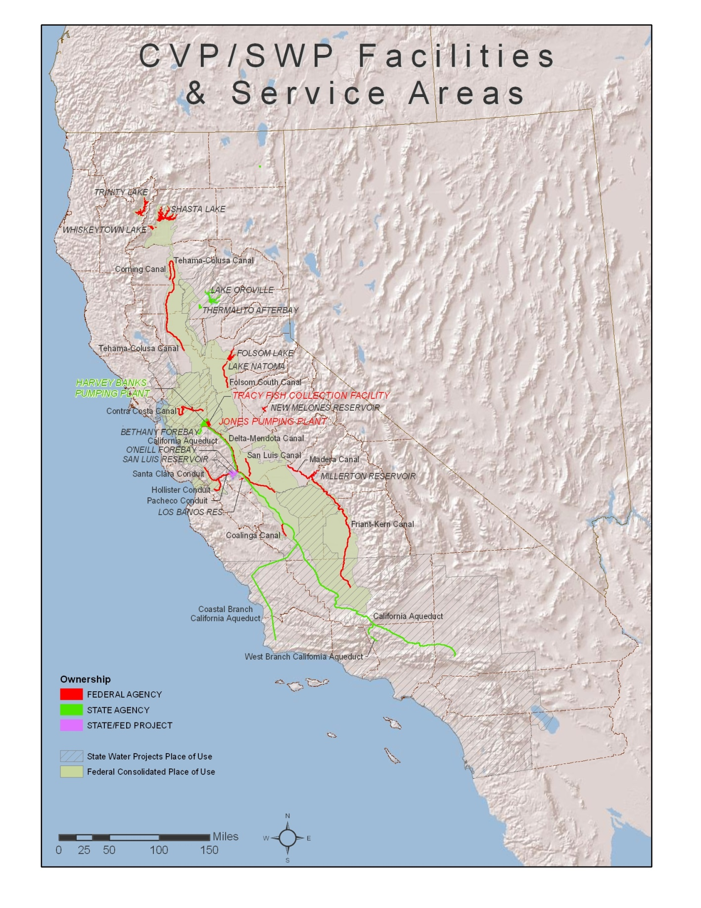
Figure 2-1 Map of California CVP and SWP Service Areas

Coordinated Operation of the CVP and SWP

Coordinated Operations Agreement
The CVP and SWP use a common water supply in the Central Valley of California. The DWR and Reclamation (collectively referred to as Project Agencies) have built water conservation and water delivery facilities in the Central Valley in order to deliver water supplies to affected water rights holders as well as project contractors. The Project Agencies’ water rights are conditioned by the SWRCB to protect the beneficial uses of water within each respective project and jointly for the protection of beneficial uses in the Sacramento Valley and the Sacramento-San Joaquin Delta Estuary. The Project Agencies coordinate and operate the CVP and SWP to meet the joint water right requirements in the Delta.
The Coordinated Operations Agreement (COA), signed in 1986, defines the project facilities and their water supplies, sets forth procedures for coordination of operations, identifies formulas for sharing joint responsibilities for meeting Delta standards, as the standards existed in SWRCB Decision 1485 (D-1485), and other legal uses of water, identifies how unstored flow will be shared, sets up a framework for exchange of water and services between the Projects, and provides for periodic review of the agreement.

Implementing the COA

Obligations for In-Basin Uses
In-basin uses are defined in the COA as legal uses of water in the Sacramento Basin, including the water required under the SWRCB D-1485 Delta standards (D-1485 ordered the CVP and SWP to guarantee certain conditions for water quality protection for agricultural, municipal and industrial [M&I], and fish and wildlife use). Each project is obligated to ensure water is available for these uses, but the degree of obligation is dependent on several factors and changes throughout the year, as described below.
Balanced water conditions are defined in the COA as periods when it is mutually agreed that releases from upstream reservoirs plus unregulated flows approximately equals the water supply needed to meet Sacramento Valley in-basin uses plus exports. Excess water conditions are periods when it is mutually agreed that releases from upstream reservoirs plus unregulated flow exceed Sacramento Valley in-basin uses plus exports. Reclamation’s Central Valley Operations Office (CVOO) and DWR’s SWP Operations Control Office jointly decide when balanced or excess water conditions exist.
During excess water conditions, sufficient water is available to meet all beneficial needs, and the CVP and SWP are not required to supplement the supply with water from reservoir storage. Under Article 6(g) of the COA, Reclamation and DWR have the responsibility (during excess water conditions) to store and export as much water as possible, within physical, legal and contractual limits. In excess water conditions, water accounting is not required. However, during balanced water conditions, the Projects share the responsibility in meeting in-basin uses.
When water must be withdrawn from reservoir storage to meet in-basin uses, 75 percent of the responsibility is borne by the CVP and 25 percent is borne by the SWP. When unstored water is available for export (i.e., Delta exports exceed storage withdrawals while balanced water conditions exist), the sum of CVP stored water, SWP stored water, and the unstored water for export is allocated 55/45 to the CVP and SWP, respectively.

Accounting and Coordination of Operations
Reclamation and DWR coordinate on a daily basis to determine target Delta outflow for water quality, reservoir release levels necessary to meet in-basin demands, schedules for joint use of the San Luis Unit facilities, and for the use of each other’s facilities for pumping and wheeling.
During balanced water conditions, daily water accounting is maintained of the CVP and SWP obligations. This accounting allows for flexibility in operations and avoids the necessity of daily changes in reservoir releases that originate several days travel time from the Delta. It also means adjustments can be made “after the fact” using actual data rather than by prediction for the variables of reservoir inflow, storage withdrawals, and in-basin uses.
The accounting language of the COA provides the mechanism for determining the responsibility of each project for Delta outflow influenced standards; however, real time operations dictate actions. For example, conditions in the Delta can change rapidly. Weather conditions combined with tidal action can quickly affect Delta salinity conditions, and therefore, the Delta outflow required to maintain joint standards. If, in this circumstance, it is decided the reasonable course of action is to increase upstream reservoir releases, then the response will likely be to increase Folsom releases first. Lake Oroville water releases require about three days to reach the Delta, while water released from Lake Shasta requires five days to travel from Keswick to the Delta. As water from the other reservoirs arrives in the Delta, Folsom releases can be adjusted downward. Any imbalance in meeting each project’s designed shared obligation would be captured by the COA accounting.
Reservoir release changes are one means of adjusting to changing in-basin conditions. Increasing or decreasing project exports can also immediately achieve changes to Delta outflow. As with changes in reservoir releases, imbalances in meeting each project’s designed shared obligations are captured by the COA accounting.
During periods of balanced water conditions, when real-time operations dictate project actions, an accounting procedure tracks the designed sharing water obligations of the CVP and SWP. The Projects produce daily and accumulated accounting balances. The account represents the imbalance resulting from actual coordinated operations compared to the COA-designed sharing of obligations and supply. The project that is “owed” water (i.e., the project that provided more or exported less than its COA-defined share) may request the other project adjust its operations to reduce or eliminate the accumulated account within a reasonable time.
The duration of balanced water conditions varies from year to year. Some very wet years have had no periods of balanced conditions, while very dry years may have had long continuous periods of balanced conditions, and still other years may have had several periods of balanced conditions interspersed with excess water conditions. Account balances continue from one balanced water condition through the excess water condition and into the next balanced water condition. When the project that is owed water enters into flood control operations, at Shasta or Oroville, the accounting is zeroed out for that respective project.

Changes in Coordinated Operation Since 1986
Implementation of the COA principles has continuously evolved since 1986 as changes have occurred to CVP and SWP facilities, to project operations criteria, and to the overall physical and regulatory environment in which the coordination of CVP and SWP operations takes place. Since 1986, new facilities have been incorporated into the operations that were not part of the original COA. New water quality and flow standards (D-1641) have been imposed by the SWRCB; the CVPIA has changed how the CVP is operated; and finally, the Federal Endangered Species Act (ESA) responsibilities have affected both the CVP and SWP operations. The following is a list of significant changes that have occurred since 1986. Included after each item is an explanation of how it relates to the COA and its general effect on the accomplishments of the Projects.

Sacramento River Temperature Control Operations
Water temperature control operations have changed the pattern of storage and withdrawal of storage at Shasta, Trinity, and Whiskeytown, for the purpose of improving temperature control and managing coldwater pool resources in the facilities. Water temperature operations have also constrained rates of flow, and changes in rates of flow below Keswick Dam in keeping with water temperature requirements. Such constraints have reduced the CVP’s capability to respond efficiently to changes in Delta export or outflow requirements. Periodically, temperature requirements have caused the timing of the CVP releases to be significantly mismatched with Delta export capability, resulting in loss of water supply. On occasion, and in accordance with Articles 6(h) and 6(i) of the COA, the SWP has been able to export water released by the CVP for temperature control in the Sacramento River. The installation of the Shasta temperature control device has significantly improved Reclamation’s ability to match reservoir releases and Delta needs.

Bay-Delta Accord, and Subsequent SWRCB Implementation of D-1641
The 1994 Bay-Delta Accord committed the CVP and SWP to a set of Delta habitat protective objectives that were eventually incorporated into the 1995 Water Quality Control Plan (WQCP), and later, along with the Vernalis Adaptive Management Plan (VAMP), were included by the SWRCB in D-1641 amending the water rights of the Projects. The actions taken by the CVP and SWP in implementing D-1641 significantly reduced the export water supply of both Projects. Article 11 of the COA describes the options available to the United States for responding to the establishment of new Delta standards.
Project operators must coordinate the day-to-day operations of the CVP and SWP to perform to the Projects water rights. The 1986 COA sharing formula has been used by Project operators for D-1641 Delta outflow and salinity based standards. SWRCB D-1641 contains significant new “export limitation” criteria such as the export to inflow (E/I) ratios and San Joaquin River pulse period “export limits”. The 1986 COA framework never contemplated nor addressed the application of such criteria to CVP and SWP permits. When the E/I or pulse period export restrictions control Project operations, project operators attempt to utilize “equity principles” to determine how to comply with D-1641 standards. In most cases, the rate of export is attempted to be evened out over the restricted period. In some cases, a seasonal time shift of the SWP exports can occur to help facilitate an equitable sharing of responsibilities. Until the COA is updated to reflect SWRCB D-1641 conditions, project operators must continually work on a case-by-case basis in order to meet the Projects’ combined water right requirements.

North Bay Aqueduct
North Bay Aqueduct, as described above, is a SWP feature that can convey up to about 175 cfs diverted from the SWP’s Barker Slough Pumping Plant. North Bay Aqueduct Diversions are conveyed to Napa and Solano Counties. Pursuant to an agreement between Reclamation, DWR, and the CVP and SWP contractors in 2003, a portion of the SWP diversions will be treated as an export in COA accounting.

Freeport Regional Water Project
The FRWP is a new facility that will divert up to a maximum of 286 cubic feet per second (cfs) from the Sacramento River near Freeport for Sacramento County and East Bay Municipal Utility District (EBMUD). EBMUD will divert water pursuant to its amended contract with Reclamation. The County will divert using its water rights and its CVP contract supply. This facility was not in the 1986 COA, and the diversions will result in some reduction in Delta export supply for both the CVP and SWP contractors. Pursuant to an agreement between Reclamation, DWR, and the CVP and SWP contractors in 2003, diversions to EBMUD will be treated as an export in the COA accounting, and diversions to Sacramento County will be treated as an in-basin use.

Loss of 195,000 af of D-1485 Condition 3 Replacement Pumping
The 1986 COA affirmed the SWP’s commitment to provide replacement capacity to the CVP to make up for May and June pumping reductions imposed by SWRCB D-1485 in 1978. In the evolution of COA operations since 1986, SWRCB D-1485 was superseded by SWRCB D-1641 and SWP water demand growth and other pumping constraints have reduced the available surplus capacity at Banks Pumping Plant. The CVP has not received replacement pumping since 1993. Since then there have been (and in the current operations environment there will continue to be) many years in which the CVP will be limited by insufficient Delta export capacity to convey its water supply. The loss of the up to 195,000 af of replacement pumping capacity has diminished the water delivery anticipated by the CVP under the 1986 COA framework. The diminished water delivery accomplishments results in a charge to CVPIA (b)(2) water.

State Water Resources Control Board Water Rights

1995 Water Quality Control Plan
The SWRCB adopted the 1995 Bay-Delta Water Quality Control Plan (WQCP) on May 22, 1995, which became the basis of SWRCB Decision-1641. The SWRCB continues to hold workshop and receive information regarding processes on specific areas of the 1995 WQCP. The SWRCB amended the WQCP in 2006, but to date, the SWRCB has made no significant change to the 1995 WQCP framework.

Decision 1641
The SWRCB imposes a myriad of constraints upon the operations of the CVP and SWP in the Delta. With Water Rights Decision 1641, the SWRCB implements the objectives set forth in the SWRCB 1995 Bay-Delta WQCP and imposes flow and water quality objectives upon the Projects to assure protection of beneficial uses in the Delta. The SWRCB also grants conditional changes to points of diversion for each project with D-1641.
The various flow objectives and export restraints are designed to protect fisheries. These objectives include specific outflow requirements throughout the year, specific export restraints in the spring, and export limits based on a percentage of estuary inflow throughout the year. The water quality objectives are designed to protect agricultural, municipal and industrial, and fishery uses, and they vary throughout the year and by the wetness of the year.
Figure 2-2 and Figure 2-3 summarize the flow and quality objectives in the Delta and Suisun Marsh for the Projects from D-1641. These objectives will remain in place until such time that the SWRCB revisits them per petition or as a consequence to revisions to the SWRCB Water Quality Plan for the Bay-Delta (which is to be revisited periodically).
On December 29, 1999, SWRCB adopted and then revised (on March 15, 2000) Decision 1641, amending certain terms and conditions of the water rights of the SWP and CVP. Decision 1641 substituted certain objectives adopted in the 1995 Bay-Delta Plan for water quality objectives that had to be met under the water rights of the SWP and CVP. In effect, D-1641 obligates the SWP and CVP to comply with the objectives in the 1995 Bay-Delta Plan. The requirements in D-1641 address the standards for fish and wildlife protection, M&I water quality, agricultural water quality, and Suisun Marsh salinity. SWRCB D-1641 also authorizes SWP and CVP to jointly use each other’s points of diversion in the southern Delta, with conditional limitations and required response coordination plans. SWRCB D-1641 modified the Vernalis salinity standard under SWRCB Decision 1422 to the corresponding Vernalis salinity objective in the 1995 Bay-Delta Plan. The criteria imposed upon the CVP and SWP are summarized in Figure 2-2 (Summary Bay-Delta Standards), Figure 2-3 (Footnotes for Summary Bay-Delta Standards), and Figure 2-4 (CVP/SWP Map).

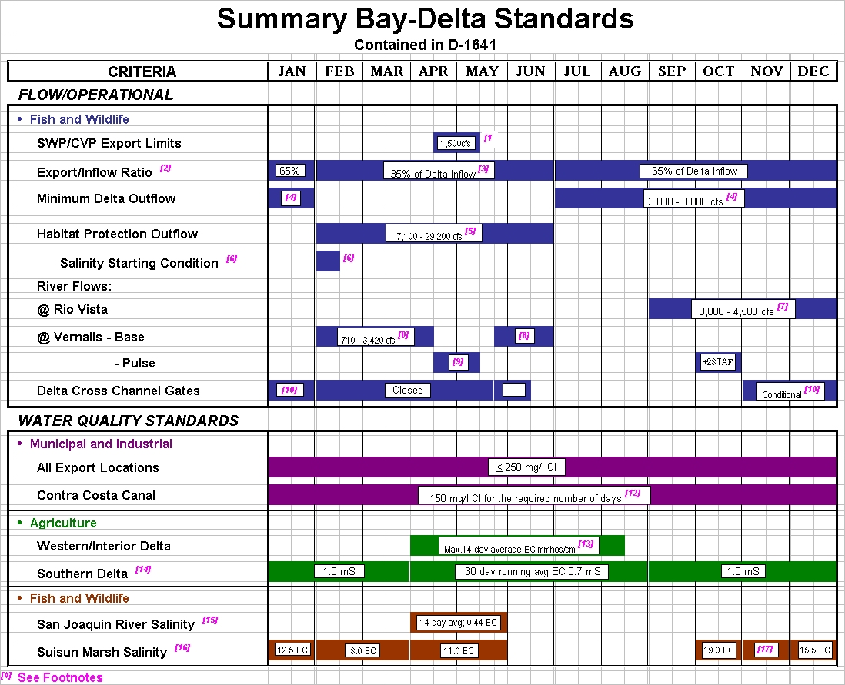
Figure 2-2 Summary Bay Delta Standards (See Footnotes below)

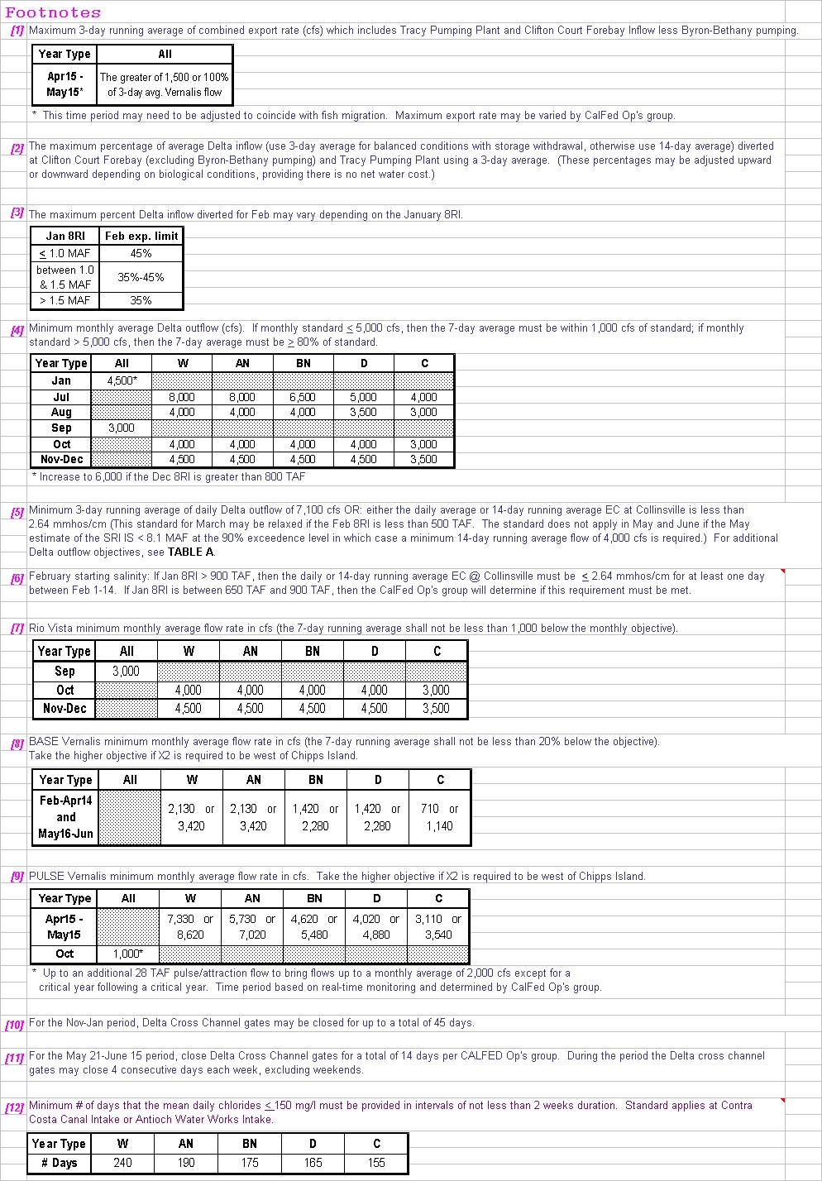
(Footnotes continued on next page)
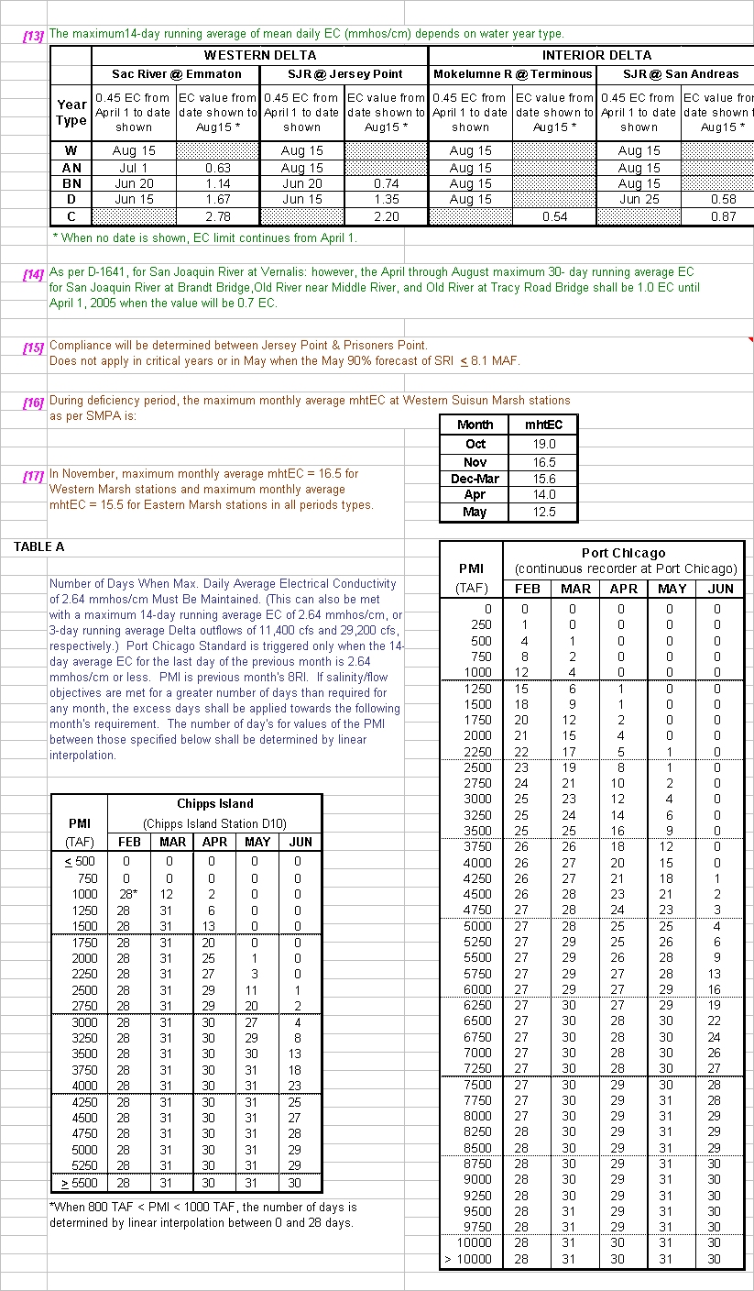
Figure 2-3 Footnotes for Summary Bay Delta Standards
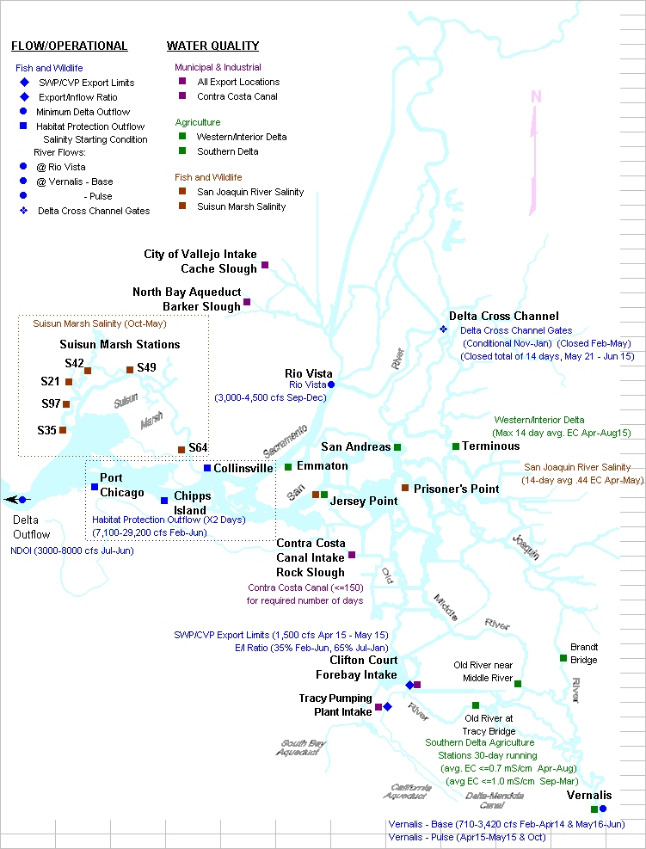
Figure 2-4 CVP/SWP Delta Map

Joint Points of Diversion
SWRCB D-1641 granted Reclamation and DWR the ability to use/exchange each Project’s diversion capacity capabilities to enhance the beneficial uses of both Projects. The SWRCB conditioned the use of Joint Point of Diversion (JPOD) capabilities based on a staged implementation and conditional requirements for each stage of implementation. The stages of JPOD in SWRCB D-1641 are:
- Stage 1 – for water service to Cross Valley Canal contractors, Tracy Veterans Cemetery and Musco Olive, and to recover export reductions taken to benefit fish.
- Stage 2 – for any purpose authorized under the current project water right permits.
- Stage 3 – for any purpose authorized up to the physical capacity of the diversion facilities.
Each stage of JPOD has regulatory terms and conditions which must be satisfied in order to implement JPOD.
All stages require a response plan to ensure water levels in the southern Delta will not be lowered to the injury of local riparian water users (Water Level Response Plan). All stages require a response plan to ensure the water quality in the southern and central Delta will not be significantly degraded through operations of the JPOD to the injury of water users in the southern and central Delta.
All JPOD diversion under excess conditions in the Delta is junior to Contra Costa Water District (CCWD) water right permits for the Los Vaqueros Project, and must have an X2 location west of certain compliance locations consistent with the 1993 Los Vaqueros Biological Opinion (BO) for delta smelt.
Stage 2 has an additional requirement to complete an operations plan that will protect fish and wildlife and other legal users of water. This is commonly known as the Fisheries Response Plan. A Fisheries Response Plan was approved by the SWRCB in February 2007, but relies in part on the 2004 and 2005 Biological Opinions. Once this consultation is complete, the Fisheries Response Plan will be re-examined. If modifications are required, the plan will be revised and re-submitted to the SWRCB at a future date.
Stage 3 has an additional requirement to protect water levels in the southern Delta under the operational conditions of Phase II of the South Delta Improvements Program, along with an updated companion Fisheries Response Plan.
Reclamation and DWR intend to apply all response plan criteria consistently for JPOD uses as well as water transfer uses.
In general, JPOD capabilities will be used to accomplish four basic CVP-SWP objectives:
- When wintertime excess pumping capacity becomes available during Delta excess conditions and total CVP-SWP San Luis storage is not projected to fill before the spring pulse flow period, the project with the deficit in San Luis storage may elect to use JPOD capabilities.
- When summertime pumping capacity is available at Banks Pumping Plant and CVP reservoir conditions can support additional releases, the CVP may elect to use JPOD capabilities to enhance annual CVP south of Delta water supplies.
- When summertime pumping capacity is available at Banks or Jones Pumping Plant to facilitate water transfers, JPOD may be used to further facilitate the water transfer.
- During certain coordinated CVP-SWP operation scenarios for fishery entrainment management, JPOD may be used to shift CVP-SWP exports to the facility with the least fishery entrainment impact while minimizing export at the facility with the most fishery entrainment impact.

Revised WQCP (2006)
The SWRCB undertook a proceeding under its water quality authority to amend the Water Quality Control Plan for the San Francisco Bay/Sacramento-San Joaquin Delta Estuary (Bay-Delta Plan) adopted in 1978 and amended in 1991 and in 1995. Prior to commencing this proceeding, the SWRCB conducted a series of workshops in 2004 and 2005 to receive information on specific topics addressed in the Bay-Delta Plan.
The SWRCB adopted a revised Bay-Delta Plan on December 13, 2006. There were no changes to the Beneficial Uses from the 1995 Plan to the 2006 Plan, nor were any new water quality objectives adopted in the 2006 Plan. A number of changes were made simply for readability. Consistency changes were also made to assure that sections of the Plan reflected the current physical condition or current regulation. The SWRCB continues to hold workshops and receive information regarding Pelagic Organism Decline (POD), Climate Change, and San Joaquin salinity and flows, and will coordinate updates of the Bay-Delta Plan with on-going development of the comprehensive Salinity Management Plan.

Real Time Decision-Making to Assist Fishery Management

Introduction
Real time decision-making to assist fishery management is a process that promotes flexible decision making that can be adjusted in the face of uncertainties as outcomes from management actions and other events become better understood. For the proposed action high uncertainty exists for how to best manage our water operations while protecting listed species. Applying real time decision-making to assist fishery management to the proposed action requires the definition of management goals and a mechanism for new information and scientific understanding to be used in changing our operations to better meet the goals.
Sources of uncertainty relative to the proposed action include:
- Hydrologic conditions
- Ocean conditions
- Listed species biology
Under the proposed action the goals for real time decision-making to assist fishery management are:
- Meet contractual obligations for water delivery
- Minimize adverse effects for listed species

Framework for Actions
Reclamation and DWR work closely with FWS, NMFS, and DFG to coordinate the operation of the CVP and SWP with fishery needs. This coordination is facilitated through several forums in a cooperative management process that allows for modifying operations based on real-time data that includes current fish surveys, flow and temperature information, and salvage or loss at the project facilities, (hereinafter “triggering event”).

Water Operations Management Team
The Water Operations Management Team (WOMT) is comprised of representatives from Reclamation, DWR, FWS, NMFS, and DFG. This management-level team was established to facilitate timely decision-support and decision-making at the appropriate level. The WOMT first met in 1999, and will continue to meet to make management decisions as part of the proposed project. Routinely, it also uses the CALFED Ops Group to communicate with stakeholders about its decisions. Although the goal of WOMT is to achieve consensus on decisions, the participating agencies retain their authorized roles and responsibilities.

Process for Real Time Decision- Making to Assist Fishery Management
Decisions regarding CVP and SWP operations to avoid and minimize adverse effects on listed species must consider factors that include public health, safety, and water supply reliability. To facilitate such decisions, the Project Agencies and the fishery agencies (consisting of FWS, NMFS, and DFG) have developed and refined a set of processes for various fish species to collect data, disseminate information, develop recommendations, make decisions, and provide transparency. This process consists of three types of groups that meet on a recurring basis. Management teams are made up of management staff from Reclamation, DWR, and the fishery agencies. Information teams are teams whose role is to disseminate and coordinate information among agencies and stakeholders. Fisheries and Operations technical teams are made up of technical staff from state and Federal agencies. These teams review the most up-to-date data and information on fish status and Delta conditions, and develop recommendations that fishery agencies’ management can use in identifying actions to protect listed species.
The process to identify actions for protection of listed species varies to some degree among species but follows this general outline: A Fisheries or Operations Technical Team compiles and assesses current information regarding species, such as stages of reproductive development, geographic distribution, relative abundance, physical habitat conditions, then provides a recommendation to the agency with statutory obligation to enforce protection of the species in question. The agency’s staff and management will review the recommendation and use it as a basis for developing, in cooperation with Reclamation and DWR, a modification of water operations that will minimize adverse effects to listed species by the Projects. If the Project Agencies do not agree with the action, then the fishery agency with the statutory authority will make a final decision on an action that they deem necessary to protect the species. In the event it is not possible to refine the proposed action in order that it does not violate section 7(a)(2) of the ESA, the Project and fisheries agencies will reinitiate consultation.
The outcomes of protective actions that are implemented will be monitored and documented, and this information will inform future recommended actions.

Groups Involved in Real Time Decision-Making to Assist Fishery Management and Information Sharing

Information Teams

CALFED Ops and Subgroups
The CALFED Ops Group consists of the Project agencies, the fishery agencies, SWRCB staff, and the U.S. Environmental Protection Agency (EPA). The CALFED Ops Group generally meets eight times a year in a public setting so that the agencies can inform each other and stakeholders about current operations of the CVP and SWP, implementation of the CVPIA and State and Federal endangered species acts, and additional actions to contribute to the conservation and protection of State- and Federally-listed species. The CALFED Ops Group held its first public meeting in January 1995, and during the next six years the group developed and refined its process. The CALFED Ops Group has been recognized within SWRCB D-1641, and elsewhere, as one forum for coordination on decisions to exercise certain flexibility that has been incorporated into the Delta standards for protection of beneficial uses (e.g., E/I ratios, and some DCC Closures). Several teams were established through the Ops Group process. These teams are described below:

Data Assessment Team (DAT)
The DAT consists of technical staff members from the Project and fishery agencies as well as stakeholders. The DAT meets frequently during the fall, winter, and spring. The purpose of the meetings is to coordinate and disseminate information and data among agencies and stakeholders that is related to water project operations, hydrology, and fish surveys in the Delta.

Operations and Fishery Forum
The Operations and Fishery Forum (OFF) was established as an ad-hoc stakeholder-driven process to disseminate information regarding recommendations and decisions about the operations of the CVP and SWP. OFF members are considered the contact person for their respective agency or interest group when information regarding take of listed species, or other factors and urgent issues need to be addressed by the CALFED Ops Group. Alternatively, the OFF may be directed by the CALFED Ops Group to develop recommendations on operational responses for issues of concern raised by member agencies.

B2 Interagency Team (B2IT)
The B2IT was established in 1999 and consists of technical staff members from the Project agencies. The B2IT meets weekly to discuss implementation of section 3406 (b)(2) of the CVPIA, which defines the dedication of CVP water supply for environmental purposes. It communicates with WOMT to ensure coordination with the other operational programs or resource-related aspects of project operations, including flow and temperature issues.

Technical Teams
Fisheries Technical Teams
Several fisheries specific teams have been established to provide guidance and recommendations on resource management issues. These teams include:
The Sacramento River Temperature Task Group (SRTTG): The SRTTG is a multiagency group formed pursuant to SWRCB Water Rights Orders 90-5 and 91-1, to assist with improving and stabilizing Chinook population in the Sacramento River. Annually, Reclamation develops temperature operation plans for the Shasta and Trinity divisions of the CVP. These plans consider impacts on winter-run and other races of Chinook salmon, and associated project operations. The SRTTG meets initially in the spring to discuss biological, hydrologic, and operational information, objectives, and alternative operations plans for temperature control. Once the SRTTG has recommended an operation plan for temperature control, Reclamation then submits a report to the SWRCB, generally on or before June 1st each year.
After implementation of the operation plan, the SRTTG may perform additional studies and commonly holds meetings as needed typically monthly through the summer and into fall. To develop revisions based on updated biological data, reservoir temperature profiles and operations data. Updated plans may be needed for summer operations protecting winter-run, or in fall for fall-run spawning season. If there are any changes in the plan, Reclamation submits a supplemental report to SWRCB.
Smelt Working Group (Working Group): The Working Group evaluates biological and technical issues regarding delta smelt and develops recommendations for consideration by the FWS. Since the longfin smelt became a state candidate species in 2008, the Working Group has also developed for DFG recommendations to minimize adverse effects to longfin smelt. The Working Group consists of representatives from FWS, DFG, DWR, EPA, and Reclamation. FWS chairs the group, and a member is assigned by each agency.
The Smelt Working Group will compile and interpret the latest near real-time information regarding state- and federally-listed smelt, such as stages of development, distribution, and salvage. After evaluating available information and if they agree that a protection action is warranted, the working group will submit their recommendations in writing to FWS and DFG.
The working group may meet at any time at the request of FWS, but generally meets weekly during the months of January through June, when smelt salvage at CVP and SWP has occurred historically. However, the Delta Smelt Risk Assessment Matrix (see below) outlines the conditions when the Working Group will convene to evaluate the necessity of protective actions and provide FWS with a recommendation. Further, with the State listing of longfin smelt, the group will also convene based on longfin salvage history at the request of DFG.
Delta Smelt Risk Assessment Matrix (DSRAM): The Working Group will employ a delta smelt risk assessment matrix to assist in evaluating the need for operational modifications of SWP and CVP to protect delta smelt. This document will be a product and tool of the Working Group and will be modified by the Working Group with the approval of FWS and DFG, in consultation with Reclamation and DWR, as new knowledge becomes available. The currently approved DSRAM is provided for information in Appendix A.
If an action is taken, the Working Group will follow up on the action to attempt to ascertain its effectiveness. The ultimate decision-making authority rests with FWS. An assessment of effectiveness will be attached to the notes from the Working Group’s discussion concerning the action.
Delta Operations Salmonid and Sturgeon (DOSS) Group: The DOSS workgroup is a technical team with relevant expertise from Reclamation, DWR, DFG, FWS, SWRCB, USGS, EPA, and NMFS that provides advice to WOMT and to NMFS on issues related to fisheries and water resources in the Delta and recommendations on measures to reduce adverse effects of Delta operations of the CVP and SWP to salmonids and green sturgeon. The purpose of DOSS is to provide recommendations for real-time management of operations to WOMT and NMFS; review annually project operations in the Delta and the collected data from the different ongoing monitoring programs; and coordinate with the SWG to maximize benefits to all listed species.
American River Group: In 1996, Reclamation established a working group for the Lower American River, known as ARG. Although open to the public, the ARG meetings generally include representatives from several agencies and organizations with on-going concerns and interests regarding management of the Lower American River. The formal members of the group are Reclamation, FWS, NMFS, and DFG.
The ARG convenes monthly or more frequently if needed, with the purpose of providing fishery updates and reports for Reclamation to help manage Folsom Reservoir for fish resources in the Lower American River.
Operations Technical Teams
An operations specific team is established to provide guidance and recommendations on operational issues and one is proposed for the SDIP operable gates. These teams are:
Delta Cross Channel (DCC) Project Work Team: The DCC Project Work Team is a multiagency group under CALFED. Its purpose is to determine and evaluate the affects of DCC gate operations on Delta hydrodynamics, water quality, and fish migration.

Gate Operations Review Team: When the gates proposed under SDIP Stage 1 are in place and operational, a federal and state interagency team will be convened to discuss constraints and provide input to the existing WOMT. The Gate Operations Review Team (GORT) will make recommendations for the operations of the fish control and flow control gates to minimize impacts on resident threatened and endangered species and to meet water level and water quality requirements for south Delta water users. The interagency team will include representatives of DWR, Reclamation, FWS, NMFS, and the DFG, and possibly others as needs change. The interagency team will meet through a conference call, approximately once a week. DWR will be responsible for providing predictive modeling, and SWP Operations Control Office will provide operations forecasts and the conference call line. Reclamation will be responsible for providing CVP operations forecasts, including San Joaquin River flow, and data on current water quality conditions. Other members will provide the team with the latest information related to south Delta fish species and conditions for crop irrigation. Operations plans would be developed using the Delta Simulation Model 2 (DSM2), forecasted tides, and proposed diversion rates of the projects to prepare operating schedules for the existing CCF gates and the four proposed operable gates. The FWS will generally rely on the SWG for recommendations regarding gate operations.

Uses of Environmental Water Accounts

CVPIA Section 3406 (b)(2)
On May 9, 2003, the Interior issued its Decision on Implementation of Section 3406 (b)(2) of the CVPIA. Dedication of (b)(2) water occurs when Reclamation takes a fish, wildlife habitat restoration action based on recommendations of the FWS (and in consultation with NMFS and DFG), pursuant to Section 3406 (b)(2). Dedication and management of (b)(2) water may also assist in meeting WQCP fishery objectives and helps meet the needs of fish listed under the ESA as threatened or endangered since the enactment of the CVPIA.
The May 9, 2003, Decision describes the means by which the amount of dedicated (b)(2) water is determined. Planning and accounting for (b)(2) actions are done cooperatively and occur primarily through weekly meetings of the B2IT. Actions usually take one of two forms — in-stream flow augmentation below CVP reservoirs or CVP Jones pumping reductions in the Delta. Chapter 9 of this BA contains a more detailed description of (b)(2) operations, as characterized in the CalSim-II modeling assumptions and results of the modeling are summarized.

CVPIA 3406 (b)(2) Operations on Clear Creek
Dedication of (b)(2) water on Clear Creek provides actual in-stream flows below Whiskeytown Dam greater than those that would have occurred under pre-CVPIA regulations, e.g., the fish and wildlife minimum flows specified in the 1963 proposed release schedule (Error! Reference source not found.). In-stream flow objectives are usually taken from the AFRP’s plan, in consideration of spawning and incubation of fall-run Chinook salmon. Augmentation in the summer months is usually in consideration of water temperature objectives for steelhead and in late summer for spring-run Chinook salmon.

CVPIA 3406 (b)(2) Operations on the Upper Sacramento River
Dedication of (b)(2) water on the Sacramento River provides actual in-stream flows below Keswick Dam greater than those that would have occurred under pre-CVPIA regulations, e.g., the fish and wildlife requirements specified in WR 90-5 and the temperature criteria formalized in the 1993 NMFS Winter-run BO as the base. In-stream flow objectives from October 1 to April 15 (typically April 15 is when water temperature objectives for winter-run Chinook salmon become the determining factor) are usually selected to minimize dewatering of redds and provide suitable habitat for salmonid spawning, incubation, rearing, and migration.

CVPIA 3406 (b)(2) Operations on the Lower American River
Dedication of (b)(2) water on the American River provides actual in-stream flows below Nimbus Dam greater than those that would have occurred under pre-CVPIA regulations, e.g., the fish and wildlife requirements previously mentioned in the American River Division. In-stream flow objectives from October through May generally aim to provide suitable habitat for salmon and steelhead spawning, incubation, and rearing, while considering impacts. In-stream flow objectives for June to September endeavor to provide suitable flows and water temperatures for juvenile steelhead rearing, while balancing the effects on temperature operations into October and November.
- Flow Fluctuation and Stability Concerns:
Through CVPIA, Reclamation has funded studies by DFG to better define the relationships of Nimbus release rates and rates of change criteria in the Lower American River to minimize the negative effects of necessary Nimbus release changes on sensitive fishery objectives. Reclamation is presently using draft criteria developed by DFG. The draft criteria have helped reduce the incidence of anadromous fish stranding relative to past historic operations.
The primary operational coordination for potentially sensitive Nimbus Dam release changes is conducted through the B2IT process. The ARG is another forum to discuss criteria for flow fluctuations. Since 1996 the group has provided input on a number of operational issues and has served as an aid towards adaptively managing releases, including flow fluctuation and stability, and managing water temperatures in the Lower American River to meet the needs of salmon and steelhead.

CVPIA 3406 (b)(2) Operations on the Stanislaus River
Dedication of (b)(2) water on the Stanislaus River provides actual in-stream flows below Goodwin Dam greater than the fish and wildlife requirements discussed below in the East Side Division, and in the past has been generally consistent with the Interim Plan of Operation (IPO) for New Melones. In-stream fishery management flow volumes on the Stanislaus River, as part of the IPO, are based on the New Melones end-of-February storage plus forecasted March to September inflow. The volume determined by the IPO is a combination of fishery flows pursuant to the 1987 DFG Agreement and the FWS AFRP in-stream flow goals. The fishery volume is then initially distributed based on modeled fish distributions and patterns used in the IPO.
Actual in-stream fishery management flows below Goodwin Dam will be determined in accordance with the Decision on Implementation of Section 3406 (b)(2) of the CVPIA. Reclamation has begun a process to develop a long-term operations plan for New Melones. The ultimate long-term plan will be coordinated with B2IT members, along with the stakeholders and the public before it is finalized.

CVPIA 3406 (b)(2) Operations in the Delta
Export curtailments at the CVP Jones Pumping Plant and increased CVP reservoir releases required to meet SWRCB D-1641, as well as direct export reductions for fishery management using dedicated (b)(2) water at the CVP Jones Pumping Plant, will be determined in accordance with the Interior Decision on Implementation of Section 3406 (b)(2) of the CVPIA. Direct Jones Pumping Plant export curtailments for fishery management protection will be based on coordination with the weekly B2IT meetings and vetted through WOMT, as necessary.
Yuba Accord - Component 1 Water
Component 1 Water under the Yuba Accord can provide up to approximately 48,000 AF of replaced supply to cover the water costs of various fishery protection actions taken by the SWP and CVP. Component 1 water comprises the release of 60,000 AF annually from the Yuba River and ultimately to the Delta. After accounting for reasonable carriage water costs, an estimate of 48,000 AF of increased diversion in the Delta would occur during July, August, and September of each year.
In years where capacity to pump the Yuba Accord Component 1 Water is not available under the normal 6680 cfs maximum diversion capacity into Clifton Court Forebay (CCF).
The maximum allowable daily diversion rate into CCF during the months of July, August, and September will be increased from 13,870 AF to 14,860 AF and three-day average diversions from 13,250 AF to 14,240 AF (500 cfs per day equals 990 AF). The increase in diversions has been permitted and in place since 2000. The current permit expires on September 30, 2012, but is expected to be renewed into the future. The purpose of this diversion increase into CCF for use by the SWP is to recover export reductions made due to the ESA or other actions taken to benefit fisheries resources. The increased diversion rate will not result in any increase in water supply deliveries than would occur in the absence of the increased diversion rate. This increased diversion over the three-month period would result in an amount not to exceed 90,000 AF each year. Increased diversions above the 48 taf discussed in the previous section (Environmental Water Account) could occur for a number of reasons including:
- Actual carriage water loss on the 60 taf of current year’s Yuba Accord Component 1 Water is less than the assumed 20%.
- Diversion of Yuba Accord Component 1 Water exceeds the current year’s 60 taf allotment to make up for a Yuba Accord Component 1 deficit from a previous year.
- In very wet years, the diversion of excess Delta outflow goes above and beyond the Yuba Accord Component 1 Water allotment.
Variations to hydrologic conditions coupled with regulatory requirements may limit the ability of the SWP to fully utilize the proposed increased diversion rate. Also, facility capabilities may limit the ability of the SWP to fully utilize the increased diversion rate.
In years where the accumulated export under the 500 cfs increased diversion exceeds 48 taf, the additional assets will be applied to earlier export reductions made due to the ESA or other actions taken to benefit fisheries resources that exceeded 48 TAF or held in the SWP share of San Luis Reservoir, as long as space is available, to be applied to subsequent export reductions made due to the ESA or other actions taken to benefit fisheries resources.
Implementation of the proposed action is contingent on meeting the following conditions:
- The increased diversion rate will not result in an increase in annual SWP water supply allocations than would occur in the absence of the increased diversion rate. Water pumped due to the increased capacity will only be used to offset reduced diversions that occurred or will occur because of ESA or other actions taken to benefit fisheries.
- Use of the increased diversion rate will be in accordance with all terms and conditions of existing biological opinions governing SWP operations.
- All three temporary agricultural barriers (Middle River, Old River near Tracy and Grant Line Canal) must be in place and operating when SWP diversions are increased.
- Between July 1 and September 30, if the combined salvage of listed fish species reaches a level of concern, the relevant fish regulatory agency will determine whether the 500 cfs increased diversion is or continues to be implemented.

Central Valley Project

Project Management Objectives
Facilities are operated and maintained by local Reclamation area offices, with operations overseen by the Central Valley Operations Office (CVOO) at the Joint Operations Center in Sacramento, California. The CVOO is responsible for recommending CVP operating policy, developing annual operating plans, coordinating CVP operations with the SWP and other entities, establishing CVP-wide standards and procedures, and making day-to-day operating decisions.

Central Valley Project Improvement Act
On October 30, 1992, Public Law 102-575, (Reclamation Projects Authorization and Adjustment Act of 1992) was passed. Included in the law was Title 34, the Central Valley Project Improvement Act (CVPIA). The CVPIA amended previous authorizations of the CVP to include fish and wildlife protection, restoration, and mitigation as project purposes having equal priority with irrigation and domestic water supply uses, and fish and wildlife enhancement having an equal priority with power generation. Among the changes mandated by the CVPIA are:
- Dedicating 800,000 af annually to fish, wildlife, and habitat restoration
- Authorizing water transfers outside the CVP service area
- Implementing an anadromous fish restoration program
- Creating a restoration fund financed by water and power users
- Providing for the Shasta Temperature Control Device
- Implementing fish passage measures at Red Bluff Diversion Dam (RBDD)
- Calling for planning to increase the CVP yield
- Mandating firm water supplies for Central Valley wildlife refuges
- Improving the Tracy Fish Collection Facility (TFCF)
- Meeting Federal trust responsibility to protect fishery resources(Trinity River)
The CVPIA is being implemented as authorized. The Final Programmatic Environmental Impact Statement (PEIS) for the CVPIA analyzed projected conditions in 2022, 30 years from the CVPIA’s adoption in 1992. The Final PEIS was released in October 1999 and the CVPIA Record of Decision (ROD) was signed on January 9, 2001. The Biological Opinions (BOs) were issued on November 21, 2000.
Operations of the CVP reflect provisions of the CVPIA, particularly sections 3406(b)(1), (b)(2), and (b)(3). On May 9, 2003, Interior issued its decision on Implementation of Section 3406 (b)(2) of the CVPIA. The CVPIA Section 3406 (b)(2) Implementation Team (B2IT) formulates recommendations for implementing upstream and Delta actions with CVP delivery capability.

Water Service Contracts, Allocations and Deliveries

Water Needs Assessment
Water needs assessments have been performed for each CVP water contractor eligible to participate in the CVP long-term contract renewal process. Water needs assessments confirm a contractor’s past beneficial use and determine future CVP water supplies needed to meet the contractor’s anticipated future demands. The assessments are based on a common methodology used to determine the amount of CVP water needed to balance a contractor’s water demands with available surface and groundwater supplies. All of the contractor assessments have been finalized.

Future American River Operations - Water Service Contracts and Deliveries
Surface water deliveries from the American River are made to various water rights entities and CVP contractors. Total American River Division annual demands on the American and Sacramento Rivers are estimated to increase from about 324,000 acre-feet in 2005 and 605,000 acre-feet in 2030 without the Freeport Regional Water project maximum of 133,000 acre-feet during drier years. Reclamation is negotiating the renewal of 13 long-term water service contracts, four Warren Act contracts, and has a role in six infrastructure or Folsom Reservoir operations actions influencing the management of American River Division facilities and water use.

Water Allocation – CVP
In most years, the combination of carryover storage and runoff into CVP reservoirs is sufficient to provide the water to meet CVP contractors’ demands. Since 1992, increasing constraints placed on operations by legislative and ESA requirements have removed significant operational flexibility to deliver water to all CVP contractors. This reduction in flexibility has its greatest allocation effect on CVP water service contractors south of the Delta.
The water allocation process for CVP begins in the fall when preliminary assessments are made of the next year’s water supply possibilities, given current storage conditions combined with a range of hydrologic conditions. These preliminary assessments may be refined as the water year progresses. Beginning February 1, forecasts of water year runoff are prepared using precipitation to date, snow water content accumulation, and runoff to date. All of CVP’s Sacramento River Settlement water rights contracts and San Joaquin River Exchange contracts require that contractors be informed no later than February 15 of any possible deficiency in their supplies. In recent years, February 20th has been the target date for the first announcement of all CVP contractors’ forecasted water allocations for the upcoming contract year. Forecasts of runoff and operations plans are updated at least monthly between February and May.
Reclamation uses the 90 percent probability of exceedance forecast as the basis of water allocations. Furthermore, NMFS reviews the operations plans devised to support the initial water allocation, and any subsequent updates to them, for sufficiency with respect to the criteria for Sacramento River temperature control.

CVP M&I Water Shortage Operational Assumptions-
The CVP has 253 water service contracts (including Sacramento River Settlement Contracts). These water service contracts have had varying water shortage provisions (e.g., in some contracts, municipal and industrial (M&I) and agricultural uses have shared shortages equally; in most of the larger M&I contracts, agricultural water has been shorted 25 percent of its contract entitlement before M&I water was shorted, after which both shared shortages equally).
The M&I minimum shortage allocation does not apply to contracts for the (1) Friant Division, (2) New Melones interim supply, (3) Hidden and Buchanan Units, (4) Cross Valley contractors, (5) Wildlife refuges, (6) San Joaquin River Exchange settlement contractors, and (7) Sacramento River settlement contractors. Any separate shortage- related contractual provisions will prevail.
There will be a minimum shortage allocation for M&I water supplies of 75 percent of a contractor’s historical use (i.e., the last 3 years of water deliveries unconstrained by the availability of CVP water). Historical use can be adjusted for growth, extraordinary water conservation measures, and use of non-CVP water as those terms are defined in the proposed policy. Before the M&I water allocation is reduced, the irrigation water allocation would be reduced below 75 percent of contract entitlement.
When the allocation of irrigation water is reduced below 25 percent of contract entitlement, Reclamation will reassess the availability of CVP water and CVP water demand; however, due to limited water supplies during these times, M&I water allocation may be reduced below 75 percent of adjusted historical use during extraordinary and rare times such as prolonged and severe drought. Under these extraordinary conditions allocation percentages for both South of Delta and North of Delta irrigation and M&I contractors are the same.
Reclamation will deliver CVP water to all M&I contractors at not less than a public health and safety level if CVP water is available, if an emergency situation exists, but not exceeding 75 percent on contract total (and taking into consideration water supplies available to the M&I contractors from other sources). This is in recognition, however, that the M&I allocation may, nevertheless, fall to 50 percent as the irrigation allocation drops below 25 percent and approaches zero due to limited CVP supplies.
Allocation Modeling Assumptions:
Ag 100% to 75% then M&I is at 100%
Ag 70% M&I 95%
Ag 65% M&I 90%
Ag 60% M&I 85%
Ag 55% M&I 80%
Ag 50% to 25% M&I 75%
Dry and Critical Years:
Ag 20% M&I 70%
Ag 15% M&I 65%
Ag 10% M&I 60%
Ag 5% M&I 55%
Ag 0% M&I 50%

Project Facilities

Trinity River Division Operations
The Trinity River Division, completed in 1964, includes facilities to store and regulate water in the Trinity River, as well as facilities to divert water to the Sacramento River Basin. Trinity Dam is located on the Trinity River and regulates the flow from a drainage area of approximately 720 square miles. The dam was completed in 1962, forming Trinity Lake, which has a maximum storage capacity of approximately 2.4 million acre-feet (maf). See map in Figure 2-4.
The mean annual inflow to Trinity Lake from the Trinity River is about 1.2 maf per year. Historically, an average of about two-thirds of the annual inflow has been diverted to the Sacramento River Basin (1991-2003). Trinity Lake stores water for release to the Trinity River and for diversion to the Sacramento River via Lewiston Reservoir, Clear Creek Tunnel, Whiskeytown Reservoir, and Spring Creek Tunnel where it commingles in Keswick Reservoir with Sacramento River water released from both the Shasta Dam and Spring Creek Debris Dam.
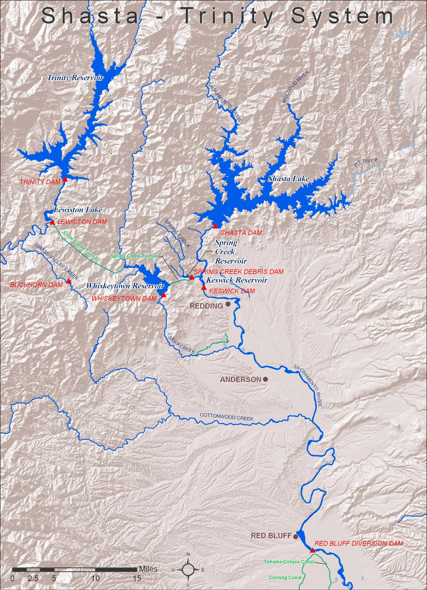
Figure 2-4 Shasta-Trinity System

Safety of Dams at Trinity Reservoir
Periodically, increased water releases are made from Trinity Dam consistent with Reclamation Safety of Dams criteria intended to prevent overtopping of Trinity Dam. Although flood control is not an authorized purpose of the Trinity River Division, flood control benefits are provided through normal operations.
The Safety of Dams release criteria specifies that Carr Powerplant capacity should be used as a first preference destination for Safety of Dams releases made at Trinity Dam. Trinity River releases are made as a second preference destination. During significant Northern California high water flood events, the Sacramento River water stages are also often at concern levels. Under such high water conditions, the water that would otherwise move through Carr Powerplant is routed to the Trinity River. Total river release can reach up to 11,000 cfs from Lewiston Dam (under Safety of Dams criteria) due to local high water concerns in the flood plain and local bridge flow capacities. The Safety of Dam criteria provides seasonal storage targets and recommended releases November 1 to March 31. During the May 2006 the river flows were over 10,000 cfs for several days.

Fish and Wildlife Requirements on Trinity River
Based on the Trinity River Main-stem Fishery Restoration ROD, dated December 19, 2000, from 368,600 af to 815,000 af is allocated annually for Trinity River flows. This amount is scheduled in coordination with the U.S. Fish and Wildlife Service (FWS) to best meet habitat, temperature, and sediment transport objectives in the Trinity Basin.
Temperature objectives for the Trinity River are set forth in SWRCB order WR 90-5. See also Table 2-5 below. These objectives vary by reach and by season. Between Lewiston Dam and Douglas City Bridge, the daily average temperature should not exceed 60 degrees Fahrenheit (°F) from July 1 to September 14, and 56°F from September 15 to September 30. From October 1 to December 31, the daily average temperature should not exceed 56°F between Lewiston Dam and the confluence of the North Fork Trinity River. Reclamation consults with FWS in establishing a schedule of releases from Lewiston Dam that can best achieve these objectives.
For the purpose of determining the Trinity Basin water year type, forecasts using the 50 percent exceedance as of April 1st are used. There are no make-up/or increases for flows forgone if the water year type changes up or down from an earlier 50 percent forecast. In the modeling, actual historic Trinity inflows were used rather than a forecast. There is a temperature curtain in Lewiston Reservoir that provides for temperature management for the diversions to Clear Creek Tunnel.

Table 2-5 Water temperature objectives for the Trinity River during the summer, fall, and winter as established by the CRWQCB-NCR (California Regional Water Quality Control Board North Coast Region).
Date | Temperature Objective (°F)
Date | Douglas City (RM 93.8) | North Fork Trinity River (RM 72.4)
July 1 through Sept 14 | 60 | -
Sept 15 through Sept 30 | 56 | -
Oct 1 through Dec 31 | - | 56

Transbasin Diversions
Diversion of Trinity water to the Sacramento Basin provides limited water supply and hydroelectric power generation for the CVP and assists in water temperature control in the Trinity River and upper Sacramento River. The amounts and timing of the Trinity exports are determined by subtracting Trinity River scheduled flow and targeted carryover storage from the forecasted Trinity water supply.
The seasonal timing of Trinity exports is a result of determining how to make best use of a limited volume of Trinity export (in concert with releases from Shasta) to help conserve cold water pools and meet temperature objectives on the upper Sacramento and Trinity rivers, as well as power production economics. A key consideration in the export timing determination is the thermal degradation that occurs in Whiskeytown Lake due to the long residence time of transbasin exports in the lake.
To minimize the thermal degradation effects, transbasin export patterns are typically scheduled by an operator to provide an approximate 120,000 af volume to occur in late spring to create a thermal connection to the Spring Creek Powerhouse before larger transbasin volumes are scheduled to occur during the hot summer months (Figure 2-5). Typically, the water flowing from the Trinity Basin through Whiskeytown Lake must be sustained at fairly high rates to avoid warming and to function most efficiently for temperature control. The time period for which effective temperature control releases can be made from Whiskeytown Lake may be compressed when the total volume of Trinity water available for export is limited.
Export volumes from Trinity are made in coordination with the operation of Shasta Reservoir. Other important considerations affecting the timing of Trinity exports are based on the utility of power generation and allowances for normal maintenance of the diversion works and generation facilities.

Figure 2-5 Sacramento-Trinity Water Quality Network (with river miles [RM]).
Trinity Lake historically reached its greatest storage level at the end of May. With the present pattern of prescribed Trinity releases, maximum storage may occur by the end of April or in early May.
Reclamation maintains at least 600,000 af in Trinity Reservoir, except during the 10 to 15 percent of the years when Shasta Reservoir is also drawn down. Reclamation will address end of water year carryover on a case-by-case basis in dry and critically dry water year types with FWS and NMFS through the WOMT and B2IT processes.

Whiskeytown Reservoir Operations
Since 1964, a portion of the flow from the Trinity River Basin has been exported to the Sacramento River Basin through the CVP facilities. Water is diverted from the Trinity River at Lewiston Dam via the Clear Creek Tunnel and passes through the Judge Francis Carr Powerhouse as it is discharged into Whiskeytown Lake on Clear Creek. From Whiskeytown Lake, water is released through the Spring Creek Power Conduit to the Spring Creek Powerplant and into Keswick Reservoir. All of the water diverted from the Trinity River, plus a portion of Clear Creek flows, is diverted through the Spring Creek Power Conduit into Keswick Reservoir.
Spring Creek also flows into the Sacramento River and enters at Keswick Reservoir. Flows on Spring Creek are partially regulated by the Spring Creek Debris Dam. Historically (1964-1992), an average annual quantity of 1,269,000 af of water has been diverted from Whiskeytown Lake to Keswick Reservoir. This annual quantity is approximately 17 percent of the flow measured in the Sacramento River at Keswick.
Whiskeytown is normally operated to (1) regulate inflows for power generation and recreation; (2) support upper Sacramento River temperature objectives; and (3) provide for releases to Clear Creek consistent with the CVPIA Anadromous Fish Restoration Program (AFRP) objectives. Although it stores up to 241,000 af, this storage is not normally used as a source of water supply. There are two temperature curtains in Whiskeytown Reservoir.

Spillway Flows below Whiskeytown Lake
Whiskeytown Lake is annually drawn down approximately 35,000 af of storage space during November through April to regulate flows for power generation. Heavy rainfall events occasionally result in spillway discharges to Clear Creek, as shown in Table 2-6 below.
Table 2-6 Days of Spilling below Whiskeytown and 40-30-30 Index from Water Year 1978 to 2010
Water Year | Days of Spilling | 40-30-30 Index
1978 | 5 | AN
1979 | 0 | BN
1980 | 0 | AN
1981 | 0 | D
1982 | 63 | W
1983 | 81 | W
1984 | 0 | W
1985 | 0 | D
1986 | 17 | W
1987 | 0 | D
1988 | 0 | C
1989 | 0 | D
1990 | 8 | C
1991 | 0 | C
1992 | 0 | C
1993 | 10 | AN
1994 | 0 | C
1995 | 14 | W
1996 | 0 | W
1997 | 5 | W
1998 | 8 | W
1999 | 0 | W
2000 | 0 | AN
2001 | 0 | D
2002 | 0 | D
2003 | 8 | AN
2004 | 0 | BN
2005 | 0 | AN
2006 | 4 | W
2007 | 0 | D
2008 | 0 | C
2009 | 0 | D
2010 | 6 | BN

Operations at Whiskeytown Lake during flood conditions are complicated by its operational relationship with the Trinity River, Sacramento River, and Clear Creek. On occasion, imports of Trinity River water to Whiskeytown Reservoir may be suspended to avoid aggravating high flow conditions in the Sacramento Basin.

Fish and Wildlife Requirements on Clear Creek
Water rights permits issued by the SWRCB for diversions from Trinity River and Clear Creek specify minimum downstream releases from Lewiston and Whiskeytown Dams, respectively. Two agreements govern releases from Whiskeytown Lake:
- A 1960 Memorandum of Agreement (MOA) with the DFG established minimum flows to be released to Clear Creek at Whiskeytown Dam, Table 2-7.
- A 1963 release schedule for Whiskeytown Dam was developed with FWS and implemented, but never finalized. Although this release schedule was never formalized, Reclamation has operated according to this proposed schedule since May 1963.
Table 2-7 Minimum flows at Whiskeytown Dam from 1960 MOA with the DFG
Period | Minimum flow (cfs)
1960 MOA with the DFG
January 1 - February 28(29) | 50
March 1 - May 31 | 30
June 1 - September 30 | 0
October 1 - October 15 | 10
October 16 - October 31 | 30
November 1 - December 31 | 100
1963 FWS Proposed Normal year flow (cfs)
January 1 - October 31 | 50
November 1 - December 31 | 100
1963 FWS Proposed Critical year flow (cfs)
January 1 - October 31 | 30
November 1 - December 31 | 70

Spring Creek Debris Dam Operations
The Spring Creek Debris Dam (SCDD) is a feature of the Trinity Division of the CVP. It was constructed to regulate runoff containing debris and acid mine drainage from Spring Creek, a tributary to the Sacramento River that enters Keswick Reservoir. The SCDD can store approximately 5,800 af of water. Operation of SCDD and Shasta Dam has allowed some control of the toxic wastes with dilution criteria. In January 1980, Reclamation, the DFG, and the SWRCB executed a Memorandum of Understanding (MOU) to implement actions that protect the Sacramento River system from heavy metal pollution from Spring Creek and adjacent watersheds. Given improved water quality in Spring Creek and at the SCDD site, a modified MOU is under consideration that could modify and update several monitoring requirements and would slightly modify operations of the SCDD.
The MOU identifies agency actions and responsibilities, and establishes release criteria based on allowable concentrations of total copper and zinc in the Sacramento River below Keswick Dam.
The MOU states that Reclamation agrees to operate to dilute releases from SCDD (according to these criteria and schedules provided) and that such operation will not cause flood control parameters on the Sacramento River to be exceeded and will not unreasonably interfere with other project requirements as determined by Reclamation. The MOU also specifies a minimum schedule for monitoring copper and zinc concentrations at SCDD and in the Sacramento River below Keswick Dam. Reclamation has primary responsibility for the monitoring; however, the DFG and the RWQCB also collect and analyze samples on an as-needed basis. Due to more extensive monitoring, improved sampling and analyses techniques, and continuing cleanup efforts in the Spring Creek drainage basin, Reclamation now operates SCDD targeting the more stringent Central Valley Region Water Quality Control Plan (Basin Plan) criteria in addition to the MOU goals. Instead of the total copper and total zinc criteria contained in the MOU, Reclamation operates SCDD releases and Keswick dilution flows to not exceed the Basin Plan standards of 0.0056 mg/L dissolved copper and 0.016 mg/L dissolved zinc. Release rates are estimated from a mass balance calculation of the copper and zinc in the debris dam release and in the river.
In order to minimize the build-up of metal concentrations in the Spring Creek arm of Keswick Reservoir, releases from the debris dam are coordinated with releases from the Spring Creek Powerplant to keep the Spring Creek arm of Keswick Reservoir in circulation with the main water body of Keswick Lake.
The operation of SCDD is complicated during major heavy rainfall events. SCDD reservoir can fill to uncontrolled spill elevations in a relatively short time period, anywhere from days to weeks. Uncontrolled spills at SCDD can occur during major flood events on the upper Sacramento River and also during localized rainfall events in the Spring Creek watershed. During flood control events, Keswick releases may be reduced to meet flood control objectives at Bend Bridge when storage and inflow at Spring Creek Reservoir are high.
Because SCDD releases are maintained as a dilution ratio of Keswick releases to maintain the required dilution of copper and zinc, uncontrolled spills can and have occurred from SCDD. In this operational situation, high metal concentration loads during heavy rainfall are usually limited to areas immediately downstream of Keswick Dam because of the high runoff entering the Sacramento River adding dilution flow. In the operational situation when Keswick releases are increased for flood control purposes, SCDD releases are also increased in an effort to reduce spill potential.
In the operational situation when heavy rainfall events will fill SCDD and Shasta Reservoir will not reach flood control conditions, increased releases from CVP storage may be required to maintain desired dilution ratios for metal concentrations. Reclamation has voluntarily released additional water from CVP storage to maintain release ratios for toxic metals below Keswick Dam. Reclamation has typically attempted to meet the Basin Plan standards but these releases have no established criteria and are dealt with on a case-by-case basis. Since water released for dilution of toxic spills is likely to be in excess of other CVP requirements, such releases increase the risk of a loss of water for other beneficial purposes.

Shasta Division and Sacramento River Division
The CVP’s Shasta Division includes facilities that conserve water in the Sacramento River for (1) flood control, (2) navigation maintenance, (3) agricultural water supplies, (4) M&I water supplies (5) hydroelectric power generation, (6) conservation of fish in the Sacramento River, and (7) protection of the Sacramento-San Joaquin Delta from intrusion of saline ocean water. The Shasta Division includes Shasta Dam, Lake, and Powerplant; Keswick Dam, Reservoir, and Powerplant, and the Shasta Temperature Control Device.
The Sacramento River Division was authorized after completion of the Shasta Division. Total authorized diversions for the Sacramento River Division are approximately 2.8 maf. Historically the total diversion has varied from 1.8 maf in a critically dry year to the full 2.8 maf in wet year. It includes facilities for the diversion and conveyance of water to CVP contractors on the west side of the Sacramento River. The division includes the Sacramento Canals Unit, which was authorized in 1950 and consists of the RBDD, the Corning Pumping Plant, and the Corning and Tehama-Colusa Canals.
The unit was authorized to supply irrigation water to over 200,000 acres of land in the Sacramento Valley, principally in Tehama, Glenn, Colusa, and Yolo counties. Black Butte Dam, which is operated by the U.S. Army Corps of Engineers (Corps), also provides supplemental water to the Tehama-Colusa Canals as it crosses Stony Creek. The operations of the Shasta and Sacramento River divisions are presented together because of their operational inter-relationships.
Shasta Dam is located on the Sacramento River just below the confluence of the Sacramento, McCloud, and Pit Rivers. The dam regulates the flow from a drainage area of approximately 6,649 square miles. Shasta Dam was completed in 1945, forming Shasta Lake, which has a maximum storage capacity of 4,552,000 af. Water in Shasta Lake is released through or around the Shasta Powerplant to the Sacramento River where it is re-regulated downstream by Keswick Dam. A small amount of water is diverted directly from Shasta Lake for M&I uses by local communities.
Keswick Reservoir was formed by the completion of Keswick Dam in 1950. It has a capacity of approximately 23,800 af and serves as an afterbay for releases from Shasta Dam and for discharges from the Spring Creek Powerplant. All releases from Keswick Reservoir are made to the Sacramento River at Keswick Dam. The dam has a fish trapping facility that operates in conjunction with the Coleman National Fish Hatchery on Battle Creek.

Flood Control
Flood control objectives for Shasta Lake require that releases be restricted to quantities that will not cause downstream flows or stages to exceed specified levels. These include a flow of 79,000 cfs at the tailwater of Keswick Dam, and a stage of 39.2 feet in the Sacramento River at Bend Bridge gauging station, which corresponds to a flow of approximately 100,000 cfs. Flood control operations are based on regulating criteria developed by the Corps pursuant to the provisions of the Flood Control Act of 1944. Maximum flood space reservation is 1.3 maf, with variable storage space requirements based on an inflow parameter.
Flood control operation at Shasta Lake requires the forecasting of runoff conditions into Shasta Lake, as well as runoff conditions of unregulated creek systems downstream from Keswick Dam, as far in advance as possible. A critical element of upper Sacramento River flood operations is the local runoff entering the Sacramento River between Keswick Dam and Bend Bridge.
The unregulated creeks (major creek systems are Cottonwood Creek, Cow Creek, and Battle Creek) in this reach of the Sacramento River can be very sensitive to a large rainfall event and produce large rates of runoff into the Sacramento River in short time periods. During large rainfall and flooding events, the local runoff between Keswick Dam and Bend Bridge can exceed 100,000 cfs.
The travel time required for release changes at Keswick Dam to affect Bend Bridge flows is approximately 8 to 10 hours. If the total flow at Bend Bridge is projected to exceed 100,000 cfs, the release from Keswick Dam is decreased to maintain Bend Bridge flow below 100,000 cfs. As the flow at Bend Bridge is projected to recede, the Keswick Dam release is increased to evacuate water stored in the flood control space at Shasta Lake. Changes to Keswick Dam releases are scheduled to minimize rapid fluctuations in the flow at Bend Bridge.
The flood control criteria for Keswick releases specify releases should not be increased more than 15,000 cfs or decreased more than 4,000 cfs in any 2-hour period. The restriction on the rate of decrease is intended to prevent sloughing of saturated downstream channel embankments caused by rapid reductions in river stage. In rare instances, the rate of decrease may have to be accelerated to avoid exceeding critical flood stages downstream.

Fish and Wildlife Requirements in the Sacramento River
Reclamation operates the Shasta, Sacramento River, and Trinity River divisions of the CVP to meet (to the extent possible) the provisions of SWRCB Order 90-05. An April 5, 1960, MOA between Reclamation and the DFG originally established flow objectives in the Sacramento River for the protection and preservation of fish and wildlife resources. The agreement provided for minimum releases into the natural channel of the Sacramento River at Keswick Dam for normal and critically dry years (Table 2-8). Since October 1981, Keswick Dam has operated based on a minimum release of 3,250 cfs for normal years from September 1 through the end of February, in accordance with an agreement between Reclamation and DFG. This release schedule was included in Order 90-05, which maintains a minimum release of 3,250 cfs at Keswick Dam and RBDD from September through the end of February in all water years, except critically dry years.
Table 2-8 Current minimum flow requirements and objectives (cfs) on the Sacramento River below Keswick Dam
Water year type | MOA | WR 90-5 | MOA and  WR 90-5 | Proposed Flow Objectives below Keswick
Period | Normal | Normal | Critically dry | All
January 1 - February 28(29) | 2600 | 3250 | 2000 | 3250
March 1 - March 31 | 2300 | 2300 | 2300 | 3250
April 1 - April 30 | 2300 | 2300 | 2300 | ---*
May 1 - August 31 | 2300 | 2300 | 2300 | ---*
September 1 - September 30 | 3900 | 3250 | 2800 | ---*
October 1 - November 30 | 3900 | 3250 | 2800 | 3250
December 1 - December 31 | 2600 | 3250 | 2000 | 3250
Note: * No regulation.

The 1960 MOA between Reclamation and the DFG provides that releases from Keswick Dam (from September 1 through December 31) are made with minimum water level fluctuation or change to protect salmon to the extent compatible with other operations requirements. Releases from Shasta and Keswick Dams are gradually reduced in September and early October during the transition from meeting Delta export and water quality demands to operating the system for flood control and fishery concerns from October through December.
Reclamation proposes a minimum flow of 3,250 cfs from October 1 through March 31 and ramping constraints for Keswick release reductions from July 1 through March 31 as follows:
- Releases must be reduced between sunset and sunrise.
- When Keswick releases are 6,000 cfs or greater, decreases may not exceed 15 percent per night. Decreases also may not exceed 2.5 percent in one hour.
- For Keswick releases between 4,000 and 5,999 cfs, decreases may not exceed 200 cfs per night. Decreases also may not exceed 100 cfs per hour.
- For Keswick releases between 3,250 and 3,999 cfs, decreases may not exceed 100 cfs per night.
- Variances to these release requirements are allowed under flood control operations.
Reclamation usually attempts to reduce releases from Keswick Dam to the minimum fishery requirement by October 15 each year and to minimize changes in Keswick releases between October 15 and December 31. Releases may be increased during this period to meet unexpected downstream needs such as higher outflows in the Delta to meet water quality requirements, or to meet flood control requirements. Releases from Keswick Dam may be reduced when downstream tributary inflows increase to a level that will meet flow needs. Reclamation attempts to establish a base flow that minimizes release fluctuations to reduce impacts to fisheries and bank erosion from October through December.
A recent change in agricultural water diversion practices has affected Keswick Dam release rates in the fall. This program is generally known as the Rice Straw Decomposition and Waterfowl Habitat Program. Historically, the preferred method of clearing fields of rice stubble was to systematically burn it. Today, rice field burning has been phased out due to air quality concerns and has been replaced by a program of rice field flooding that decomposes rice stubble and provides additional waterfowl habitat. The result has been an increase in water demand to flood rice fields in October and November, which has increased the need for higher Keswick releases in all but the wettest of fall months.
The changes in agricultural practice over the last decade related to the Rice Straw Decomposition and Waterfowl Habitat Program have been incorporated into the systematic modeling of agricultural use and hydrology effects, and the CalSim-II model used here incorporates these effects. The increased water demand for fall rice field flooding and decomposition on the Sacramento River during this timeframe affects Reclamation’s ability to maintain a stable base flow.

Minimum Flow for Navigation – Wilkins Slough
Historical commerce on the Sacramento River resulted in a CVP authorization to maintain minimum flows of 5,000 cfs at Chico Landing to support navigation. Currently, there is no commercial traffic between Sacramento and Chico Landing, and the Corps has not dredged this reach to preserve channel depths since 1972. However, long-time water users diverting from the river have set their pump intakes just below this level. Therefore, the CVP is operated to meet the navigation flow requirement of 5,000 cfs to Wilkins Slough, (gauging station on the Sacramento River), under all but the most critical water supply conditions, to facilitate pumping and use of screened diversions.
At flows below 5,000 cfs at Wilkins Slough, diverters have reported increased pump cavitation as well as greater pumping head requirements. Diverters are able to operate for extended periods at flows as low as 4,000 cfs at Wilkins Slough, but pumping operations become severely affected and some pumps become inoperable at flows lower than this. Flows may drop as low as 3,500 cfs for short periods while changes are made in Keswick releases to reach target levels at Wilkins Slough, but using the 3,500 cfs rate as a target level for an extended period would have major impacts on diverters.
No criteria have been established specifying when the navigation minimum flow should be relaxed. However, the basis for Reclamation’s decision to operate at less than 5,000 cfs is the increased importance of conserving water in storage when water supplies are not sufficient to meet full contractual deliveries and other operational requirements.

Water Temperature Operations in the Upper Sacramento River
Water temperature in the upper Sacramento River is governed by current water right permit requirements and is consistent with past biological opinion requirements. Water temperature on the Sacramento River system is influenced by several factors, including the relative water temperatures and ratios of releases from Shasta Dam and from the Spring Creek Powerplant. The temperature of water released from Shasta Dam and the Spring Creek Powerplant is a function of the reservoir temperature profiles at the discharge points at Shasta and Whiskeytown, the depths from which releases are made, the seasonal management of the deep cold water reserves, ambient seasonal air temperatures and other climatic conditions, tributary accretions and water temperatures, and residence time in Keswick, Whiskeytown and Lewiston Reservoirs, and in the Sacramento River.

SWRCB Water Rights Order 90-05 and Water Rights Order 91-01
In 1990 and 1991, the SWRCB issued Water Rights Orders 90-05 and 91-01 modifying Reclamation’s water rights for the Sacramento River. The orders stated Reclamation shall operate Keswick and Shasta Dams and the Spring Creek Powerplant to meet a daily average water temperature of 56°F as far downstream in the Sacramento River as practicable during periods when higher temperature would be harmful to fisheries. The optimal control point is the RBDD.
Under the orders, the water temperature compliance point may be modified when the objective cannot be met at RBDD. In addition, Order 90-05 modified the minimum flow requirements initially established in the 1960 MOA for the Sacramento River below Keswick Dam. The water right orders also recommended the construction of a Shasta Temperature Control Device (TCD) to improve the management of the limited cold water resources.
Pursuant to SWRCB Orders 90-05 and 91-01, Reclamation configured and implemented the Sacramento-Trinity Water Quality Monitoring Network to monitor temperature and other parameters at key locations in the Sacramento and Trinity Rivers. The SWRCB orders also required Reclamation to establish the Sacramento River Temperature Task Group (SRTTG) to formulate, monitor, and coordinate temperature control plans for the upper Sacramento and Trinity Rivers. This group consists of representatives from Reclamation, SWRCB, NMFS, FWS, DFG, Western, DWR, and the Hoopa Valley Indian Tribe.
Each year, with finite cold water resources and competing demands usually an issue, the SRTTG will devise operation plans with the flexibility to provide the best protection consistent with the CVP’s temperature control capabilities and considering the annual needs and seasonal spawning distribution monitoring information for winter-run and fall-run Chinook salmon. In every year since the SWRCB issued the orders, those plans have included modifying the RBDD compliance point to make best use of the cold water resources based on the location of spawning Chinook salmon. Reports are submitted periodically to the SWRCB over the temperature control season defining our temperature operation plans. The SWRCB has overall authority to determine if the plan is sufficient to meet water right permit requirements.

Shasta Temperature Control Device
Construction of the Temperature Control Device (TCD) at Shasta Dam was completed in 1997. This device is designed for greater flexibility in managing the cold water reserves in Shasta Lake while enabling hydroelectric power generation to occur and to improve salmon habitat conditions in the upper Sacramento River. The TCD is also designed to enable selective release of water from varying lake levels through the power plant in order to manage and maintain adequate water temperatures in the Sacramento River downstream of Keswick Dam.
Prior to construction of the Shasta TCD, Reclamation released water from Shasta Dam’s low-level river outlets to alleviate high water temperatures during critical periods of the spawning and incubation life stages of the winter-run Chinook stock. Releases through the low-level outlets bypass the power plant and result in a loss of hydroelectric generation at the Shasta Powerplant. The release of water through the low-level river outlets was a major facet of Reclamation’s efforts to control upper Sacramento River temperatures from 1987 through 1996.
The seasonal operation of the TCD is generally as follows: during mid-winter and early spring the highest elevation gates possible are utilized to draw from the upper portions of the lake to conserve deeper colder resources (see Table 2-9). During late spring and summer, the operators begin the seasonal progression of opening deeper gates as Shasta Lake elevation decreases and cold water resources are utilized. In late summer and fall, the TCD side gates are opened to utilize the remaining cold water resource below the Shasta Powerplant elevation in Shasta Lake.

Table 2-9 Shasta Temperature Control Device Gates with Elevation and Storage
TCD Gates | Shasta Elevation with 35 feet of submergence | Shasta Storage
Upper Gates | 1035 | ~3.65 MAF
Middle Gates | 935 | ~2.50 MAF
Pressure Relief Gates | 840 | ~0.67 MAF
Side Gates | 720* | ~0.01 MAF
* Low Level intake bottom.
The seasonal progression of the Shasta TCD operation is designed to maximize the conservation of cold water resources deep in Shasta Lake, until the time the resource is of greatest management value to fishery management purposes. Recent operational experience with the Shasta TCD has demonstrated significant operational flexibility improvement for cold water conservation and upper Sacramento River water temperature and fishery habitat management purposes. Recent operational experience has also demonstrated the Shasta TCD has significant leaks that are inherent to TCD design.

Reclamation’s Proposed Upper Sacramento River Temperature Objectives
Reclamation will continue a policy of developing annual operations plans and water allocations based on a conservative 90 percent exceedance forecast. Reclamation is not proposing a minimum end-of-water-year (September 30) carryover storage in Shasta Reservoir.
In continuing compliance with Water Rights Orders 90-05 and 91-01 requirements, Reclamation will implement operations to provide year round temperature protection in the upper Sacramento River, consistent with the intent of Order 90-05 that protection be provided to the extent controllable. Among factors that affect the extent to which river temperatures will be controllable will include Shasta TCD performance, the availability of cold water, the balancing of habitat needs for different species in spring, summer, and fall, and the constraints on operations created by the combined effect of the projects and demands assumed to be in place in the future.
Under all but the most adverse drought and low Shasta Reservoir storage conditions, Reclamation proposes to continue operating CVP facilities to provide water temperature control at Ball’s Ferry or at locations further downstream (as far as Bend Bridge) based on annual plans developed in coordination with the Sacramento River Temperature Task Group (SRTTG). Reclamation and the SRTTG will take into account projections of cold water resources, numbers of expected spawning salmon, and spawning distribution (as monitoring information becomes available) to make the decisions on allocation of the cold water resources.
Locating the target temperature compliance at Ball’s Ferry (1) reduces the need to compensate for the warming effects of Cottonwood Creek and Battle Creek during the spring runoff months with deeper cold water releases and (2) improves the reliability of cold water resources through the fall months. Reclamation proposes Sacramento River temperature control point to be consistent with the capability of the CVP to manage cold water resources and to use the process of annual planning in coordination with the SRTTG to arrive at the best use of that capability.

Anderson-Cottonwood Irrigation District (ACID) Diversion Dam
ACID holds senior water rights and has diverted into the ACID Canal for irrigation along the west side of the Sacramento River between Redding and Cottonwood since 1916. The United States and ACID signed a contract providing for the project water service and agreement on diversion of water. ACID diverts to its main canal (on the right bank of the river) from a diversion dam located in Redding about five miles downstream from Keswick Dam.
Close coordination is required between Reclamation and ACID for regulation of river flows to ensure safe operation of ACIDs diversion dam during the irrigation season. The irrigation season for ACID runs from April through October.
Keswick release rate decreases required for the ACID operations are limited to 15 percent in a 24-hour period and 2.5 percent in any one hour. Therefore, advance notification is important when scheduling decreases to allow for the installation or removal of the ACID diversion dam.

Red Bluff Diversion Dam Operations
The Red Bluff Diversion Dam (RBDD), located on the Sacramento River approximately two miles southeast of Red Bluff, is a gated structure with fish ladders at each abutment. When the gates are lowered, the impounded water rises about 13 feet, creating Lake Red Bluff and allowing gravity diversions through a set of drum fish screens into the stilling basin servicing the Tehama-Colusa and Corning canals. Construction of RBDD was completed in 1964.
The Tehama-Colusa Canal is a lined canal extending 111 miles south from the RBDD and provides irrigation service on the west side of the Sacramento Valley in Tehama, Glenn, Colusa, and northern Yolo counties. Construction of the Tehama-Colusa Canal began in 1965, and it was completed in 1980.
The Corning Pumping Plant lifts water approximately 56 feet from the screened portion of the settling basin into the unlined, 21 mile-long Corning Canal. The Corning Canal was completed in 1959, to provide water to the CVP contractors in Tehama County that could not be served by gravity from the Tehama-Colusa Canal. The Tehama-Colusa Canal Authority (TCCA) operates both the Tehama-Colusa and Corning canals.
Since 1986, the RBDD gates have been raised during winter months to improve passage conditions for winter-run Chinook salmon and spring-run Chinook salmon. As documented in the 2004 NMFS biological opinion addressing the long-term CVP and SWP operations and in the recent past, the gates are raised from approximately September 15 through May 14, each year. Future gate operations are further modified by the Red Bluff Fish Passage Improvement Project as detailed below.

Red Bluff Fish Passage Improvement Project and Red Bluff Diversion Dam Pumping Plant
Reclamation signed a ROD on July 16, 2008 for the Red Bluff Fish Passage Improvement Project. The project includes reoperation of the RBDD to allow future unrestricted fish passage and features construction of a new pumping plant to enhance pumping capacity while the RBDD gates are open. Reclamation completed ESA section 7 consultations with FWS and the NMFS to address construction and operation of the new pumping plant at a maximum capacity of 2,500 cfs.
The new pumping plant is currently under construction, and is scheduled to be operational by May 2012. In 2009 Reclamation agreed to only operate the RBDD with the gates in from June 15 to August 31 during the construction of the new pumping plant. In the absence of any unforeseen or unavoidable pumping plant construction delays, the RBDD will be operated with gates out permanently after May 15, 2012.

American River Division
Reclamation’s Folsom Lake, the largest reservoir in the watershed, has a capacity of 977,000 af. Folsom Dam, located approximately 30 miles upstream from the confluence with the Sacramento River, is operated as a major component of the CVP. The American River Division includes facilities that provide conservation of water on the American River for flood control, fish and wildlife protection, recreation, protection of the Delta from intrusion of saline ocean water, irrigation and M&I water supplies, and hydroelectric power generation. Initially authorized features of the American River Division included Folsom Dam, Lake, and Powerplant; Nimbus Dam and Powerplant, and Lake Natoma. See map in Figure 2-6.
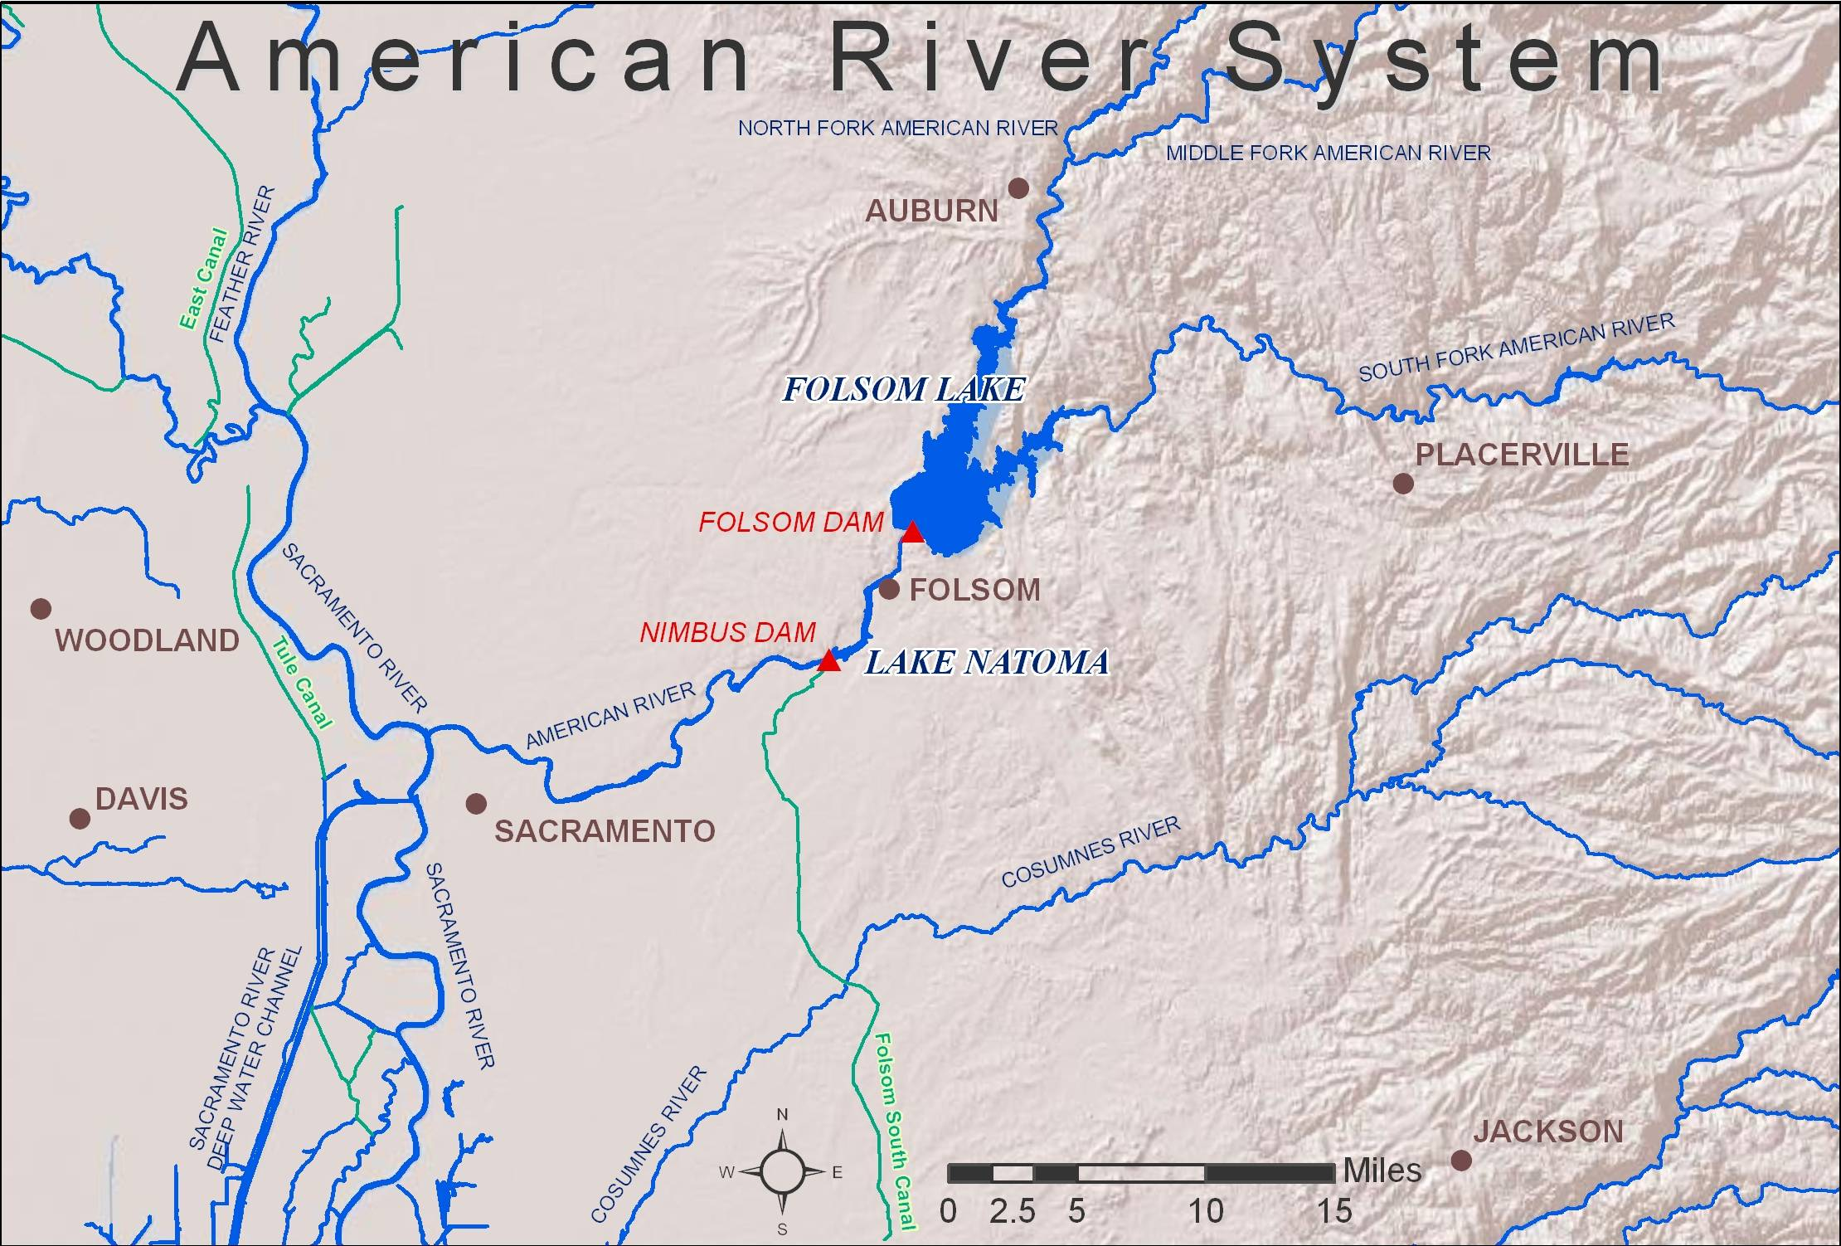
Figure 2-6 American River System

Table 2-10 provides Reclamation’s annual water deliveries for the period 2000 through 2010 in the American River Division. The totals reveal an increasing trend in water deliveries over that period. For this Biological Assessment, present level of American River Division water demands are modeled at about 325 taf per year. Future level (2030) water demands are modeled at near 800 taf per year. The modeled deliveries vary depending on modeled annual water allocations.
Table 2-10 Annual Water Delivery - American River Division
Year | Water Delivery (taf)¹
2000 | 174
2001 | 223
2002 | 221
2003 | 270
2004 | 266
2005 | 297
2006 | 280
2007 | 113
2008 | 233
2009 | 260
2010 | 125
1 Annual Water Delivery data has been enhanced and the annual totals include CVP contracts, water rights and other deliveries.
Releases from Folsom Dam are re-regulated approximately seven miles downstream by Nimbus Dam. This facility is also operated by Reclamation as part of the CVP. Nimbus Dam creates Lake Natoma, which serves as a forebay for diversions to the Folsom South Canal. This CVP facility serves water to M&I users in Sacramento County. Releases from Nimbus Dam to the American River pass through the Nimbus Powerplant, or, at flows in excess of 5,000 cfs, the spillway gates.
Although Folsom Lake is the main storage and flood control reservoir on the American River, numerous other small reservoirs in the upper basin provide hydroelectric generation and water supply. None of the upstream reservoirs have any specific flood control responsibilities. The total upstream reservoir storage above Folsom Lake is approximately 820,000 af. Ninety percent of this upstream storage is contained by five reservoirs: French Meadows (136,000 af); Hell Hole (208,000 af); Loon Lake (76,000 af); Union Valley (271,000 af); and Ice House (46,000 af). Reclamation has agreements with the operators of some of these reservoirs to coordinate operations for releases.
French Meadows and Hell Hole reservoirs, located on the Middle Fork of the American River, are owned and operated by the Placer County Water Agency (PCWA). The PCWA provides wholesale water to agricultural and urban areas within Placer County. For urban areas, PCWA operates water treatment plants and sells wholesale treated water to municipalities that provide retail delivery to their customers. The cities of Rocklin and Lincoln receive water from PCWA. Loon Lake (also on the Middle Fork), and Union Valley and Ice House reservoirs on the South Fork, are all operated by the Sacramento Municipal Utilities District (SMUD) for hydropower purposes.

Flood Control
Flood control requirements and regulating criteria are specified by the Corps and described in the Folsom Dam and Lake, American River, California Water Control Manual (Corps 1987). Flood control objectives for the Folsom unit require the dam and lake are operated to:
- Protect the City of Sacramento and other areas within the Lower American River floodplain against reasonable probable rain floods.
- Control flows in the American River downstream from Folsom Dam to existing channel capacities, insofar as practicable, and to reduce flooding along the lower Sacramento River and in the Delta in conjunction with other CVP projects.
- Provide the maximum amount of water conservation storage without impairing the flood control functions of the reservoir.
- Provide the maximum amount of power practicable and be consistent with required flood control operations and the conservation functions of the reservoir.
From June 1 through September 30, no flood control storage restrictions exist. From October 1 through November 16 and from April 20 through May 31, reserving storage space for flood control is a function of the date only, with full flood reservation space required from November 17 through February 7. Beginning February 8 and continuing through April 20, flood reservation space is a function of both date and current hydrologic conditions in the basin.
If the inflow into Folsom Reservoir causes the storage to encroach into the space reserved for flood control, releases from Nimbus Dam are increased. Flood control regulations prescribe the following releases when water is stored within the flood control reservation space:
- Maximum inflow (after the storage entered into the flood control reservation space) of as much as 115,000 cfs, but not less than 20,000 cfs, when inflows are increasing.
- Releases will not be increased more than 15,000 cfs or decreased more than 10,000 cfs during any two-hour period.
- Flood control requirements override other operational considerations in the fall and winter period. Consequently, changes in river releases of short duration may occur.
In February 1986, the American River Basin experienced a significant flood event. Folsom Dam and Reservoir moderated the flood event and performed the flood control objectives, but with serious operational strains and concerns in the Lower American River and the overall protection of the communities in the floodplain areas. A similar flood event occurred in January 1997. Since then, significant review and enhancement of Lower American River flooding issues has occurred and continues to occur. A major element of those efforts has been the Sacramento Area Flood Control Agency (SAFCA) sponsored flood control plan diagram for Folsom Reservoir.
Since 1996, Reclamation has operated according to modified flood control criteria, which reserve 400 to 670 thousand af of flood control space in Folsom and in a combination of three upstream reservoirs. This flood control plan, which provides additional protection for the Lower American River, is implemented through an agreement between Reclamation and the SAFCA. The terms of the agreement allow some of the empty reservoir space in Hell Hole, Union Valley, and French Meadows to be treated as if it were available in Folsom.
The SAFCA release criteria are generally equivalent to the Corps plan, except the SAFCA diagram may prescribe flood releases earlier than the Corps plan. The SAFCA diagram also relies on Folsom Dam outlet capacity to make the earlier flood releases. The outlet capacity at Folsom Dam is currently limited to 32,000 cfs based on lake elevation. However, in general the SAFCA plan diagram provides greater flood protection than the existing Corps plan for communities in the American River floodplain.
Required flood control space under the SAFCA diagram will begin to decrease on March 1. Between March 1 and April 20, the rate of filling is a function of the date and available upstream space. As of April 21, the required flood reservation is about 225,000 af. From April 21 to June 1, the required flood reservation is a function of the date only, with Folsom Reservoir storage permitted to fill completely on June 1.
Reclamation and the Corps are jointly working on construction of an auxiliary spillway that will assist in meeting the established flood damage reduction objectives for the Sacramento area (at least 1-in-200-year flood protection) while continuing to preserve and expedite safely passing the Probable Maximum Flood. This project is commonly referred as the Joint Federal Project. Other partners in this project include the Department of Water Resources and SAFCA.
The Corps is also undertaking a Folsom Dam Reoperation Study to develop, evaluate, and recommend changes to the flood control operations of the Folsom Dam project that will further the goal of reduced flood risk for the Sacramento area. Operational changes may be necessary to fully realize the flood risk reduction benefits of the additional operational capabilities created by completion of the Joint Federal Project, and the increased system capabilities provided by the implemented and authorized features of the Common Features Project (a project being carried by the Corps designed to strengthen the American River levees so they can safely pass a flow of 160,000 cfs), and those anticipated to be provided by completion of the authorized Folsom Dam Mini-Raise Project. The Folsom Dam Reoperation Study will also consider improved forecasts from the National Weather Service. Once a modified flood operation plan is complete, the Corps, in cooperation with Reclamation, will consult with FWS and NMFS relative to any changes to American River and/or system-wide CVP operations that may result.

Fish and Wildlife Requirements in the Lower American River
The minimum allowable flows in the Lower American River are defined by SWRCB Decision 893 (D-893) which states that, in the interest of fish conservation, releases should not ordinarily fall below 250 cfs between January 1 and September 15 or below 500 cfs at other times. D-893 minimum flows are rarely the controlling objective of CVP operations at Nimbus Dam. Nimbus Dam releases are nearly always controlled during significant portions of a water year by either flood control requirements or are coordinated with other CVP and SWP releases to meet downstream Sacramento-San Joaquin Delta WQCP requirements and CVP water supply objectives. Power regulation and management needs occasionally control Nimbus Dam releases. Nimbus Dam releases are expected to exceed the D-893 minimum flows in all but the driest of conditions.
In July 2006, Reclamation, the Sacramento Area Water Forum and other stakeholders completed a draft technical report establishing a flow regime intended to improve conditions for fish in the lower American River (i.e., the Lower American River Flow Management Standard [FMS]). Reclamation began operating to the FMS immediately thereafter. Reclamation continues to operate to this flow regime and the modeling assumptions herein include the operational components of the recommended Lower American River flows consistent with the proposed FMS (Appendix A). Until this action is adopted by the SWRCB, the minimum legally required flows will be defined by D-893. However, Reclamation intends to operate to the proposed flow management standard using releases of additional water pursuant to Section 3406 (b)(2) of the CVPIA, if necessary.
Use of additional (b)(2) flows above the proposed flow standard is envisioned only on a case-by-case basis. Such additional use of (b)(2) flows would be subject to available resources and such use would be coupled with plans to not intentionally cause significantly lower river flows later in a water year. This case-by-case use of additional (b)(2) for minimum flows is not included in the modeling results.
Water temperature control operations in the Lower American River are affected by many factors and operational tradeoffs. These include available cold water resources, Nimbus release schedules, annual hydrology, Folsom power penstock shutter management flexibility, Folsom Dam Urban Water Supply TCD management, and Nimbus Hatchery considerations. Shutter and TCD management provide the majority of operational flexibility used to control downstream temperatures.
During the late 1960s, Reclamation designed a modification to the trashrack structures to provide selective withdrawal capability at Folsom Dam. Folsom Powerplant is located at the foot of Folsom Dam on the right abutment. Three 15-foot-diameter steel penstocks for delivering water to the turbines are embedded in the concrete section of the dam. The centerline of each penstock intake is at elevation 307.0 feet and the minimum power pool elevation is 328.5 feet. A reinforced concrete trashrack structure with steel trashracks protects each penstock intake.
The steel trashracks, located in five bays around each intake, extend the full height of the trashrack structure (between 281 and 428 feet). Steel guides were attached to the upstream side of the trashrack panels between elevation 281 and 401 feet. Forty-five 13-foot steel shutter panels (nine per bay) and operated by the gantry crane, were installed in these guides to select the level of withdrawal from the reservoir. The shutter panels are attached to one another, in a configuration starting with the top shutter, in groups of three, two, and four.
Selective withdrawal capability on the Folsom Dam Urban Water Supply Pipeline became operational in 2003. The centerline to the 84-inch-diameter Urban Water Supply intake is at elevation 317 feet. An enclosure structure extending from just below the water supply intake to an elevation of 442 feet was attached to the upstream face of Folsom Dam. A telescoping control gate allows for selective withdrawal of water anywhere between 331 and 401 feet elevation under normal operations.
The current objectives for water temperatures in the Lower American River address the needs for steelhead incubation and rearing during the late spring and summer, and for fall–run Chinook spawning and incubation starting in late October or early November.
A major challenge is determining the starting date at which time the objective is met. Establishing the start date requires a balancing between forecasted release rates, the volume of available cold water, and the estimated date at which time Folsom Reservoir turns over and becomes isothermic. Reclamation will work to provide suitable spawning temperatures as early as possible (after November 1) to help avoid temperature related pre-spawning mortality of adults and reduced egg viability. Operations will be balanced against the possibility of running out of cold water and increasing downstream temperatures after spawning is initiated and creating temperature related effects to eggs already in the gravel.
The cold water resources available in any given year at Folsom Lake needed to meet the stated water temperature goals are often insufficient. Only in wetter hydrologic conditions is the volume of cold water resources available sufficient to meet all the water temperature objectives. Therefore, significant operations tradeoffs and flexibilities are considered part of an annual planning process for coordinating an operation strategy that realistically manages the limited cold water resources available. Reclamation’s coordination on the planning and management of cold water resources is done through the B2IT and ARG groups as discussed earlier in this Chapter.
The management process begins in the spring as Folsom Reservoir fills. All penstock shutters are put in the down position to isolate the colder water in the reservoir below an elevation of 401 feet. The reservoir water surface elevation must be at least 25 feet higher than the sill of the upper shutter (426 feet) to avoid cavitation of the power turbines. The earliest this can occur is in the month of March, due to the need to maintain flood control space in the reservoir during the winter. The pattern of spring run-off is then a significant factor in determining the availability of cold water for later use. Folsom inflow temperatures begin to increase and the lake starts to stratify as early as April. By the time the reservoir is filled or reaches peak storage (sometime in the May through June period), the reservoir is highly stratified with surface waters too warm to meet downstream temperature objectives. There are, however, times during the filling process when use of the spillway gates can be used to conserve cold water.
In the spring of 2003, high inflows and encroachment into the allowable storage space for flood control required releases that exceeded the available capacity of the power plant. Under these conditions Folsom Dam standard operations involve the use of the river outlets that would draw upon the cold water pool. Instead, Reclamation reviewed the release requirements, Safety of Dams issues, reservoir water temperature conditions, and the benefits to the cold water pool and determined that the spillway gates should be used to make the incremental releases above powerplant capacity, thereby conserving cold water for later use. The ability and necessity to take similar actions will be evaluated on a case-by-case basis.
The annual temperature management strategy and challenge is to balance conservation of cold water for later use in the fall, with the more immediate needs of steelhead during the summer. The planning and forecasting process for the use of the cold water pool begins in the spring as Folsom Reservoir fills. Actual Folsom Reservoir cold water resource availability becomes significantly more defined through the assessment of reservoir water temperature profiles and more definite projections of inflows and storage. Technical modeling analysis begins in the spring for the projected Lower American River water temperature management plan. The significant variables and key assumptions in the analysis include:
- Starting reservoir temperature conditions
- Forecasted inflow and outflow quantities
- Assumed meteorological conditions
- Assumed inflow temperatures
- Assumed Water Supply Intake TCD operations
A series of shutter management scenarios are then incorporated into the model to gain a better understanding of the potential for meeting water temperature needs for both over-summer rearing steelhead and spawning Chinook salmon in the fall. Most annual strategies contain significant tradeoffs and risks for water temperature management for steelhead and fall–run Chinook salmon goals and needs due to the frequently limited coldwater resource. The planning process continues throughout the summer. New temperature forecasts and operational strategies are updated as more information on actual operations and ambient conditions is gained. This process is shared with the American River Group (ARG).
Meeting both the summer steelhead and fall salmon temperature objectives without negatively impacting other CVP project purposes requires the final shutter pull be reserved for use in the fall to provide suitable fall-run Chinook salmon spawning temperatures. In most years, the volume of cold water is not sufficient to support strict compliance with the summer water temperature target at the downstream end of the compliance reach (i.e., Watt Avenue Bridge) while at the same time reserving the final shutter pull for fall-run Chinook salmon, or in some cases, continue to meet steelhead over-summer rearing objectives later in the summer. A strategy that is used under these conditions is to allow the annual compliance location water temperatures to warm towards the upper end of the annual water temperature design value before making a shutter pull. This management flexibility is essential to the annual management strategy to extend the effectiveness of cold water management through the summer and fall months.
The Folsom Water Supply Intake TCD has provided additional flexibility to conserve cold water for later use. As anticipated, the TCD has been operated during the summer months and delivers water that is slightly warmer than that which could be used to meet downstream temperatures (60°F to 62°F), but not so warm as to cause significant treatment issues.
Water temperatures feeding the Nimbus Fish Hatchery were historically too high for hatchery operations during some dry or critical years. Water temperatures in the Nimbus Hatchery are generally in the desirable range of 42°F to 55°F, except for the months of June, July, August, and September. When temperatures get above 60°F during these months, the hatchery must begin to treat the fish with chemicals to prevent disease. When temperatures reach the 60°F to 70°F range, treatment becomes difficult and conditions become increasingly dangerous for the fish. In years when mean daily water temperatures are forecast to approach 70°F, a significant number of steelhead may be released early in the summer. Stocked fish have the opportunity to find suitable rearing habitat within the river and reduced densities result in lower mortality in the group of fish that remain in the hatchery.
Reclamation operates Nimbus Dam to maintain the health of the hatchery fish while minimizing the loss of the coldwater pool for fish spawning in the river during fall. Evaluation of Nimbus Dam operations is done on a case-by-case basis and is different in various months and year types. Water temperatures above 70°F in the hatchery usually mean the fish need to be moved to another hatchery or released to the river. The real time implementation of CVPIA AFRP objective flows and meeting SWRCB D-1641 Delta standards with the limited water resources of the Lower American River requires a significant coordination effort to manage the cold water resources at Folsom Lake. Reclamation consults with the FWS, NMFS, and DFG through B2IT when these types of difficult decisions are needed. In addition, Reclamation communicates with the American River Group (ARG) on real time data and operational tradeoffs.
A fish diversion weir at the hatcheries blocks Chinook salmon from continuing upstream and guides them to the hatchery fish ladder entrance. The fish diversion weir consists of eight piers on 30-foot spacing, including two riverbank abutments. Fish rack support frames and walkways are installed each fall via an overhead cable system. A pipe rack is then put in place to support the pipe pickets (¾-inch steel rods spaced on 2½-inch centers). The pipe rack rests on a submerged steel I-beam support frame that extends between the piers and forms the upper support structure for a rock filled crib foundation. The rock foundation has deteriorated with age and is subject to annual scour which can leave holes in the foundation that allow fish to pass if left unattended. Reclamation released the final environmental documentation in August 2011 that selected an alternative to extend the existing fishway up to Nimbus Dam as the solution to the issues associated with the weir. Construction of the new fishway is expected to begin in 2014.
Fish rack supports and pickets are installed around September 15, of each year and correspond with the beginning of the fall-run Chinook salmon spawning season. A release equal to or less than 1,500 cfs from Nimbus Dam is required for safety and to provide full access to the fish rack supports. It takes six people approximately three days to install the fish rack supports and pickets. In years after high winter flows have caused active scour of the rock foundation, a short period (less than eight hours) of lower flow (approximately 500 cfs) is needed to remove debris from the I-beam support frames, seat the pipe racks, and fill holes in the rock foundation. Compete installation can take up to seven days, but is generally completed in less time. The fish rack supports and pickets are usually removed at the end of fall-run Chinook salmon spawning season (mid-January) when flows are less than 2,000 cfs. If Nimbus Dam releases are expected to exceed 5,000 cfs during the operational period, the pipe pickets are removed until flows decrease.

Delta Division and West San Joaquin Division

CVP Facilities
The CVP’s Delta Division includes the Delta Cross Channel (DCC), the Contra Costa Canal and Pumping Plants, Contra Loma Dam, Martinez Dam, the Jones Pumping Plant (formerly Tracy Pumping Plant), the Tracy Fish Collection Facility (TFCF), and the Delta Mendota Canal (DMC). The DCC is a controlled diversion channel between the Sacramento River and Snodgrass Slough. The Contra Costa Water District (CCWD) diversion facilities use CVP water resources to serve district customers directly and to operate CCWD’s Los Vaqueros Project. The Jones Pumping Plant diverts water from the Delta to the head of the DMC. See map in Figure 2-7.
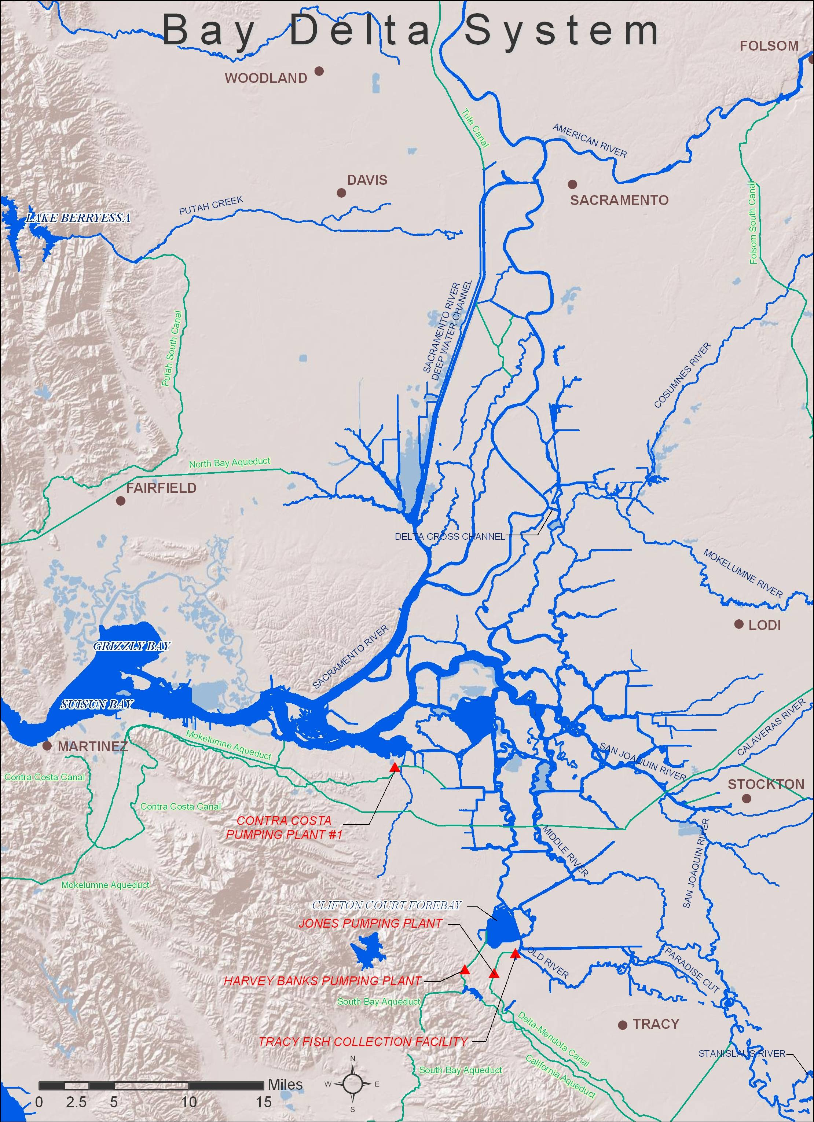
Figure 2-7. Bay-Delta System.

Delta Cross Channel Operations
The DCC is a gated diversion channel in the Sacramento River near Walnut Grove and Snodgrass Slough. Flows into the DCC from the Sacramento River are controlled by two 60-foot by 30-foot radial gates. When the gates are open, water flows from the Sacramento River through the cross channel to channels of the lower Mokelumne and San Joaquin Rivers toward the interior Delta. The DCC operation improves water quality in the interior Delta by improving circulation patterns of good quality water from the Sacramento River towards Delta diversion facilities.
Reclamation operates the DCC in the open position to (1) improve the transfer of water from the Sacramento River to the export facilities at the Banks and Jones Pumping Plants, (2) improve water quality in the southern Delta, and (3) reduce salt water intrusion rates in the western Delta. During the late fall, winter, and spring, the gates are often periodically closed to protect out-migrating salmonids from entering the interior Delta. In addition, whenever flows in the Sacramento River at Sacramento reach 20,000 to 25,000 cfs (on a sustained basis) the gates are closed to reduce potential scouring and flooding that might occur in the channels on the downstream side of the gates.
Flow rates through the gates are determined by Sacramento River stage and are not affected by export rates in the south Delta. The DCC also serves as a link between the Mokelumne River and the Sacramento River for small craft, and is used extensively by recreational boaters and fishermen whenever it is open. Because alternative routes around the DCC are quite long, Reclamation tries to provide adequate notice of DCC closures so boaters may plan for the longer excursion.
SWRCB D-1641 DCC standards provide for closure of the DCC gates for fisheries protection at certain times of the year. From November through January, the DCC may be closed for up to 45 days for fishery protection purposes. From February 1 through May 20, the gates are closed for fishery protection purposes. The gates may also be closed for 14 days for fishery protection purposes during the May 21 through June 15 time period. Reclamation determines the timing and duration of the closures after discussion with FWS, DFG, and NMFS. These discussions will occur through WOMT as part of the weekly review of CVP/SWP operations.
WOMT typically relies on monitoring for fish presence and movement in the Sacramento River and Delta, the salvage of salmon at the Tracy and Skinner facilities, and hydrologic cues when considering the timing of DCC closures. However, the overriding factors are current water quality conditions in the interior and western Delta. From mid-June to November, Reclamation usually keeps the gates open on a continuous basis. The DCC is also usually opened for the busy recreational Memorial Day weekend, if this is possible from a fishery, water quality, and flow standpoint.
The Salmon Decision Process (see Appendix B) includes “Indicators of Sensitive Periods for Salmon” such as hydrologic changes, detection of spring-run salmon or spring-run salmon surrogates at monitoring sites or the salvage facilities, and turbidity increases at monitoring sites to trigger the Salmon Decision Process.
The Salmon Decision Process is used by the fishery agencies and project operators to facilitate the often complex coordination issues surrounding DCC gate operations and the purposes of fishery protection closures, Delta water quality, and/or export reductions. Inputs such as fish life stage and size development, current hydrologic events, fish indicators (such as the Knight’s Landing Catch Index and Sacramento Catch Index), and salvage at the export facilities, as well as current and projected Delta water quality conditions, are used to determine potential DCC closures and/or export reductions. The coordination process has worked well during the recent fall and winter DCC operations and is expected to be used in the present or modified form in the future.

Jones Pumping Plant
The CVP and SWP use the Sacramento River, San Joaquin River, and Delta channels to transport water to export pumping plants located in the south Delta. The CVP’s Jones Pumping Plant, about five miles north of Tracy, consists of six available pumps. The Jones Pumping Plant is located at the end of an earth-lined intake channel about 2.5 miles in length. At the head of the intake channel, louver screens (that are part of the TFCF) intercept fish, which are then collected, held, and transported by tanker truck to release sites far away from the pumping plants.
Jones Pumping Plant has a permitted diversion capacity of 4,600 cfs with maximum pumping rates typically ranging from 4,500 to 4,300 cfs during the peak of the irrigation season and approximately 4,200 cfs during the winter non-irrigation season until construction and full operation of the proposed DMC/California Aqueduct Intertie, described on page 2-124. The winter-time constraints at the Jones Pumping Plant are the result of a DMC freeboard constriction between Jones Pumping Plant and O’Neill Forebay, O’Neill Pumping Plant capacity, and the current water demand in the upper sections of the DMC.

Tracy Fish Collection Facility
The TFCF is located in the south-west portion of the Sacramento-San Joaquin Delta and uses behavioral barriers consisting of primary and secondary louvers as illustrated in Figure 2-8, to guide entrained fish into holding tanks before transport by truck to release sites within the Delta. The original design of the TFCF focused on smaller fish (<200 mm) that would have difficulty fighting the strong pumping plant induced flows since the intake is essentially open to the Delta and also impacted by tidal action.
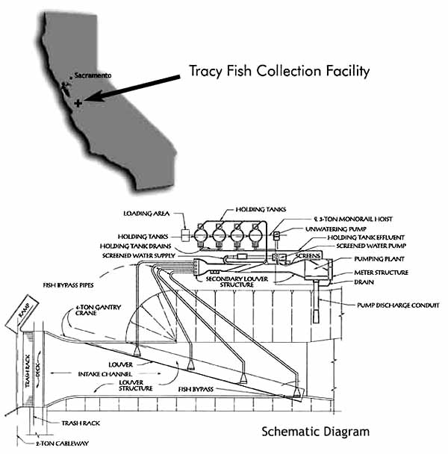

Figure 2-8 Tracy Fish Collection Facility Diagram
The primary louvers are located in the primary channel just downstream of the trashrack structure. The secondary louvers are located in the secondary channel just downstream of the traveling water screen. The louvers allow water to pass through onto the pumping plant but the openings between the slats are tight enough and angled against the flow of water such a way as to prevent most fish from passing between them and instead enter one of four bypass entrances along the louver arrays.
There are approximately 52 different species of fish entrained into the TFCF per year; however, the total numbers are significantly different for the various species salvaged. Also, it is difficult if not impossible to determine exactly how many safely make it all the way to the collection tanks awaiting transport back to the Delta. Hauling trucks used to transport salvaged fish to release sites inject oxygen and contain an eight parts per thousand salt solution to reduce stress. The CVP uses two release sites, one on the Sacramento River near Horseshoe Bend and the other on the San Joaquin River immediately upstream of the Antioch Bridge. During a facility inspection a few years ago, TFCF personnel noticed significant decay of the transition boxes and conduits between the primary and secondary louvers. The temporary rehabilitation of these transition boxes and conduits was performed during the fall and winter of 2002. Extensive rehabilitation of the transition boxes and conduits was completed during the San Joaquin pulse period of 2004.
When south Delta hydraulic conditions allow, and within the original design criteria for the TFCF, the louvers are operated with the D-1485 and federal ESA BO objectives of achieving water approach velocities: for striped bass of approximately 1 foot per second (ft/s) from May 15 through October 31, and for salmon of approximately 3 ft/s from November 1 through May 14. Channel velocity criteria are a function of bypass ratios through the facility. Due to changes in south Delta hydrology over the past fifty years, the present-day TFCF is able to meet these conditions approximately 55 percent of the time.
Fish passing through the facility will be sampled at intervals of no less than 20 minutes every 2 hours when listed fish are present, generally December through June. When few fish are present, sampling intervals will be 10 minutes every 2 hours. Fish observed during sampling intervals are identified by species, measured to fork length, examined for marks or tags, and placed in the collection facilities for transport by tanker truck to the release sites in the North Delta away from the pumps. In addition, TFCF personnel are presently required, per the court order, to monitor for the presence of spent female delta smelt in anticipation of expanding the salvage operations to include sub 20 mm larval delta smelt detection.
DFG is leading studies to look at fish survival during the Collection, Handling, Transportation and Release (CHTR) process examining delta smelt injury, stress, survival, and predation. Thus far they have presented initial findings at various interagency meetings (IEP, CVFFRT, and AFS) showing relatively high survival and low injury. Final reports are forthcoming and should be finished within the next year. DWR has concurrently been conducting focused studies examining the release phase of the salvage process including a study examining predation at the point of release and a study examining injury and survival of delta smelt and Chinook salmon through the release pipe. Data analyses for these studies are ongoing and reports should be available in early 2009. Based on these studies, improvements to release operations and/or facilities studies are being implemented.
There does not appear to be any previously generated information on present day efficiencies other than some very limited Tracy Research work for salmon that needs to be redone. The last efficiency and survival studies were the original studies when they were designing and testing the louver concept back in the 1950s/1960s. DFG and USFWS (Jerry Morinaka and Gonzalo Castillo, PI’s) have recently begun a 3 year study examining pre-screen loss and facility/louver efficiency for juvenile and adult delta smelt at the skinner fish facility. DWR has also conducted pre-screen loss and facility efficiency studies for steelhead with a final report due for publication in the early fall 2008.

Contra Costa Water District Diversion Facilities
Contra Costa Water District (CCWD) diverts water from the Delta for irrigation and M&I uses under its CVP contract and under its own water right permits and license, issued by the State Water Resources Control Board (SWRCB). CCWD’s water system includes intake facilities on Mallard Slough, Rock Slough, Old River, and Victoria Canal; the Contra Costa Canal and shortcut pipeline; and the Los Vaqueros Reservoir. The Rock Slough intake facilities, the Contra Costa Canal, and the shortcut pipeline are owned by Reclamation, and operated and maintained by CCWD under contract with Reclamation. Construction of the fish screen at the Rock Slough intake was completed by Reclamation in 2011. Mallard Slough Intake, Old River Intake and Los Vaqueros Reservoir are owned and operated by CCWD.
The Mallard Slough Intake is located at the southern end of a 3,000-foot-long channel running south from Suisun Bay, near Mallard Slough (across from Chipps Island). The Mallard Slough Pump Station was refurbished in 2002, which included constructing a positive barrier fish screen at this intake. The Mallard Slough Intake can pump up to 39.3 cfs. CCWD’s d water rights (License No. 10514 and Permit No. 19856) authorize diversions of up to 26,780 acre-feet per year at Mallard Slough. However, this intake is rarely used due to the generally high salinity at this location. Pumping at the Mallard Slough Intake since 1993 has on average accounted for about 3 percent of CCWD’s total diversions. When CCWD diverts water at the Mallard Slough Intake, CCWD reduces pumping of CVP water at its other intakes.
The Rock Slough Intake is located about four miles southeast of Oakley, where water flows through a positive barrier fish screen into the earth-lined portion of the Contra Costa Canal. The fish screen at this intake was constructed by Reclamation in accordance with the CVPIA and the 1993 FWS Biological Opinion for the Los Vaqueros Project. Completed in 2011, this new fish screen is expected to reduce take of fish through entrainment at the Rock Slough Intake. The Canal connects the fish screen at Rock Slough to Pumping Plant 1, approximately four miles to the west. The earth-lined portion of the Canal is open to tidal influence for approximately 3.7 miles from the Rock Slough fish screen. Approximately 0.3 miles of the Canal immediately east (upstream) of Pumping Plant 1 have been encased in concrete pipe, the first portion of the Contra Costa Canal Encasement Project to be completed. When completed, the Canal Encasement Project will eliminate tidal flows into the Canal. Pumping Plant 1 has capacity to pump up to 350 cfs into the concrete-lined portion of the Canal. Diversions at Rock Slough Intake are typically taken under CVP contract. With completion of the Rock Slough fish screen, CCWD may divert approximately 30 to 50 percent of its total supply through the Rock Slough Intake.
Construction of the Old River Intake was completed in 1997 as a part of the Los Vaqueros Project. The Old River Intake is located on Old River near State Route 4. The intake has a positive-barrier fish screen and a pumping capacity of 250 cfs, and can pump water via pipeline either to the Contra Costa Canal or to Los Vaqueros Reservoir. Diversions at Old River to the Contra Costa Canal are typically taken under CVP contract or under the District’s Los Vaqueros water right (Permit 20749). Pumping to storage in Los Vaqueros Reservoir is limited to 200 cfs by the terms of the Los Vaqueros Project biological opinions and by SWRCB Decision 1629, the SWRCB water right decision for the Los Vaqueros Project. From 1998 through 2009, CCWD has diverted about 80 percent of its total supply through the Old River Intake; with the completion of the Rock Slough fish screen and Middle River Intake, the average percentage of CCWD supply diverted at Old River will decrease. The CCWD’s water diversions that are not made at Rock Slough will now be split between the Middle River and Old River intakes, contingent primarily by the CCWD water quality goals, as described below.
In 2010, CCWD completed construction of the Middle River Intake (formerly referred to as Alternative Intake Project,) on Victoria Canal. The Middle River Intake consist of a new 250 cfs capacity intake on Victoria Canal, with positive-barrier fish screens, and a conveyance pipeline to CCWD’s existing conveyance facilities. Similar to the Old River Intake, the Middle River Intake can be used to either pump to the Contra Costa Canal or to fill the Los Vaqueros Reservoir. Diversions to the Contra Costa Canal are typically taken under CVP contract, while diversions to storage in the Los Vaqueros Reservoir can be taken either under CVP contract or under CCWD’s Los Vaqueros water right (Permit 20749). The effects of the Middle River Intake on delta smelt are covered by the April 27, 2007 FWS biological opinion (amended on May 16, 2007). Effects on salmonids and green sturgeon are covered by the July 13, 2007 NMFS biological opinion for this intake project.
CCWD operates the Middle River Intake together with its other intake facilities to better meet its delivered water quality goals and to better protect listed species. The choice of which intake to use at any given time is based in large part upon salinity, consistent with fish protection requirements in the biological opinions for the Middle River Intake and the Los Vaqueros Project. The Middle River Intake was built as a project to improve the water quality delivered to the CCWD service area, and does not increase CCWD’s average annual diversions from the Delta. However, it can alter the timing and pattern of CCWD’s diversions, because Middle River Intake salinity tends to be lower in the late summer and fall than salinity at CCWD’s other intakes. This could allow CCWD to decrease winter and spring diversions while still meeting water quality goals in the summer and fall through use of the new intake.
Los Vaqueros Reservoir is an off-stream reservoir in the Kellogg Creek watershed to the west of the Delta. Originally constructed as a 100,000 acre foot reservoir in 1997 as part of the Los Vaqueros Project, the facility is used to improve delivered water quality and emergency storage reliability for CCWD’s customers. Los Vaqueros Reservoir is filled with Delta water from either the Old River Intake or the Middle River Intake, when salinity in the Delta is low. In the late summer and fall months, CCWD releases water from Los Vaqueros Reservoir to blend with higher-salinity direct diversions from the Delta to meet CCWD water quality goals. Releases from Los Vaqueros Reservoir are conveyed to the Contra Costa Canal via a pipeline.
Construction of expanded storage capacity at Los Vaqueros Reservoir is ongoing in 2011, with completion scheduled in 2012. This expansion, to 160,000 acre feet, will provide additional water quality and water supply reliability benefits, and will maintain the existing functions of the reservoir. With the expanded reservoir, CCWD’s average annual diversions from the Delta will remain the same as they have been with the 100 TAF reservoir. A Feasibility Study is ongoing to evaluate whether an additional expansion of this reservoir is in the federal interest; a draft Feasibility Report is scheduled for completion by 2013.
CCWD diverts approximately 127 TAF per year in total, and will continue to divert the same amount with the expanded reservoir. Approximately 110 TAF is CVP contract supply. In winter and spring months when the Delta is relatively fresh (generally January through July), deliveries to the CCWD service area are made by direct diversion from the Delta. In addition, when salinity is low enough, Los Vaqueros Reservoir is filled at a rate of up to 200 cfs from the Old River Intake and Middle River Intake. The biological opinions for the Los Vaqueros Project, CCWD’s Incidental Take Permit issued by DFG, and SWRCB D-1629 of the State Water Resources Control Board include fisheries protection measures consisting of a 75-day period during which CCWD does not fill Los Vaqueros Reservoir and a concurrent 30-day period during which CCWD halts all diversions from the Delta, provided that Los Vaqueros Reservoir storage is above emergency levels. The default dates for the no-fill and no-diversion periods are March 15 through May 31 and April 1 through April 30, respectively. The FWS, NMFS and DFG can change these dates to best protect the subject species. CCWD coordinates the filling of Los Vaqueros Reservoir with Reclamation and DWR to avoid water supply impacts to the CVP and SWP. During the no-diversion period, CCWD customer demand is met by releases from Los Vaqueros Reservoir.
In addition to the existing 75-day no-fill period (March 15-May 31) and the concurrent no-diversion 30-day period, CCWD operates to an additional term in the Incidental Take Permit issued by DFG. Under this term, CCWD shall not divert water to store in Los Vaqueros Reservoir for 15 days from February 14 through February 28, provided that reservoir storage is at or above 90 TAF on February 1. If reservoir storage is at or above 80 TAF on February 1, but below 90 TAF, CCWD shall not divert water to storage in Los Vaqueros Reservoir for 10 days from February 19 through February 28. If reservoir storage is at or above 70 TAF on February 1, but below 80 TAF, CCWD shall not divert water to storage in Los Vaqueros Reservoir for 5 days from February 24 through February 28. These dates can be changed to better protect Delta fish species, at the direction of DFG.

Water Demands—Delta Mendota Canal (DMC) and San Luis Unit
Water demands for the DMC and San Luis Unit are primarily composed of three separate types: CVP water service contractors, exchange contractors, and wildlife refuge contractors. A significantly different relationship exists between Reclamation and each of these three groups. Exchange contractors “exchanged” their senior rights to water in the San Joaquin River for a CVP water supply from the Delta. Reclamation thus guaranteed the exchange contractors a firm water supply of 840,000 af per annum, with a maximum reduction under the Shasta critical year criteria to an annual water supply of 650,000 af.
Conversely, water service contractors did not have water rights. Agricultural water service contractors also receive their supply from the Delta, but their supplies are subject to the availability of CVP water supplies that can be developed and reductions in contractual supply can exceed 25 percent. Wildlife refuge contractors provide water supplies to specific managed lands for wildlife purposes and the CVP contract water supply can be reduced under critically dry conditions up to 25 percent.
To achieve the best operation of the CVP, it is necessary to combine the contractual demands of these three types of contractors to achieve an overall pattern of requests for water. In most years sufficient supplies are not available to meet all water demands because of reductions in CVP water supplies which are due to restricted Delta pumping capability. In some dry or critically dry years, water deliveries are limited because there is insufficient storage in northern CVP reservoirs to meet all in-stream fishery objectives including water temperatures, and to make additional water deliveries via the Jones Pumping Plant. The scheduling of water demands, together with the scheduling of the releases of water supplies from the northern CVP to meet those demands, is a CVP operational objective that is intertwined with the Trinity, Sacramento, and American River operations.

East Side Division

New Melones Operations
The Stanislaus River originates in the western slopes of the Sierra Nevada and drains a watershed of approximately 900 square miles. The average unimpaired runoff in the basin is approximately 1.2 maf per year; the median historical unimpaired runoff is 1.1 maf per year. Snowmelt contributes the largest portion of the flows in the Stanislaus River, with the highest runoff occurring in the months of April, May, and June. Agricultural water supply development in the Stanislaus River watershed began in the 1850s and has significantly altered the basin’s hydrologic conditions. See map in Figure 2-9.
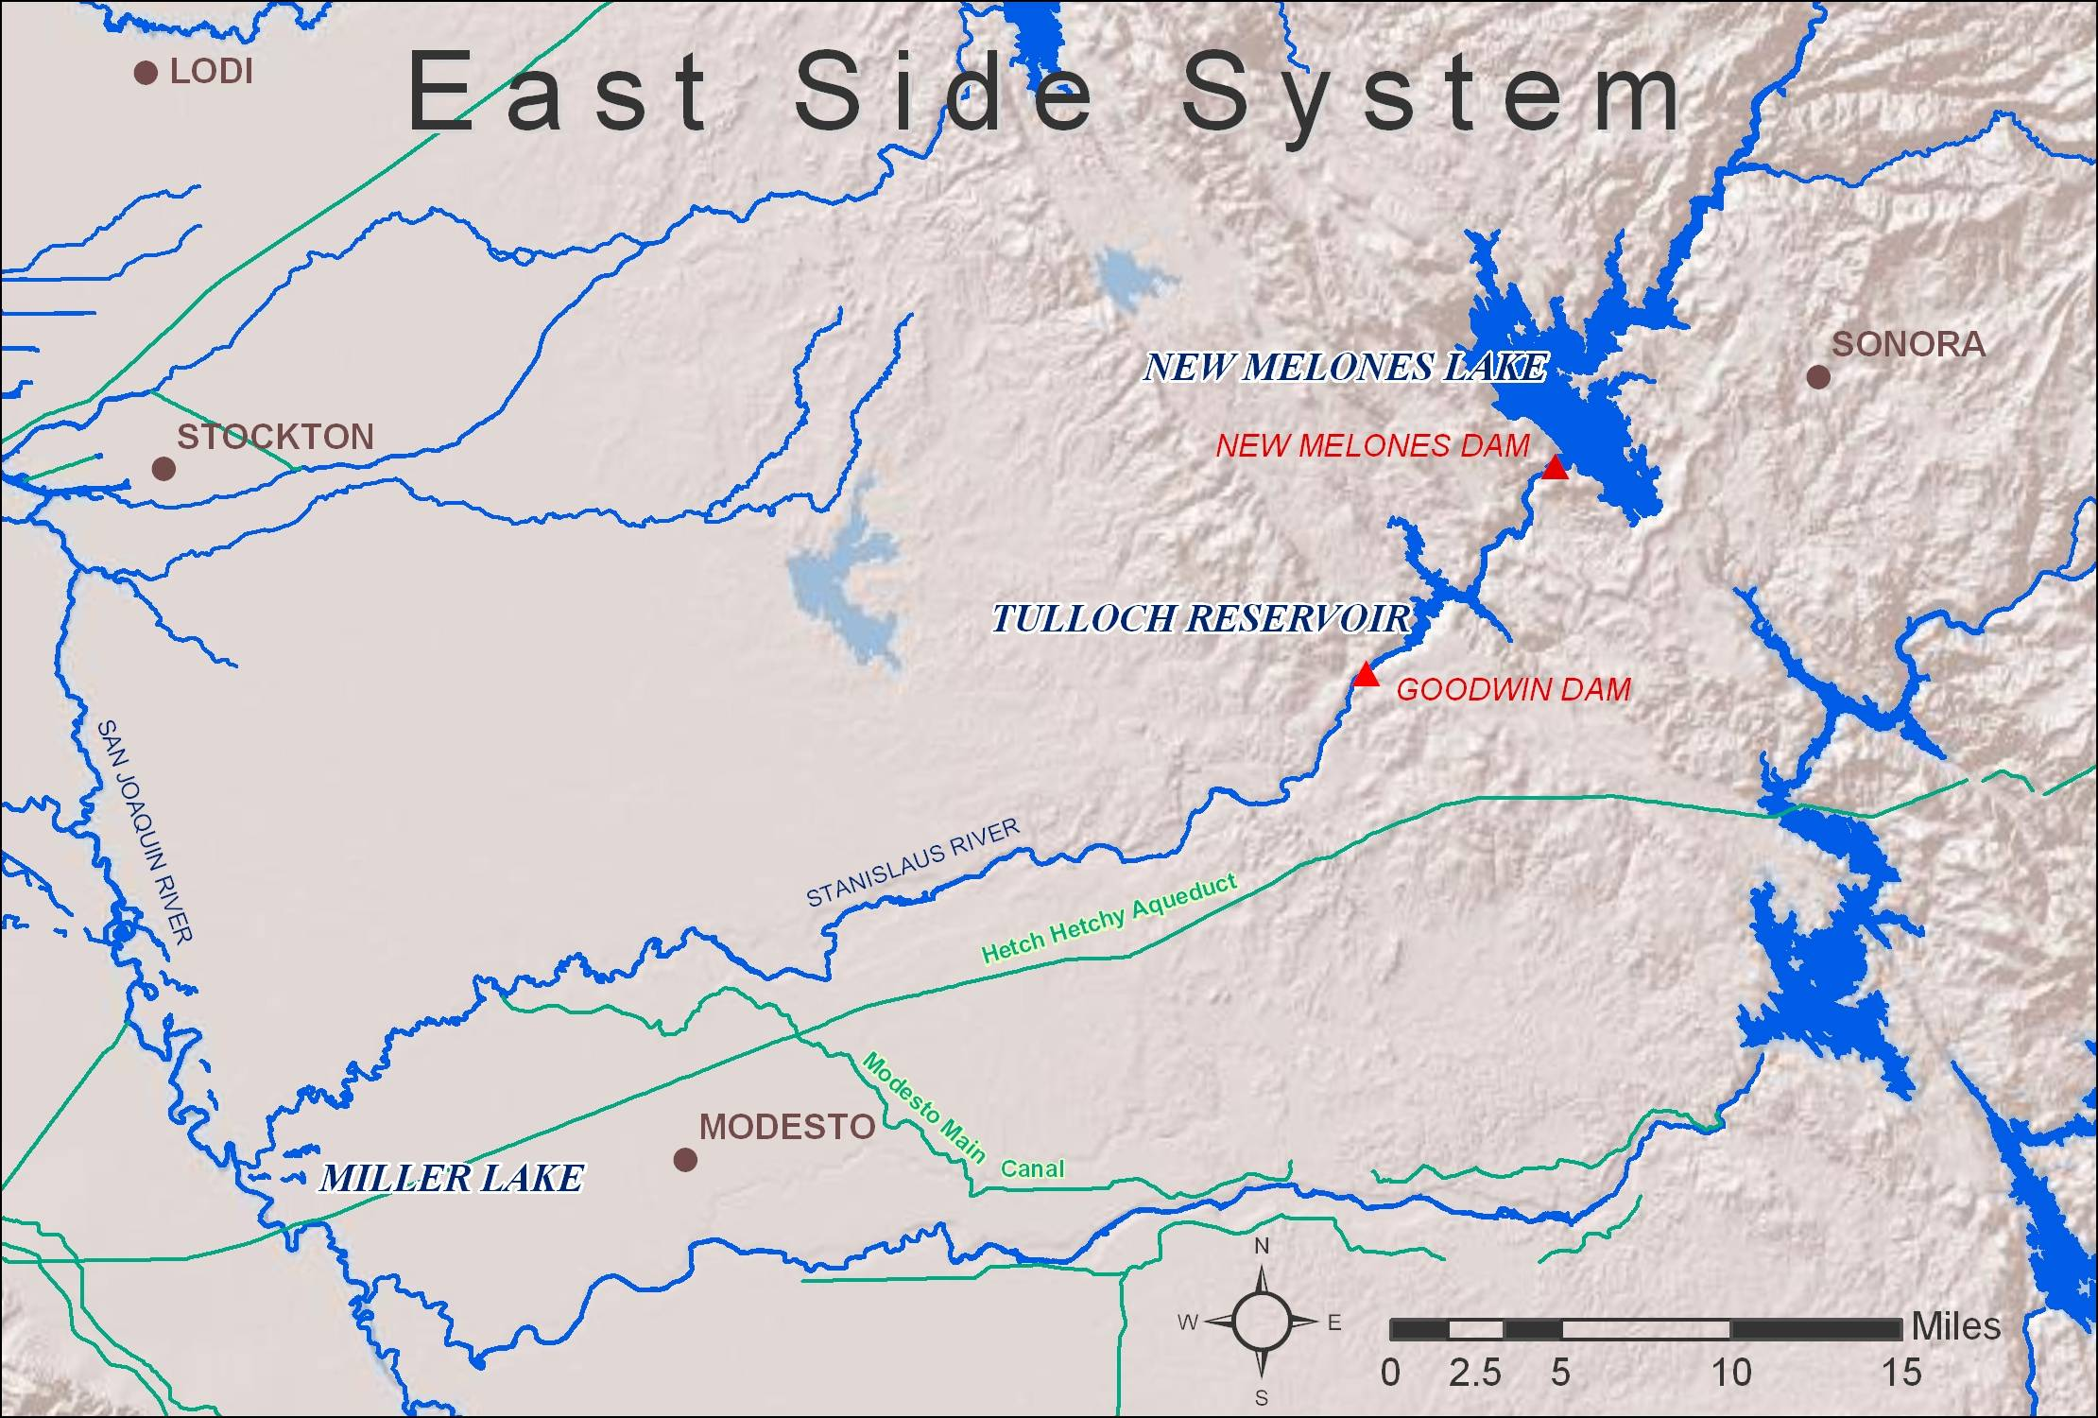
Figure 2-9 East Side System
Currently, the flow in the lower Stanislaus River is primarily controlled by New Melones Reservoir, which has a storage capacity of about 2.4 maf. The reservoir was completed by the Corps in 1978 and approved for filling in 1983. New Melones Reservoir is located approximately 60 miles upstream from the confluence of the Stanislaus River and the San Joaquin River and is operated by Reclamation. Congressional authorization for New Melones integrates New Melones Reservoir as a financial component of the CVP, but it is authorized to provide water supply benefits within the defined Stanislaus Basin per the 1980 ROD before additional water supplies can be used out of the defined Stanislaus Basin.
New Melones Reservoir is operated primarily for purposes of water supply, flood control, power generation, fishery enhancement, and water quality improvement in the lower San Joaquin River. The reservoir and river also provide recreation benefits. Flood control operations are conducted in conformance with the Corps’s operational guidelines.
Another major water storage project in the Stanislaus River watershed is the Tri-Dam Project, a power generation project that consists of Donnells and Beardsley Dams, located upstream of New Melones Reservoir on the middle fork Stanislaus River, and Tulloch Dam and Powerplant, located approximately 6 miles downstream of New Melones Dam on the main stem Stanislaus River. New Spicer Reservoir on the north fork of the Stanislaus River has a storage capacity of 189,000 af and is used for power generation.
Releases from Donnells and Beardsley Dams affect inflows to New Melones Reservoir. Under contractual agreements between Reclamation, the Oakdale Irrigation District (OID), and South San Joaquin Irrigation District (SSJID), Tulloch Reservoir provides afterbay storage to re-regulate power releases from New Melones Powerplant. The main water diversion point on the Stanislaus River is Goodwin Dam, located approximately 1.9 miles downstream of Tulloch Dam.
Goodwin Dam, constructed by OID and SSJID in 1912, creates a re-regulating reservoir for releases from Tulloch Powerplant and provides for diversions to canals north and south of the Stanislaus River for delivery to OID and SSJID. Water impounded behind Goodwin Dam may be pumped into the Goodwin Tunnel for deliveries to the Central San Joaquin Water Conservation District and the Stockton East Water District.
Twenty ungaged tributaries contribute flow to the lower portion of the Stanislaus River, below Goodwin Dam. These streams provide intermittent flows, occurring primarily during the months of November through April. Agricultural return flows, as well as operational spills from irrigation canals receiving water from both the Stanislaus and Tuolumne Rivers, enter the lower portion of the Stanislaus River. In addition, a portion of the flow in the lower reach of the Stanislaus River originates from groundwater accretions.

Flood Control
The New Melones Reservoir flood control operation is coordinated with the operation of Tulloch Reservoir. The flood control objective is to maintain flood flows at the Orange Blossom Bridge at less than 8,000 cfs. When possible, however, releases from Tulloch Dam are maintained at levels that would not result in downstream flows in excess of 1,250 cfs to 1,500 cfs because of seepage problems in agricultural lands adjoining the river associated with flows above this level. Up to 450,000 af of the 2.4 maf storage volume in New Melones Reservoir is dedicated for flood control and 10,000 af of Tulloch Reservoir storage is set aside for flood control. Based upon the flood control diagrams prepared by the Corps, part or all of the dedicated flood control storage may be used for conservation storage, depending on the time of year and the current flood hazard.

Requirements for New Melones Operations
The operating criteria for New Melones Reservoir are affected by (1) water rights, (2) in-stream fish and wildlife flow requirements (3) SWRCB D-1641 Vernalis water quality requirements, (4) dissolved oxygen (DO) requirements on the Stanislaus River, (5) SWRCB D-1641 Vernalis flow requirements, (6) CVP contracts, and (7) flood control considerations. Water released from New Melones Dam and Powerplant is re-regulated at Tulloch Reservoir and is either diverted at Goodwin Dam or released from Goodwin Dam to the lower Stanislaus River.
Flows in the lower Stanislaus River serve multiple purposes concurrently. The purposes include water supply for riparian water right holders, fishery management objectives, and DO requirements per SWRCB D-1422. In addition, water from the Stanislaus River enters the San Joaquin River where it contributes to flow and helps improve water quality conditions at Vernalis. D-1422, issued in 1973, provided the primary operational criteria for New Melones Reservoir and permitted Reclamation to appropriate water from the Stanislaus River for irrigation and M&I uses. D-1422 requires the operation of New Melones Reservoir include releases for existing water rights, fish and wildlife enhancement, and the maintenance of water quality conditions on the Stanislaus and San Joaquin Rivers.

Water Rights Obligations
When Reclamation began operations of New Melones Reservoir in 1980, the obligations for releases (to meet downstream water rights) were defined in a 1972 Agreement and Stipulation among Reclamation, OID, and SSJID. The 1972 Agreement and Stipulation required Reclamation release annual inflows to New Melones Reservoir of up to 654,000 af per year for diversion at Goodwin Dam by OID and SSJID, in recognition of their prior water rights. Actual historical diversions prior to 1972 varied considerably, depending upon hydrologic conditions. In addition to releases for diversion by OID and SSJID, water is released from New Melones Reservoir to satisfy riparian water rights totaling approximately 48,000 af annually downstream of Goodwin Dam.
In 1988, following a year of low inflow to New Melones Reservoir, the Agreement and Stipulation among Reclamation, OID, and SSJID was superseded by an agreement that provided for conservation storage by OID and SSJID. The new agreement required Reclamation to release New Melones Reservoir inflows of up to 600,000 af each year for diversion at Goodwin Dam by OID and SSJID.
In years when annual inflows to New Melones Reservoir are less than 600,000 af, Reclamation provides all inflows plus one-third the difference between the inflow for that year and 600,000 af per year. The 1988 Agreement and Stipulation created a conservation account in which the difference between the entitled quantity and the actual quantity diverted by OID and SSJID in a year may be stored in New Melones Reservoir for use in subsequent years. This conservation account has a maximum storage limit of 200,000 af, and withdrawals are constrained by criteria in the agreement.

In-stream Flow Requirements
Under D-1422, Reclamation is required to release 98,000 af of water per year, with a reduction to 69,000 af in critical years, from New Melones Reservoir to the Stanislaus River on a distribution pattern to be specified each year by DFG for fish and wildlife purposes. In 1987, an agreement between Reclamation and DFG provided for increased releases from New Melones to enhance fishery resources for an interim period, during which habitat requirements were to be better defined and a study of Chinook salmon fisheries on the Stanislaus River would be completed.
During the study period, releases for in-stream flows would range from 98,300 to 302,100 af per year. The exact quantity to be released each year was to be determined based on a formulation involving storage, projected inflows, projected water supply, water quality demands, projected CVP contractor demands, and target carryover storage. Because of dry hydrologic conditions during the 1987 to 1992 drought period, the ability to provide increased releases was limited. FWS published the results of a 1993 study, which recommended a minimum in-stream flow on the Stanislaus River of 155,700 af per year for spawning and rearing (Aceituno 1993).

Dissolved Oxygen Requirements
SWRCB D-1422 requires that water be released from New Melones Reservoir to maintain DO standards in the Stanislaus River. The 1995 revision to the WQCP established a minimum DO concentration of 7 milligrams per liter (mg/L), as measured on the Stanislaus River near Ripon. Although not part of the proposed action, Reclamation is evaluating studies to support moving the DO compliance point upstream to Orange Blossom Bridge. The location would better correspond to steelhead rearing in the spring and summer months. If movement of the DO compliance point appears adequately protective, Reclamation will petition the SWRCB to modify the standard.

Vernalis Water Quality Requirement
SWRCB D-1422 also specifies that New Melones Reservoir must operate to maintain average monthly level total dissolved solids (TDS), commonly measured as a conversion from electrical conductivity, in the San Joaquin River at Vernalis as it enters the Delta. SWRCB D-1422 specifies an average monthly concentration of 500 parts per million (ppm) TDS for all months. Historically, releases were made from New Melones Reservoir for this standard, but due to shortages in water supply and high concentrations of TDS upstream of the confluence of the Stanislaus River, the D-1422 standard was not always met during the 1987-1992 drought. Reclamation has always met the D-1641 standard since 1995.
In the past, when sufficient supplies were not available to meet the water quality standards for the entire year, the emphasis for use of the available water was during the irrigation season, generally from April through September. SWRCB D-1641 modified the water quality objectives at Vernalis to include the irrigation and non-irrigation season objectives contained in the 1995 Bay-Delta WQCP. The revised standard is an average monthly electric conductivity 0.7 milliSiemens per centimeter (mS/cm) (approximately 455 ppm TDS) during the months of April through August, and 1.0 mS/cm (approximately 650 ppm TDS) during the months of September through March.

Bay-Delta Vernalis Base Flow Requirements
SWRCB D-1641 sets flow requirements on the San Joaquin River at Vernalis from February to June. These flows are commonly known as San Joaquin River base flows.
Table 2-11 San Joaquin base flows-Vernalis
Water Year Class | February-June Flow (cfs)*
Critical | 710-1140
Dry | 1420-2280
Below Normal | 1420-2280
Above Normal | 2130-3420
Wet | 2130-3420
*the higher flow required when X2 is required to be at or west of Chipps Island

Since D-1641 has been in place, the San Joaquin base flow requirements have at times, been an additional demand on the New Melones water supply beyond what is identified in the Interim Plan of Operation (IPO) described below.

CVP Contracts
Reclamation entered into water service contracts for the delivery of water from New Melones Reservoir, based on a 1980 hydrologic evaluation of the long-term availability of water in the Stanislaus River Basin. Based on this study, Reclamation entered into a long-term water service contract for up to 49,000 af per year of water annually (based on a firm water supply), and two long-term water service contracts totaling 106,000 af per year (based on an interim water supply). Water deliveries under these contracts were not immediately available prior to 1992 for two reasons: 1) new diversion facilities were required to be constructed and prior to 1992 were not yet fully operational; and 2) water supplies were severely limited during the 1987 to 1992 drought.

New Melones Operations
Since 1997, the New Melones IPO has guided, to varying degrees, CVP operations on the Stanislaus River and at New Melones Reservoir. The IPO was developed as a joint effort between Reclamation and FWS, in conjunction with the Stanislaus River Basin Stakeholders (SRBS). The process of developing the plan began in 1995 with a goal to develop a long-term management plan with clear operating criteria, given a fundamental recognition by all parties that New Melones Reservoir water supplies are over-committed on a long-term basis, and consequently, unable to meet all the potential beneficial uses designated as purposes.
In 1996, the focus shifted to the development of an interim operations plan for 1997 and 1998. At an SRBS meeting on January 29, 1997, a final interim plan of operation was agreed to in concept. The IPO was transmitted to the SRBS on May 1, 1997. Although meant to be a short-term plan, it continued to be the guiding operations criteria in effect for the annual planning to meet multiple beneficial uses from New Melones storage.
In summary, the IPO suggests available quantities for various categories of water supply based on storage and projected inflow. The annual water categories are for in-stream fishery enhancement (1987 DFG Agreement and CVPIA Section 3406(b)(2) management), SWRCB D-1641 San Joaquin River water quality requirements (Water Quality), SWRCB D-1641 Vernalis flow requirements (Bay-Delta), and use by CVP contractors.
Table 2-12 Inflow/Storage characterization for the New Melones IPO
Annual water supply category | March-September forecasted inflow plus end of February storage (thousand af)
Low | 0 – 1400
Medium-low | 1400 – 2000
Medium | 2000 – 2500
Medium-high | 2500 – 3000
High | 3000 – 6000

Table 2-13 New Melones Modified IPO flow objectives (in thousand af)
Storage  plus inflow |  | Fishery |  | Vernalis  water quality |  | Bay-Delta |  | CVP  contractors
From | To | From | To | From | To | From | To | From | To
1400 | 2000 | 98 | 125 | 70 | 80 | 0 | 0 | 0 | 0
2000 | 2500 | 125 | 345 | 80 | 175 | 0 | 0 | 0 | 155*
2500 | 3000 | 345 | 467 | 175 | 250 | 75 | 75 | 155* | 155*
3000 | 6000 | 467 | 467 | 250 | 250 | 75 | 75 | 155* | 155*
* Note: The original IPO limited Eastside CVP contract allocation to 90 TAF.
It should be noted that when the water supply condition is determined to be in the “Low” IPO designation, the IPO proposes no operations guidance. In this case, Reclamation would meet with the SRBS group to coordinate a practical strategy to guide annual New Melones Reservoir operations under this very limited water supply condition.
In addition, the IPO is limited in its ability to fully provide for CVP contract deliveries (155 TAF), and for the D-1641 Vernalis salinity and base flow objectives using Stanislaus River flows in all year types. If the Vernalis salinity standard cannot be met using the IPO designated Goodwin release pattern, then an additional volume of water is dedicated to meet the salinity standard. This permit obligation is met before an allocation is made available to CVPIA (b)(2) uses or CVP Eastside contracts.
In water years 2002, 2003, 2004, 2009, and 2010 Reclamation deviated from the IPO to provide additional releases for Vernalis salinity and Vernalis base flow standards and additional deliveries to CVP contractors. Several consecutive years of dry hydrology in the San Joaquin River Basin have demonstrated the limited ability of New Melones to fully satisfy all the demands placed on its yield. Despite the need to consider annual deviations, the IPO remains the initial guidance for New Melones Reservoir operations.
CVPIA Section 3406 (b)(2) releases from New Melones Reservoir consist of the portion of the fishery flow management volume utilized that is greater than the 1987 DFG Agreement and the volume used in meeting the Vernalis water quality requirements and/or Ripon dissolved oxygen requirements.

Vernalis Spring Pulse Flow/San Joaquin River Agreement/Vernalis Adaptive Management Plan (VAMP)
Adopted by the SWRCB in D-1641, the San Joaquin River Agreement (SJRA) included a 12-year program providing for flows and exports in the lower San Joaquin River during a 31-day pulse flow period during April and May. It also provided for the collection of experimental data during that time to further the understanding of the effects of flows, exports, and the barrier at the head of Old River on salmon survival. This experimental program is commonly referred to as the VAMP (Vernalis Adaptive Management Plan). The SWRCB indicated that VAMP experimental data will be used to create permanent objectives for the pulse flow period. The SJRA expired 2009 and extensions of the VAMP were in place for both 2010 and 2011. Reclamation and DWR intend to continue a VAMP-like action for the foreseeable future or until the SWRCB adopts new permanent objectives that replace the current program. The SWRCB is currently developing a Basin Plan amendment for the San Joaquin River. It is anticipated that new SWRCB objectives will be as protective as the current program and that such protections will remain in place through 2030.
Continuation of a VAMP-like operation for the next few years may be considered reasonably foreseeable because it could be accomplished using well established capabilities and authorities already available to Reclamation and DWR. Specifically, flow increases to achieve designated pulse flow targets can be provided using CVPIA section 3406 (b)(3). Export reductions would be provided by Reclamation using CVPIA section 3406 (b)(1) or (b)(2), and by DWR using the substitution of the water supply acquired from the Yuba Accord flows. The combination of those operations elements would enable Reclamation and DWR to meet a VAMP-like operation for several years until the SWRCB completes its Basin Plan amendment. Chapter 9 contains an analysis of DWR’s use of the 48,000 acre feet of substitute supply assumed to be available from the Yuba Accord.
The target flow at Vernalis for the spring pulse flow period is determined each year in a manner similar to the specifications contained in the SJRA, with the exception that a “single step” flow increase is no longer used to set the target flow. The target flow is determined prior to the spring pulse flows as an increase above the existing base flows, and so “adapts” to the prevailing hydrologic conditions. Possible target flows are (1) 2000 cfs, (2) 3200 cfs, (3) 4450 cfs, (4) 5700 cfs, and (5) 7000 cfs.

Water Temperatures
Water temperatures in the lower Stanislaus River are affected by many factors and operational tradeoffs. These include available cold water resources in New Melones reservoir, Goodwin release rates for fishery flow management and water quality objectives, ambient air conditions as well as residence time in Tulloch Reservoir, as affected by local irrigation demand.
Reclamation anticipates that the Stanislaus River operations to meet instream flow, DO, and Vernalis flow and water quality requirements will typically meet a goal of an average daily water temperature of 65 degrees F at Orange Blossom Bridge for steelhead incubation and rearing during the late spring and summer. However, during critically dry years and low reservoir storages this temperature goal would likely be exceeded. FWS, in coordination with NMFS and DFG, identifies the schedule for Reclamation to provide fall pulse attraction flows for fall-run Chinook salmon. The pulse flows are a combination of purchased water and CVPIA (b)(2) and (3) water. This movement of water also helps to transport cold water from New Melones Reservoir into Tulloch Reservoir before the spawning season begins.

San Felipe Division
Construction of the San Felipe Division of the CVP was authorized in 1967 (Figure 2-10). The San Felipe Division provides a supplemental water supply (for irrigation, M&I uses) in the Santa Clara Valley in Santa Clara County, and the north portion of San Benito County.
The San Felipe Division delivers both irrigation and M&I water supplies. Water is delivered within the service areas not only by direct diversion from distribution systems, but also through in-stream and offstream groundwater recharge operations being carried out by local interests. A primary purpose of the San Felipe Division in Santa Clara County is to provide supplemental water to help prevent land surface subsidence in the Santa Clara Valley. The majority of the water supplied to Santa Clara County is used for M&I purposes, either pumped from the groundwater basin or delivered from treatment plants. In San Benito County, a distribution system was constructed to provide supplemental water to about 19,700 arable acres.
The facilities required to serve Santa Clara and San Benito Counties include 54 miles of tunnels and conduits, two large pumping plants, and one reservoir. Water is conveyed from the Delta of the San Joaquin and Sacramento Rivers through the DMC. It is then pumped into the San Luis Reservoir and diverted through the 1.8-mile long of Pacheco Tunnel inlet to the Pacheco Pumping Plant. Twelve 2,000-horse-power pumps lift a maximum of 490 cfs a height varying from 85 feet to 300 feet to the 5.3-mile-long Pacheco Tunnel. The water then flows through the tunnel and without additional pumping, through 29 miles of concrete, high-pressure pipeline, varying in diameter from 10 feet to 8 feet, and the mile-long Santa Clara Tunnel. In Santa Clara County, the pipeline terminates at the Coyote Pumping Plant, which is capable of pumping water to into Anderson Reservoir or Calero Reservoir for further distribution at treatment plants or groundwater recharge.
Santa Clara Valley Water District is the non-Federal operating entity for all the San Felipe Division facilities except for the Hollister Conduit and San Justo Reservoir. The San Benito County Water District operates San Justo Reservoir and the Hollister Conduit.

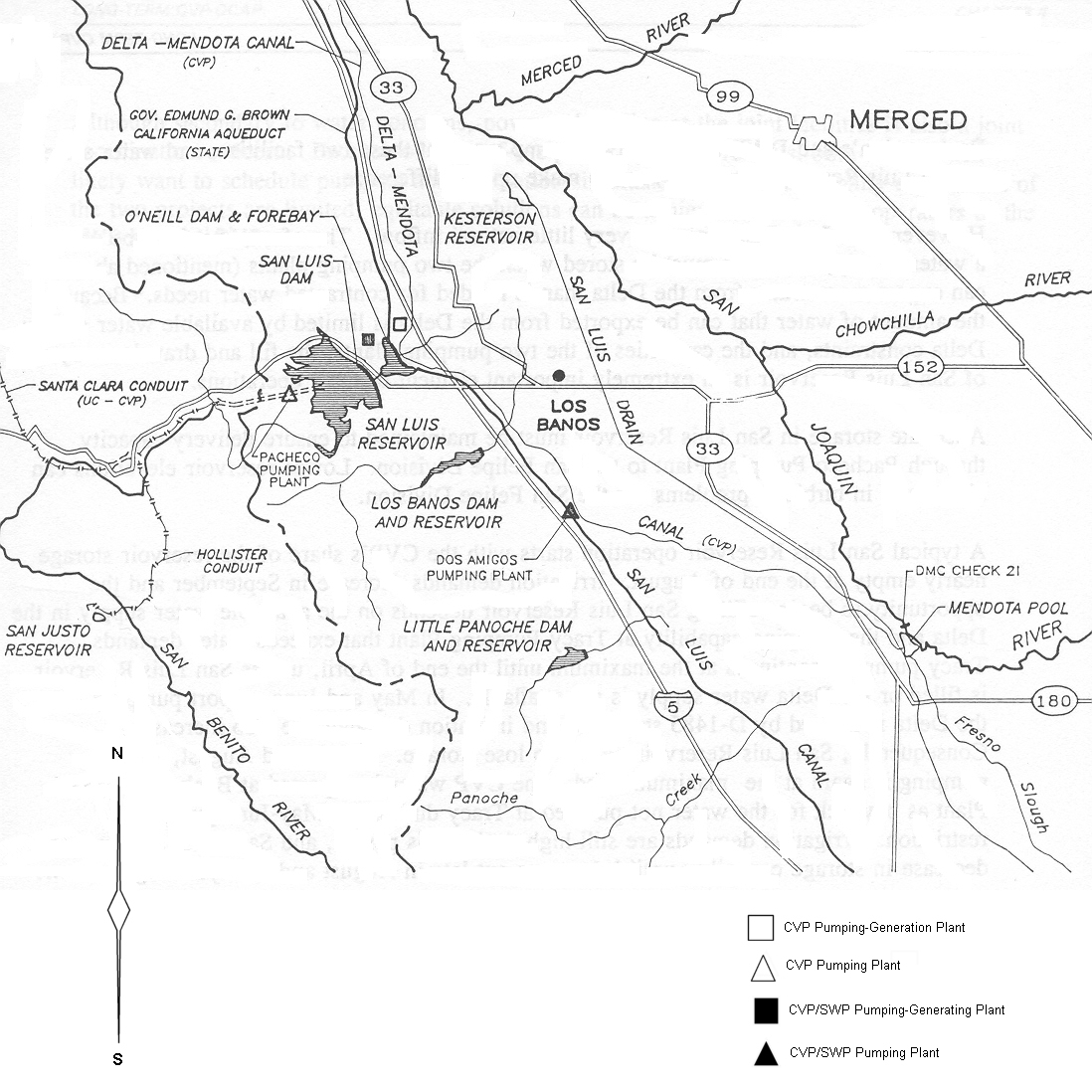
Figure 2-10 West San Joaquin Division and San Felipe Division
The Hollister Conduit branches off the Pacheco Conduit 8 miles from the outlet of the Pacheco Tunnel. This 19.1-mile-long high-pressure pipeline, with a maximum capacity of 83 cfs, terminates at the San Justo Reservoir.
The 9,906 af capacity San Justo Reservoir is located about three miles southwest of the City of Hollister. The San Justo Dam is an earthfill structure 141 feet high with a crest length of 722 feet. This project includes a dike structure 66 feet high with a crest length of 918 feet. This reservoir regulates San Benito County’s import water supplies, allows pressure deliveries to some of the agricultural lands in the service area, and provides storage for peaking of agricultural water.
The San Benito County Water District operates San Justo Reservoir and the Hollister Conduit.

Friant Division
Historically, this division operated separately from the rest of the CVP and was not integrated into the CVP OCAP. Friant Dam is located on the San Joaquin River, 25 miles northeast of Fresno where the San Joaquin River exits the Sierra foothills and enters the valley. The drainage basin is 1,676 square miles with an average annual runoff of 1,774,000 af. Completed in 1942, the dam is a concrete gravity structure, 319-feet high, with a crest length of 3,488 feet. Although the dam was completed in 1942, it was not placed into full operation until 1951. The reservoir, Millerton Lake, first stored water on February 21, 1944. It has a total capacity of 520,528 AF, a surface area of 4,900 acres, and is approximately 15-miles long. The lake’s 45 miles of shoreline varies from gentle slopes near the dam to steep canyon walls farther inland. The reservoir provides boating, fishing, picnicking, and swimming.
The dam provides flood control on the San Joaquin River, provides downstream releases to meet senior water rights requirements above Mendota Pool, and provides conservation storage as well as diversion into Madera and Friant-Kern Canals. Water is delivered to a million acres of agricultural land in Fresno, Kern, Madera, and Tulare Counties in the San Joaquin Valley via the Friant-Kern Canal south into Tulare Lake Basin and via the Madera Canal northerly to Madera and Chowchilla IDs. A minimum of 5 cfs is required to pass the last water right holding located about 40 miles downstream near Gravelly Ford. . Before October 1, 2009, and the initiation of Interim Flows for the San Joaquin River Restoration Program (SJRRP), the Friant Division was generally hydrologically disconnected from the Delta. The San Joaquin River was dewatered in two reaches between Friant Dam and the confluence of the Merced River, except under flood conditions.
Flood control storage space in Millerton Lake is based on a complex formula, which considers upstream storage in the Southern California Edison reservoirs, forecasted snowmelt, and time of year. Flood management releases occur approximately every 3 years and are managed based on downstream channel design flow of approximately 8,000 cfs, to the extent possible. Under flood conditions, water is diverted into two bypass channels that carry flood flows to near the confluence of the Merced River, as well as divert flows into the Mendota Pool that may be used to meet irrigation demands there.
In 2006, parties to NRDC, et al., v. Rodgers, et al., executed a stipulation of settlement that called for a comprehensive long-term effort to restore flows to the San Joaquin River from Friant Dam to the confluence of the Merced River and a self-sustaining Chinook salmon fishery while reducing or avoiding adverse water supply impacts. The SJRRP implements the Settlement consistent with the San Joaquin River Restoration Settlement Act in Public Law 111-11. Consultation with the National Marine Fisheries Service and U.S. Fish and Wildlife Service under the Endangered Species Act on implementation of the settlement will occur as part of the SJRRP and will evaluate the effects of implementation of settlement actions on listed species. Recapture and recirculation at Mendota Pool of Friant Dam releases made pursuant to the settlement and the effects of any flows that may reach the confluence of the Stanislaus River will be included in the SJRRP ESA consultation. Any export changes that may occur as a result of SJRRP flows reaching the Delta are included within this consultation on the Coordinated Long-term Operation of the CVP and SWP.
Figure 2-11 shows the settlement-required flow targets for releases from Friant Dam. The settlement includes six water year types for releases depending upon available water supply as measures as inflow to Millerton Lake. The releases from Friant Dam include the flexibility to reshape and retime releases forwards or backwards by four weeks during the spring pulse and fall pulse periods. Flood flows may potentially occur and meet or exceed the settlement flow targets. If flood flows meet the settlement flow targets, then Reclamation would not release additional water. The San Joaquin River channel downstream of Friant Dam currently lacks the capacity to convey flows to the Merced River and releases are limited accordingly. Reclamation has initiated planning and environmental compliance activities to improved conveyance and allow for the full release of the flows. Diversions and infiltration losses reduce the amount of settlement flows reaching the San Joaquin and Merced River confluence. Figure 2-12 shows the targets for flows below Mendota Pool. These flows would then continue downstream to the San Joaquin and Merced River confluence and on to the Delta.

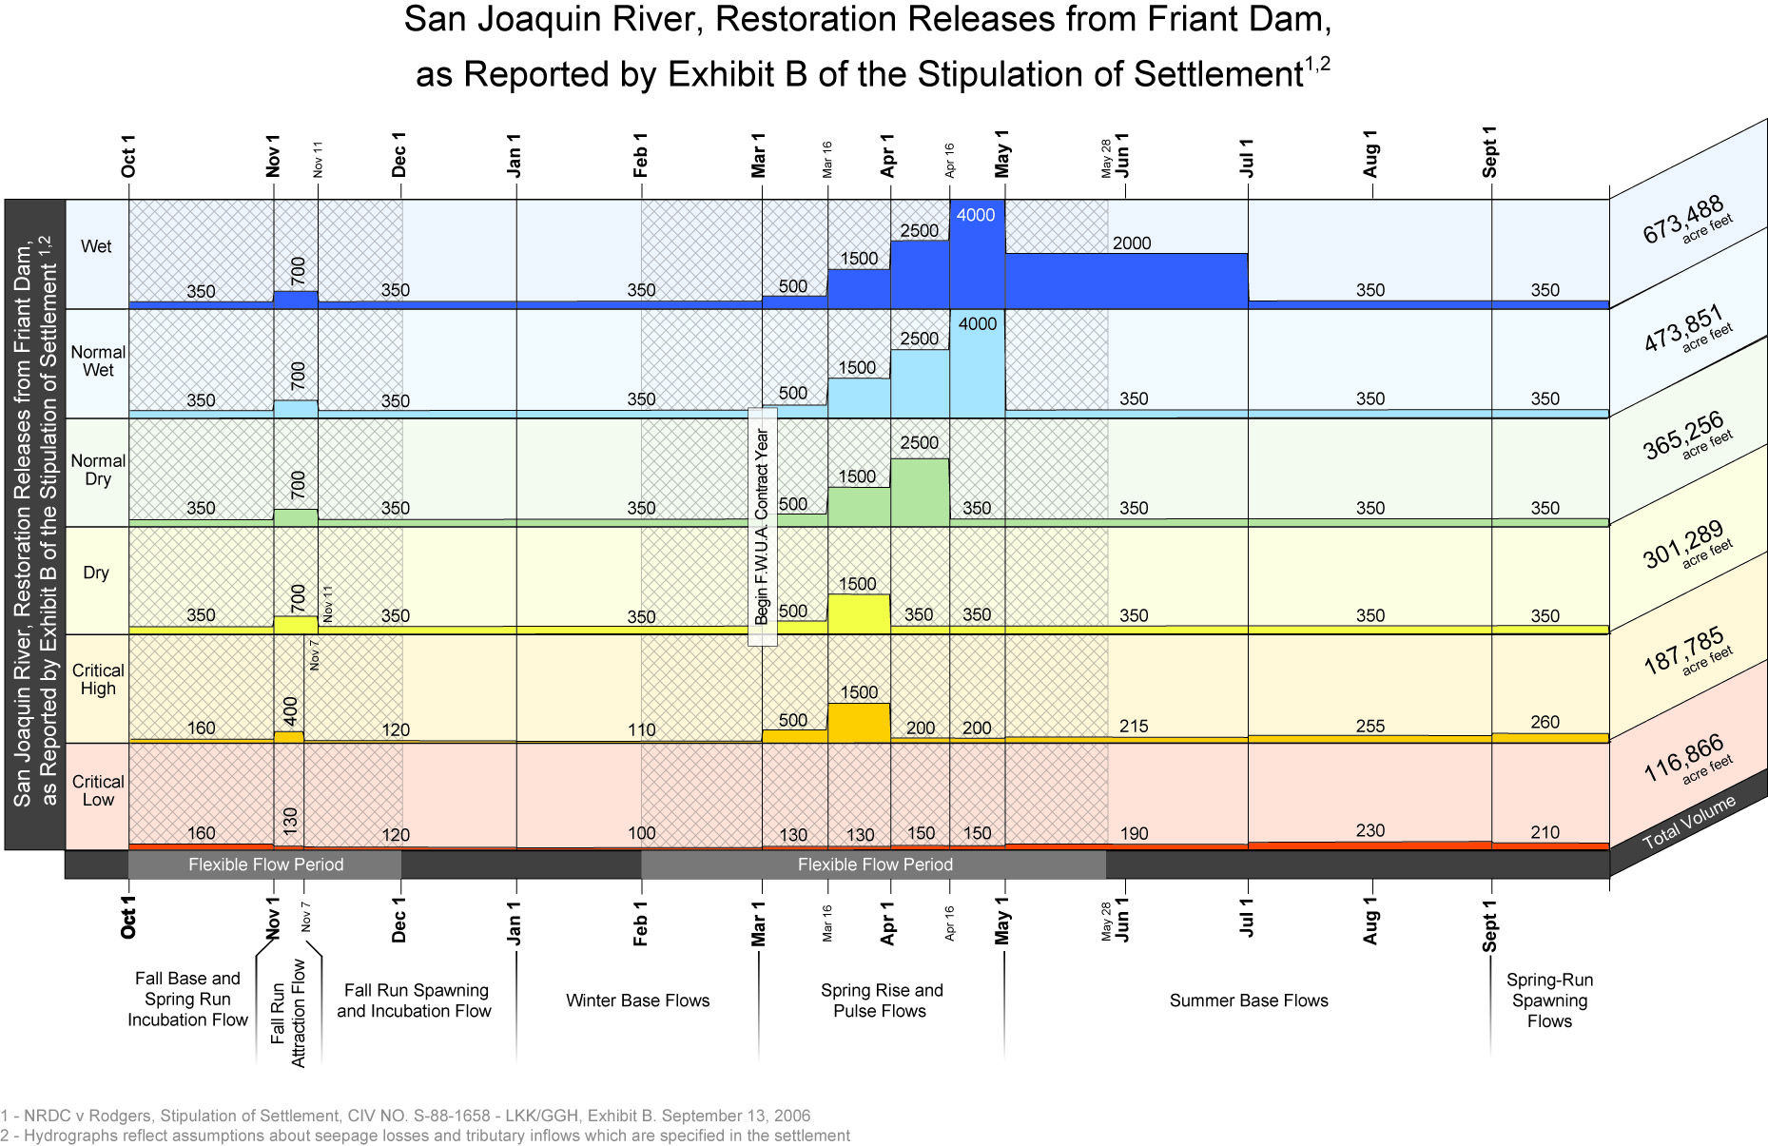
Figure 2-11 Settlement Flow Target Releases from Friant Dam

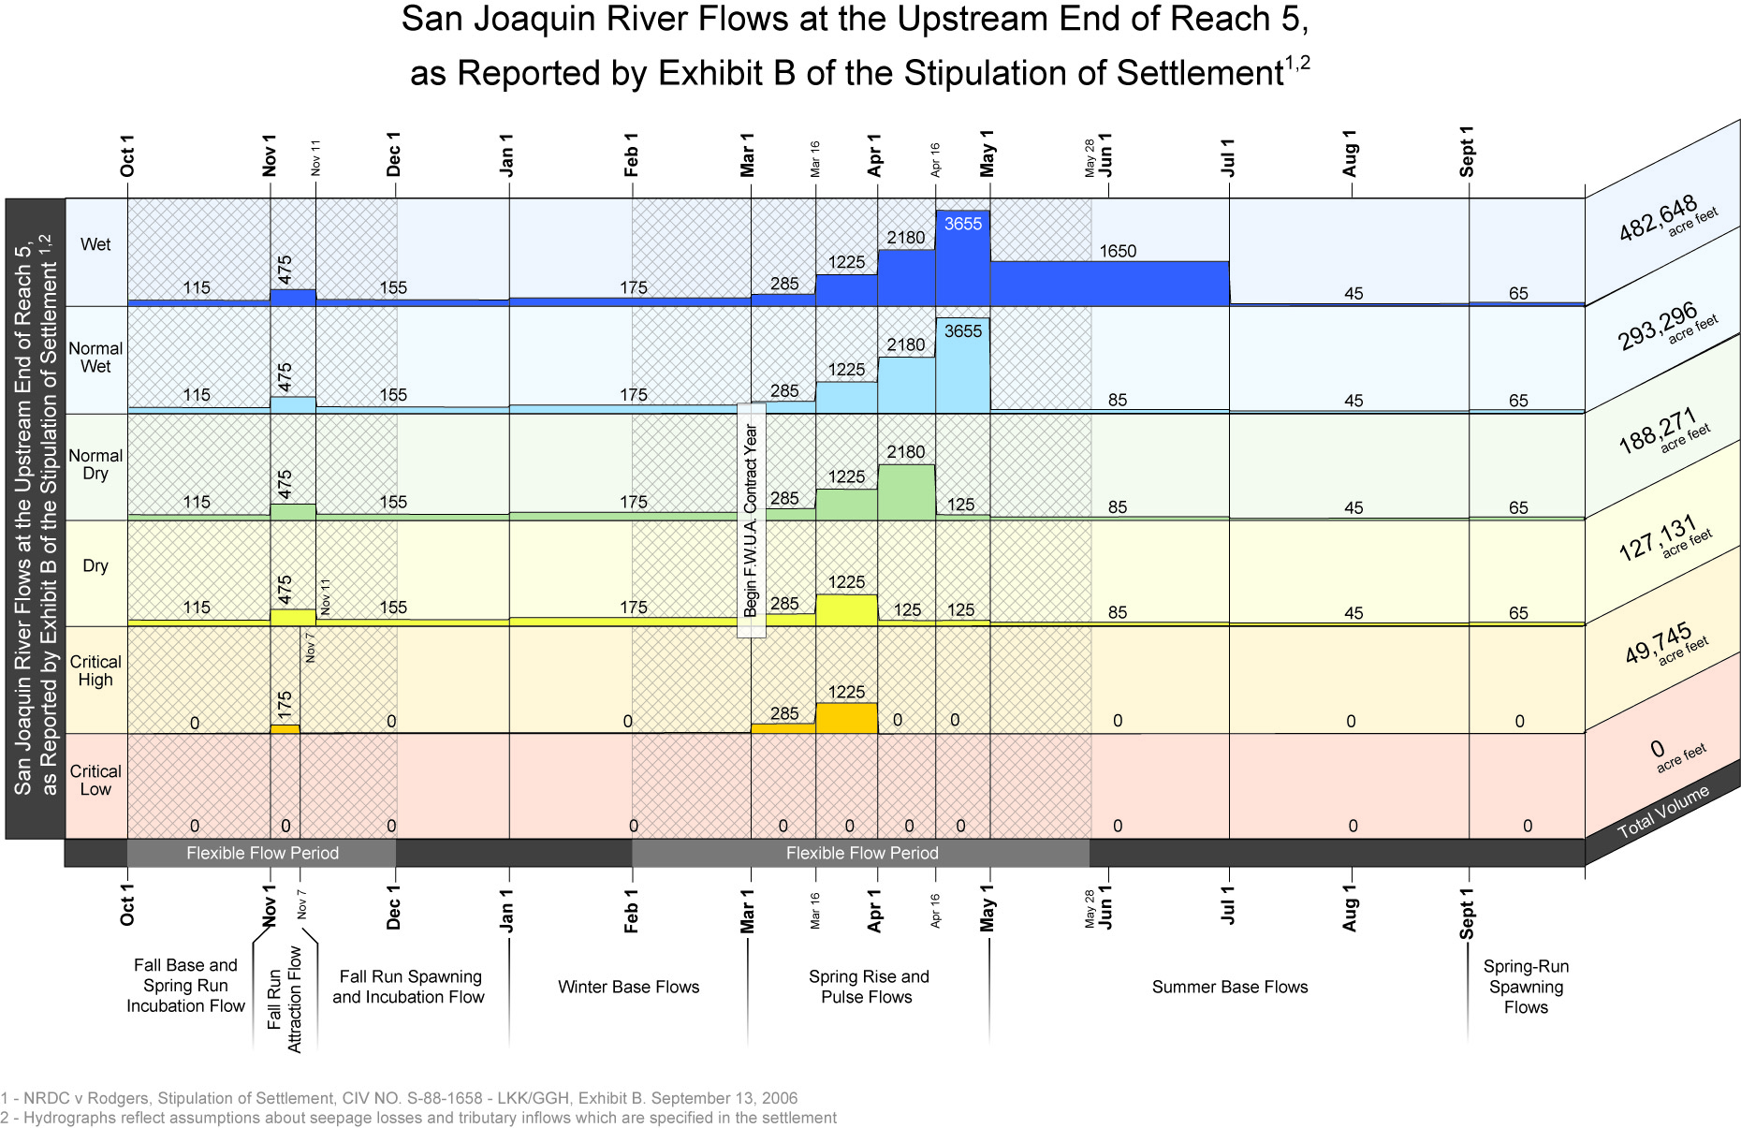
Figure 2-12 Settlement Flow Targets for Flows below Mendota Pool

State Water Project
The DWR holds contracts with 29 public agencies in Northern, Central and Southern California for water supplies from the SWP. Water stored in the Oroville facilities, along with excess water available in the Sacramento-San Joaquin Delta is captured in the Delta and conveyed through several facilities to SWP contractors.
The SWP is operated to provide flood control and water for agricultural, municipal, industrial, recreational, and environmental purposes. Water is conserved in Oroville Reservoir and released to serve three Feather River area contractors and two contractors served from the North Bay Aqueduct, and to be pumped at the Harvey O. Banks Pumping Plant (Banks) in the Delta and delivered to the remaining 24 contractors in the SWP service areas south of the Delta. In addition to pumping water released from Oroville Reservoir, the Banks pumps water from other sources entering the Delta.

Project Management Objectives
The SWP is managed to maximize the capture of water in the Delta and the usable supply released to the Delta from Oroville storage. The maximum daily pumping rate at Banks is controlled by a combination of the State Water Resources Control Board’s Water Rights Decision 1641 (D-1641), the adaptive management process described in this biological assessment, and permits issued by the Corps that regulate the rate of diversion of water into Clifton Court Forebay (CCF) for pumping at Banks. This diversion rate is normally restricted to 6,680 cfs as a three-day average inflow to CCF and 6,993 cfs as a one-day average inflow to CCF. CCF diversions may be greater than these rates between December 15 and March 15, when the inflow into CCF may be augmented by one-third of the San Joaquin River flow at Vernalis when those flows are equal to or greater than 1,000 cfs. Additionally, the SWP has a permit to export an additional 500 cfs between July 1 and September 30. (Please see section on 500 cfs permit, below.) The purpose for the current permitted action is to replace pumping foregone for the benefit of Delta fish species, making the summer limit effectively 7,180 cfs. Prior to creation of the EWA, this summer capacity was available to SWP to offset pumping curtailments made to benefit fish.
The hourly operation of the CCF radial gates is governed by agreements with local agricultural interests to protect water levels in the south Delta area. The radial gates controlling inflow to the forebay may be open during any period of the tidal cycle with the exception of the two hours before and after the low-low tide and the hours leading up to the high-high tide each day. CCF gate operations are governed by agreements and response plans to protect south Delta water users.
Banks is operated to minimize the impact to power loads on the California electrical grid to the extent practical, using CCF as a holding reservoir to allow that flexibility. Generally more pump units are operated during off-peak periods and fewer during peak periods. Because the installed capacity of the pumping plant is 10,300 cfs, the plant can be operated to reduce power grid impacts, by running all available pumps at night and a reduced number during the higher energy demand hours, even when CCF is admitting the maximum permitted inflow.
There are years (primarily wetter years) when CFF operations are demand limited, and enough water from the Delta to fill San Luis Reservoir and meet all contractor demands without maximizing its pumping capability every day of the year. However, CFF operations are more often supply limited. Under these current full demand conditions, CFF is almost always operated to the maximum extent possible to maximize the water captured, subject to the limitations of water quality, Delta standards, and a host of other variables, until all needs are satisfied and all storage south of the Delta is full.
San Luis Reservoir is an offstream storage facility located along the California Aqueduct downstream of Banks. San Luis Reservoir is used by both projects to augment deliveries to their contractors during periods when Delta pumping is insufficient to meet downstream demands.
San Luis Reservoir operates like a giant regulator on the SWP system, accepting any water pumped from Banks that exceeds contractor demands, then releasing that water back to the aqueduct system when Banks pumping is insufficient to meet demands. The reservoir allows the SWP to meet peak-season demands that are seldom balanced by Banks pumping.
San Luis Reservoir is generally filled in the spring or even earlier in some years. When it and other SWP storage facilities south of the Delta are full or nearly so, when Banks pumping is meeting all current Table A demands, and when the Delta is in excess conditions, DWR will use any available excess pumping capacity at Banks to deliver Article 21 water to the SWP contractors.
Article 21 water is one of several types of SWP water supply made available to the SWP contractors under the long-term SWP water supply contracts between DWR and the SWP contractors. As its name implies, Article 21 water is provided for under Article 21 of the contracts. Unlike Table A water, which is an allocated annual supply made available for scheduled delivery throughout the year, Article 21 water is an interruptible water supply made available only when certain conditions exist. However, Article 21 water is an important part of the total SWP supplies contractually provided under the SWP contracts. As with all SWP water, Article 21 water is supplied under existing SWP water rights permits, and is pumped from the Delta under the same environmental, regulatory, and operational constraints that apply to all SWP supplies.
When Article 21 water is available, DWR may only offer it for a short time, and the offer may be discontinued when the necessary conditions no longer exist. While not a dependable supply, Article 21 water is an important part of the total SWP supplies available to contractors. Since Article 21 deliveries are in addition to scheduled Table A deliveries, this supply is delivered to contractors that can, on relatively short notice, put it to beneficial use. Typically, contractors have used Article 21 water to meet needs such as additional short-term irrigation demands, replenishment of local groundwater basins, and storage in local surface reservoirs, all of which provide contractors with opportunities for better water management through more efficient coordination with their local water supplies. When Article 21 of the long-term water supply contracts was developed, both DWR and the contractors recognized that DWR was not capable of meeting the full contract demands in all years because not all of the planned SWP facilities had been constructed.
Article 21 water is typically offered to contractors on a short-term (daily or weekly) basis when all of the following conditions exist: the SWP share of San Luis Reservoir is physically full, or projected to be physically full; other SWP reservoirs south of the Delta are at their storage targets or the conveyance capacity to fill these reservoirs is maximized; the Delta is in excess condition; current Table A demand is being fully met; and Banks has export capacity beyond that which is needed to meet current Table A and other SWP operational demands. The increment of available unused Banks capacity is offered as the Article 21 delivery capacity. Contractors then indicate their desired rate of delivery of Article 21 water. It is allocated in proportion to their Table A contractual quantities if requests exceed the amount offered. Deliveries can be discontinued at any time, when any of the above factors change. In the modeling for Article 21, deliveries are only made in months when the State share of San Luis Reservoir is full. In actual operations, Article 21 may be offered a few days in advance of actual filling. By April or May, demands from both agricultural and M&I contractors usually exceed the pumping rate at Banks, and releases from San Luis Reservoir to the SWP facilities are needed to supplement the Delta pumping at Banks to meet contractor demands for Table A water.
During this summer period, DWR is also releasing water from Oroville Reservoir to supplement Delta inflow and allow Banks to export the stored Oroville water to help meet demand. These releases are scheduled to maximize export capability and gain maximum benefit from the stored water while meeting fish flow requirements, temperature requirements, Delta water quality, and all other applicable standards in the Feather River and the Delta.
DWR must balance storage between Oroville and San Luis Reservoirs carefully to meet flood control requirements, Delta water quality and flow requirements, and optimize the supplies to its contractors consistent with all environmental constraints. Oroville Reservoir may be operated to move water through the Delta to San Luis Reservoir via Banks under different schedules depending on Delta conditions, reservoir storage volumes, and storage targets. Predicting those operational differences is difficult, as the decisions reflect operator judgment based on many real-time factors as to when to move water from Oroville Reservoir to San Luis Reservoir.
As San Luis Reservoir is drawn down to meet contractor demands, it usually reaches its low point in late August or early September. From September through early October, demand for deliveries usually drops below the ability of Banks to divert from the Delta, and the difference in Banks pumping is then added to San Luis Reservoir, reversing its spring and summer decline. From early October until the first major storms in late fall or winter unregulated flow continues to decline and releases from Lake Oroville are restricted (due to flow stability agreements with DFG) resulting in export rates at Banks that are somewhat less than demand typically causing a second seasonal decrease in the SWP’s share of San Luis Reservoir. Once the fall and winter storms increase runoff into the Delta, Banks can increase its pumping rate and eventually fill (in all but the driest years) the state portion of San Luis Reservoir before April of the following year.

Water Service Contracts, Allocations, and Deliveries
The following discussion presents the practices of DWR in determining the overall amount of Table A water that can be allocated and the allocation process itself. There are many variables that control how much water the SWP can capture and provide to its contractors for beneficial use.
The allocations are developed from analysis of a broad range of variables that include:
- Volume of water stored in Oroville Reservoir
- Flood operation restrictions at Oroville Reservoir
- End-of-water-year (September 30) target for water stored in Oroville Reservoir
- Volume of water stored in San Luis Reservoir
- End-of-month targets for water stored in San Luis Reservoir
- Snow survey results
- Forecasted runoff
- Feather River flow requirements for fish habitat
- Feather River service area delivery obligations
- Feather River flow for senior water rights river diversions
- Anticipated depletions in the Sacramento River basin
- Anticipated Delta flow and water quality requirements
- Precipitation and streamflow conditions since the last snow surveys and forecasts
- Contractor delivery requests and delivery patterns
From these and other variables, the Operations Control Office estimates the water supply available to allocate to contractors and meet other project needs. The Operations Control Office transmits these estimates to the State Water Project Analysis Office, where staff enters the water supply, contractor requests, and Table A amounts into a spreadsheet and computes the allocation percentage that would be provided by the available water supply.
The staffs of the Operations Control Office and State Water Project Analysis Office meet with DWR senior management, usually including the Director, to make the final decision on allocating water to the contractors. The decision is made, and announced in a press release followed by Notices to Contractors.
The initial allocation announcement is made by December 1 of each year. The allocation of water is made with a conservative assumption of future precipitation, and generally in graduated steps, carefully avoiding over-allocating water before the hydrologic conditions are well defined for the year.
Both the DWR and the contractors are conservative in their estimates, leading to the potential for significant variations between projections and actual operations, especially under wet hydrologic conditions.
Other influences affect the accuracy of estimates of annual demand for Table A and the resulting allocation percentage. One factor is the contractual ability of SWP contractors to carry over allocated but undelivered Table A from one year to the next if space is available in San Luis Reservoir. Contractors will generally use their carryover supplies early in the calendar year if it appears that San Luis reservoir will fill. By using the prior year’s carryover, the contractors reduce their delivery requests for the current year’s Table A allocation and instead schedule delivery of carryover supplies.
Carryover supplies left in San Luis Reservoir by SWP contractors may result in higher storage levels in San Luis Reservoir at December 31 than would have occurred in the absence of carryover. If there were no carryover privilege, contractors would seek to store the water within their service areas or in other storage facilities outside of their service areas. As project pumping fills San Luis Reservoir, the contractors are notified to take or lose their carryover supplies. If they can take delivery of and use or store the carryover water, San Luis Reservoir storage then returns to the level that would have prevailed absent the carryover program.
If the contractors are unable to take delivery of all of their carryover water, that water then converts to project water as San Luis Reservoir fills, and Article 21 water becomes available for delivery to contractors.
Article 21 water delivered early in the calendar year may be reclassified as Table A later in the year depending on final allocations, hydrology, and contractor requests. Such reclassification does not affect the amount of water carried over in San Luis Reservoir, nor does it alter pumping volumes or schedules. The total water exported from the Delta and delivered by the SWP in any year is a function of a number of variables that is greater than the list of variables shown above that help determine Table A allocations.
If there are no carryover or Article 21 supplies available, Table A requests will be greater in the January-April period, and there would be a higher percentage allocation of Table A for the year than if carryover and Article 21 were available to meet demand. For this reason, the total amount of Article 21 water delivered does not provide a measure of the change in Delta diversions attributable to Article 21 deliveries. Instead, one must analyze the total exports from the Delta.

Monterey Agreement
In 1994, DWR and certain representatives of the SWP contractors negotiated a set of principles designed to modify the long-term SWP water supply contracts. This set of principles which came to be known as the Monterey Agreement, helped to settle long-term water allocation disputes, and to establish new water management strategies for the SWP. The Monterey Agreement resulted in 27 of the 29 SWP contractors signing amendments to their long-term water supply contracts in 1995, with implementation since 1996. The 1995 Program Environmental Impact Report prepared for the Monterey Agreement was subject to judicial challenge, and in 2000 the PEIR was decertified. In May 2003, the parties to the litigation negotiated a settlement agreement which committed DWR to a process for including the plaintiffs and SWP contractors in the development of a new EIR on the Monterey Amendment. A draft of the new EIR was released in October 2007. After incorporating over 600 comments, the final EIR was noticed with the State Clearinghouse on May 5, 2010. After considering the final EIR and the alternatives, DWR determined that the proposed project could be carried out by continuing to operate under the existing Monterey Amendment and Settlement Agreement. Additionally, the Court explicitly ordered that DWR could continue to operate the SWP in accordance with the Monterey Amendment as it had done since 1996.

Changes in DWR’s Allocation of Table A Water and Article 21 Water
The Monterey Amendment revised the allocation procedures for both Table A and Article 21 water supplies. The revised Article 18(a) eliminated the temporary shortage provision that specified an initial reduction of supplies for agricultural use when requests for SWP water exceeded the available supply. The Amendment specifies instead that whenever the supply of Table A water is less than the total of all contractors’ requests, the available supply of Table A water is allocated among all contractors in proportion to each contractor’s annual Table A amount.
The Monterey Amendment also amended Article 21 by eliminating the category of scheduled "surplus water," which was available for scheduled delivery and by renaming "unscheduled water" to "interruptible water." Surplus water was scheduled water made available to the contractors when DWR had supplies beyond what was needed to meet Table A deliveries, reservoir storage targets, and Delta regulatory requirements. Surplus water and unscheduled water were made available first to contractors requesting it for agricultural use or for groundwater replenishment. Because of the contractors’ increasing demands for Table A water and the increasing regulatory requirements imposed on SWP operations, DWR is now able to supply water that is not Table A water only on an unscheduled, i.e., interruptible basis.
Pursuant to the revised Article 21, DWR allocates the available interruptible supply (now referred to by DWR as Article 21 water) to requesting contractors in proportion to their annual Table A amounts.
The result of these contractual changes are that DWR now allocates Table A and Article 21 water among SWP contractors in proportion to annual Table A amounts without consideration of whether the water would be used for M&I or agricultural purposes. Agricultural and M&I contractors share any reductions in deliveries or opportunities for surplus water in proportion to their annual Table A amounts.

Historical Water Deliveries to Southern California
The pumping from the Delta to serve southern California has been influenced by changes in available water supply sources to serve the region. The Colorado River and the SWP have been the major supply sources for southern California.
The Quantification Settlement Agreement (QSA) signed in 2003 resulted in a decrease in the amount of Colorado River water available to California. To illustrate the impact of that decrease on demand from the Sacramento-San Joaquin Delta, it is instructive to look at the magnitude of the two imported supply sources available to MWDSC.
During part of this period, MWDSC was also filling Diamond Valley Lake (810,000 acre-feet, late 1998-early 2002) and adding some water to groundwater storage programs. In wetter years, demand for imported water may often decrease because local sources are augmented and local rainfall reduces irrigation demand. Table 2-14 below illustrates the effects of the wet years from 1995-1998 on demand for imported water and the effect of reduced Colorado River diversions under the QSA on MWDSC deliveries from the Delta.
Table 2-14 Wet Year effects
Calendar Year | Sacramento Valley Water Year Type | Delta Supplies | Colorado Supplies | Total
1994 | Critically Dry | 807,866 | 1,303,212 | 2,111,078
1995 | Wet | 436,042 | 997,414 | 1,433,456
1996 | Wet | 593,380 | 1,230,353 | 1,823,733
1997 | Wet | 721,810 | 1,241,821 | 1,963,631
1998 | Wet | 410,065 | 1,073,125 | 1,483,190
1999 | Wet | 852,617 | 1,215,224 | 2,067,841
2000 | Above Normal | 1,518,941 | 1,303,148 | 2,822,089
2001 | Dry | 1,017,186 | 1,253,579 | 2,270,765
2002 | Dry | 1,333,927 | 1,241,088 | 2,575,015
2003 | Above Normal | 1,563,842 | 688,043 | 2,251,885
2004 | Below Normal | 1,615,929 | 733,095 | 2,349,024
2005 | Above Normal | 1,478,045 | 839,704 | 2,317,749
2006 | Wet | 1,512,186 | 594,544 | 2,106,730
2007 | Dry | 1,327,623 | 713,456* | 2,041,079

Project Facilities

Oroville Field Division
Oroville Dam and related facilities comprise a multipurpose project. The reservoir stores winter and spring runoff, which is released into the Feather River to meet the Project's needs. It also provides pumpback capability to allow for on-peak electrical generation, 750,000 acre-feet of flood control storage, recreation, and freshwater releases to control salinity intrusion in the Sacramento-San Joaquin Delta and for fish and wildlife protection.
The Oroville facilities are shown in Figure 2-13. Two small embankments, Bidwell Canyon and Parish Camp Saddle Dams, complement Oroville Dam in containing Lake Oroville. The lake has a surface area of 15,858 acres, a storage capacity of 3,538,000 af, and is fed by the North, Middle, and South forks of the Feather River. Average annual unimpaired runoff into the lake is about 4.5 million af.
A maximum of 17,000 cfs can be released through the Edward Hyatt Powerplant, located underground near the left abutment of Oroville Dam. Three of the six units are conventional generators driven by vertical-shaft, Francis-type turbines. The other three are motor-generators coupled to Francis-type, reversible pump turbines. The latter units allow pumped storage operations. The intake structure has an overflow type shutter system that determines the level from which water is drawn.
Approximately four miles downstream of Oroville Dam and Edward Hyatt Powerplant is the Thermalito Diversion Dam. Thermalito Diversion Dam consists of a 625-foot-long, concrete gravity section with a regulated ogee spillway that releases water to the low flow channel of the Feather River. On the right abutment is the Thermalito Power Canal regulating headwork structure.

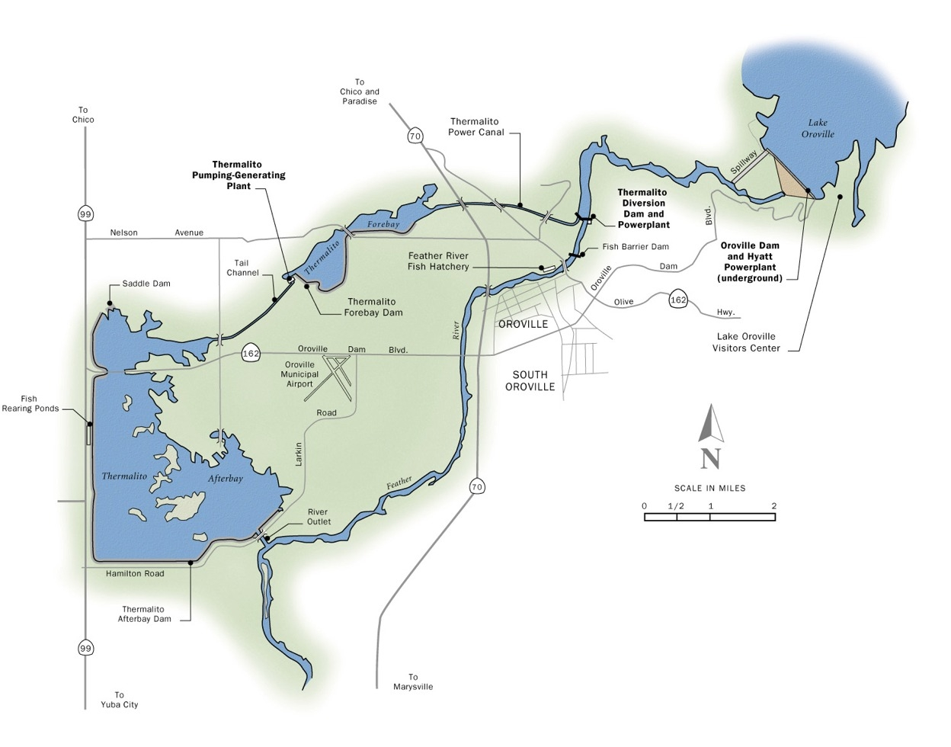

Figure 2-13 Oroville Facilities on the Feather River
The purpose of the diversion dam is to divert water into the 2-mile long Thermalito Power Canal that conveys water in either direction and creates a tailwater pool (called Thermalito Diversion Pool) for Edward Hyatt Powerplant. The Thermalito Diversion Pool acts as a forebay when Hyatt is pumping water back into Lake Oroville. On the left abutment is the Thermalito Diversion Dam Powerplant, with a capacity of 600 cfs that releases water to the low-flow section of the Feather River.
Thermalito Power Canal hydraulically links the Thermalito Diversion Pool to the Thermalito Forebay (11,768 af), which is the off-stream regulating reservoir for Thermalito Powerplant. Thermalito Powerplant is a generating-pumping plant operated in tandem with the Edward Hyatt Powerplant. Water released to generate power in excess of local and downstream requirements is conserved in storage and, at times, pumped back through both powerplants into Lake Oroville during off-peak hours. Energy price and availability are the two main factors that determine if a pumpback operation is economical. A pumpback operation most commonly occurs when energy prices are high during the weekday on-peak hours and low during the weekday off-peak hours or on the weekend. The Oroville Thermalito Complex has a capacity of approximately 17,000 cfs through the powerplants, which can be returned to the Feather River via the Afterbay’s river outlet.
Local agricultural districts divert water directly from the afterbay. These diversion points are in lieu of the traditional river diversion exercised by the local districts whose water rights are senior to the SWP. The total capacity of afterbay diversions during peak demands is 4,050 cfs.
The Feather River Fish Hatchery (FRFH), mitigation for the construction of Oroville Dam, produces Chinook salmon and steelhead and is operated by DFG. The FRFH program, operations and production, is detailed in the FERC Biological Assessment for the Oroville Project and will be detailed in the NMFS FERC Biological Opinion, expected in June 2008. Both indirect and direct take resulting from FRFH operations will be authorized through section 4(d) of the Endangered Species Act, in the form of NMFS-approved Hatchery and Genetic Management Plans (HGMPs). DWR is preparing HGMPs for the spring and fall-run Chinook and steelhead production programs at the Feather River Fish Hatchery.

Current Operations - Minimum Flows and Temperature Requirements
Operation of Oroville will continue under existing criteria, consistent with past project descriptions, until DWR receives the new FERC license. The release temperatures from Oroville Dam are designed to meet Feather River Fish Hatchery and Robinson Riffle temperature schedules included in the 1983 DFG Agreement, “Agreement Concerning the Operation of the Oroville Division of the State Water Project for Management of Fish and Wildlife”, concerning the operations of the Oroville Division of the State Water Project for Management of Fish and Wildlife and OCAP while also conserving the coldwater pool in Lake Oroville. Current operation indicates that water temperatures at Robinson Riffle are almost always met when the hatchery objectives are met. Due to temperature requirements of endangered fish species and the hatchery and overriding meteorologic conditions, the temperature requests for agriculture can be difficult to satisfy.
Water is withdrawn from Lake Oroville at depths that will provide sufficiently cold water to meet the Feather River Fish Hatchery and Robinson Riffle temperature targets. The reservoir depth from which water is released initially determines the river temperatures, but atmospheric conditions, which fluctuate from day to day, modify downstream river temperatures. Altering the reservoir release depth requires installation or removal of shutters at the intake structures. Shutters are held at the minimum depth necessary to release water that meets the Feather River Fish Hatchery and Robinson Riffle criteria. In order to conserve the coldwater pool during dry years, DWR has strived to meet the Robinson Riffle temperatures by increasing releases to the Low flow Channel (LFC) rather than releasing colder water.
Additionally, DWR maintains a minimum flow of 600 cfs within the Feather River LFC (except during flood events when flows are governed by the Flood Operations Manual and under certain other conditions as described in the 1984 FERC order). Downstream of the Thermalito Afterbay Outlet, in the High Flow Channel (HFC), a minimum release for flows in the Feather River is to be 1,000 cfs from April through September and 1,700 cfs from October through March, when the April-to-July unimpaired runoff in the Feather River is greater than 55 percent of normal. When the April-to-July unimpaired runoff is less than 55 percent of normal, the License requires minimum flows of 1,000 cfs from March to September and 1,200 cfs from October to February (Table 2-15). In practice, flows are maintained below 2,500 cfs from October 15 to November 30 to prevent spawning in the overbank areas.
According to the 1983 Agreement, if during the period of October 15 to November 30, the average highest 1-hour flow of combined releases exceeds 2,500 cfs; with the exception of flood management, accidents, or maintenance; then the minimum flow must be no lower than 500 cfs less than that flow through the following March 31. The 1983 Agreement also states that if the April 1 runoff forecast in a given year indicates that the reservoir level will be drawn down to 733 feet, water releases for fish may be reduced, but not by more than 25 percent.

Table 2-15 Combined Minimum Instream Flow Requirements in the Feather River Below Thermalito Afterbay Outlet When Lake Oroville Elevation is Projected to be Greater vs. Less Than 733’ in the Current Water Year
Conditions | Period | Minimum Flows
When Lake Oroville Elevation is Projected to be Greater Than 733’ & the Preceding Water Year’s April – July Water Conditions are  > 55% of Normal (1) | October - February | 1,700 cfs
 | March | 1,700 cfs
 | April - September | 1,000 cfs
When Lake Oroville Elevation is Projected to be Greater Than 733’ & the Preceding Water Year’s April – July Water Conditions are  < 55% of Normal (1) | October - February | 1,200 cfs
 | March | 1,000 cfs
 | April - September | 1,000 cfs
When Lake Oroville Elevation is Projected to be Less Than 733’ in the Current Water Year (2) | October - February | 900 cfs < Q < 1,200 cfs
 | March | 750 cfs < Q < 1,000 cfs
 | April - September | 750 cfs < Q < 1,000 cfs
Notes:
- Normal is defined as the Mean April – July Unimpaired Runoff of the Feather River near Oroville of 1,942,000 AF (1911 – 1960).
- In accordance with FERC’s Order Amending License dated September 18, 1984, Article 53 was amended to provide a third tier of minimum flow requirements defined as follows: If the April 1 runoff forecast in a given water year indicates that, under normal operation of Project 2100, the reservoir level will be drawn to elevation 733 feet (approximately 1,500,000 AF), releases for fish life in the above schedule may suffer monthly deficiencies in the same proportion as the respective monthly deficiencies imposed upon deliveries of water for agricultural use from the Project. However, in no case shall the fish water releases in the above schedule be reduced by more than 25 percent.

Current operations of the Oroville Facilities are governed by water temperature requirements at two locations: the FRFH and in the LFC at Robinson Riffle. DWR has taken various temperature management actions to achieve the water temperature requirements, including curtailing pumpback operations, removing shutters at intakes of the Hyatt Pumping-Generating Plant, releasing flow through the river valves (for FRFH only), and redirecting flows at the Thermalito Diversion Dam to the LFC (for Robinson Riffle only).
To date, the river valves have been used infrequently. Prior to 1992, they were used twice: first in 1967 during the initial construction of the dam, and second in 1977 during the drought of record. Since 1992, the river valves have only been used for temperature control: in 2001 and 2002 and in 2008. Currently the river valves are inoperable. DWR plans to manage its cold water storage and its intake shutters in order to meet its temperature obligations. Other than local diversions, outflow from the Oroville Complex is to the Feather River, combining flows from the LFC and Thermalito Afterbay. Outflow typically varies from spring seasonal highs averaging 8,000 cfs to about 3,500 cfs in November. The average annual outflow from the Project is in excess of 3 maf to support downstream water supply, environmental, and water quality needs.
Table 2-16 shows an example of releases from Oroville for various downstream uses during dry hydrologic conditions (Water Years 2001 and 2002). As a practical matter, water supply exports are met with water available after Delta requirements are met. Some of the water released for instream and Delta requirements may be available for export by the SWP after Delta standards have been met.
Table 2-16 Historical Records of Releases from the Oroville Facilities in 2008 and 2009, by Downstream Use
Downstream Use | Water Year 2008 Release |  | Water Year 2009 Release
Downstream Use | Volume (taf) | Percentage | Volume (taf) | Percentage
Feather River Service Area | 1,039 | 47 | 1,077 | 40
Instream and Delta Requirements | 1,043 | 47 | 1,140 | 42
Flood Management | 0 | 0 | 0 | 0
Support of Exports | 130 | 6 | 506 | 19
Total | 2,212 | 100 | 2,723 | 100
Source: DWR SWP Operations Control Office
Key:
taf – thousand acre-feet

Feather River Flow Requirements
The existing Feather River flow requirements below Oroville Dam are based on an August 1983 Agreement between the DWR and DFG and the Federal Energy Regulatory Commission license terms. The 1983 Agreement established criteria and objectives for flow and temperatures in the LFC, FRFH, and HFC. This agreement includes the following:
- Established minimum flows between the Thermalito Afterbay Outlet and Verona that vary by water year type.
- Required flow changes under 2,500 cfs to be reduced by no more than 200 cfs during any 24-hour period, except flood management operations.
- Required flow stability during the peak of the fall-run Chinook spawning season.
- Set an objective of suitable water temperature conditions during the fall months for salmon and during the later spring/summer months for shad and striped bass.
- Established a process whereby DFG would recommend each year, by June 1, a spawning gravel maintenance program to be implemented during that calendar year.

Low Flow Channel
The 1983 Agreement specifies that DWR release a minimum of 600 cfs into the Feather River from the Thermalito Diversion Dam for fishery purposes. This is the total volume of flows from the Diversion Dam Outlet, Diversion Dam Powerplant, and FRFH Pipeline.

High Flow Channel
Based on the 1983 Agreement, Table 2-17 summarizes the minimum flow requirement for the HFC when releases would not draw Oroville Reservoir below elevation 733 feet above mean sea level (ft msl).
Table 2-17 High Flow Channel minimum flow requirements as measured downstream from the Thermalito Afterbay Outlet.
Forecasted April-through- July unimpaired runoff (percent of normal¹) | Minimum Flow in HFC (cfs)
 | October through February | March | April through September
55 percent or greater | 1,700 | 1,700 | 1,000
Less than 55 percent | 1,200 | 1,000 | 1,000
Source: 1983 Agreement
¹ The preceding water year’s unimpaired runoff shall be reported in Licensee’s Bulletin 120, “Water Conditions in California-Fall Report.” The term “normal” is defined as the April-through-July mean unimpaired runoff near Oroville of 1,942,000 af in the period of 1911 through 1960.
Key:
cfs – cubic feet per second
HFC – High Flow Channel

If the April 1 forecast in a given water year indicates that Oroville Reservoir would be drawn down to elevation 733 ft msl, minimum flows in the HFC may be diminished on a monthly average basis, in the same proportion as the respective monthly deficiencies imposed on deliveries for agricultural use of the Project. However, in no case shall the minimum flow releases be reduced by more than 25 percent. If between October 15 and November 30, the highest total 1-hour flow exceeds 2,500 cfs, DWR shall maintain a minimum flow within 500 cfs of that peak flow, unless such flows are caused by flood flows, or an inadvertent equipment failure or malfunction.

Temperature Requirements

Low Flow Channel
NMFS has established a water temperature requirement for steelhead trout and spring-run Chinook salmon at Feather River RM 61.6 (Robinson Riffle in the LFC) from June 1 through September 30. The water temperature should be maintained at less than or equal to 65°F on a daily average basis.

High Flow Channel
While no numeric temperature requirement currently exists for the HFC, the 1983 Agreement requires DWR to provide suitable Feather River water temperatures for fall-run salmon not later than September 15, and to provide for suitable water temperatures below the Thermalito Afterbay Outlet for shad, striped bass, and other warm water fish between May 1 and September 15.
Current FRFH intake water temperature, as required by the 1983 DFG and DWR Agreement and the FERC license are in Table 2-18.
Table 2-18 Feather River Fish Hatchery Temperature Requirements
Period |  | Degrees F  (± 4 ºF allowed)
April 1 – November 30
 | April 1 – May 15 | 51
 | May 16 – May 31 | 55
 | June 1 – June 15 | 56
 | June 16 – August 15 | 60
 | August 16 – August 31 | 58
 | September 1 – September 30 | 52
 | October 1 – November 30 | 51
December 1 – March 31 |  | No greater than 55

Table 2-19 summarizes current flow and temperature management in the Feather River Fish Hatchery and the Lower Feather River below Oroville Dam. These operational measures are in place in compliance with FERC license terms, agency agreements or ESA Biological Opinions and are provided to fully describe the baseline conditions.

Table 2-19 Lower Feather River Flows and Temperature Management under Existing Conditions
Type of Measure | Title | Description
Minimum Flows | Minimum Release to Low Flow Channel (this includes water that returns from hatchery) | Maintain minimum flow of 600 cubic feet per second (cfs) within the Feather River downstream of the Thermalito Diversion Dam and the Feather River Fish Hatchery. FERC 1984. [Low Flow Channel Flow Standard]
Minimum Flows | Minimum Release to High Flow Channel | Release water necessary to maintain flows in the Feather River below the Thermalito Afterbay Outlet in accordance with the minimum flow schedule presented in the Federal Energy Regulatory Commission (FERC) order, provided that releases will not cause Lake Oroville to be drawn below elevation 733 feet (ft) (approximately 1.5 million acre-feet [maf] of storage). If the April 1 runoff forecast in a given year indicates that the reservoir level will be drawn to 733 ft, water releases for fish may be reduced, but not by more than 25 percent.
Maximum Flows (non-flood control) | Maximum Flow into Feather River Fish Hatchery | Maximum flow into Feather River Fish Hatchery from the Diversion Pool is 115 cfs year round.
Maximum Flows (non-flood control) | Maximum Flow in the High Flow Channel | Maximum flow at Feather River below Thermalito Afterbay Outlet is 10,000 cfs when Lake Oroville inflow is less than 10,000 cfs. [High Flow Channel Flow Standard] When Lake Oroville inflow is greater than 10,000 cfs, the maximum flow in the river below Thermalito Afterbay Outlet will be limited to inflow. If higher flow releases coincide with Chinook spawning activity, the ramping rate used to return to the minimum flow requirement will be chosen to avoid redd dewatering.
Ramping Rates | Ramping Rate Criteria | Flows less than 2,500 cfs cannot be reduced more than 300 cfs during any 24-hour period, except for flood releases, failures, etc. (as per the 2004 Operating Criteria and Plan [OCAP] Biological Opinion [BO]).
Water Supply | Releases from Lake Oroville | Releases for water supply, flood control, Sacramento–San Joaquin Delta (Delta) water quality requirements, and instream flow requirements of an average of 3 million acre-feet per year (maf/year) and approximately 1 maf/year to the Feather River Service Area (FRSA) for agricultural, municipal, and industrial uses in accordance with State Water Project (SWP) contracts, California Department of Water Resources (DWR) agreements, and water rights.
Water Supply | Diversions from Feather River | Diversion of an estimated 60–70 thousand acre-feet per year (taf/year) from the Feather River by senior water right holders per State Water Resources Control Board (SWRCB) licenses or permits for appropriative users.
Flood Protection/Management | Flood Protection | The Oroville Facilities are operated for flood control purposes in conformance with the flood management regulations prescribed by the Secretary of the Army under the provisions of an Act of Congress (58 Stat. 890; 33 United States Code [USC] 709).  - During floods, water releases from Oroville Dam and Thermalito Afterbay Dam will not increase floodflows above those prior to project existence. Operation of the project in the interest of flood control shall be in accordance with Section 204 of the Flood Control Act of 1958.  - At high flows, fluctuate releases at least every couple of days to avoid riverbank/levee damage at one level.  - Avoid extended periods of flow over the quantities listed above as much as possible to minimize the risk of seepage damage to orchards adjacent to the Feather River.  - Maximum allowable flow is 180,000 cfs year round at the Feather River above the Yuba River. Maximum allowable flow is 300,000 cfs year round at the Feather River below the Yuba River.  - Maximum allowable flow is 320,000 cfs year round at the Feather River below the Bear River.
Temperature Criteria/Targets | At the Feather River Fish Hatchery and Robinson Riffle | Water temperature at Robinson Riffle must be less than 65 degrees between June and September.  Water temperature during the fall months, after September 15, should be suitable for fall-run Chinook salmon.  Water temperature from May through August should be suitable for American shad, striped bass, etc.  At the Feather River Fish Hatchery  Temperature (+/- 4°F)  April 1–May 15 51°  May 16–May 31 55°  June 1–June 15 56°  June 16–August 15 60°  August 16–August 31 58°  September 1–September 30 52°  October 1–November 30 51°  December 1–March 31 no greater than 55°
Temperature Criteria/Targets | Thermalito Afterbay Temperature Control | Operate facilities pursuant to the May 1968 Joint Water Agreement.
Natural Salmonid Spawning and Rearing Habitat | Salmonid Habitat Improvement – Endangered Species Act (ESA) Species Recovery Measures | Maintain conditions in the Low Flow Channel pursuant to 1983 Operating Agreement between DFG and DWR which is to prevent damage to fish and wildlife resources from operations and construction of the project.
Excerpt from Appendix B of the FERC Preliminary Draft Environmental Assessment, Oroville Facilities—FERC Project No. 2100

Flood Control
Flood control operations at Oroville Dam are conducted in coordination with DWR’s Flood Operations Center and in accordance with the requirements set forth by the Corps. The Federal Government shared the expense of Oroville Dam, which provides up to 750,000 af of flood control space. The spillway is located on the right abutment of the dam and has two separate elements: a controlled gated outlet and an emergency uncontrolled spillway. The gated control structure releases water to a concrete-lined chute that extends to the river. The uncontrolled emergency spill flows over natural terrain.

Feather River Ramping Rate Requirements
Maximum allowable ramp-down release requirements are intended to prevent rapid reductions in water levels that could potentially cause redd dewatering and stranding of juvenile salmonids and other aquatic organisms. Ramp-down release requirements to the LFC during periods outside of flood management operations, and to the extent controllable during flood management operations, are shown in Table 2-20.
Table 2-20 Lower Feather River Ramping Rates
Releases to the Feather River  Low Flow Channel  (cfs) | Rate of Decrease  (cfs)
5,000 to 3,501 | 1,000 per 24 hours
3,500 to 2,501 | 500 per 24 hours
2,500 to 600 | 300 per 24 hours
Key:
cfs = cubic feet per second
Source: NMFS 2004a

Proposed Operational Changes with the Federal Energy Regulatory Commission (FERC) Relicensing of the Oroville Project– Near Term and Future Operations
Until FERC issues the new license for the Oroville Project, DWR will not significantly change the operations of the facilities and when the FERC license is issued, it is assumed that downstream of Thermalito Afterbay Outlet, the future flows will remain the same.
Given the uncertainty of what will be in the FERC license or 401 Certification, it is not possible to establish the DWR proposed Settlement Agreement (SA) conditions as the baseline for the OCAP Biological Assessment.
The original FERC license to operate the Oroville Project expired in January 2007. Since then, annual licenses have been issued, with DWR operating to the existing FERC license. FERC continues to issue an annual license until it is prepared to issue the new 50-year license. In preparation for the expiration of the FERC license, DWR began working on the relicensing process in 2001. As part of the process, DWR entered into a SA, signed in 2006, with State, federal and local agencies, State Water Contractors, Non-Governmental Organizations, and Tribal governments and others to implement improvements within the FERC Boundary. The FERC boundary includes all of the Oroville Project facilities, extends upstream into the tributaries of Lake Oroville, includes portions of the LFC on the lower Feather River and downstream of the Thermalito Afterbay Outlet into the HFC. In addition to the SA, a Habitat Expansion Agreement was negotiated to address the fish passage issue over Oroville Dam and NMFS and FWS’ Section 18 Authority under the Federal Power Act.
The Oroville FERC license may be issued in 2011. The Final EIS was prepared by FERC and completed in 2007. The Final EIR was prepared by DWR and completed in 2008. A draft Biological Opinion was prepared by NMFS in 2009 but is not yet final. The SWRCB issued the Clean Water Act Section 401 Certification (401 Cert) for the project in 2010. The new FERC license, when issued, will include the FERC license terms and conditions, the 401 Cert and the terms and conditions therein, and DWR will also comply with the requirements in the NMFS Final Biological Opinion.
The new FERC license may include most if not all of the commitments from the SA so a summary is provided below. The SA does not change the flows in the HFC although there will be a proposed increase in minimum flows in the LFC. The SA includes habitat restoration actions such as side-channel construction, structural habitat improvement such as boulders and large woody debris, spawning gravel augmentation, a fish counting weir, riparian vegetation and floodplain restoration, and facility modifications to improve coldwater temperatures in the low and high flow channels. The SA, EIR, and the FERC Biological Assessment provide substantial detail on the SA restoration actions in the Lower Feather River.
Below is a summary of articles in the SA referred to by number and is by no means a complete description of the terms and conditions therein. The numbering of the tables in this section is consistent with the numbering in the SA for direct comparison. The reader is encouraged to read the source document for a full understanding of the terms and related details.

Minimum Flows in the Low Flow and High Flow Channels
In the SA, a minimum flow of 700 cfs will be released into the Low Flow Channel (LFC). The minimum flow shall be 800 cfs from September 9 to March 31 of each year to accommodate spawning of anadromous fish, unless the NMFS, FWS, DFG, and California SWRCB provide a written notice that a lower flow (between 700 cfs and 800 cfs) substantially meets the needs of anadromous fish. If the DWR receives such a notice, it may operate consistent with the revised minimum flow. HFC flows will remain the same as the existing license, consistent with the 1983 DWR and DFG Operating Agreement to continue to protect Chinook salmon from redd dewatering (A108.2).

Water Temperatures for the Feather River Fish Hatchery
When the FERC license is issued, DWR will use the temperatures in Table 2-21 as targets, and will seek to achieve them through the use of operational measures described below.
Table 2-21 Maximum Mean Daily Temperatures,
September 1-September 30 | 56 °F
October 1 – May 31 | 55 °F
June 1 – August 31 | 60°F

The temperatures in Table 2-20 are Maximum Mean Daily Temperatures, calculated by adding the hourly temperatures achieved each day and dividing by 24. DWR will strive to meet Maximum Mean Daily Temperatures through operational changes including but not limited to (i) curtailing pump-back operation and (ii) removing shutters on Hyatt intake and (iii) after river valve refurbishment. DWR will consider the use of the river valve up to a maximum of 1500 cfs; however these flows need not exceed the actual flows in the HFC, and should not be less than those specified in HFC minimum flows described above, which will not change with the new FERC license. During this interim period, DWR shall not be in violation if the Maximum Mean Daily Temperatures are not achieved through operational changes.
Prior to FERC license implementation, DWR agreed to begin the necessary studies for the refurbishment or replacement of the river valve. On October 31, 2006, DWR submitted to specific agencies a Reconnaissance Study of Facilities Modification to address temperature habitat needs for anadromous fisheries in the Low Flow Channel and the HFC. Under the provisions of SA Appendix B Section B108(a), DWR has begun a study to evaluate whether to refurbish or replace the river valve that may at times be used to provide cold water for the Feather River Fish Hatchery.
Upon completion of Facilities Modification(s) as provided in A108, and no later than the end of year ten following license issuance, Table 2-20 temperatures shall become requirements, and DWR shall not exceed the Maximum Mean Daily Temperatures in Table 2-20 for the remainder of the License term, except in Conference Years as referenced in A107.2(d).
During the term of the FERC license, DWR will not exceed the hatchery water temperatures in Table 2-22. There will be no minimum temperature requirement except for the period of April 1 through May 31, during which the temperatures shall not fall below 51 ºF.
Table 2-22 Hatchery Water Temperatures
September 1-September 30 | 56 °F
October 1 – November 30 | 55 °F
December 1 – March 31 | 55 °F
April 1 – May 15 | 55 °F
May 16-May 31 | 59°F
June 1-June 15 | 60°F
June 16- August 15 | 64°F
August 16 – August 31 | 62°F

Upon completion of Facilities Modification(s) as provided in A108 (discussed below), DWR may develop a new table for hatchery temperature requirements that is at least as protective as Table 2-21. If a new table is developed, it shall be developed in consultation with the Ecological Committee, including specifically FWS, NMFS, DFG, California SWRCB, and RWQCB. The new table shall be submitted to FERC for approval, and upon approval shall become the temperature requirements for the hatchery for the remainder of the license term.
During Conference Years, as defined in A108.6, DWR shall confer with the FWS, NMFS, DFG, and California SWRCB to determine proper temperature and hatchery disease management goals.

Water Temperatures in the Lower Feather River
Under the SA, DWR is committing to a Feasibility Study and Implementation Plan to improve temperature conditions (Facilities Modification(s)) for spawning, egg incubation, rearing and holding habitat for anadromous fish in the Low Flow Channel and HFC (A108.4). The Plan will recommend a specific alternative for implementation and will be prepared in consultation with the resource agencies.
Prior to the Facilities Modification(s) described in Article A108.4, if DWR does not achieve the applicable Table 2-22 Robinson Riffle temperature upon release of the specified minimum flow, DWR shall singularly, or in combination perform the following actions:
- Curtail pump-back operation,
- Remove shutters on Hyatt Intake, and
- Increase flow releases in the LFC up to a maximum of 1500 cfs, consistent with the minimum flow standards in the HFC. Table 2-22 temperatures are targets and if they are not met there is no license violation.
If in any given year DWR anticipates that these measures will not achieve the temperatures in Table 2-23. DWR shall consult with the NMFS, FWS, DFG, and California SWRCB to discuss potential approaches to best managing the remaining coldwater pool in Lake Oroville, which may result in changes in the way Licensee performs actions (1), (2), and (3) listed above.

Table 2-23 LFC as Measured at Robinson Riffle.
(all temperatures are in daily mean value (degrees F))
Month | Temperature (° F)
January | 56
February | 56
March | 56
April | 56
May 1-15 | 56-63*
May 16-31 | 63
June 1 – 15 | 63
June 16 – 30 | 63
July | 63
August | 63
September 1-8 | 63-58*
September 9 – 30 | 58
October | 56
November | 56
December | 56
* Indicates a period of transition from the first temperature to
the second temperature.

After completion of the Facilities Modification(s), DWR shall no longer be required to perform the measures listed in (1), (2), and (3), unless Table 2-22 temperatures are exceeded. DWR shall operate the project to meet temperature requirements in Table 2-22 in the LFC, unless it is a Conference Year as described in Article 108.6. The proposed water temperature objectives in Table 2-23 (in Article 108), measured at the southern FERC project boundary, will be evaluated for potential water temperature improvements in the HFC. DWR will study options for Facilities Modification(s) to achieve those temperature benefits.
There would be a testing period of at least five years in length to determine whether the HFC temperature benefits are being realized (A108.5). At the end of the testing period, DWR will prepare a testing report that may recommend changes in the facilities, compliance requirements for the HFC and the definition of Conference Years (those years where DWR may have difficulties in achieving the temperature requirements due to hydrologic conditions.) The challenges of implementing Table 2-23 temperatures will require the phased development of the Table 2-23 water temperature objective and likely, a revision to Table 2-23 prior to Table 2-24 becoming a compliance obligation.
Table 2-24 HFC as measured at Downstream Project Boundary
(all temperatures are in daily mean value (degrees F))
Month | Temperature
January | 56
February | 56
March | 56
April | 61
May | 64
June | 64
July | 64
August | 64
September | 61
October | 60
November | 56
December | 56

Habitat Expansion Agreement
The Habitat Expansion Agreement is a component of the 2006 SA to address DWR obligations in regard to blockage and fish passage issues in regard to the construction of Oroville Dam. Because it deals with offsite mitigation it will not included in the new FERC license.
Construction of the Oroville Facilities and Pacific Gas and Electric Company’s construction of other hydroelectric facilities on the upper Feather River tributaries blocked passage and reduced available habitat for ESA listed anadromous salmonids Central Valley spring-run Chinook salmon (Oncorhynchus tshawytscha) (spring-run) and Central Valley steelhead (O. mykiss) (steelhead). The reduction in spring-run habitat resulted in spatial overlap with fall-run Chinook salmon and has led to increased redd superimposition, competition for limited habitat, and genetic introgression. FERC relicensing of hydroelectric projects in the Feather River basin has focused attention on the desirability of expanding spawning, rearing and adult holding habitat available for Central Valley spring-run and steelhead. The SA Appendix F includes a provision to establish a habitat enhancement program with an approach for identifying, evaluating, selecting and implementing the most promising action(s) to expand such spawning, rearing and adult holding habitat in the Sacramento River Basin as a contribution to the conservation and recovery of these species. The specific goal of the Habitat Expansion Agreement is to expand habitat sufficiently to accommodate an estimated net increase of 2,000 to 3,000 spring-run or steelhead for spawning (Habitat Expansion Threshold). The population size target of 2,000 to 3,000 spawning individuals was selected because it is approximately the number of spring-run and steelhead that historically migrated to the upper Feather River. Endangered species issues will be addressed and documented on a specific project-related basis for any restoration actions chosen and implemented under this Agreement.

Anadromous Fish Monitoring on the Lower Feather River
Until the new FERC license is issued and until a new monitoring program is adopted, DWR will continue to monitor anadromous fish in the Lower Feather River in compliance with the project description set out in Reclamation’s 2004 BA.
As required in the SA (Article A101), within three years following the FERC license issuance, DWR will develop a comprehensive Lower Feather River Habitat Improvement Plan that will provide an overall strategy for managing the various environmental measures developed for implementation, including the implementation schedules, monitoring, and reporting. Each of the programs and components of the Lower Feather River Habitat Improvement Plan shall be individually evaluated to assess the overall effectiveness of each action within the Lower Feather River Habitat Improvement Plan.

Delta Field Division
SWP facilities in the southern Delta include CCF, John E. Skinner Fish Facility, and the Banks Pumping Plant. CCF is a 31,000 af reservoir located in the southwestern edge of the Delta, about ten miles northwest of Tracy. CCF provides storage for off-peak pumping, moderates the effect of the pumps on the fluctuation of flow and stage in adjacent Delta channels, and collects sediment before it enters the California Aqueduct (CA). Diversions from Old River into CCF are regulated by five radial gates.
The John E. Skinner Delta Fish Protective Facility is located west of the CCF, two miles upstream of the Banks Pumping Plant. The Skinner Fish Facility screens fish away from the pumps that lift water into the CA). Large fish and debris are directed away from the facility by a 388-foot long trash boom. Smaller fish are diverted from the intake channel into bypasses by a series of metal louvers, while the main flow of water continues through the louvers and towards the pumps. These fish pass through a secondary system of screens and pipes into seven holding tanks, where a subsample is counted and recorded. The salvaged fish are then returned to the Delta in oxygenated tank trucks.
The Banks Pumping Plant is in the south Delta, about eight miles northwest of Tracy and marks the beginning of the CA. The plant provides the initial lift of water 244 feet into the CA by means of 11 pumps, including two rated at 375 cfs capacity, five at 1,130 cfs capacity, and four at 1,067 cfs capacity. The nominal capacity of the Banks Pumping Plant is 10,300 cfs.
Other SWP operated facilities in and near the Delta include the North Bay Aqueduct (NBA), the Suisun Marsh Salinity Control Gates (SMSCG), Roaring River Distribution System (RRDS), and up to four temporary barriers in the south Delta. Each facility is discussed further in later sections.

Clifton Court Forebay Aquatic Weed Control Program
Dense growth of submerged aquatic weeds in CCF, predominantly Egeria densa, can cause severe head loss and pump cavitation at Banks Pumping Plant when the stems of rooted plants break free, combine into “mats,” and drift into the trashracks. This mass of uprooted and broken vegetation essentially forms a watertight plug at the trashracks and vertical louver array. The resulting blockage necessitates a reduction in the water pumping rate to prevent potential equipment damage through pump cavitation. Cavitation creates excessive wear and deterioration of the pump impeller blades. Excessive floating weed mats also block the passage of fish into the Skinner Fish Facility, thereby reducing the efficiency of fish salvage operations. Ultimately, this all results in a reduction in the volume of water diverted by the State Water Project. Algal blooms in CCF are also problematic because they degrade drinking water quality through tastes and odors and production of algal toxins.
Beginning in 1995, DWR has applied copper based herbicide complexes to control aquatic weeds and algal blooms in CCF. These herbicides included copper sulfate pentahydrate, Komeen,® and Nautique®.. These herbicides were applied on an as-needed basis. Komeen® is a chelated copper herbicide (copper-ethylenediamine complex and copper sulfate pentahydrate) and Nautique® is a copper carbonate compound (see Sepro product labels).
Due to concerns that the pesticide treatments may adversely affect the green sturgeon, during 2006 DWR ceased using aquatic pesticides and employed the use of a mechanical aquatic weed harvester. That practice continues today.
If DWR resumes herbicide treatments, they will occur only in July and August on an as needed basis in the CCF dependent upon the level of vegetation biomass in the enclosure. It is not possible to predict future CCF conditions with climate change. However, the frequency of herbicide applications is not expected to occur more than twice per year, as demonstrated by the history of past applications. Herbicides are typically applied early in the growing season when plants are susceptible to the herbicides due to rapid growth and formation of plant tissues, or later in the season, when plants are mobilizing energy stores from their leaves towards their roots for over wintering senescence.
Aquatic weed management problems in CCF have historically been limited to about 700 acres of the 2,180 total water surface acres. Application of the herbicide during 1995-2006 was limited to only those areas in CCF that require treatment. The copper based herbicides, Komeen® or Nautique, were applied by helicopter or boat to only those portions where aquatic weeds presented a management problem to the State.
Historically, algal problems in CCF have been caused by attached benthic cyanobacteria which produce unpleasant tastes and odors in the domestic drinking water derived from the SWP operations. Copper sulfate is applied to the nearshore areas of CCF when results of Solid phase microextraction (SPME) (APHA________, 2005) analysis exceed the control tolerances (MIB < 5 ng/L and geosmin < 10 ng/L are not detected by consumers in drinking water supplies). (Aquatic Pesticide Application Plan, 2004). Highest biomass of taste and odor producing cyanobacteria was present in the nearshore areas but not limited to shallow benthic zone. Historically, application areas varied considerably based on the extent of the algal infestation in CCF.
The DWR receives Clean Water Act pollutant discharge coverage under the National Pollutant Discharge Elimination System (NPDES) Permit No. CAG990005 (General Permit) issued by the SWRCB for application of aquatic pesticides to the State Water Project’s (SWP) aqueducts, forebays, and reservoirs. The SWRCB functions as the U.S. Environmental Protection Agency’s (EPA) non-federal representative for implementation of the Clean Water Act in California.
A Mitigated Negative Declaration was prepared by DWR to comply with California Environmental Quality Act (CEQA) requirements associated with regulatory requirements established by the SWRCB. DWR, a public entity, was granted a Section 5.3 Exception by the SWRCB (Water Quality Order 2004-0009-DWQ). Under the exception, DWR is not required to meet the copper limitation in receiving waters during the exception period from March 1 to November 30 as described in the DWR’s Aquatic Pesticide Application Plan. DWR's Mitigated Negative Declaration was reviewed by DFG and no comments were submitted. However, to date, neither DWR nor the SWRCB has engaged the Services in section 7 consultations regarding the adverse impacts of the aquatic weed control program on listed fish species within the Forebay as a result of actions undertaken under the authority of DWR’s NPDES permit.

Proposed Measures to Reduce Fish Mortality
If DWR resumes application of Komeen® or similar aquatic herbicides, it will be applied according to the manufacturer instructions, following the operational procedures in Table P-24, and in accordance with state and federal law. CCF elevation will be raised to +2 feet above mean sea level for an average depth of about 6 feet within the 700-water surface acre treatment zone. The herbicide will be applied at a rate of 13 gallons per surface acre to achieve a final operational concentration in the water body of 0.64 mg/L Cu²⁺ (640 ppb). The application rate of 13 gallons per surface area is calculated based on mean depth. The product label allows applications up to 1 mg/L (1000 ppb or 1 ppm). DWR applies Komeen in accordance with the product label that states, "If treated water is a source of potable water, the residue of copper must not exceed 1 ppm (mg/L)".
In 2005, 770 surface acres were treated with Komeen®. CCF has a mean depth of 6 feet at 2 feet above mean sea level; thus the volume treated was 4,620 acre-feet.
The concentration of the active ingredient (Cu²⁺) is calculated from the following equation:
Cu²⁺ (ppm) = Komeen (gallon)/ (Mean Depth (feet) * 3.34)) Source: Komeen® Specimen Label EPA reg No. 67690-25
The calculated concentration of Cu²⁺ for the 2005 application was 0.65 mg/L Cu²⁺. The copper level required to control Egeria densa (the main component of the CCF aquatic plant community) is 0.5 - 0.75 mg/L Cu²⁺. Source: Komeen® Specimen Label.
Toxicity testing and literature review of LC-50 levels for salmon, steelhead, delta smelt, and green sturgeon were conducted. Once applied, the initial stock copper concentration is reduced rapidly (hours) by dilution (Komeen® applied according to the Specimen Label (SePro Corporation) in the receiving water will achieve final concentration levels. Based on the treatment elevation of +2 feet, only about 20 percent (4,630 AF) of the 22,665 AF CCF will be treated (AF = Acre-feet= volume). If herbicide treatments resume, the copper will be applied beginning on one side of the CCF allowing fish to move out of the treatment area. In addition, Komeen® will be applied by boats at a slower rate than in previous years when a helicopter was used.

North Bay Aqueduct Intake at Barker Slough
The Barker Slough Pumping Plant diverts water from Barker Slough into the NBA for delivery in Napa and Solano Counties. Maximum pumping capacity is 175 cfs (pipeline capacity). During the past few years, daily pumping rates have ranged between 0 and 140 cfs. The current maximum pumping rate is 140 cfs because an additional pump is needed to be installed to reach 175 cfs. In addition, growth of biofilm in a portion of the pipeline is also limiting the NBA ability to reach its full capacity.
The NBA intake is located approximately 10 miles from the main stem Sacramento River at the end of Barker Slough. Per salmon screening criteria, the ten NBA pump bays is individually screened with a positive barrier fish screen consisting of a series of flat, stainless steel, wedge-wire panels with a slot width of 3/32 inch. This configuration is designed to exclude fish approximately one inch or larger from being entrained. The bays tied to the two smaller units have an approach velocity of about 0.2 ft/s. The larger units were designed for a 0.5 ft/s approach velocity, but actual approach velocity is about 0.44 ft/s. The screens are routinely cleaned to prevent excessive head loss, thereby minimizing increased localized approach velocities.
Delta smelt monitoring was required at Barker Slough under the March 6, 1995 OCAP BO. Starting in 1995, monitoring was required every other day at three sites from mid-February through mid-July, when delta smelt may be present and continued monitoring was stopped in 2005. As part of the Interagency Ecological Program (IEP), DWR has contracted with the DFG to conduct the required monitoring each year since that BO was issued. Details about the survey and data are available on DFG’s website (http://www.delta.dfg.ca.gov/data/NBA).
Beginning in 2008, the NBA larval sampling was replaced by an expanded 20 mm survey (described at http://www.delta.dfg.ca.gov/data/20mm) that has proven to be fairly effective in tracking delta smelt distribution and reducing entrainment. The expanded survey covers all existing 20-mm stations, in addition to a new suite of stations near NBA. The expanded survey also has an earlier seasonal start and stop date to focus on the presence of larvae in the Delta. TA towed surface boom was the preferred survey gear, as opposed to oblique sled tows that have traditionally been used to sample larval fishes in the San Francisco Estuary.

Coordinated Facilities of the CVP and SWP

Joint Project Facilities

Suisun Marsh
Since the early 1970's, the California Legislature, SWRCB, Reclamation, DFG, Suisun Resource Conservation District (SRCD), DWR, and other agencies have worked to preserve beneficial uses of Suisun Marsh in mitigation for perceived impacts of reduced Delta Outflow on the salinity regime. Early on, salinity standards were set by the SWRCB to protect alkali bulrush production, a primary waterfowl plant food. The most recent standard under Water Right Decision 1641 (D-1641) acknowledges that multiple beneficial uses deserve protection.
A contractual agreement between DWR, Reclamation, DFG and SRCD contains provisions for DWR and Reclamation to mitigate the effects on Suisun Marsh channel water salinity from the SWP and CVP operations and other upstream diversions. The Suisun Marsh Preservation Agreement (SMPA) requires DWR and Reclamation to meet salinity standards (Figure 2-14), sets a timeline for implementing the Plan of Protection, and delineates monitoring and mitigation requirements. In addition to the contractual agreement, SWRCB Water Rights Decision 1485 codified salinity standards in 1978, which have been carried forward to SWRCB D-1641.
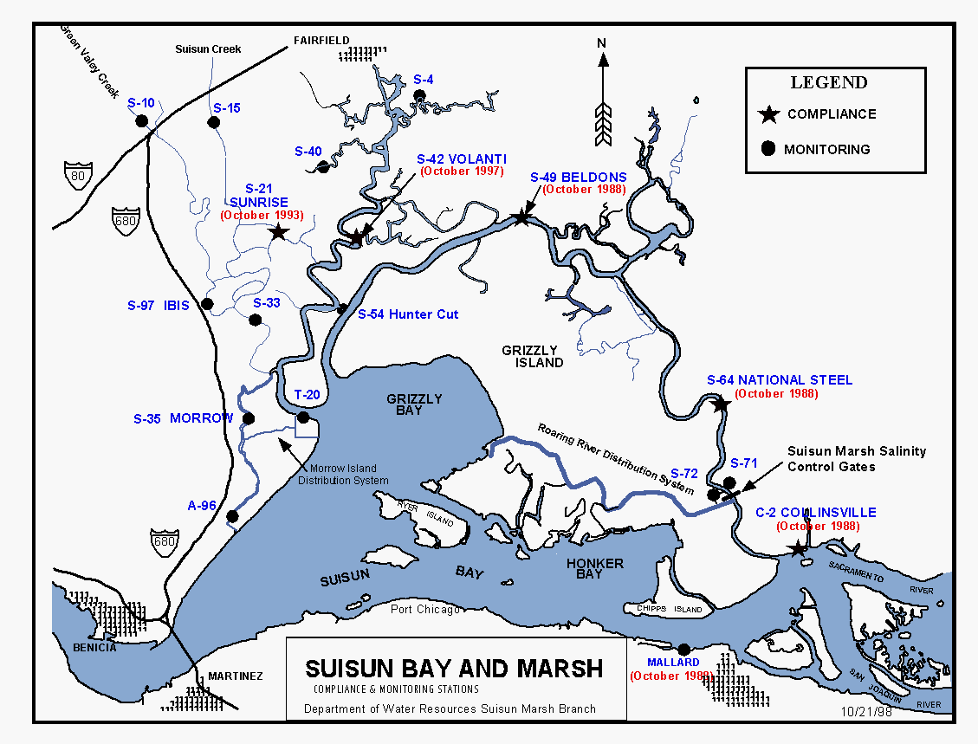
Figure 2-14 Compliance and monitoring stations and salinity control facilities in Suisun Marsh.
There are two primary physical mechanisms for meeting salinity standards set forth in D-1641 and the SMPA: (1) the implementation and operation of physical facilities in the Marsh; and (2) management of Delta outflow (i.e. facility operations are driven largely by salinity levels upstream of Montezuma Slough and salinity levels are highly sensitive to Delta outflow). Physical facilities (described below) have been operating since the early 1980s and have proven to be a highly reliable method for meeting standards. However, since Delta outflow cannot be actively managed by the Suisun Marsh Program, Marsh facility operations must be adaptive in response to changing salinity levels in the Delta.

CALFED Charter for Development of an Implementation Plan for Suisun Marsh Wildlife Habitat Management and Preservation
The goal of the CALFED Charter is to develop a regional plan that balances implementation of the CALFED Program, SMPA, and other management and restoration programs within Suisun Marsh. This is to be conducted in a manner that is responsive to the concerns of stakeholders and based upon voluntary participation by private land owners. The Habitat Management, Preservation, and Restoration Plan for the Suisun Marsh (Suisun Marsh Plan) and its accompanying Programmatic Environmental Impact Statement/Report (PEIS/EIR) will develop, analyze, and evaluate potential effects of various actions in the Suisun Marsh. The actions are intended to preserve and enhance managed seasonal wetlands, implement a comprehensive levee protection/improvement program, and protect ecosystem and drinking water quality, while restoring habitat for tidal marsh-dependent sensitive species, consistent with the CALFED Bay-Delta Program's strategic goals and objectives. The FWS and Reclamation are NEPA co-leads while DFG is the lead state CEQA agency. The Suisun Marsh Plan is anticipated to be finalized in 2011.
A complete list of participating agencies is provided below:
- Bureau of Reclamation (Reclamation)
- U.S. Fish & Wildlife Service (FWS)
- California Department of Fish and Game (DFG)
- Suisun Resource Conservation District (SRCD)
- California Department of Water Resources (DWR)
- U.S. Army Corps of Engineers (Corps)
- NOAA National Marine Fisheries Service (NMFS)
- San Francisco Bay-Delta Science Consortium (Bay-Delta Consortium)
- California Bay-Delta Authority (CBDA)
- CALFED Ecosystem Restoration, Levees, Drinking Water, and Science Programs
- Bay Conservation and Development Commission (BCDC)
- U.S. Geological Survey (USGS) Suisun Resource Conservation District

Suisun Marsh Salinity Control Gates
The SMSCG are located on Montezuma Slough about 2 miles downstream from the confluence of the Sacramento and San Joaquin Rivers, near Collinsville. Operation of the SMSCG began in October 1988 as Phase II of the Plan of Protection for the Suisun Marsh. The objective of Suisun Marsh Salinity Control Gate operation is to decrease the salinity of the water in Montezuma Slough The facility, spanning the 465 foot width of Montezuma Slough, consists of a boat lock, a series of three radial gates, and removable flashboards. The gates control salinity by restricting the flow of higher salinity water from Grizzly Bay into Montezuma Slough during incoming tides and retaining lower salinity Sacramento River water from the previous ebb tide. Operation of the gates in this fashion lowers salinity in Suisun Marsh channels and results in a net movement of water from east to west.
When Delta outflow is low to moderate and the gates are not operating, tidal flow past the gate is approximately +/- 5,000-6,000 cfs while the net flow is near zero. When operated, flood tide flows are arrested while ebb tide flows remain in the range of 5,000-6,000 cfs. The net flow in Montezuma Slough becomes approximately 2,500-2,800 cfs. The Corps of Engineers permit for operating the SMSCG requires that it be operated between October and May only when needed to meet Suisun Marsh salinity standards. Historically, the gate has been operated as early as October 1, while in some years (e.g. 1996) the gate was not operated at all. When the channel water salinity decreases sufficiently below the salinity standards, or at the end of the control season, the flashboards are removed and the gates are raised to allow unrestricted movement through Montezuma Slough. Details of annual gate operations can be found in “Summary of Salinity Conditions in Suisun Marsh During Water Years 1984-1992" (DWR, 1994b), or the “Suisun Marsh Monitoring Program Data Summary” produced annually by DWR, Division of Environmental Services.
The approximately 2,800 cfs net flow induced by SMSCG operation is effective at moving the salinity downstream in Montezuma Slough. Salinity is reduced by roughly one-hundred percent at Beldons Landing, and lesser amounts further west along Montezuma Slough. At the same time, the salinity field in Suisun Bay moves upstream as net Delta outflow (measured nominally at Chipps Island) is reduced by gate operation (Figure 2-15). Net outflow through Carquinez Strait is not affected. Figure 2-15 indicates the approximate position of X2 and how is transported upstream when the gate is operated.
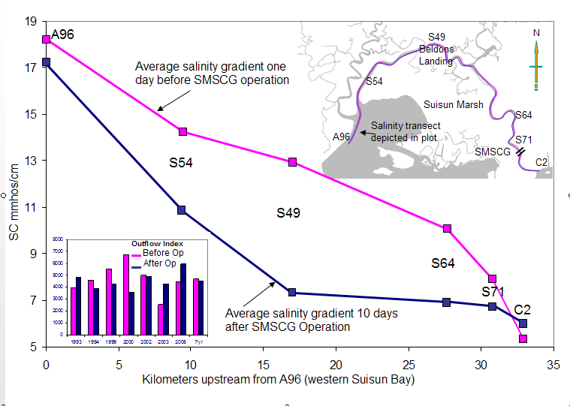
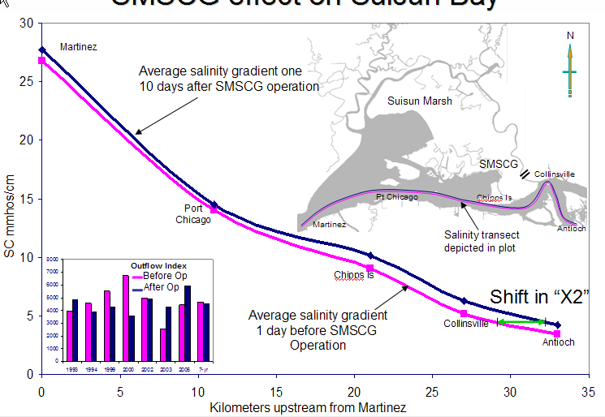
Figure 2-15 Average of seven years salinity response to SMSCG gate operation in Montezuma Slough and Suisun Bay.
Note: Magenta line is salinity profile 1 day before gate operation, blue line is salinity 10 days after gate operation.
It is important to note that historical gate operations (1988 – 2002) were much more frequent than recent and current operations (2006 – May 2008). Operational frequency is affected by many drivers (hydrologic conditions, weather, Delta outflow, tide, fishery considerations, etc). The gates have also been operated for scientific studies. Figure 2-16 shows that the gates were operated between 60 and 120 days between October and December during the early years (1988-2004). Salmon passage studies between 1998 and 2003 increased the number of operating days by up to 14 to meet study requirements. After discussions with NMFS based on study findings, the boat lock portion of the gate is now held open at all times during SMSCG operation to allow for continuous salmon passage opportunity. With increased understanding of the effectiveness of the gates in lowering salinity in Montezuma Slough, salinity standards have been met with less frequent gate operation since 2006. Figure 3 shows that despite very low outflow in the fall of the two most recent water years, gate operation was not required at all in fall 2007 and was limited to 17 days in winter 2008 21 days in 2009 and 22 days in 2010. Assuming no significant, long-term changes in the drivers mentioned above, this level of operational frequency (10 – 22 days per year) can generally be expected to continue to meet standards in the future except perhaps during the most critical hydrologic conditions and/or other conditions that affect Delta outflow.
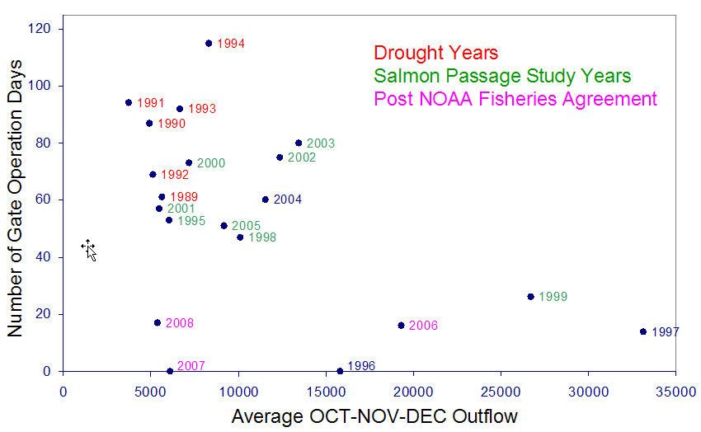
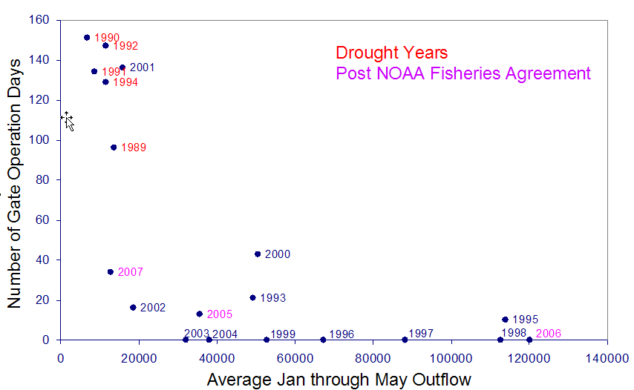
Figure 2-16 SMSCG operation frequency versus outflow since 1988.

SMSCG Fish Passage Study
The SMSCG were constructed and operate under Permit 16223E58 issued by the Corps, which includes a special condition to evaluate the nature of delays to migrating fish. Ultrasonic telemetry studies in 1993 and 1994 showed that the physical configuration and operation of the gates during the Control Season have a negative effect on adult salmonid passage (Tillman et al 1996: Edwards et al 1996).
The Department coordinated additional fish passage studies in 1998, 1999, 2001, 2002, 2003, and 2004. Migrating adult fall-run Chinook salmon were tagged and tracked by telemetry in the vicinity of the SMSCG to assess potential measures to increase the salmon passage rate and decrease salmon passage time through the gates.
Results in 2001, 2003, and 2004 indicate that leaving the boat-lock open during the Control Season when the flashboards are in place at the SMSCG and the radial gates are tidally operated provides a nearly equivalent fish passage to the Non-Control Season configuration when the flashboards are out and the radial gates are open. This approach minimizes delay and blockage of adult Sacramento River winter-run Chinook salmon, Central Valley spring-run Chinook salmon, and Central Valley steelhead migrating upstream during the Control Season while the SMSCG is operating. However, the boat-lock gates may be closed temporarily to stabilize flows to facilitate safe passage of watercraft through the facility.
Reclamation and DWR are continuing to coordinate with the SMSCG Steering Committee in identifying water quality criteria, operational rules, and potential measures to facilitate removal of the flashboards during the Control Season that would provide the most benefit to migrating fish. However, the flashboards would not be removed during the Control Season unless it was certain that standards would be met for the remainder of the Control Season without the flashboards installed.

Roaring River Distribution System
The RRDS was constructed during 1979 and 1980 as part of the Initial Facilities in the Plan of Protection for the Suisun Marsh. The system was constructed to provide lower salinity water to 5,000 acres of private and 3,000 acres of DFG managed wetlands on Simmons, Hammond, Van Sickle, Wheeler, and Grizzly Islands.
The RRDS includes a 40-acre intake pond that supplies water to Roaring River Slough. Motorized slide gates in Montezuma Slough and flap gates in the pond control flows through the culverts into the pond. A manually operated flap gate and flashboard riser are located at the confluence of Roaring River and Montezuma Slough to allow drainage back into Montezuma Slough for controlling water levels in the distribution system and for flood protection. DWR owns and operates this drain gate to ensure the Roaring River levees are not compromised during extremely high tides.
Water is diverted through a bank of eight 60-inch-diameter culverts equipped with fish screens into the Roaring River intake pond on high tides to raise the water surface elevation in RRDS above the adjacent managed wetlands. Managed wetlands north and south of the RRDS receive water, as needed, through publicly and privately owned turnouts on the system.
The intake to the RRDS is screened to prevent entrainment of fish larger than approximately 25 mm. DWR designed and installed the screens based on DFG criteria. The screen is a stationary vertical screen constructed of continuous-slot stainless steel wedge wire. All screens have 3/32-inch slot openings. After the listing of delta smelt, RRDS diversion rates have been controlled to maintain an average approach velocity below 0.2 ft/s at the intake fish screen. Initially, the intake culverts were held at about 20 percent capacity to meet the velocity criterion at high tide. Since 1996, the motorized slide gates have been operated remotely to allow hourly adjustment of gate openings to maximize diversion throughout the tide.
Routine maintenance of the system is conducted by DWR and primarily consists of maintaining the levee roads and fish screens. RRDS, like other levees in the marsh, have experienced subsidence since the levees were constructed in 1980. In 1999, DWR restored all 16 miles of levees to design elevation as part of damage repairs following the 1998 flooding in Suisun Marsh. In 2006, portions of the north levee were repaired to address damage following the January 2006 flooding.

Morrow Island Distribution System
The Morrow Island Distribution System (MIDS) was constructed in 1979 and 1980 in the south-western Suisun Marsh as part of the Initial Facilities in the Plan of Protection for the Suisun Marsh. The contractual requirement for Reclamation and DWR is to provide water to the ownerships so that lands may be managed according to approved local management plans. The system was constructed primarily to channel drainage water from the adjacent managed wetlands for discharge into Suisun Slough and Grizzly Bay. This approach increases circulation and reduces salinity in Goodyear Slough (GYS).
The MIDS is used year-round, but most intensively from September through June. When managed wetlands are filling and circulating, water is tidally diverted from Goodyear Slough just south of Pierce Harbor through three 48-inch culverts. Drainage water from Morrow Island is discharged into Grizzly Bay by way of the C-Line Outfall (two 36-inch culverts) and into the mouth of Suisun Slough by way of the M-Line Outfall (three 48-inch culverts), rather than back into Goodyear Slough. This helps prevent increases in salinity due to drainage water discharges into Goodyear Slough. The M-Line ditch is approximately 1.6 miles in length and the C-Line ditch is approximately 0.8 miles in length.
The 1997 FWS BO issued for dredging of the facility included a requirement for screening the diversion to protect delta smelt. Due to the high cost of fish screens and the lack of certainty surrounding their effectiveness at MIDS, DWR and Reclamation proposed to investigate fish entrainment at the MIDS intake with regard to fishery populations in Goodyear Slough and to evaluate whether screening the diversion would provide substantial benefits to local populations of listed fish species. DWR and Reclamation are analyzing conservation alternatives to a fish screen in coordination with FWS and DFG to meet this requirement. DWR staff monitored fish entrainment from September 2004 to June 2006 at the MIDS in Suisun Marsh (Figure 1) to evaluate entrainment losses at the facility. Monitoring took place over several months under various operational configurations to provide data on the site-specific impact of the MIDS diversion with a focus on delta smelt and salmonids. Over 20 different species were identified during the sampling, yet only two fall-run sized Chinook salmon (south intake, 2006) and no delta smelt from entrained water were caught. Two species that associate with instream structures, threespine stickleback and prickly sculpin, comprised most of the entrained fish. DWR and Reclamation staff will continue coordination with the fishery agencies to address the screening requirement.
Reclamation and DWR continue to coordinate with FWS, NMFS, and DFG regarding fish entrainment at this facility. The objective remains to provide the greatest benefit for aquatic species in Suisun Marsh. Studies suggest that GYS is a marginal, rarely used habitat for special-status fishes. Therefore, implementation and/or monitoring of a tidal restoration project elsewhere is emerging as the most beneficial and practical approach (in lieu of installing and maintaining fish screens). Restoration of tidal wetland ecosystems is expected to aid in the recovery of several listed and special status species within the marsh and improve food availability for delta smelt and other pelagic organisms.
To meet contractual commitments, the typical MIDS annual operations are described in detail in this BA. There are currently no plans to modify operations.

South Delta Temporary Barriers Project
The South Delta Temporary Barrier Project (TBP) was initiated by DWR in 1991. Permit extensions were granted in 1996, 2001, 2008 and 2011, when DWR obtained permits to extend the Temporary Barriers Project through 2016. The current Biological Opinion issued by the FWS for the construction and demolition effects is still applicable. Continued coverage by FWS for the TBP operational effects is separate and will be assessed under this BA for the continued long-term operation of the SWP and CVP. The NMFS recently submitted a biological opinion to the Corps which provides incidental take coverage for the construction of the TBP in 2011. DWR will re-initiate consultation with NMFS via Corps to extend the TBP construction coverage through 2016. DWR plans to seek approvals through 2016 prior to 2012 construction, and Corps and NMFS staff are supportive of a multiple year BO and Corps permit. The project consists of four rock barriers across south Delta channels. In various combinations, these barriers improve water levels and San Joaquin River salmon migration in the south Delta. The existing TBP consists of installation and removal of temporary rock barriers at the following locations:
- Middle River near Victoria Canal, about 0.5 miles south of the confluence of Middle River, Trapper Slough, and North Canal
- Old River near Tracy, about 0.5 miles east of the DMC intake
- Grant Line Canal near Tracy Boulevard Bridge, about 400 feet east of Tracy Boulevard Bridge
- The head of Old River at the confluence of Old River and San Joaquin River
The barriers on Middle River, Old River near Tracy, and Grant Line Canal are flow control facilities designed to improve water levels for agricultural diversions and are in place during the irrigation season. Under the FWS BO for the Temporary Barriers, operation of the barriers at Middle River and Old River near Tracy can begin May 15, or as early as April 15 if the spring barrier at the head of Old River is in place. From May 16 to May 31 (if the barrier at the head of Old River is removed) the tide gates are tied open in the barriers in Middle River and Old River near Tracy. After May 31, the barriers in Middle River, Old River near Tracy, and Grant Line Canal are permitted to be operational until they are completely removed by November 30.
During the spring, the barrier at the head of Old River is designed to reduce the number of out-migrating salmon smolts entering Old River. During the fall, this barrier is designed to improve flow and DO conditions in the San Joaquin River for the immigration of adult fall-run Chinook salmon. The barrier at the head of Old River barrier is typically in place between April 15 to May 15 for the spring, and between early September to late November for the fall. Installation and operation of the barrier at the head of Old river also depends on the San Joaquin flow conditions.

Proposed Installation and Operations of the Temporary Barriers
The installation and operation of the TBP is planned to continue indefinitely. The proposed installation schedule through 2016 will be identical to the current schedule. However, because of recent court rulings to protect Delta smelt, the installation of the spring HOR barrier was prohibited in 2008. As a result, the agricultural barriers installations were delayed per permit requirements until mid-May.
In lieu of the HOR spring rock barrier, an experimental non-physical barrier was installed in 2009 and 2010 with the intention of deterring out-migrating juvenile salmonids from entering Old River. This experimental barrier is a patented technology using sound and light as a deterrent. Although high flows prohibited installation of the non-physical barrier in 2011, a without-barrier study of predator behavior was conducted. The barrier designed for installation in 2011 is planned to be installed in 2012.
To improve water circulation and quality, DWR in coordination with the South Delta Water Agency and Reclamation, began in 2007 to manually tie open the culvert flap gates at the Old River near Tracy barrier to improve water circulation and untie them when water levels fell unacceptably. This operation is expected to continue in subsequent years as needed to improve water quality. In addition, DWR has consulted with Corps and received FWS and NMFS approval to raise the Middle River weir height by one foot. The weir height will be raised during the summer irrigation season only after Delta smelt concerns have passed. The requested modification was approved late in the 2010 irrigation season, and although approval for 2011 has been received the weir has not needed to be raised because of high river flows.
In the absence of permanent operable gates, the TBP will continue as planned and permitted. Computer model forecasts, real time monitoring, and coordination with local, State, and federal agencies and stakeholders will help determine if the temporary rock barriers operations need to be modified during the transition period.

DMC/CA Intertie
DMC and CA Intertie (DMC/CA Intertie) is currently under construction. The project consists of a pumping plant and pipeline connections between the DMC and the CA. The DMC/CA Intertie Pumping Plant is located at DMC milepost 7.2 where the DMC and the CA are about 500 feet apart.
The DMC/CA Intertie will be used in a number of ways to achieve multiple benefits, including meeting current water supply demands, allowing for the maintenance and repair of the CVP Delta export and conveyance facilities, and providing operational flexibility to respond to emergencies. The Intertie will allow flow in both directions, which would provide additional flexibility to both CVP and SWP operations. The Intertie includes a pumping plant at the DMC that will allow up to 467 cfs to be pumped from the DMC to the CA. Up to 900 cfs can be conveyed from the CA to the DMC using gravity flow.
The DMC/CA Intertie will be operated by the San Luis and Delta-Mendota Water Authority (Authority). Agreements between Reclamation, DWR, and the Authority will identify the responsibilities and procedures during operation of the Intertie.

Operations
The Intertie will be used under three different scenarios:
- Up to 467 cfs may be pumped from the DMC to the CA to ease DMC conveyance constraints and help meet water supply demands of CVP contractors. This would allow Jones Pumping Plant to pump to its design capacity of up to 4,600 cfs, subject to all applicable export pumping restrictions for water quality and fishery protections.
- Up to 467 cfs may be pumped from the DMC to the CA to minimize impacts to water deliveries due to temporary restrictions in flow or water levels on the lower DMC (south of the Intertie) or the upper CA (north of the Intertie) for system maintenance or due to an emergency shutdown.
- Up to 900 cfs may be conveyed from the CA to the DMC using gravity flow to minimize impacts to water deliveries due to temporary restrictions in flow or water levels on the lower CA (south of the Intertie) or the upper DMC (north of the Intertie) for system maintenance or due to an emergency shutdown.
The DMC/CA Intertie provides operational flexibility between the DMC and CA. It will not result in any changes to authorized pumping capacity at Jones Pumping Plant or Banks Delta Pumping Plant.
Water conveyed at the Intertie to minimize reductions to water deliveries during system maintenance or an emergency shutdown on the DMC or CA can include pumping of CVP water at Banks Pumping Plant or SWP water at Jones Pumping Plant through use of JPOD. In accordance with COA Articles 10(c) and 10(d), JPOD may be used to replace conveyance opportunities lost because of scheduled maintenance, or unforeseen outages. Use of JPOD for this purpose can occur under Stage 2 operations defined in SWRCB D-1641, or could occur as a result of a Temporary Urgency request to the SWRCB. Use of JPOD in this case does not result in any net increase in allowed exports at CVP and SWP export facilities. When in use, water within the DMC will be conveyed to the CA via the Intertie. Water diverted through the Intertie will then be conveyed through the CA to O’Neill Forebay.

Conservation Strategies and Mitigation Measures
Various measures and conditions required by regulatory agencies under past and current permits to avoid, minimize, and compensate for the TBP impacts have been complied with by DWR. An ongoing monitoring plan is implemented each year the barriers are installed and an annual monitoring report is prepared to summarize the activities. The monitoring elements include fisheries monitoring and water quality analysis, salmon smolt survival investigations, barrier effects on SWP and CVP entrainment, Swainson’s Hawk monitoring, water elevation, water quality sampling, and hydrologic modeling. DWR operates fish screens to offset TBP impacts at Sherman Island. Studies of predator behavior in the vicinity of the non-physical barrier began in 2011 as required by DFG.
The 2008 NMFS BO for the TBP requires a fisheries monitoring program using biotelemetry techniques to examine the movements and survival of juvenile salmon and juvenile steelhead through the channels of the south Delta. The BO also requires that predation effects associated with the barriers be examined. Information gained as part of the 2009 pilot study was used to develop the full scale study that started in 2010. 2011 was the third and final year of the studies mandated in the 2008 BO. Any future telemetry studies at the barriers would be required from a subsequent BO.
The DFG Incidental Take Permit provides California Endangered Species coverage through 2016. Six acres of shallow water habitat is required by this permit and will be provided through a purchase from the Wildlands Liberty Island mitigation bank.

Transfers
California Water Law and the CVPIA promote water transfers as important water resource management measures to address water shortages provided certain protections to source areas and users are incorporated into the water transfer. Parties seeking water transfers generally acquire water from sellers who have surplus reservoir storage water, sellers who can pump groundwater instead of using surface water, or sellers who will fallow crops or substitute a crop that uses less water in order to reduce normal consumptive use of surface diversions.
Water transfers (relevant to this document) occur when a water right holder within the Sacramento-San Joaquin River watershed undertakes actions to make water available for transfer by export through the Delta. With the exception of the Component 1 pursuant to the Yuba River Accord discussed below, this BA does not address the upstream operations that may be necessary to make water available for transfer. Also, this document does not address the impacts of water transfers to terrestrial species.
Transfers requiring export from the Delta are done at times when pumping and conveyance capacity at the CVP or SWP export facilities is available to move the water. Additionally, operations to accomplish these transfers must be carried out in close coordination with CVP and SWP operations, such that the capabilities of the Projects to exercise their own water rights or to meet their legal and regulatory requirements are not diminished or limited in any way. In particular, parties to the transfer are responsible for providing for any incremental changes in flows required to protect Delta water quality standards. All transfers will be in accordance with all existing regulations and requirements.
Purchasers of water for transfers may include Reclamation, CVP Contractors, DWR, SWP contractors, other State and Federal agencies, or other parties. DWR and Reclamation have operated water acquisition programs in the past to provide water for environmental programs and additional supplies to SWP contractors, CVP contractors, and other parties. Past transfer programs include:
- DWR administrated the 1991, 1992, 1994, and 2009 Drought Water Banks and Dry Year Programs in 2001 and 2002.
- Reclamation operated a forbearance program in 2001 by purchasing CVP contractors’ water in the Sacramento Valley for CVPIA in-stream flows, and to augment water supplies for CVP contractors south of the Delta and wildlife refuges. Reclamation administers the CVPIA Water Acquisition Program for Refuge Level 4 supplies and fishery in-stream flows.
- DWR, and potentially Reclamation in the future, has agreed to participate in the Yuba River Accord that will provide fish flows on the Yuba River and also water supply that may be transferred at DWR and Reclamation Delta Facilities.
- Also in the past, CVP and SWP contractors have independently acquired water and arranged for pumping and conveyance through SWP facilities. State Water Code provisions grant other parties access to unused conveyance capacity from the SWP, although SWP contractors have priority access to capacity not being used by the DWR to meet SWP contract amounts.

Yuba River Accord
The Yuba River Accord includes three sets of agreements designed to protect and enhance fisheries resources in the lower Yuba River, increase local water supply reliability, provide DWR with increased operational flexibility for protection of Delta fisheries resources, and provide added dry-year water supplies to state and federal water contractors. These agreements are the:
- Lower Yuba River Fisheries Agreement (Fisheries Agreement)
- Agreements for the Conjunctive Use of Surface and Groundwater Supplies (Conjunctive Use Agreements)
- Agreement for the Long-term Purchase of Water from Yuba County Water Agency by the Department of Water Resources (Water Purchase Agreement)
The Fisheries Agreement is the cornerstone of the Yuba Accord. It was developed by state, federal, and consulting fisheries biologists, fisheries advocates, policy representatives, and the YCWA. Compared to the interim flow requirements of the SWRCB Revised Water Right Decision 1644 (RD-1644), the Fisheries Agreement establishes higher minimum instream flows during most months of most water years.
To assure that Yuba County Water Agency’s (YCWA) water supply reliability is not reduced by the higher minimum instream flows and water transfers, YCWA and seven of its Member Units have signed Conjunctive Use Agreements. These agreements establish a conjunctive use program that facilitates the integration of the surface water and groundwater supplies of the seven local irrigation districts and mutual water companies that YCWA serves in Yuba County. Integration of surface water and groundwater allows YCWA to increase the efficiency of its water management.
Under the Water Purchase Agreement, DWR administers the water transfer activities. The Water Transfer Agreement allows DWR to purchase water from YCWA to generally off-set water costs resulting from export restrictions in April and May each year to benefit out-migrating San Joaquin River salmonids. This quantity of water is known as “C1” under the Water Purchase Agreement and is quantified as a 60,000 AF of water from YCWA that generally can produce a mitigation offset of approximately 48,000 AF of reduced exports.
Additional water supplies purchased by the SWP contractors and/or CVP contractors under the Water Purchase Agreement is administered by DWR as a water transfer program in drier years. Reclamation is not a signatory to the Water Purchase Agreement, but may consider partnering under the agreement at a future date.
All three sets of agreements (Fisheries, Water Purchase, and Conjunctive Use) completed CEQA and NEPA review in 2007 and were fully executed between late 2007 and early 2008. The SWRCB approved the flow schedules and water transfer aspects of the Yuba River Accord on March 18, 2008. The Fisheries Agreement expires in 2015, the Water Purchase Agreement expires in 2025, and the expiration of the Conjunctive Use Agreements is contingent on the Fisheries and Water Purchase Agreement expiration terms. The FERC license for the Yuba River Development Project expires in April 2016. A new FERC license is expected to impose new flow requirements, and a renegotiation of the agreements is expected to be required at that time.

Transfer Capacity
The assumption in this BA is that under both existing conditions and in the future, water transfer programs for environmental and water supply augmentation will continue in some form, and that in most years (all but the driest), the scope of annual water transfers will be limited by available Delta pumping capacity, and exports for transfers will be limited to the months July-September. As such, looking at an indicator of available transfer capacity in those months is one way of estimating an upper boundary to the effects of transfers on an annual basis.
The CVP and SWP may provide Delta export pumping for transfers using pumping capacity at Banks and Jones beyond that which is being used to deliver project water supply, up to the physical maximums of the pumps, consistent with prevailing operations constraints such as E/I ratio, conveyance or storage capacity, and any protective criteria in effect that may apply as conditions on such transfers. For example, pumping for transfers may have conditions for protection of Delta water levels, water quality, fisheries, or other beneficial uses.
The surplus capacity available for transfers will vary a great deal with hydrologic conditions. In general, as hydrologic conditions get wetter, surplus capacity diminishes because the CVP and SWP are more fully using export pumping capacity for Project supplies. CVP’s Jones Pumping Plant has little surplus capacity, except in the driest hydrologic conditions. SWP has the most surplus capacity in critical and some dry years, less or sometimes none in most median hydrologic conditions, and some surplus again in some above normal and wet years when demands may be lower because some water users may have alternative supplies.
The availability of water for transfer and the demand for transferred water may also vary with hydrologic conditions. Accordingly, since many transfers are negotiated between willing buyers and sellers under prevailing market conditions, price of water also may be a factor determining how much is transferred in any year. This document does not attempt to identify how much of the available and useable surplus export capacity of the CVP and SWP will actually be used for transfers in a particular year, but given the recent history of water transfer programs and requests for individual water transfers, trends suggest a growing reliance on transfers to meet increasing water demands.
Under both the present and future conditions, capability to export transfers will often be capacity-limited, except in Critical and some Dry years. In Critical and some Dry years, both Banks and Jones will likely have surplus capacity for transfers. As a result, export capacity is less likely to limit transfers in these years. During such years, low project exports and high demand for water supply could make it possible to transfer larger amounts of water.
Proposed Exports for Transfers
Although transfers may occur at any time of year, this BA covers proposed exports for transfers during only the months July through September. For transfers outside those months, or in excess of the proposed amounts, Reclamation and DWR would request separate consultation. In consideration of the estimates of available capacity for export of transfers during July-September, and in recognition of the many other possible operations contingencies and constraints that may limit actual use of that capacity for transfers, the proposed use of SWP/CVP export capacity for transfers is as follows:

Water Year Class Maximum Transfer Amount
Critical up to 600 kaf
Dry (following Critical) up to 600 kaf
Dry (following Dry) up to 600 kaf
All other Years up to 360 kaf

Other Future Projects
These projects are potential future actions that have not been approved; however, the effects of these actions are analyzed in this BA.

Sacramento River Reliability Project
The Sacramento River Reliability Project (SRRP) consists of constructing an in-river intake and fish screens (Elverta Diversion) on the Sacramento River at RM 74.6 and support facilities, north of Elverta Road, in Sacramento County. The SRRP includes realignment of 0.3 miles of the Garden Highway near the new Elverta intake structure; constructing a 235 mgd (365 cfs) North Natomas water treatment plant near the new intake facility, water pipelines from the intake structure to the North Natomas water treatment plant, a booster pump station, and 27 to 30 miles of new underground treated water pipelines from the North Natomas water treatment plant to connection points within existing water distribution systems of Placer County Water Agency (PCWA), City of Roseville (Roseville), Sacramento Suburban Water District (SSWD), and City of Sacramento (Sacramento).
Diversion from the SRRP would be made as described below:
- PCWA would divert its 35-taf CVP water from the Elverta Diversion.
- SSWD would divert up to 29 taf of PCWA’s MFP water from the Elverta Diversion through exchange with the CVP during Water Forum non-wet years.
- Roseville would divert its CVP water first, and MFP water next, at Folsom Dam in accordance with its WFA limitation on American River Diversion (maximum annual amount of 54.9 taf). Roseville would also receive 4 taf transfer of MFP water from SJWD at Folsom Dam during Water Forum wet and average years. Roseville would divert from Elverta Diversion the remaining of 30 taf PCWA’s MFP water not diverted at Folsom Dam through exchange with CVP due to its WFA limitation on diversion from the American River.
- For the City of Sacramento diversion priority would be the (1) Fairbairn WTP, (2) North Natomas WTP, and (3) Sacramento River WTP. The annual diversion amount at Fairbairn WTP is subject to WFA limitations (varied with hydrological conditions) while the annual diversion amount at the North Natomas WTP is up to Sacramento’s Sacramento River water right (81.8 taf per year). The diversion amount at Sacramento River WTP is intended to meet the remaining demand after diversions from Fairbairn WTP and North Natomas WTP.

These percentages were derived from negotiations between Reclamation and DWR for SWRCB D-1485 standards
The DAT holds weekly conference calls and may have additional discussions during other times as needed.
Article 21 provides, in part: “Each year from water sources available to the project, the State shall make available and allocate interruptible water to contactors. Allocations of interruptible water in any one year may not be carried over for delivery in a subsequent year, nor shall the delivery of water in any year impact a contractor’s approved deliveries of annual [Table A water] or the contractor’s allocation of water for the next year. Deliveries of interruptible water in excess of a contractor’s annual [Table A water] may be made if the deliveries do not adversely affect the State’s delivery of annual [Table A water] to other contractors or adversely affect project operations…”

